Registering your iClicker - Remote Registration
Go to this site in the Chrome Browser: https://lmsreg.iclicker.com/Register_Clicker.aspx
And you should see this
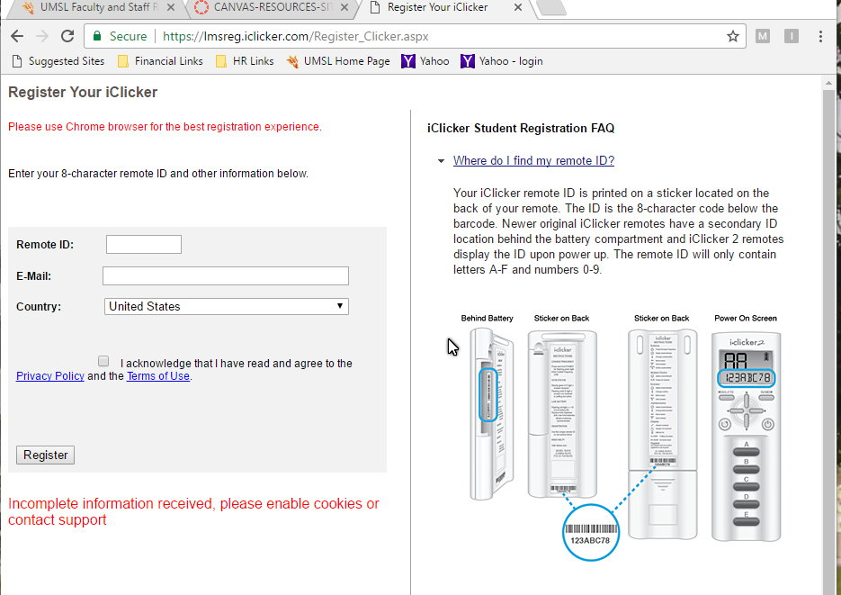
Below that are some frequently asked questions with answers. It would be wise to check these out.

Then you may have to do this too: (I’m still learning about this)
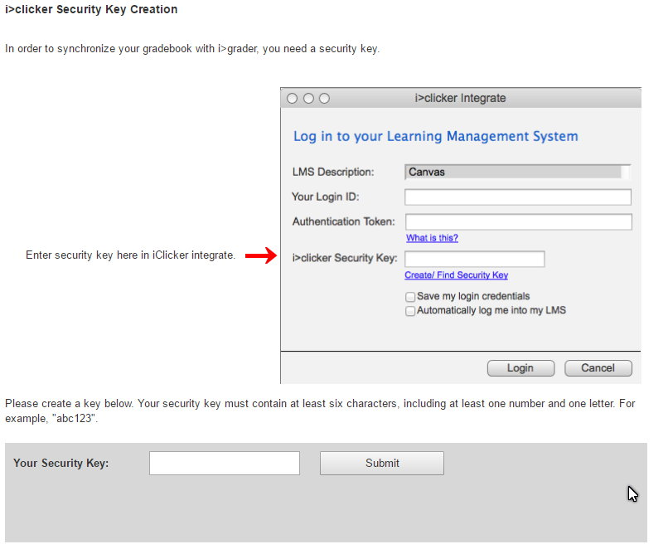

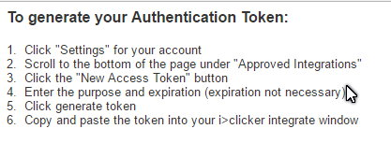
I will provide more information if I learn that you need more.

