ITO and BPO in Europe

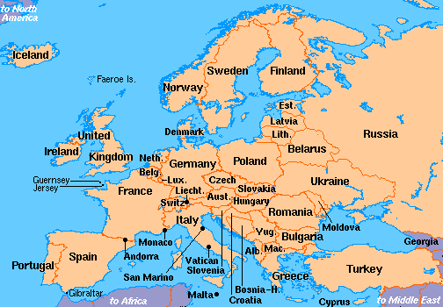

Europe has a very large share of the global ITO and BPO markets. In particular, Western Europe has been increasingly outsourcing IT and business processes to Eastern European countries such as Romania, Western Russia, and Czech Republic. The IAOP had a European Summit Conference since 2009.

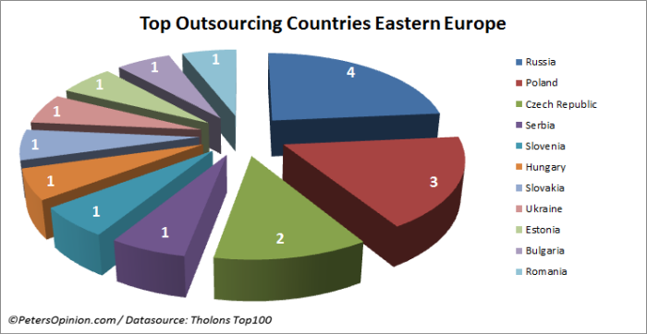

Your group is tasked with explaining the ITO and BPO markets in Europe. Your group should:

1. Provide an overview of the continent: Show us the major countries exporting ITO and BPO services on this continent and showed us the major countries to which they export.

2. Find top 10 providers of ITO and BPO services and compared the top providers in terms of revenue, number or employees (if possible), services, etc.

3. Focus on one country. For this one country:

- Describe relevant attributes of the country or countries in terms of GDP relative to the United States

- ITO/BPO services exports and imports (if possible)

- Key government policies pertaining to ITO/BPO (tax incentives, government agencies that help promote ITO and BPO).

- ITO/BPO workforce (e.g., number of graduates per year)

- Major cities within the country providing ITO/BPO services

- The quality of the Infrastructure (internet, electricity, roads, air travel, etc).

- Describe the major risks US managers will have to mitigate when outsourcing to providers in this country. Risks may include political risks, cultural risks, human resource risks (number of qualified workers, turnover), etc.

4. Focus on one to three of the top providers within this same country.

Tell us about the provider’s history, CEO, major customers, competitive positioning, and financial performance in terms of five year stock price, five year sales, five year profits if possible.

Interview relevant people—these could be marketing directors in the provider firms, clients who outsource to providers in this country, government officials from this country (like economic development officials). Have courage! They will want to speak with potential clients and students from the United States.

Some places to look:

Consulting Reports Posted in Mygateway

http://www.euroitx.com/content/countries.php
http://www.euroitx.com/content/ict_program.php
http://www.slideshare.net/Marina_Pavlovskaya/outsourcing-to-eastern-europe-financial-services-industry-perspective-3829307
http://nearshoreoutsourcing.blogspot.com/2010/10/bpo-in-europe-offshore-or-nearshore.html
http://www.iaop.org/content/23/154/1799/

http://www.softwareprojects.org/offshore-outsourcing-eastern-europe.htm

