ITO and BPO in Africa

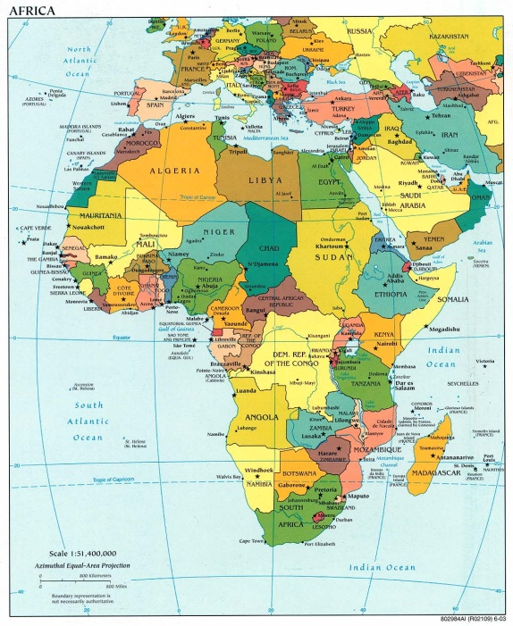

Africa currently has a very small share of the global ITO and BPO markets. However, many African countries are hoping to export ITO and BPO services. In particular, Northern Africa has been increasingly outsourcing IT and business processes to European countries such as France. South Africa is a good destination for UK and Dutch client firms. We’ve done quite a bit of research on South Africa:

Willcocks, L. Lacity, M., and Craig, A. (2015), South Africa’s BPO Service Advantage, Palgrave, London).

Lacity, M., Willcocks, L. and Craig, A. (2014), “South Africa’s Business Process Outsourcing Services Sector: Lessons for Western-based Client Firms,” The South African Journal of Business Management, December

Lacity, M., Willcocks,L., and Craig, A. (2013), “South Africa’s Maturing BPO Service Advantage: Case Studies of Success 2013”, available at www.outsourcingunit.org
Lacity, M., Willcocks,L., and Craig, A. (2013), “ South Africa’s BPO Service Advantage Case Study: radiant.law: Rethinking Legal Services,” available at www.outsourcingunit.org
Willcocks, L., Craig, A., and Lacity, M. (2012), “Becoming Strategic - South Africa’s BPO Service Advantage” available at www.outsourcingunit.org
Besides South Africa, many other countries want to sell services to clients based in high-cost countries. At the 2010 world Summit, for example,an entire delegation from Ghana came to sell clients on the idea of sourcing work to Africa. Egypt was on the rise as a preferred destination, although political unrest in 2011 has made its future less certain.

Your group is tasked with explaining the ITO and BPO markets in Africa. Your group should:

1. Provide an overview of the continent: Show us the major countries exporting ITO and BPO services on this continent and showed us the major countries to which they export.

2. Find top 10 providers of ITO and BPO services and compared the top providers in terms of revenue, number or employees (if possible), services, etc.

3. Focus on one country. For this one country:

- Describe relevant attributes of the country or countries in terms of GDP relative to the United States

- ITO/BPO services exports and imports (if possible)

- Key government policies pertaining to ITO/BPO (tax incentives, government agencies that help promote ITO and BPO).

- ITO/BPO workforce (e.g., number of graduates per year)

- Major cities within the country providing ITO/BPO services

- The quality of the Infrastructure (internet, electricity, roads, air travel, etc).

- Describe the major risks US managers will have to mitigate when outsourcing to providers in this country. Risks may include political risks, cultural risks, human resource risks (number of qualified workers, turnover), etc.

4. Focus on one to three of the top providers within this same country.

Tell us about the provider’s history, CEO, major customers, competitive positioning, and financial performance in terms of five year stock price, five year sales, five year profits if possible.

Interview relevant people—these could be marketing directors in the provider firms, clients who outsource to providers in this country, government officials from this country (like economic development officials). Have courage! They will want to speak with potential clients and students from the United States.

Some places to look:

Consulting Reports (may be dated)

http://www.economist.com/node/15777592

http://www.globalservicesmedia.com/Destinations/Africa-and-Middle-East/IT-Outsourcing-to-Africa/25/23/9932/GS100810178657

http://www.globalservicesmedia.com/Destinations/Africa-and-Middle-East/Africa:-The-emerging-frontier-for-services-offshoring/25/23/10282/GS101216709012

http://www.globalservicesmedia.com/Destinations/Africa-and-Middle-East/Africa-as-an-Outsourcing-Destination/25/23/10276/GS101215659006

http://www.globalservicesmedia.com/Destinations/Asia/Cairo,-Egypt:The-Victorious-City-of-the-Middle-East/25/22/0/GS101217649033

http://www.google.com/imgres?imgurl=http://whiteafrican.com/wp-content/uploads/2009/06/africa-undersea-cables-map.jpg&imgrefurl=http://whiteafrican.com/2009/06/11/map-and-stats-for-africas-undersea-internet-cables/&usg=__QuM7pXuaQUokGxTss0ekgNkm7Bg=&h=483&w=500&sz=127&hl=en&start=0&zoom=1&tbnid=fLd9Mhe1lFSDZM:&tbnh=131&tbnw=136&ei=FKMlTv6vKe_DsQLIlY37Cw&prev=/search%3Fq%3DMap%2Bof%2BAfrica%2BInternet%26um%3D1%26hl%3Den%26rls%3Dcom.microsoft:en-us:IE-SearchBox%26rlz%3D1I7GGHP_en%26biw%3D1440%26bih%3D695%26tbm%3Disch&um=1&itbs=1&iact=rc&dur=109&page=1&ndsp=32&ved=1t:429,r:1,s:0&tx=63&ty=62

http://www.ghanabusinessnews.com/2009/05/27/business-outsourcing-to-create-40000-jobs-in-ghana-in-five-years/

http://blogs.wsj.com/digits/2009/02/27/egypt-land-of-pyramids-the-sphinx%E2%80%A6and-outsourcing/

http://www.rayacorp.com/ShowPage.aspx?PID=63

http://www.info.gov.za/speeches/2008/08060611151003.htm (might try to email contacts to find out about how the event went).

