EXECUTIVE SUMMARY

ENTERPRISE RESOURCE PLANNING

By:
Jun Han
Rongbi Liu
Brandon Swanner
Shicheng Yang

Advances in information technology, expansion of the Internet and electronic business as well as an ever-growing global competition have made running a successful business more difficult than ever before. Currently, a popular approach to the development of an integrated enterprise-wide system is the implementation of an enterprise resource planning system.

What is ERP?
Enterprise Resource Planning (ERP) is software that attempts to integrate all departments and functions across a company onto a single computer system that can serve all those departments’ particular needs. ERP allows a company to automate and integrate the majority of its business processes, including product planning, purchasing, production control, inventory control, interaction with suppliers and customer, delivery of customer service and keeping track of orders, to share common data and practices across the entire enterprise, and to produce and access information in a real-time environment. ERP enables decision-makers to have an enterprise-wide view of the information they need in a timely, reliable and consistent fashion. ERP applications market grew to $25.4 billion in 2005, and will reach $29 billion in 2006. Over the next five years, the market will grow at an average of 10%.

Advantages of ERP
With ERP to automate processes, the benefits are as follows:
- Increase inventory turns
- Increase inventory accuracy rate
- Reduce inventory costs
- Improve customer service
- Reduce setup times
- Reduce paper work.
- Provide a unified customer database usable by all applications
- Provide greater and effective control on account.
- Faster response and follow ups to customers
- Improves supply demand linkage with remote locations and branches in different locations
- Higher quality, less re-work
- Timely revenue collection, improved cash flow

Risks of ERP
There was 70% percent of all ERP projects fail to be fully implemented, even after three years. Few companies are making full use of their ERP systems, despite the high cost of the software and the length of time an implementation can take. Once installed, more than 50% of companies said it was hard to make changes to ERP software in order to meet any changes in business processes or requirements. More than 50% of the companies did not measure their return on investment from business applications. The failure rates for ERP projects are relatively high and could lead to the bankruptcy of the corporation.

Challenges of ERP Implementation
- Customization Related Challenges
- Redesigning Business Processes
- Cost of upgrades/updates
- Training
- Little flexibility in adapting to business processes
- High integration costs
- High maintenance costs
- Lengthy or incomplete integrations

Critical Success Factors of Implementing ERP
Critical factors to ERP implementation success:
- ERP teamwork and composition;
- Change management program and culture;
- Top management support;
- Business plan and vision; '
- Business process re-engineering and minimum customization;
- Effective communication;
- Project management;
- Software development, testing, and trouble shooting;
- Monitoring and evaluation of performance;
- Project champion; and
- Appropriate business and information technology legacy systems.

ENTERPRISE RESOURCE PLANNING
CONTENTS
EXECUTIVE SUMMARY 1
What is ERP? 1
Advantages of ERP 1
Risks of ERP 2
Challenges of ERP Implementation 2
Critical Success Factors of Implementing ERP 2
INTRODUCTION 4
WHAT IS ERP? 4
Definition of ERP 4
Understanding ERP 4
Core Components of ERP 5
Evolution of ERP 6
Interface of Modules 7
WHY IS ERP? 8
Key Motivating Factors 8
Tangible and intangible Benefits 9
The Percentage and Age of ERP Implementations 9
The Number of ERP Packages Implemented 9
Factors Affecting Upgrade Decisions. 10
Factors Impacting ERP Strategies 11
Plan of Action 11
HOW TO IMPLEMENT ERP? 12
Buy or Make ERP Software 12
ERP Implementation Challenges and Responses 12
ERP Implementation - Considerations 12
Critical Success Factors of Implementing ERP 13
Measuring Success 13
ERP Software 14
ORACLE 16
mySAP ERP 17
Comparison of ERP Software 18
CASE STUDIES 19
Case 1 - Failed ERP Gamble Haunts Hershey 20
Case 2 - KV 21
Case 3 - Business Transformation Through ERP 23
Comparisons of the Three Cases 30
THE FUTURE OF ERP 31
REFERENCES 31

INTRODUCTION
Advances in information technology, expansion of the Internet and electronic business as well as an ever-growing global competition have made running a successful business more difficult than ever before [1]. To remain successful and to be competitive, managers of manufacturing and service organizations must use technology to improve information flow, reduce costs, streamline business processes, offer product variety, establish linkage with suppliers, and to reduce response time to customer needs and expectations [1]. Corporate-wide technology integration allows information users of the company to have access to the needed information in a timely fashion and make intelligent decisions. Currently, a popular approach to the development of an integrated enterprise-wide system is the implementation of an enterprise resource planning (ERP) system, also called enterprise system [1].

WHAT IS ERP?

Definition of ERP
Enterprise Resource Planning (ERP) is software that attempts to integrate all departments and functions across a company onto a single computer system that can serve all those departments’ particular needs [2].
Evolving out of the manufacturing industry, ERP implies the use of packaged software rather than proprietary software written by or for one customer. ERP modules may be able to interface with an organization's own software with varying degrees of effort, and, depending on the software, ERP modules may be alterable via the vendor's proprietary tools as well as proprietary or standard programming languages [3].
As we all know, a company consists of many function departments, such as finance, HR, purchasing, manufacturing and logistics etc. Because application of information technologies is more and more popular than before, each of these departments typically has its own computer system optimized for the particular ways that the department does its work, not only for office automation, but also for helping people to analyze data and make right decision. Not building a single software program that serves the needs of specialized functions, ERP combines them all software together into single, integrated software program that runs off a single database so that the various departments can easily share information and communicate with each other.

Understanding ERP
There are two flows across supply chain, one is product flow, and the other is information flow. In the past, information system tended to be islands, depending on their functions within the company. For instance, when orders came from customers, they were processed and recorded by sales department, and then the sales transferred the information to manufacturing. After the production made the master schedule, the logistics knew the distribution requirements and then planned the delivery. Finally, the accounting was able to bill to customers. Under this business process, a lot of problems might occur, like delay, lost order, input errors and long lead time, which is illustrated by the following chart:
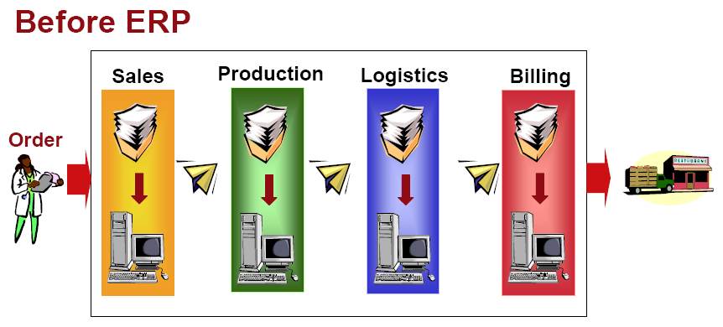
Figure 1. Order fulfillment before ERP [4]

Ideally, everyone should be access to the same real time data through some interface when they are needed to. This requires a single-point-of-contact system. That is one of the original ideas of ERP. Based on the identical system and database, the information flow and product flow can be processed efficiently. To guarantee the effectiveness of ERP implementation, we need to link all the functions of the chain seamlessly. As mention above, there are walls, barriers between departments. So what we need to do is to smash the walls, to get connected tightly via the system.
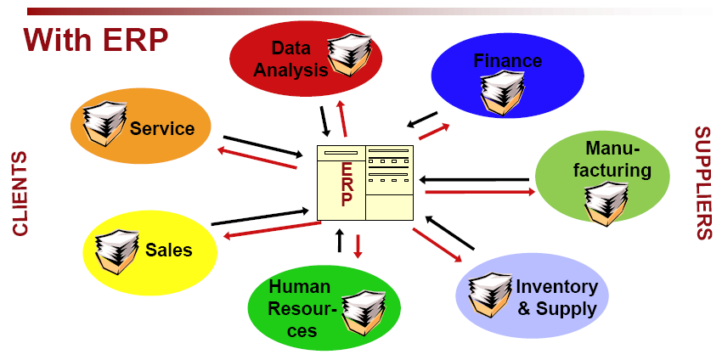
Figure 2. Order fulfillment after ERP [4]

Core Components of ERP
ERP totally changed the old computer systems from each separate department, and replaced them with a single unified software program that can be divided into software modules. The modules roughly approximate the old stand-alone systems. Since 1990s, ERP software has become flexible enough that you can install only some modules without buying the whole package. Many companies, for example, will install only part of ERP modules, like finance, HR, Material Management or Production Planning module and leave the rest of the functions for the future.

To enable the easy handling of the system the ERP has been divided into the following Core subsystems [5]:
- Shop floor control
- Accounts Payable/Receivable
- Logistics
- Asset Management
- Financial Accounting
- Sales and Marketing
- Master Scheduling
- Material Requirement Planning
- Capacity Requirement Planning
- Bill of Materials
- Purchasing

Evolution of ERP

The evolution of Enterprise Resource Planning (ERP) through the perspective of the historical development of business integration concepts. Business integration concepts commonly connected to the development of ERP include Inventory Control (IC), Material Requirements Planning (MRP), Manufacturing Resource Planning (MRPII), and Computer Integrated Manufacturing (CIM). This review of the development of business integration concepts depicts the process that has led to the development of the modern ERP applications and thus, helps to better understand the nature of present-day ERP software.

The history of ERP can be traced back to the first inventory control (IC) and manufacturing management applications of 1960s [6, 7]. These first applications for the manufacturing were generally limited to IC and purchasing, which was due to the origins of these applications in the accounting software [6, 7]. The accounting, with its definition based around generally accepted standards, had been one of the first business functions to be computerized and the first applications for the manufacturing were created as by-products of accounting software driven by the desire of the accountants to know the value of the inventory [6, 7].

During the 1970s, MRP packages were extended with further applications in order to offer complete support for the entire production planning and control cycle. This led to the next stage in the evolution of ERP, which was the introduction of the concept of Manufacturing Resource Planning (MRPII). The concept of MRPII emerged as a logical consequence of the development in earlier approaches to material control. MRPII seeks to improve the efficiency of manufacturing enterprises through integration of the application of information and manufacturing technologies [7]. MRPII approach was extended in the 1980s towards the more technical areas that cover the product development and production process, and that these functions were named with various CA- (Computer Aided) acronyms and included [7].

The Gartner Group introduced the term Enterprise Resource Planning (ERP) in the early
1990s. The ERP evolution implies an extension of MRPII with enhanced and added functionality, encompassing functions that are not within the traditional focus of MRPII, such as, decision support, supply chain management, maintenance support, quality, regulatory control, and health and safety compliance [7]. Today, ERP is the foundation of businesses domestically and globally. It is used as a management tool and gives organizations a great competitive advantage.
As e-business becomes business as usual, sharing accurate real-time information about orders and inventory is critical to success. Now, business needs to move that information across a supply chain. A new term to describe the enterprise systems for the 21st century: ERP II, has been introduced.

The expansion process can be showed as following figure,

ERP
MRPⅡ
MRP
1970s
1980s
1990s
1960s
IC

Figure 3: Evolution of ERP

Interface of Modules

ERP-Interface module manages the import and export data for the higher-level systems. Interfaces to all popular ERP systems are available; e.g. SAP, Navision, infor, proALPHA, BAAN. The software package combines two individual modules, the communication module ERP-Export/Import and the ERP-Interface module.

All CROS modules [8] are related to each other, all users working simultaneously through the network, using the same data, according to their attributions and access rights.
- There are direct connections between different modules, without data's imports and exports and without data redundancy [8].
- The system brings together universally accepted models for all the organization processes, adapted and developed as a result of successful implementations in Romanian organizations [8].
- The data flows within the informational system are faster and better organized with CROS, this representing an important support for organization management [8].

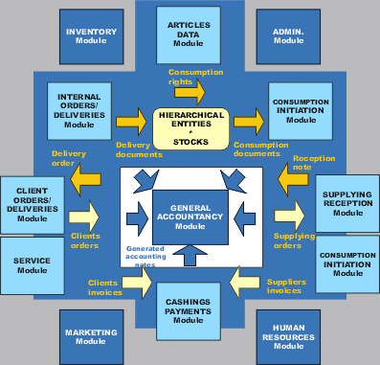

Figure 4: All CROS modules [8]

WHY IS ERP?

Key Motivating Factors
When asked to identify the motivating factors behind the ERP decision, the key decision makers and MIS directors at all three companies mentioned similar factors[9]:
- Standardize supply chain practices across multiple sites.
- Simplify the software environment by replacing multiple, highly customized legacy systems with a single “fleet” solution.
- Support corporate-level visibility and control of key supply chain processes, such as procurement and production scheduling.

Tangible and intangible Benefits
The analysis must consider not only the obvious cost/benefit analysis, but also the non-financial factors. Non-financial benefits include information visibility and flexibility. A more complete listing of tangible and intangible benefits is provided in Table 1 [10].
Table 1: Tangible and intangible benefits.
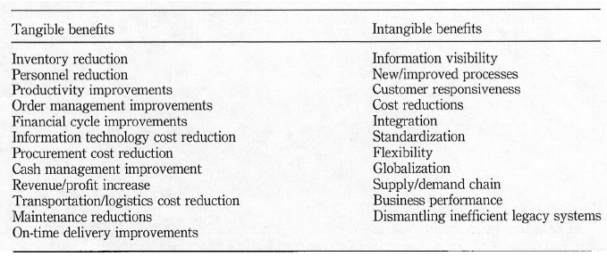

The Percentage and Age of ERP Implementations
ERP systems and their MRP (Material Requirements Planning) predecessors have been implemented for a long time.
- 91% of the sample (n>500) has implemented ERP (including MRP).
- 31% are more than 10 years old.
- 24% of them still had the first ERP system implemented
- 42% of their current ERP had replaced home-grown or custom developed applications
- Only 34% of their current implementation as a replacement of another ERP.

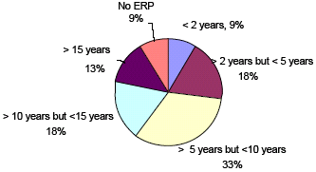

Figure 5: Age of ERP implementation (N>500) [11]

The Number of ERP Packages Implemented

As ERP implementations have been aging, they also been proliferating
- 71% of large companies have two or more ERP packages implemented across the enterprise.
- 26% with four or more. (large company is the revenue over 1b,small company with revenues less than $50M.)

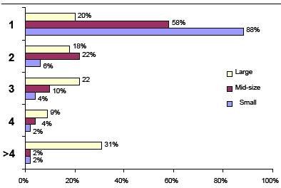
Figure 6. ERP’s across enterprises (N>500).

Factors Affecting Upgrade Decisions.
A large percentage (45%) of respondents indicated plans to upgrade to the latest release of their software within the next 12 months. However, a full 77% of respondents were not currently implemented on the latest release (Figure 8). While 14% intend to replace ERP at selected installations, this still leaves a large percentage intending to be one or more releases behind [11].

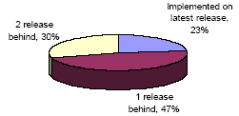
Figure 7: Current ERP Release Status (N>500) [11].

There are many reasons to delay the upgrade process [11] and skip one or more releases. These companies eventually play leap frog and catch up, but at any point in time, they are equally or more likely to not be at the latest release.

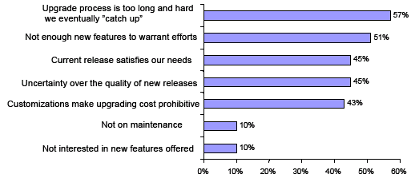

Figure 8: Reasons to delay ERP upgrading (N>500) [11].

Factors Impacting ERP Strategies
No manufacturing company today is immune from the impact of globalization or the acceleration of change. Most companies are looking for demonstrable business value from ERP, and view the need to improve customer service as a key driver as well. Few companies viewed the growth, either organically or through mergers and acquisitions as a driving factor impacting ERP decisions [11].

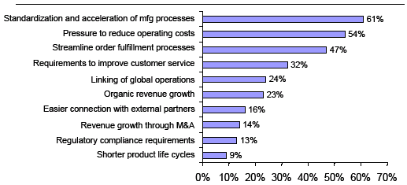

Figure 9: Business Drivers impacting ERP strategies (N>500) [11].

Plan of Action

Intentions to upgrading current ERP software vary with the level of maturity of the ERP implementation. 40% anticipate keeping current versions of existing implementations at status quo, but there is also significant activity planned (Figure 11). A surprising 14% across all companies have a replacement strategy at selected locations and almost half (45%) plan to upgrade to the latest release [11].

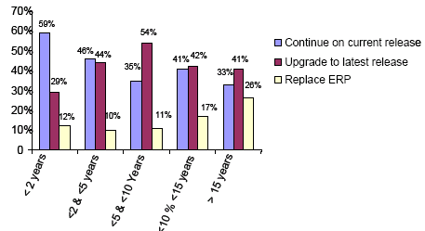

Figure 10: Planned ERP actions within the next 12 months (N>500) [11].

HOW TO IMPLEMENT ERP?

Buy or Make ERP Software

In house development
Although make what you need provides the ultimate in control, there are three fatal limitations to use this as primary strategy: investment, discipline and support [12]. Other concerns include:
- Time consuming
- Documentation is difficult
- Maintenance depends on individuals
- EDI modification to be taken of
- Each unit follows different software option
- Latest developments to be studied before implementation

ERP package
The attractions of buy option are well documented by the solutions vendors. The advantages include:
- Ready made projects
- Needs only customization
- Documentation is part of system
- Company takes care of
- EDI compatible
- The package itself is designed as enterprise package
- Constant updates assured
Because, while we can do both, we really need to be good at “assemble” if we’re to own our own application and data destinies [12].

ERP Implementation Challenges and Responses

Standing in the way of optimized ERP implementations is the alignment of software capabilities with business processes often producing customization related challenges (Table 2).
Table 2: ERP Implementation Challenges and Responses (N>500).
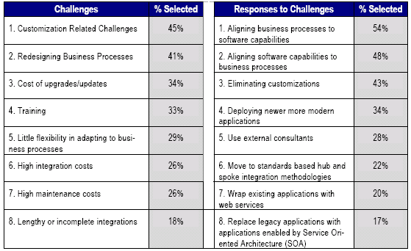

ERP Implementation - Considerations

According to The Gartner Group, 70 percent of all ERP projects fail to be fully implemented, even after three years. Typically, there is no single culprit responsible for a "failed implementation", and no individual reason to be credited for a successful one. Even the definitions of failure and success are gray areas, lending to interpretation. There are generally two levels of failure: complete failures and partial failures. In a complete failure, the project either was scuttled before implementation or failed so miserably that the company suffered significant long-term financial damage. Those implementations considered partial failures often resulted in tenuous adjustment processes for the company; creating some form of disruption in daily operations. In the same vein, an ERP success can be a complete success - one in which everything goes off without a hitch, or one in which there are few alignment problems, resulting in minor inconvenience or downtime. Frequently, these situational circumstances that have to be ironed out in the weeks and months after the "go-live" date are not severe enough to disrupt the daily operations [10]. The challenge for ERP II is 2-fold. First it is to aggregate and manage the data surrounding all the transactions of an enterprise as accurately as possible in real time. Then it is to open up the system to make that information available to trading partners. ERP is all about sharing information and collaboration. Management is under constant pressure to improve competitiveness by lowering operating cost and improving logistics. Organization therefore have to be more responsive to the customer and competition [13].

Critical Success Factors of Implementing ERP

Nah et al. [14], based on a study of earlier papers (most of which were normative/prescriptive in nature), identified 11 factors that were critical to ERP implementation success. The 11 factors noted by them are [10, 14]
- Effective communication;
- Project management;
- Software development, testing, and trouble shooting;
- Monitoring and evaluation of performance;
- Project champion; and
- Appropriate business and information technology legacy systems.
- ERP teamwork and composition;
- Change management program and culture;
- Top management support;
- Business plan and vision;
- Business process re-engineering and minimum customization

Measuring Success
ERP implementation is a complex process. Success or failure depends on many factors, and it is difficult to plan for all potential pitfalls. Comparable to the difficulty in identifying the source of success or failure is the difficulty in arriving at a clear definition of either term. Despite the fact that this distinction may intuitively seem simple, across companies and professionals, no agreement can be reached on a definition of success or failure [10].
A complete failure may be a project that was discarded prior to implementation or one that is so fraught with difficulties that the company is affected for a significant amount of time (e.g. financially, etc.) Similarly, a partial failure is one in which the operations of the company experience significant slowdowns or stoppages, though the difficulties are eventually overcome [10].
On the other hand, a complete success is an implementation which experiences virtually no problems or only problems that are quickly overcome. A partial success is characterized by more problems but ones which are overcome in the short term [10]. Ultimately, it may be useful for a company in the planning phase to determine what will constitute a success or failure, partial or complete. This will help in making decisions about how to proceed when problems arise [10].

More than one factor contributed to the outcome of a project. The 44 companies listed a total of 81 occurrences of these factors. For the 29 firms where SAP was "successfully" implemented, the six factors were listed 60 times and the in the 15 firms where SAP implementation was "unsuccessful" the six factors were listed 21 times. Table 2 shows a listing of each factor, and its relative percentage of frequency [10].

Table 3: Frequency of factors reported by the "Successful" and "Unsuccessful" implementation firms [10].
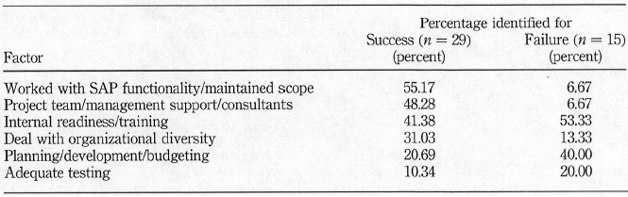

Generally speaking the respondents had a hybrid approach to measuring success (Figure 5). Most individuals selected a combination of metrics that measured business value but combined these with some measurement of cost and time to gain those benefits [11].
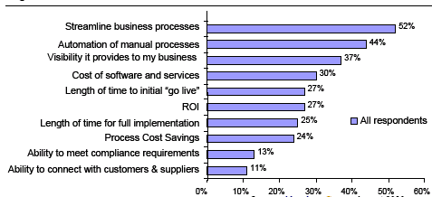
Figure 11: A hybrid approach to measuring success (N>500) [11]

ERP Software
A report that stated the enterprise resource planning (ERP) applications market grew to $25.4B in 2005, and will reach $29B in 2006. Over the next five years, the market will grow at an average of 10% [15].
The ERP market continues to benefit from a widespread acceptance of the idea that businesses must have integrated information systems to be competitive. Management and IT organizations are realizing that the most effective way to satisfy this need is to purchase an ERP package that features broad functionality and pre-built integration [15].

Table 4: ERP vendor ranked by 2005 application revenue (include est. ’06 growth) [15].
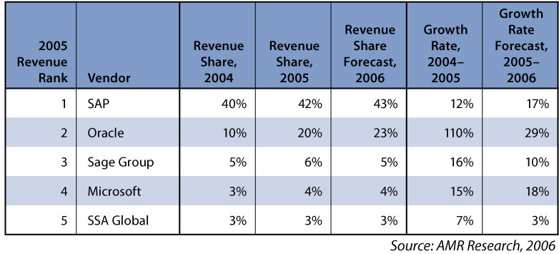

ERP vendors ranked by 2004 worldwide ERP license revenue can be seen in the chart below. The top ten ERP vendors by revenue include the following companies [16].

Table 5: ERP vendor ranked by 2004 application revenue (include est. ’05 growth) [16].
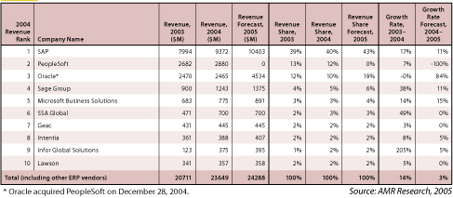
The report revealed several trends that affected the ERP market in 2004, including: The ERP market is entering another major technology transition phase. Service Oriented Architectures (SOA) may have the same disruptive effect that other technologies have had on the market, such as the emergence of client-server systems had in the 1990’s.
The pace of acquisitions shows no sign of slowing down. Oracle’s recent purchase of Retek makes it very clear that PeopleSoft was simply the first of what is likely to be a series of purchases. Vendors like Sage Group, SSA Global, Infor Global Solutions, and Epicor have all been very active in the Merger and Acquisitions (M&A’s), and as a result have all been growing more rapidly than the overall ERP market.

ERP buyers have moved away from large, upfront purchases. Now most tend to license user seats and functional ERP modules incrementally as they deploy a product. Along with widespread discounting, this has led to smaller average deal sizes.

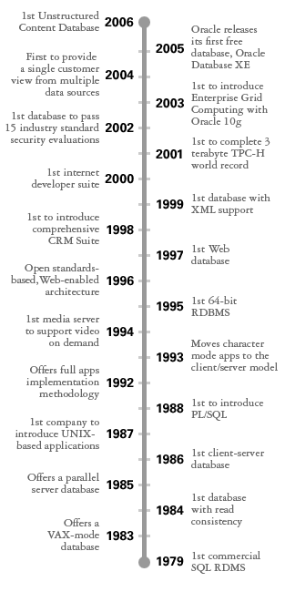
ORACLE
Almost thirty years ago, Larry Ellison and his co-founders, Bob Miner and Ed Oates, realized there was tremendous business potential in the relational database model--but they may not have realized that they would change the face of business computing forever [17].
Today Oracle (Nasdaq: ORCL) is still at the head of the pack. Oracle technology can be found in nearly every industry around the world and in the offices of 98 of the Fortune 100 companies. Oracle is the first software company to develop and deploy 100 percent internet-enabled enterprise software across its entire product line: database, business applications, and application development and decision support tools. Oracle is the world's leading supplier of software for information management, and the world's second largest independent software company [17].
Oracle has always been an innovative company. It was one of the first companies to make its business applications available through the internet--today, that idea is pervasive. Now Oracle is committed to making sure that all of its software is designed to work together--the suite approach--and other companies, analysts, and the press is beginning to acknowledge that Oracle is right. What's in store for tomorrow? We will continue to innovate and to lead the industry--while always making sure that we're focused on solving the problems of the customers who rely on our software [17].

ORACLE Merger History
•On Dec13, 2004, Oracle Corporation announced that it has signed a definitive merger agreement to acquire PeopleSoft, Inc., for $26.50 per share (approximately $10.3 billion)[18].
•On Jul 18, 2003, PeopleSoft Inc. announced it had completed its $1.8 billion acquisition of J.D. Edwards & Co.[19],

After a succession of acquisitions, Oracle prides itself on innovation and forward thinking. PeopleSoft acquired competitor JD Edwards. Oracle acquired PeopleSoft, and therefore, the rights to JD Edwards applications. In addition, Oracle acquired Siebel. Each company had its own uniqueness and brought that uniqueness to the culmination, yielding a diverse set of application options for Oracle customers.
Options with Oracle include the following:

mySAP ERP
- Oracle e-Business Suite
- PeopleSoft Enterprise
- JD Edwards Enterprise One
- JD Edwards World
- Siebel

Founded in 1972 as Systems Applications and Products (SAP) in Data Processing, SAP is the recognized leader in providing collaborative business solutions for all types of industries and for every major market [20].
Serving more than 36,200 customers worldwide, SAP is the world's largest business software company and the world's third-largest independent software provider overall. Today, SAP employs more than 38,400 people in more than 50 countries. Our professionals are dedicated to providing the highest level of customer service and support [20].

The best ERP software --SAP R/3.

SAP R/3 is provided by world’s largest enterprise software company SAP AG.
SAP R/3 is acronym for Systems Applications and Products in data processing. R/3 means Runtime System, Three Tier Architecture.
Figure 12: ERP software shares in 2005 [21]
SAP R/3’s Advantages:
- Faster Speed
- Integrated
- Global Basis
- Knowledge Sharing
- Flexibility for changes(Business and IT)
- Can be implemented as an individual module.

Figure 13: SAP Business Modules [22]
SAP offers several software packages:
- mySAP Business Suite – All-in-One
- mySAP Business One
- Duet (a collaboration with Microsoft)
- SAP xApps – specifically designed software for individual company needs

Comparison of ERP Software

Out of 268 respondents, only 23 percent of respondents say they are very satisfied with their ERP implementation, which suggests the absence of a viable alternative. Who wants to rip and replace core applications and relive the tremendous disruption and expense of another big bang? Actually, many of our readers might, if they could escape high ERP licensing fees. In answer to a question we asked out of curiosity, a stunning 53 percent of respondents say they would consider an open source alternative to their current ERP system. The catch: No such system exists [23].

Meanwhile, in the real world, when we asked readers which vendors they had chosen to supply their ERP software, Oracle, PeopleSoft, and SAP got the most mentions. Applications from SAP earned the most "functions well" ratings in all but the human resources category (see results for additional modules at infoworld.com/1121). A whopping 69 percent of survey respondents think SAP's core financials function well, awarding it nearly 20 points more than nearest competitor Oracle. SAP's manufacturing application also enjoys a similar lead [23].

PeopleSoft's customers seem just as pleased as SAP's; the company was in a statistical tie with SAP in readers' overall satisfaction with their ERP vendor. A year into a PeopleSoft implementation, Craig Hunter, director of information technology for the City of North Vancouver, British Columbia, offers this testimonial: "It's already gotten us payback. We've installed it in house, and we didn't need a ton of consultants." He also notes his IT group made a conscious decision to modify PeopleSoft as little a possible [23].

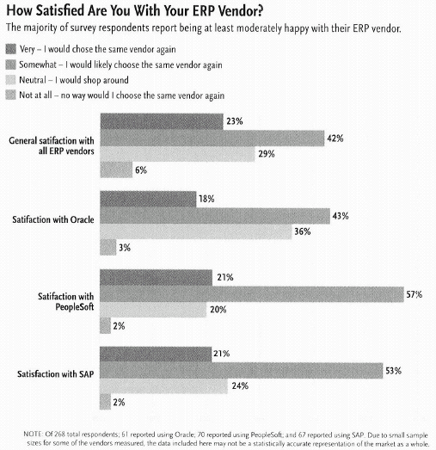

Figure 14: How Satisfied Are You With Your ERP Vendor?[23]

CASE STUDIES

Although corporate expenditures for ERP (excluding implementation costs) were 530 billion in 2004 and have been growing at about 150 percent per year in recent years, many firms have had difficulties with implementation. Because it has been shown to be difficult and expensive for firms to achieve the desired level of functional interoperability with inhouse developed systems, most firms purchase "packaged" software from vendors [24].

Before 1998, there was 70% percent of all ERP projects fail to be fully implemented, even after three years [25]. Few companies are making full use of their enterprise resource planning systems, despite the high cost of the software and the length of time an implementation can take, research has revealed. In a survey of 100 global or pan-European companies by PMP Research, just 5% of those polled said they were using their ERP software to its full extent [26]. Most users customize the software, with only 12% installing ERP packages "out of the box". Once installed, more than 50% of companies said it was hard to make changes to ERP software in order to meet any changes in business processes or requirements [26]. The survey also found that more than 50% of the companies surveyed did not measure their return on investment from business applications [26]. The failure rates for ERP projects are relatively high and could lead to the bankruptcy of the corporation. In case of malfunctions ERP software’s are often blamed and made responsible[27].

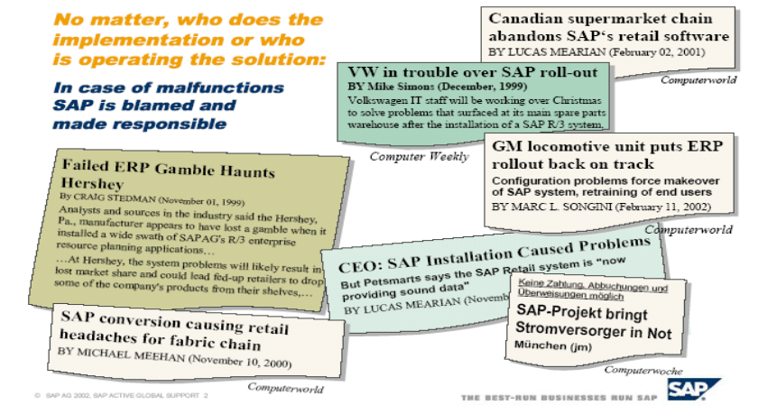
Figure 15: SAP is blamed and made responsible [27].

Case 1 - Failed ERP Gamble Haunts Hershey

The Hershey company started at the 1893. Today, The Hershey Company is a leading snack food company and the largest North American manufacturer of quality chocolate and non-chocolate confectionery products as well as chocolate-related grocery products with revenues of over $4 billion and more than 13,000 employees worldwide. Outside of the US and Canada, the company exports its products to over 90 countries worldwide[28].

It was reported that a $112 million ERP project had blown up in the face of Hershey Foods Corp in 1999. The malfunction of ERP software made up of parts from SAP, Siebel, and Manugistics resulted in the order-processing problems that were hampering the ability to ship candy and other products to retailers
[29]. SAP AG's R/3 provided the main components of the system, Siebel provided the CRM, and Manugistics provided supply chain management.
Analysts and sources in the industry said the Hershey, Pa., manufacturer appeared to have lost a gamble when it installed a wide swath of SAP AG's R/3 enterprise resource planning applications, plus companion packages from two other vendors, simultaneously during one of its busiest shipping seasons [29].
There were three obvious mistakes in the implementation of ERP system in Hershey [30]:
- The project was originally scheduled to take 4 years, but Hershey decided to squeeze the implementation into 30 months
- Hershey also decided to go live with the system in July, just in time for orders to start rolling in Halloween,
- The 3rd flaw in their plan was to roll out the system all at once.

Because of these mistakes Hershey was unable to effectively ship candy and other products to retailers for Halloween and Christmas of 1999. The company took a 19% hit in candy sales for the 1999 Halloween season and a 12% hit in 1999 revenue [29, 30].
Back in 1999, of course, it was a terrifying new prospect for investors to consider: Could a failed computer project take down a Fortune 500 company? Hershey's stock price fell more than 8 percent on that September day, and the computer system mystery made the front page of The Wall Street Journal. Analysts didn't fully trust Hershey's ability to deliver candy until the following fall, when things had long been back to normal [31]. Even in 1999, however, enough details about the difficulties of other enterprise software implementations had leaked out that analysts could have seen that Hershey's only real failure was its timing—the system went live right about the time when orders were pouring in for Halloween, and they couldn't be fulfilled. Other than that, Hershey's experience was pretty average. Studies have shown that most companies that install enterprise software are late, their business processes suffer temporarily, and their revenue can take a hit for as long as six months [31].

When Hershey issued a press release in August saying that it had completed a successful upgrade of its SAP ERP system, the company might want to end the 3-year-old mystery [31]. Enterprise software is hard. It takes a long time. It's hard to get people to change the ways they work so that the system will function correctly. But they eventually adapt. And you will have problems in your business at first because enterprise software isn't just software. It requires changing the way you do business [31].

Lessons learned from Hershey Case [30]
- Take your time. Hershey didn’t seem to need this ERP system implemented so quickly, and certainly didn’t plan accordingly. At the time Hershey was tight-lipped about the project and its problems and has remained that way, although I don’t expect Hershey to be discussing the issue at this point.
- Don’t rollout an ERP system before a critical business season. Halloween has got to be one of the busiest times for a company like Hershey. I can’t imagine why they would need to speed up the implementation of this system so it could be in place before Halloween.
- For a company of Hersheys size, and the size of the project ($112 Million), they should have rolled out the components in a more staggered fashion. Training users on each component, and ensuring the system was working as planned every step of the way. Implementing a project this large all at once does not provide the time to learn and test everything extensively.

Case 2 - KV
KV started more than six decades ago. KV has consistently ranked as one of America's fastest growing small companies. Today, KV offers many drug technologies, used in most of the company's more than 100 generic and non-branded drugs and 15 branded drugs that are sold today [32].
The Business Technology (BT) department is in charge of information technology (IT).
- There are more than 50 employees in IT department.
- There are more than 1000 computers
- Today KV has more than 1,000,000 square feet of predominantly owned facility space located in 15 different locations.
- Vice president (CIO) in Business Technology (BT/IT) reports to senior vice president and/or CEO

JD Edwards World

Today, KV is using JD Edwards World as ERP software that started in 2000 and finished implementing in 2003. After implementation, all the information from the old systems was moved into JD Edwards World system. Software license fee was about 1 millions. It has spent about 10 millions on the JD Edwards, including the purchasing the program, implementing, upgrading and maintaining from 2000 to 2007 fiscal year.

The JD Edwards was successfully implemented at 2003 with spending about 1 millions and the maintaining fee is about 1 million each year.
There are about 900 users in 15 locations connecting to the ERP system.
The following is the interface of KV JD Edwards World ERP system.
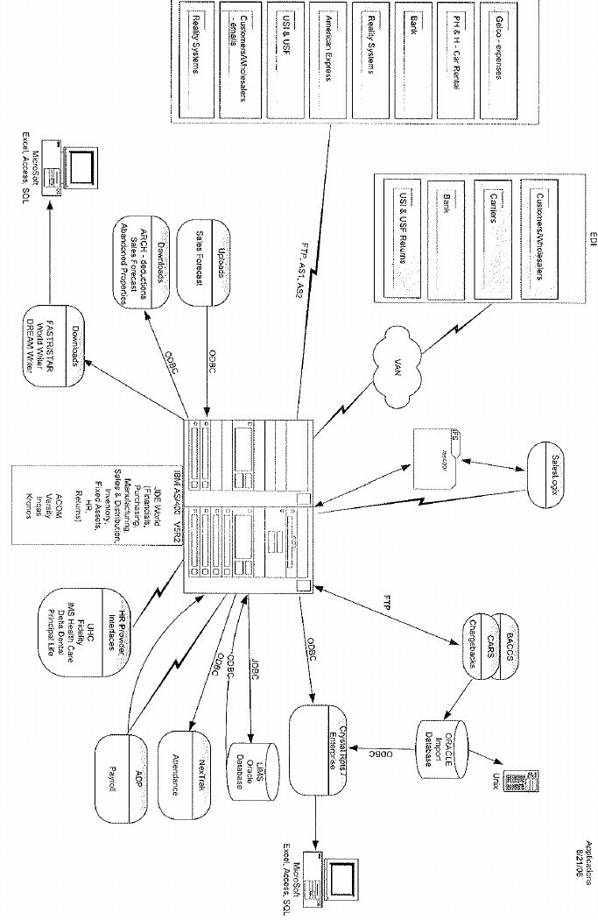
Figure 16: The interface of KV JD Edwards World ERP system at KV

With ERP to automate processes, the benefits are as follows:
- Increase inventory turns
- Increase inventory accuracy rate
- Reduce inventory costs
- Improve customer service
- Reduce setup times
- Reduce paper work reduced.
- Provide a unified customer database usable by all applications
- Provide greater and effective control on account.
- Faster response and follow ups to customers
- Improves supply demand linkage with remote locations and branches in different locations

Case 3 - Business Transformation Through ERP
-A Case Study of an Asian Company [33]

Background of Almab
Almab, a pseudo-name, is a leading newspaper company in one Asian country. It has it's headquarter in the Capital and 52 offices in more than eleven major cities. The company publishes more than 67 publications nationwide and has the highest number of readers among the English publications in the country. It is the number one national daily in the capital and the third highest read publication nationwide[33].
The industry within which Almab operates is characterized by some growth (annual growth rate of 6%) and high rivalry (on the basis of reputation, circulation, and readership) both from within and from alternative media. Over 80% of Almab's revenue is generated from advertising. Customers have enormous alternatives to advertise not only in the print but also in the electronic media. Because of ease of switching to rivals, efficient handling of the advertising process-from booking to billing- has a major impact on business bottom line [33]. Its survival and competitive advantage depend on its ability to offer clients with as many packages as possible, with least cost, maximum visibility, and increased flexibility. Moreover, because of Almab's physical scale of operation, it depends on a number of advertising agencies to solicit and retain customers. This requires effective coordination of the activities of the agencies and management of their contracts, invoices, premiums and relationships[33].
However, back in 1999, the company had serious problems that motivated the implementation of ERP. Following the implementation, Almab has not only solved its problems and streamlined its business processes but has managed to double its turnover to US $400million within three years. This is a significant gain in an industry where total annual advertising revenue was estimated above US$800 million. As a result, Almab's senior mangers now believe that the system has provided them with significant competitive gains in terms of "speed, efficiency and turnaround time" [33].
ERP Implementation

In order to provide maximum value to customers, stay profitable and gain strategic flexibility needed to maintain its competitive position in the industry, Almab decided to look for solutions that resolve its problems and that meet its core criteria of "integration, speed and scalability" [33]. After searching the market by employing the service of a sourcing consultant, the company selected SAP AG and reached a memorandum of understanding about expectations from the system, resource commitment and delivery plans [33].
Championed by the top management, the implementation project began in the first quarter of 2000. The main departments to be integrated via the implementation of ERP were the Classifieds, Display, Finance, Production and Print departments. A total of 120 senior managers from all parts of Almab were briefed about the business change that was to take place. An implementation team comprised of senior managers, heads of various departments was formed. Users from various departments were brought to the head office to test the system and participate in the training of trainers. The system went live on time after 14 months in the 2nd quarter of 2001. In the following two subsections, the pre and post-ERP profile of Almab using the Seven S framework will be constructed [33].
Various Perspectives In ERP Studies

- Theoretical models and frameworks development
- Investigations of the strong-order drivers and second-order facilitators/inhibitors of ERP adoption and implementation
- Investigations of project, change management and other implementation issues
- Defining ERP success criteria and investigations of the critical factors that influence ERP outcomes
- Investigations of ERP in different cultural contexts
- Analyses of the changes and impacts on organizations as a result of implementing ERP

This study is in the tradition of the sixth stream of research and direction in that it investigates the transformative potential of ERP systems [33].

THE SEVEN "S" FRAMEWORK
The role of IT in organizational transformation can be captured in terms of its influence on key organizational dimensions outlined as Seven "S"s:
- Strategy: Strategy refers to the mechanisms by which a business allocates its resources to operate in its environment, propose value to customers and ensure its survival and profitability [34].
- Structure: This defines allocation of responsibilities and authority relationships in an organization that is the skeleton of the organization [34].
- System: This refers to key processes that support the business, covering reward, control, information, work flow and feedback mechanisms. Systems populate the structure and influence how an organization makes decisions, relates to customers, shares information and rewards its employees [34].
- Staff. The demographic profile of the people working for an organization makes this dimension. Crucial in this category is the quality of those staff critical to the success of the business [34].
- Skill: Skill refers to the core competence and capabilities of an organization [34].
- Style. Mangers differ in terms of their treatment of information, conflict resolution, problem solving, communication and motivation of staff. Style reflects the manner and approach of key managers and leaders of an organization in dealing with these management issues
- Shared values. Organizations impose different values and beliefs (also commonly known as culture) on their members.

The Seven S framework stresses that organizational effectiveness depends on the interaction between all the Ss of an organization. These elements are interconnected and must be coordinated properly to avoid conflicts and bottlenecks

Research Questions:

Research questions addressed in this paper are:
•
- What are important contextual characteristics that influence transformation
- What are organizational dynamics that are key indicators that transformation is happening
- What key lessons can be drawn in terms of achieving and sustaining Information Technology (IT)-enabled organizational transformation.

Data Collection and Analysis [33]
The data were collected using retrospective participant observation, unstructured interview and document analysis [35, 36]. One of the authors of this paper had worked for Almab and was involved in the ERP project as an officer in the classified and data processing departments. The observer, based on his experience of working in Almab, various meetings, seminars and briefings attended and from countless informal encounters with members of the company over a three-year period produced a retrospective account of the pre and post ERP scenario. In order to control for possible observation and retrospective bias, we followed Golden [37] recommendation and the other author reviewed and questioned the observation data. This process, in itself, provided an in-depth insight into the firm and its process of ERP implementation but, as per norms of triangulation, this was supplemented by interview and document analysis [33, 36].
A total of five interviews were conducted with the Executive Director, Brand Director, Head of the Department of the Classified Marketing, Head of Operations and Customer Care and ERP project leader and Head of the IT. Materials reviewed included project documentation and briefings (which showed the nature of the project, the kinds of resources, detailed information on the composition of the project team and change management issues) samples of the ERP managerial reports (which allowed evaluation and comparison of pre and post ERP information flow) and Intranet documents (which allowed the examination of help and trainings given to end users) [33].
Data were analyzed using qualitative techniques informed by the Seven Ss framework. Interview transcripts, documents and observation notes were read to produce a pre and post ERP description for each of the seven S dimensions. These were re-examined to identify key dimensions that were transformed in the course of implementing ERP. After data analysis, a draft case report was produced and shared with the heads of the department of classified marketing and electronic data processing. They offered helpful comments and verified the analysis and interpretation [33].

Data Transfer

Pre-ERP, each branch had its own centralized mainframe server at the main office and a different server at each of the sub offices in the same city. Data transfer and update between branches involved first uploading the data from sub office servers into branch servers and then transferring it to central server. Because of the fragmentation of data, it was difficult to generate aggregate reports required by the top management [33].

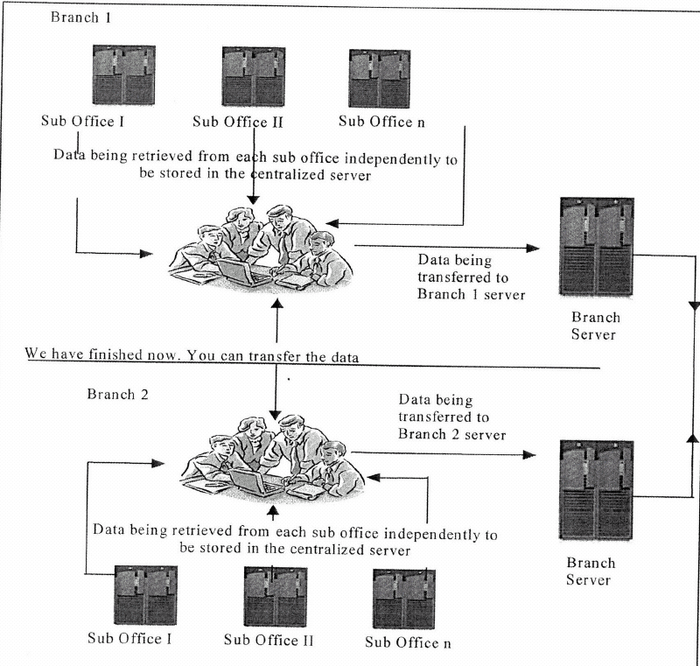
Figure 17: Pre-ERP Data Transfer Between Almab's Branches [33].
Post-ERP, Almab moved from the mainframe based computing architecture to client server technology. IT was centralized at the head office with backup servers in one of the regional branches. Data transfer and sharing has been enhanced significantly (see figure 2). This has created easy coordination and organizational flexibility at the level that could never have been achieved prior to the implementation of the new system. Clients are offered more options and external agencies that were responsible for bringing in business were linked via the new system. This offered increased flexibility, meeting of deadlines and tracking of advertisements [33].
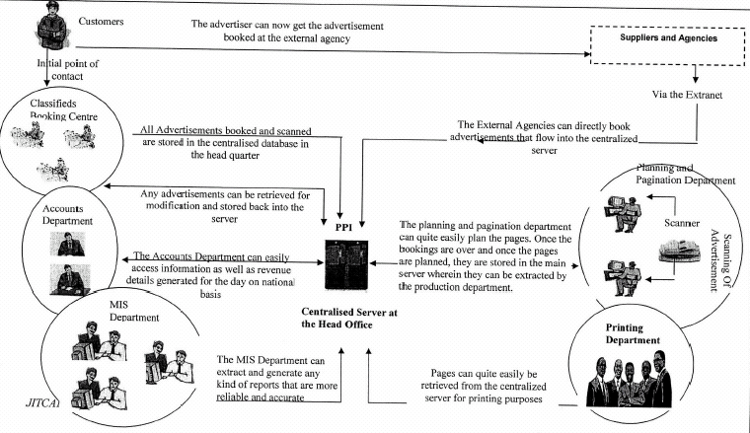
Figure 18: Post-ERP workflow in Almab [33].

Pre and Post-ERP Comparison [33]

The implementation of ERP offered Almab an opportunity not only to diagnose its strengths and weaknesses but also to clearly communicate its re-assessed objectives and future directions. It affected back office, financial, editorial, advertising and press operations. However, because of the focus of the ERP project, major transformation happened in advertising handling and as a result a significant proportion of the analysis here is going to focus on that.

Table 5: Pre and Post-ERP Comparison of Almab [33].
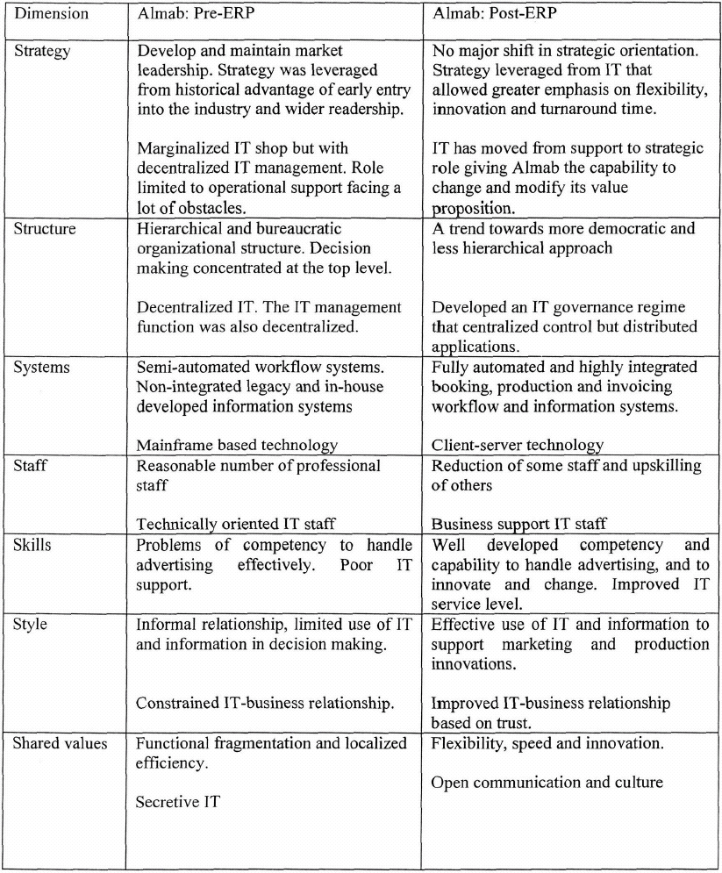

Theoretical Implications [33]

In terms of theoretical contribution, we have demonstrated the utility of the Seven S framework in analyzing and understanding potential transformations in key organizational dimensions following large scale enterprise systems implementation. The use of the Seven S framework has proven workable and useful in analyzing business transformation during large scale ERP implementation. Almab was successful in adapting itself and managing the changes needed to benefit from ERP. In fact ERP served as a platform to successfully introduce other production and marketing changes. This could relate to the clarity and articulation of expectations from the system; to the rigorous pre-selection process; and to the change management and project governance practices. The research helps to move beyond a gross categorization of developing countries to illustrate how and when particular contextual factors may or may not impact ERP related organizational transformation. Another contribution is related to the value of using organizational transformation in evaluating ERP outcomes.
Practical Implications [33]
This case study represents a successful ERP outcome. This can be related to Almab's practical approach in implementing ERP. Six practical lessons outline can be useful to other organizations in transforming themselves during a large scale enterprise application.
First is mustering the momentum for transformation. The top management of Almab had a very clear vision as to what exactly was expected from the ERP system and as a result was able to clearly communicate the vision to the senior managers, who in turn were responsible for their respective departments. Because of clear vision and extensive and open communication, the system was developed within time, within the budget and to the requirements of the business.
Effective managerial coordination is a second lesson that emerged out of Almab's experience. The objective of the system was to bring together numerous departments and hence on geographical basis coordinated with each other for the development of the system. The empowerment of managers make important decisions related to their respective departments, the system was customized to meet the specification of business requirements. There was an organizational wide recognition that for the organization to utilize the ERP systems effectively, they need to develop both the technical as well as the managerial capabilities.
The third key lesson is the importance of investing in human resources development. Because of the extensive process of implementing ERP within the organization, each and every manager and employee understood the role of the systems within the organization. Almab also spent a lot of time and money on training employees on the system. Whenever there was an upgrade, the employees were trained and educated about the functionalities that were made available.
Fourth, the development of ERP systems requires building mutual relationship within and with partner organizations and understanding of the organizational processes.
The fifth lesson is related to its assimilation of ERP with its routines. Almab demonstrated a commitment to constantly innovate and introduce new production, marketing and pricing strategies that were leveraged from its ERP. Hence, ERP systems played an important role in the development of the complexity of the organizational processes and routines.
Last but not least is the emphasis placed on organizational learning. The process of organizational learning not only assisted Almab to implement one system but the process had a dual effect of getting into a habit of coordinative learning and hence shared knowledge across the organization.
Conclusion [33]
The organizational equilibrium has shifted to a new state after ERP implementation. The transformation is greatly enabled by ERP but its cause might not necessarily be attributed to ERP only. The work practices and innovations ERP allowed, the acceptance and assimilation of those work practices by Almab staff and management coupled with the desire to gain competitive advantage have all contributed to the transformation of Almab.
A longitudinal approach of observing an organization over an extended period of time would be most useful to develop a better understanding of organizational transformation "enacted slowly, smoothly and subtly". The Seven S dimensions provide an effective utility to conduct such observations.

Comparisons of the Three Cases
The comparison of the above three cases is listed below.
Table 6: Cross comparison of the Cases Study
 | Case 1 - Hershey | Case 2 -KV | Case 3 - Almab
Revenue | ~$ 4 billion | ~$ 400 million | ~ $ 1 billion
Reason for ERP | Not clear. Replace legacy systems to provide global business processes | Replace legacy systems to provide integration processes | Replace legacy systems to provide business processes
Cost of ERP | $ 112 million | 3 - 5 million | N/A
Time | Scheduled 4 years Actually 30 months | ~ 2 years | 14 month
Outcomes | Malfunction  Cause order-processing problems | Success  - Provide a unified customer database usable by all applications  - Faster response and follow ups to customers  - Improves supply demand linkage  - Increase in inventory turns  - Reduction in administration costs  - Better order fulfillment rates | Success  - Increase in inventory turns  - Reduction in administration costs  - Better order fulfillment rates
Business Transformation | N/A | N/A | Significant

THE FUTURE OF ERP

The dream of enterprise resource planning systems is that a single application can track and monitor all of a business’s functions. In a perfect world, a manager opens a single ERP app to find data about any aspect of the business, from financials to HR to distribution schedules [38].
There are still a lot of gaps in ERP systems, particularly in industries where ERP functionality has grown up from its historic origins in manufacturing. Despite the challenges, the movement toward a global ERP system is a key factor shaping the future of enterprise resource planning [38].
Significant shifts are taking place in how ERP vendors generate revenues. Echoing changes taking place throughout the software industry, the transition is toward recurring and variable revenue models – with maintenance charges driving industry growth [38].
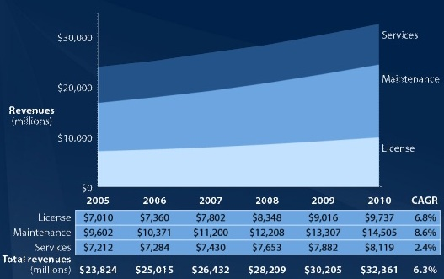
Variable revenue schemes are becoming the sweet spot for big ERP vendors. Faced with scarce possibilities for new large licensing deals, “vendors have adjusted their pricing models so that they can get incremental license revenue though higher levels of usage.” [38].
Figure 19: ERP Revenue Growth [38].

REFERENCES

1. Beheshti, H.M., What managers should know about ERP/ERP II. Management Research News, 2006. 29(4): p. 184-193.
2. Koch, C., The ABCs of ERP. http:// www.CIO.com.
3. ERP. http://www.answers.com/topic/enterprise-resource-planning.
4. Andrea, R., S. Sieber, and J. Valor, Introduction of ERP. http://webprofesores.iese.edu/Valor/Docs/EMBA/Intro%20ERPs.pdf.
5. Enterprise Resource Planning. http://www.erpfans.com/erpfans/erpca.htm.
6. Gumaer, R., Beyond ERP and MRPII – optimized planning and synchronized manufacturing. IIE Solutions, 1996. 29(9): p. 32-36.
7. Sarpola, S., Enterprise Resource Planning (ERP) Software Selection And Success Of Acquisition Process In Wholesale Companies. 2003.
8. CROS - Bar codes system integration. http://www.crisoft.ro/Engleza/prod&serv/cros.html.
9. Bozarth, C., ERP Implementation: Motivation and Justification. http://scm.ncsu.edu/public/lessons/less060406.html.
10. Gargeya, V.B. and C. Brady, Success and failure factors of adopting SAP in ERP system implementation. Business Process Management Journal, 2005. 11(5): p. 501-516.
11. Jutras, C., The ERP in Manufacturing Benchmark Report.
12. Weir, B. and R. Mickool, For Enterprise Applications and Data, the Question Is Not Make Versus Buy ... Educase Quarterly, 2003(November 1): p. 5-9.
13. Kämpf, R., ERP-Systems – Situation and future Developments. http://www.ebz-beratungszentrum.de/pps_seiten/sonstiges/erp_engl.htm.
14. Nah, F.F., J.L.a. Lau, and J. Kuang, Critical factors for successful implementation of enterprise systems. Business Process Management Journal, 2001. 7(3): p. 285-296.
15. Reilly, K., Enterprise Resource Planning Software Will Grow to $29 Billion in 2006. AMR Research, October 10, 2006.
16. Reilly, K., AMR Research Releases Report Showing Overall European Market for ERP Vendors to Grow 7% Annually Through 2009. AMR Research, June 20, 2005.
17. Oracle histry. http://www.oracle.com/corporate/story.html.
18. http://www.oracle.com/corporate/press/2004_dec/acquisition.html.
19. http://www.peoplesoft.com/media/en/pdf/jdedwards_pr060203.pdf.
20. mySAP. http://www.sap.com/company/index.epx.
21. SAP Annual Report 2005. http://www.sap.com/company/investor/reports/annualreport/2005/pdf/2005_SAP_Annual_Report.pdf.
22. ttp://www.cbe.wwu.edu/misclasses/mis320S06lab/erp/intro_files/intro.htm.
23. Knorr, E., ERP Springs Eternal. InfoWorld, 2004. 26(12): p. 44-54.
24. King, W.R., Ensuring ERP implementation success. Information Systems Management, 2005. 22(3): p. 83-84.
25. Gillooly, C., Disillusionment ,. Information Week, 1998. February 16: p. 46-56.
26. Mohamed, A., Firms failing to fully exploit ERP systems. Computer Weekly, 2006. Jan 17: p. pg. 8, 1 pgs.
27. Will, L., SAP Active Global Support. http://web.f4.fhtw-berlin.de/ginnold/stuff/sapat/at19/will.pdf.
28. The Hershey Company. http://www.thehersheycompany.com/about/.
29. Stedman, C., Failed ERP gamble haunts Hershey. Computerworld; Nov 1, 1999;, 1999: p. Nov 1.
30. Lessons From Hershey. ERP Channel, 2006. http://www.erpchannel.com/archives/erp-gone-wrong/lessons-from-hershey/: p. February 14.
31. Hershey's Bittersweet Lesson. http://www.cio.com/archive/111502/tl_hershey.html.
32. KV Pharmaceutical Company. http://www.kvpharmaceutical.com/about/default.htm.
33. Molla, A. and A. Bhalla, Business Transformation Through ERP: A Case Study of an Asian Company. Journal of Information Technology Case and Application Research, 2006. 8(1): p. 34-54.
34. Pascale, R.T. and A.G. Athos, The Art of Japanese Management, Middlesex, England: Penguin Books. 1981.
35. Creswell, J.W., Research Design: Qualitative, Quantitative And Mixed Approaches, 2nd ed., New Delhi: Sage Publications. 2003.
36. Yin, R.K., Case Study Research: Design and Methods, 2nd ed., London: Sage Publications. 1994.
37. Golden, B.R., The past is the past-or is it? The use of retrospective accounts as indicators of past strategy. Academic Management Journal, 1992. 35: p. 848-860.
38. Maguire, J., The Future of ERP. http://itmanagement.earthweb.com/erp/article.php/11072_3643966_1, 2006.

