KNOWLEDGE MANAGEMENT Theory and Case studies
Mike Seabough, Keith Floyd, Nick Carron and Nattapon Lertsrijatuporn
____________________________________

Executive summary

Knowledge Management is too important for managers to avoid. In today’s global market, the idea of gaining a competitive advantage drives business. A knowledge management system, when put into place, will help increase firm efficiency, information overload, and even help decrease the learning curve for new employees if a manger is faced with a high turnover. Knowledge management has in one instance alone, attributed more than $200 million in direct costs saved and additional income in one year for a company. The overall market for knowledge management is over $6.3 billion in 2003 alone. A successful KM implementation includes the vocal and strong support of upper management, an incentive for employee participation, and a gatekeeping method of ensuring quality contributions. It is also important to avoid eliminating too much information (in an attempt to streamline), holding onto too much information, merely supplying a company intranet and expecting knowledge management returns, and not providing protection to keep the company secrets from being available to too many people. It is possible that knowledge management is too often overlooked, meaning that the company that actively pursues knowledge management is in a great position to enhance their business.

Bryan Cave focuses on technology to provide the best possible service to its clients. Through this focus, the firm has developed and employed many knowledge management databases to assist the staff, lawyers, and various clients of the firm. The firm builds the databases and other programs on the basic foundations of reliability, connectivity, and availability. These databases allow people to search for and access many different items. For instance, lawyers can search for others who have skill and experience in a field a client may need help in. Also, a database is made available that stores various information pertaining to litigation engaged in by the firm. The firm issues and stores many opinions by its lawyers and it makes it readily available to others who may need information or assistance on a certain subject. Another database allows employees to train themselves by providing videos and other training materials over the web. It is for these and many other reasons that Bryan Cave was the recipient of the first-ever “Champion of Technology Award” presented by the Law Technology News. All of this has proven Bryan Cave’s commitment to technology.

In today’s business world, knowledge management can be the key to a company’s success. When a company does not fully utilize its knowledge, it can waste its resources by having to “reinvent the wheel.” This can make it very difficult for companies to be profitable and competitive. A second-hand case study on knowledge management at Xerox shows that this company realizes how crucial KM is to its business operations. Three of Xerox’s successful KM projects that will be analyzed are Eureka, Code X, and Docushare. All three of these projects teach that knowledge management is not just putting information on a company’s Intranet. An actual KM system must have steps in place to ensure that the information entered into the system is valid and not repetitive. It also shows the importance of motivating knowledge sharing and creating a community atmosphere. This is because a KM system is only as effective as the knowledge that it contains. Lastly, the case study demonstrates the cost savings that can be achieved when knowledge is made available throughout an entire company.

Knowledge in Asia-pacific is becoming a hot issue. Japan, Hong Kong, India, Singapore, South Korea and Taiwan are the leaders in Asia continent. These countries have fostered the growth of knowledge management. They have encouraged superior organizational efficiencies and organizational innovation in organizations in their countries. For the new era of knowledge management, the Most Admired Knowledge Enterprises Study is providing practitioners and researchers with a clearer picture of how organizations are managing knowledge as a key competitive differentiator in the 21st century. It is investigating organizations for their abilities to deliver superior performance. In the Global MAKE study, Asia countries have not been able to the highest percentage of organizations. However, they become more powerful in the near distant future. In particular, Japanese knowledge communities have been turning an old form of Japanese cultures to be a new one. In-ward looking and high context has currently changed to Open and low context.

Knowledge Management: An Overview

The idea of competitive advantage is one that every business, in every industry, strives towards. It is competitive advantage that leads to new ideas, new inventions, and sometimes, new ways of doing business. One of these methods has come to be called Knowledge Management. Central to knowledge management is the idea that a firm strengthens itself through the ongoing pursuit of knowledge. Sharing and multiplying knowledge helps a corporation become more powerful in today’s global market. But what is knowledge management?

It is written in Organizational Behavior: Emerging Realities for the Workplace Revolution, that knowledge management can be defined as “any structured activity that improves an organization’s capacity to acquire, share, and utilize knowledge in ways that improves its survival and success” (1). This definition helps to illustrate the goals of knowledge management, but in order to properly understand a knowledge management system; one must first understand some basic information of knowledge.

Knowledge Management: Knowledge Basics

The goal of any knowledge management system is to turn company or industry data into useful knowledge. In order to accomplish this, data must go through a series of changes in which it is combined with other information, becoming more useful at every step. Data, in its simplest form, is “a set of discrete facts” or “text that does not answer questions to a particular problem” (4). An example of data: Company K has a $4 million budget for the in-house IT department. On the surface this information appears useful, but it does not represent the whole picture of Company K and the IT Department. Is the IT department shrinking or growing, why is this so, and what causes the changes to the budget?
Information is the next step on the trail to knowledge management. Information is best described as “data with relevance and purpose,” or, “facts (data) organized to describe a situation or condition” (4). An example of information relating to the data example is as follows: The $4 million budget for Company K was a 20% increase over the 2003 budget. This information is useful, but still does not answer the question of why the budget grew. Furthermore, we still do not know how this information is useful to us.

It is after information is processed that it becomes knowledge. Knowledge can be defined as “valuable information for the human mind,” or “text that answers the questions of why or how,” (4). Continuing on the earlier example; the increase of Company K’s IT budget is due to the competitive edge that the in-house Knowledge Management program has helped to generate. Once data goes through the transformation to become knowledge, a company has the potential to use it to their advantage. However, the process of knowledge management does not end there. Knowledge can be divided into the following two categories: tacit and explicit.

Tacit knowledge is described as what one “knows how” to do. Tacit knowledge can be extremely difficult to describe, and people would often prefer to illustrate the tacit knowledge by example rather than explaining it. In the workplace, tacit knowledge represents the experience an employee has through on the job training, and the methods acquired and developed therein (3). Some more common examples of tacit knowledge are riding a bike, throwing a ball, or tying a shoe. All of these examples are easy to accomplish, but difficult to describe without providing the new user some “hands on” experience. Explicit knowledge, on the other hand, is much easier to pass from one person to the other. It can be written out in step by step guidelines that one can follow to complete a task. An example of explicit knowledge is the ability to create a PowerPoint slide.

The process of turning raw data into knowledge, and combining the tacit and explicit knowledge of the firm is the goal of a knowledge management system. It is important to note that a knowledge management system is not a document control specialist, nor is it a technology, knowledge management is a “strategic solution that applies information technology” (2). Some have compared a knowledge management system to a company intranet, but that is only looking at the surface of knowledge management. KM is a means of sharing knowledge amongst employees to increase efficiency of a firm. A company intranet merely supplies a means of accessing the same data or a method of communication. Money can be saved when a business can share methods of solving problems with its various branches throughout the globe. The comparison of knowledge management to an intranet leads to the next point, why have Knowledge Management?

Knowledge Management: The purpose

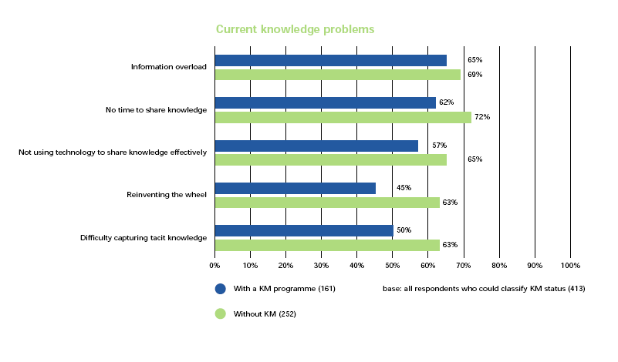
The main reason for an in-house knowledge management program is really quite simple; firms often do not know what they know. Information moves both horizontally and vertically too slowly to be of benefits. In fact, the information often ends up being unavailable to those who need it in order to make costly decisions. Once a KM system is put into place, knowledge problems of the firm begin to disappear. According to a KPMG Consulting study involving 423 organizations, those with a KM system in place report a lower occurrence of the problems often associated with a company’s organization of knowledge (12). Furthermore, the study helps to illustrate that having no time to share the knowledge and information overload are problems that often occur. Many do not realize that too much knowledge is detrimental to a firm’s efficiency, but when the information overload reaches a point where it begins to become difficult in finding what one needs, then some of the outdated information should be purged.

Knowledge Management: Difficulties of Implementation

Knowledge Management is a particularly difficult IT system to implement. Like all other IT changes, it is of utmost importance that upper management be supportive of the new system. However, getting senior management involved in KM is more difficult than other IT projects because of the very nature of KM. KM focuses on sharing information, and it is a common fear of upper management that they lose control (power) when information no longer has to pass through them. However, convincing upper management to support the system is not the only difficulty in implementing knowledge management. The upper management then must convince the employees to take time out of their day in order to contribute to the KM system. “While employees may not deliberately hoard their knowledge, convincing them to make the time to participate in and contribute to a knowledge management system or community can be a challenge,” (5). The IT department also must overcome the common belief that knowledge is power, so holding information makes them more powerful than their colleagues. It is also a tough decision regarding what information should be retained. As mentioned above, information overload affects the efficiency of a firm, so during the design of the system, IT must decide what is important to the firm and what can be discarded. One more issue to consider is access to the KM network. Does a company give the client access to the KM system, and if so, should they be allowed to contribute? Furthermore, it is also possible that access to the KM system should not be universal to all employees and perhaps a confidentiality agreement should be distributed. It may take some time for the business to overcome these implementation difficulties, but the benefits of a successful KM system will far outweigh any potential hardships.

Knowledge Management: Trends

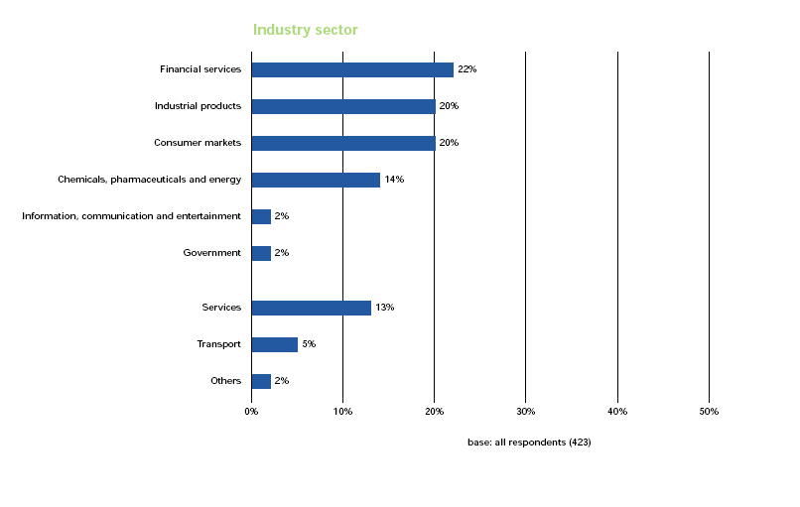
As noted in the figure above, of the 423 organizations surveyed, the largest industries with a KM system in place are the financial and industrial sectors (12). It is also notable that the government sector represents a small portion of the KM market. While this may be true, it helps to indicate the size of the KM market, as federal spending on KM products were expected to reach $6.3 billion in 2003 (8). KM continues to grow as methods improve and only 2% of the KMPG respondents reported that they considered a KM system and decided against it. Furthermore, one can see that the United States is lagging behind Europe and particularly the UK in knowledge management, but that the U.S. is leading in the category of “considering” a program (12).

Knowledge Management: Benefits

“We had a critical launch problem that was going to prevent us from launching a new product line on time. We posted the question to the knowledge base and got an answer from an engineer who had just solved a similar problem. We made the fix and got the product out on time, saving us millions in lost revenue” (3).
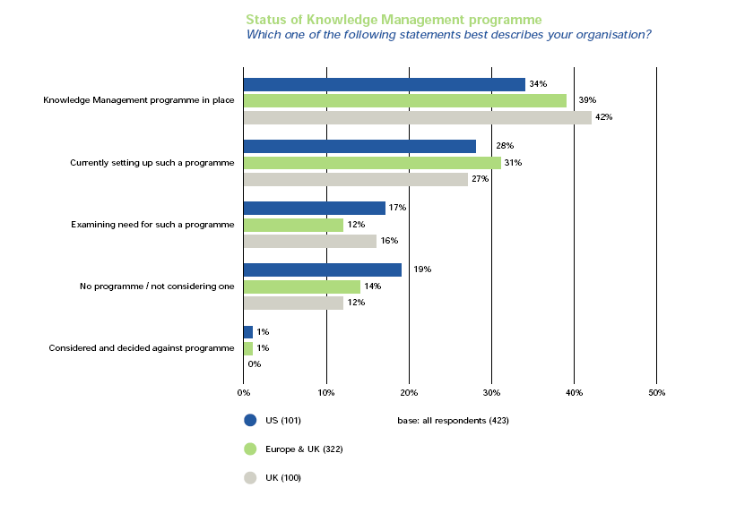
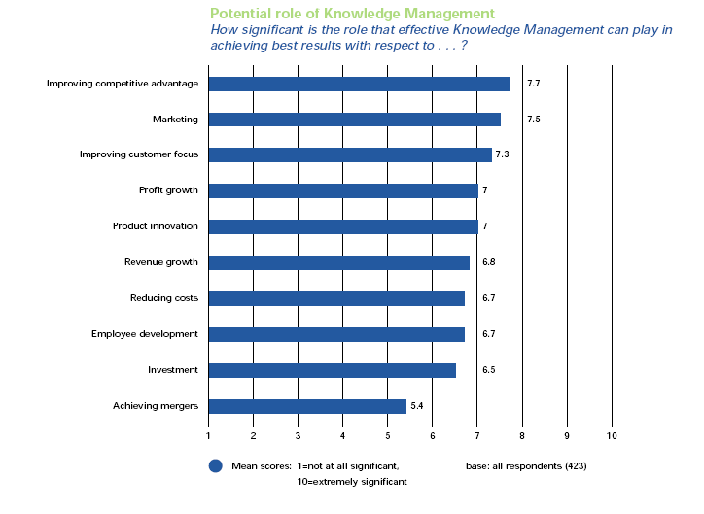
The quote on the previous page symbolizes the best that knowledge management has to offer. Quite simply, KM increases responsiveness to consumers, the efficiency of the staff, and the process of innovation. As the following chart indicates, KM may also eliminate some of the problems relating to employee turnover. As more knowledge is readily available to all employees, the learning curve of “new-hires” drops considerably. KM may also improve company morale as employees increase networking and improve support among colleagues due to the value of knowledge they receive (12). Also, it is important to consider the idea that KM may improve reduce costs as less time is spent “reinventing the wheel.”

Knowledge Management: Real Results

Shell International Exploration and Production attributes more than $200 million in direct costs saved and additional income in 2002 to the use of its SiteScape online collaboration forum (7).

Knowledge Management: Best Practices

It is important to understand the best practices of KM systems before implementing Knowledge Management internally. First, as discussed above, convince upper management to openly support the KM system and set strategic priorities for the implementation process. You also should make it “abundantly clear that contributing knowledge will benefit them personally, not just the company. For example, an overworked programmer would personally appreciate the shortcut of grabbing code from a reusable library, rather than having to rewrite it every time it’s needed”(6). Perhaps an incentive program will help facilitate employee contribution to a KM system. Whether the employee gets name recognition or some sort of financial bonus, an incentive program will encourage a successful KM deployment. However, another best practice would include a form of gate keeping, whereby a potential contribution is judged on its usefulness and accuracy before being available to the firm community, this practice would serve to eliminate misleading information.

Bryan Cave was founded in 1873 in St. Louis. Over the past 130 years it has grown to 16 offices worldwide. These offices are located in Santa Monica, Orange County, Phoenix, Kansas City, Jefferson City, St. Louis, Chicago, New York, Washington D.C., London, Riyadh, Abu Dhabi, Dubai, Kuwait City, Hong Kong and Shanghai. The headquarters remain in St. Louis. The company employs over 800 Lawyers, and over 1900 total staff. (32)

In 1939, the firm began a relationship with a client who was a “poor Scotsman with just a little ‘bitty aviation company,’ and has continued its relationship with that client since. That client was McDonnell Aircraft Company, which became McDonnell Douglas, and is now The Boeing Company. Also, in 1993, Bryan Cave was chosen to represent the Government of Kuwait in International Court against the State of Iraq for the submission and prosecution of claims resulting from Iraq’s invasion and occupation of Kuwait (32, 34, and 35).

In order to allow all offices to work together in the greatest and easiest way, Bryan Cave has invested much time, money, and people into technology to achieve its goal. In the legal world, knowledge is power, and all lawyers must work together to achieve success and share their knowledge in specific areas. To do this efficiently and effectively, the firm has developed many resources the lawyers can use to best help the various needs of their clients (32).

The three main keys to technology at Bryan Cave are reliability, connectivity, and availability. The firm must provide their lawyers with the best tools possible to serve their clients. In order to be confident in what services they can provide the clients, the lawyers must first know and trust the tools with which they are working. Knowing what resources are available to them and the quality of those resources allow the lawyers to have the best grasp of what they can do for their client. Connectivity is an invaluable key because that it allows the lawyers to always be in touch with others in the firm. The more places where a person can connect to the system, the better they will be at figuring out what needs to be done and how to do it. In America, everyone is obsessed with availability. The last thing that anyone wants to here is that the computer is down and they can’t access a system or use a tool. It is Bryan Cave’s goal to keep the availability of their system at the highest level possible (32).

Bryan Cave has a very detailed infrastructure that keeps all offices in constant communication. All offices are connected via a Wide Area Network (WAN), and all documents, spreadsheets, and presentations can be shared across this network. Also, all traveling lawyers and staff are given wireless devices, such as blackberries, so that they can check e-mail and remain in contact with other in the office and around the world while they are away. Finally, all personnel are given access to the Internet, Extranet, and Intranet. This allow people to share and look up references, and also access knowledge and other databases that are located on the Intranet (32).

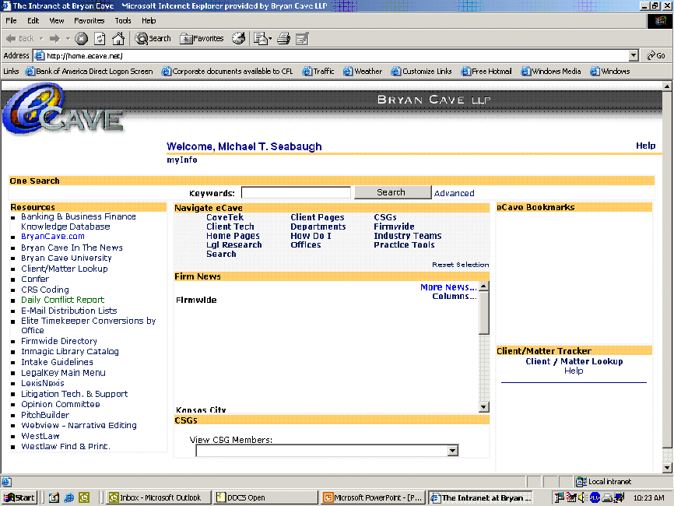

When on the Intranet, employees can access a various number of different items. For lawyers who are seeking help with certain needs of clients, they can look up and find out which other lawyers in the firm have the greatest amount of experience in the area in which they are researching. The lawyers are sorted by level of experience in the area (significant, extensive, some, and not at all), then by the area which the person is looking for, and finally by the office location of the lawyer (32).

Another knowledge database is that of the Case Database. This is the database where all litigation filed in cases in which Bryan Cave is involved are stored. This allows lawyers to look up information on related cases that they may be working on or investigating. This database can be sorted by whatever category a person may be looking for. Lawyers can search by judge, ruling, party, date, case, and lawyer. By doing this, lawyers can find information quicker, and better serve their clients (32).

Another database that Bryan Cave offers is that for the various opinions issued by the firm on many different types of legal issues. This database is the most important for lawyers, as it pertains to what types of services they will be providing and how they will be providing it, as well as information useful for various other activities. The approval process for getting an opinion published in the database is very complicated. After the opinion is drawn up, it must first be fact-checked. After this is done, it is given to the group leader, who will either sign off on it or send it back for revision. Once the group leader signs off on the opinion, it is given to the Partner in charge of the group, who presents it to the Executive Committee. If the Executive Committee agrees with the opinion, then it is published (32).

Perhaps the most interesting database deals with computer training. This database is called Bryan Cave University. This is a database where employees can go and learn about many different computer programs that are on the system (32).

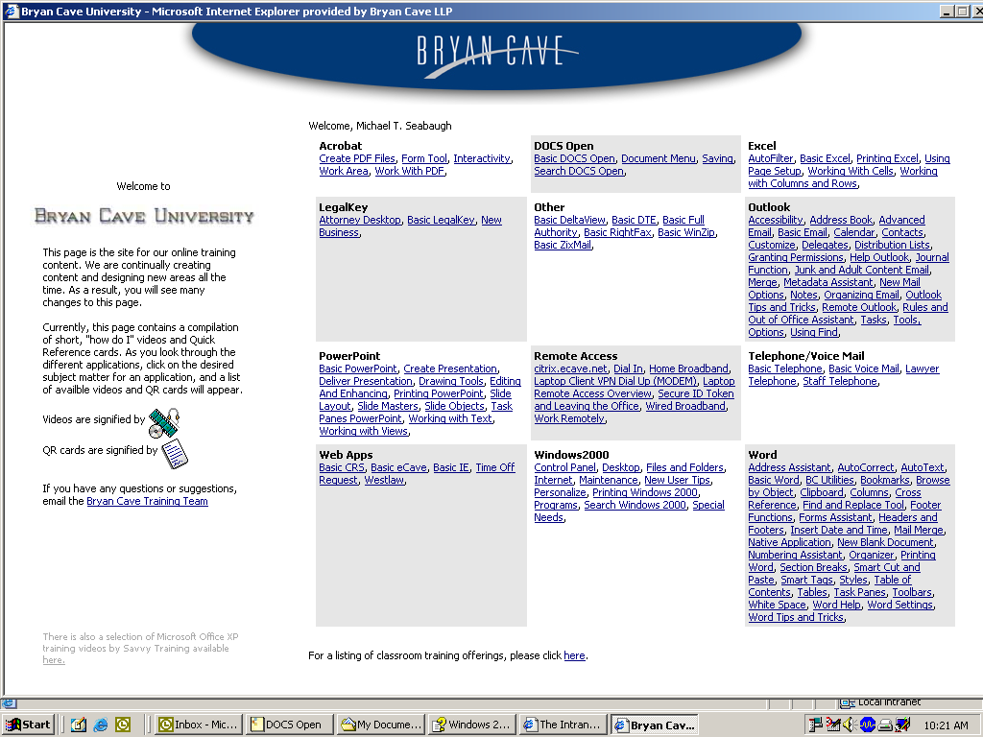

People can simply click on the hypertext link shown, and a video will pop up on their screen telling them how to operate the program they are trying to run. This database has saved the company countless dollars on training costs, as employees are now given the tools to train themselves (32).

Some clients of the firm are constantly needing information or assistance with many different issues that they or their company may encounter on any given day. To provide them with the most efficient and effective service, Bryan Cave has developed a database to advise these clients on their various questions and needs. When a client has an issue that they need assistance with, they can access the database and pose the question. The database will search over all the files contained in it, and come back with an answer for the client. Sometimes the database will answer the inquiry fully, while other times it will advise the client to speak with one of the firm’s lawyers. It really just depends on the issue being posed. The database is constantly being updated in accordance with all changes in the law (32).

The final Knowledge Management procedure employed at Bryan Cave is with the help desk. In most offices, dealing with the help desk or support team is a very difficult procedure, because some people may have problems describing the problem, and the people at the Help Desk understanding what the problem is and how to fix it. When you call the Help Desk at Bryan Cave, you have the option of allowing the technician access to your desktop. What this does is that it actually gives the technician to see exactly what you see; they can even use your pointer. An example of this would be with an employee who is having trouble printing a document. The employee would call down to the help desk to tell them that there is a problem, then the technician would ask for permission to access the employee’s desktop, once the employee allows the technician access, it is like that person is at the employees desk. By providing this type of service, the help desk technicians can employ their knowledge to the other person much faster, and save a great amount of time that would have been spent describing the problem and what the computer is saying is wrong(32).

These programs employed by Bryan Cave has proven their commitment to technology. One of the major facets of the tools which the firm provides to its employees is that it has flexibility built into the technology. The databases and programs can be used by people for many different purposes. Also, with respect to the technology, there is no “one way of doing things.” The firm realizes that people use programs in many ways, and everyone approaches a problem differently. The firm tries to take as much input into designing a system as possible and incorporate them accordingly. Bryan Cave is also one of the first law firms to use web-based tools. This allows clients and others to digitally access the resources of the firm and receive assistance. This increases both the speed and productivity of all those involved (32).

In recognition of Bryan Cave’s exceptional use of technology to address client’s needs, the firm was award the first ever “Champion of Technology” award given by the Law Technology News. This was earned by Partner John Alber’s leadership in the creation of the Client Technology Group in 2003. This is a multi-functional team which uses technology to deliver the best client service possible. This group is not just made up of lawyers, but it also contains business analysts, web developers, multimedia professionals, and litigation support experts who utilize the technology platform at the firm in a way centered on the client. Some of the various projects the group has employed are (33):
- Client extranets
- Custom Web Sites which provide certain training and decision support for different client matters
- Interactive features on the Bryan Cave website such as newsletters and resource repositories.
- Developed and implemented an electronic library which provides litigation support training materials.
Alber was quoted in Law Technology News as saying: “We wanted to create a group whose sole focus was on helping the firm achieve extraordinary client service. Though we use it, technology is secondary. The client is first. In only one year’s time that structure has permitted us to achieve extraordinary results.”(33)

Bryan Cave has focused on technology to provide extraordinary service to its clients. Through this use of technology, the firm has been able to develop many different knowledge management systems to assist the lawyers, staff, and clients in their various needs and questions. It is because of this commitment to technology that the firm won the first-ever “Champion of Technology Award,” and can provide the best service to clients in the most efficient and effective (33).

Xerox: Leader in Knowledge Management

A case study on Xerox is a great example of how a company effectively utilizes KM by actively pursuing and implementing KM projects. Three of Xerox’s successful KM projects that will be analyzed are Eureka, Code X, and Docushare. All three of these projects teach that knowledge management is not just putting information on a company’s Intranet. An actual KM system must have steps in place to ensure that the information entered into the system is valid and not repetitive. It also shows the importance of motivating knowledge sharing and creating a community atmosphere. This is because a KM system is only as effective as the knowledge that it contains. Lastly, the case study demonstrates the cost savings that can be achieved when knowledge is made available throughout an entire company.

Xeroxing is Photocopying

Xerox was founded in 1906 as the Haloid Company, but later changed its name to Xerox in 1961. It did this so its name would be similar to the word xerography, which is a Greek work that means “dry-writing.” It proved to be a good idea because many consumers started referring to the process of photocopying as xeroxing. This can be a sign for success when consumers have a direct association with a product and a company’s name (29).

When the sale of copiers took of in the 1960s and 70s, Xerox experienced immediate success because of the patents that it had on the process of photocopying. For the most part, the company focused on the sale of copiers and printers until the early 1980s when it lost its monopoly on the manufacture of copiers. This resulted in an immediate increase in competition, and forced the company to expand its product line. It also had to find ways to lower its operating costs (29).

Xerox is All About Documents

Xerox’s product line focuses on products and services that allow its customers to utilize the knowledge and information that exist within their business operations. The company’s slogan is that they are the “Document Company” because they allow their customers to create, manage, and share documents. Their products include copiers, printers, office supplies, and software. Services include document management and consulting. It’s 2003 IT and research and development budget totaled $868 million, which is 5.5% of its revenue (31).

Profitability is Improving

Xerox’s 2003 gross revenue totaled $15.7 billion, which was down $200 million from 2002. Its 2003 net income equaled $360 million, up approximately $260 million from 2002. This shows that the company has been able to decrease costs while overall revenue has declined. In 2003, Xerox ranked 130th among Fortune 500 companies. It has 61,100 total employees worldwide, with 35,600 of them being in the United States (31).

The following graph is of Xerox’s net income for the last five years. Along with the economy, Xerox’s business struggled immensely in the years 2000 and 2001. It is important to note that even during these down times, the company continued to invest in IT and R & D, realizing how important it is to its business (28).
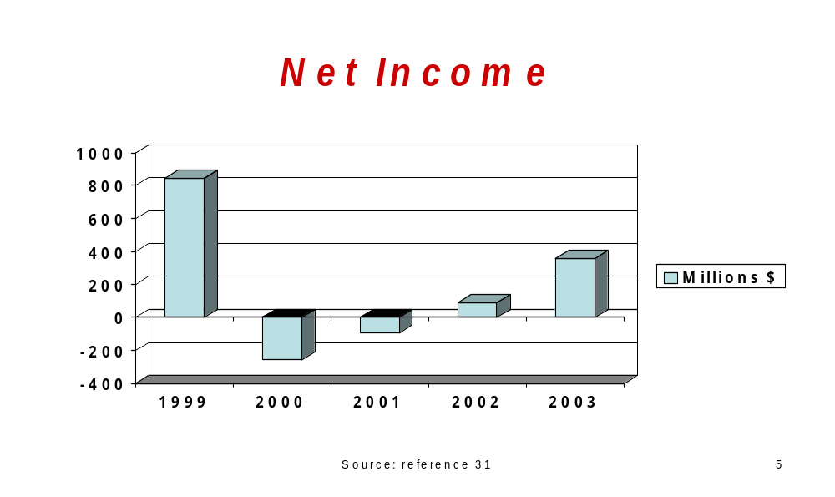
The following is a graph of Xerox’s stock price over the last five years: 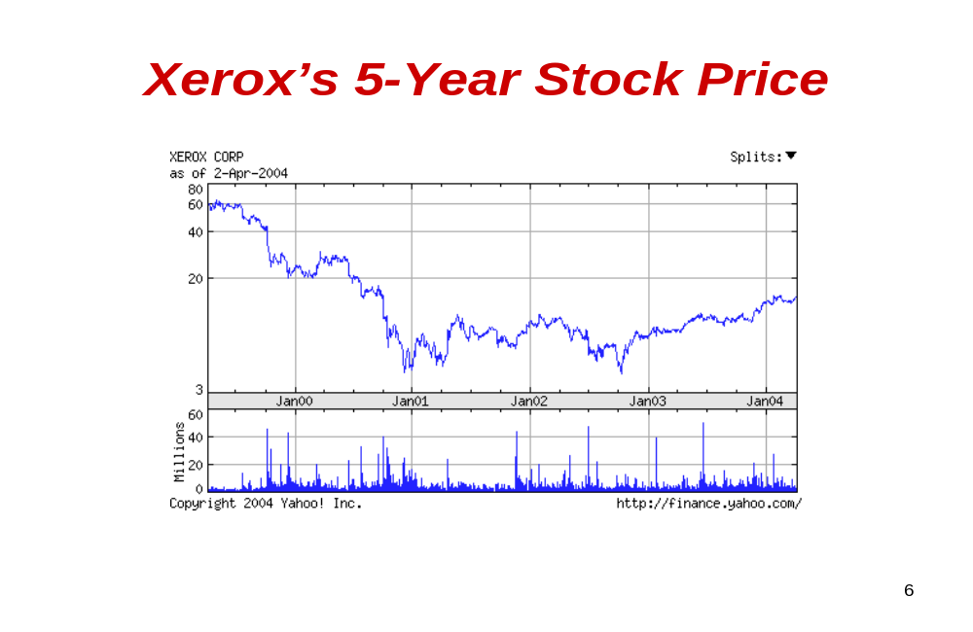This chart is very similar to the previous one on its net income. Its dedication to KM has started to show benefits in the last twelve months (36).

Xerox Doesn’t Overlook the Small Companies

Xerox has a wide-variety of customers ranging from large companies such as Microsoft and Sun Microsystems, to small ones like my company that has only ten employees. Its CIO reports directly in the company’s CEO and is also the Vice President of the Corporate Operations Group, which is responsible for information management and strategy (31).

Xerox KM Strategy: Being Proactive

In 1996, knowledge management was a new concept for many companies. Instead of having a cautious attitude towards KM, Xerox chose to implement a KM strategy. At this time, there were three main KM strategies.

- A top-down, corporate-wide strategy
- A middle-out strategy
- A bottom-up, low budget strategy (28)

The top-down, corporate-wide strategy is where KM is closely tied to a top-level executive such as CIO and it is funded with a large budget. The middle-out strategy is one in which a company creates a KM department with a moderate budget. The last option was a bottom-up, low budget strategy that empowers employees. Xerox chose this bottom-up strategy, but gave it some organization by tying it to the company’s vision for KM. It assigned 30 to 40 employees to communicate this strategy throughout the company. When positive KM results occurred, these practices could be implemented throughout the company (28).

Xerox chose the bottom-up strategy for several reasons. One reason is that it had small risk, big gain potential because it initially required little investment. Another reason is that it could lead to the development of new products and entry into new markets. Finally, this strategy fit best within Xerox’s corporate environment because of its innovative employees (28).

Three Successful KM Projects

The following are three of Xerox’s KM projects that have proven to be successful:

- Eureka – first and most successful KM project (28)
- Code X – an open-source software sharing platform (28)
- Docushare – research sharing platform (29)

Eureka: A Service Technician’s Best Tool

Eureka is a KM project that focuses on Xerox’s 18,000 service technicians who fix copiers around the world. The company discovered an opportunity for this project when its researchers actually went along with several service technicians on their daily routines. The researchers discovered that while fixing copiers, there were certain problems that were not covered in the company’s repair manuals (30).

To solve these problems, service technicians that worked in the same community were found to share their solutions with one another. Some technicians were even found to discuss the solutions over breakfast on a regular basis. The problem for Xerox was that these solutions were not being shared throughout the company, and many technicians were encountering problems that technicians in other regions had already solved. This was wasting both time and money (30).

The following diagram shows how Eureka’s KM process works:

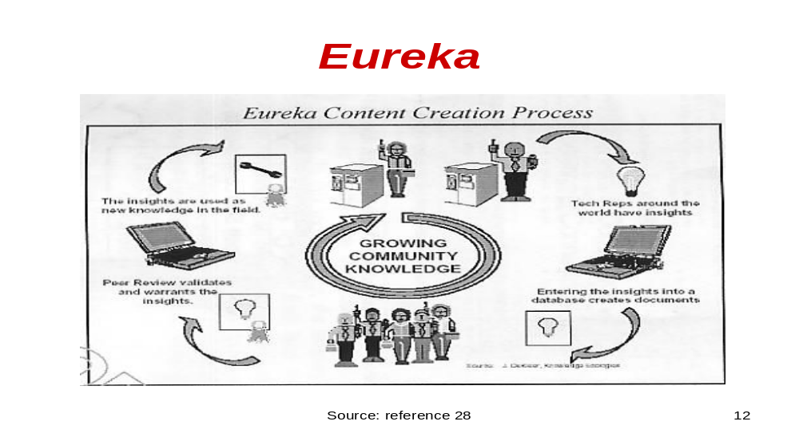The process begins when technicians encounter difficult problems while fixing copiers. When the technicians discover solutions to the problems, they enter them into the Eureka database using laptops that they are provided with. A designated department of employees then validates these solutions or insights. During this peer review, it is checked that the insights are credible and are not duplicate entries into the system. This extremely important step of quality control is what differentiates Eureka from being only an Intranet to being an actual KM system. The company even has a specific position of a Eureka Database Quality Coordinator that oversees this function. After the solution is validated, it is then made available to other technicians worldwide in the system (28).

Motivation for knowledge sharing with Eureka is based on social recognition because the technician’s name is attached to any solutions submitted. This has created both competition and a sense of community. Some technicians have even been noted to express gratitude to the person whose tip they used. Xerox had thought about giving compensation for the tips, but concluded that this would result in an increase in the quantity of tips, but not the quality (30).

The following is a list of Eureka’s positive results for Xerox:

- It saves the company between 5% and 10% on labor and parts
- Annual savings total $10 million
- It holds 50,000 problem solving tips
- In 2001, it solved 350,000 problems
- In 1999, it was vote the Best KM Project in the Information Management Awards
- Inspired other KM projects – both internally and externally (28)

The last result is something that Swiss Bank was not able to accomplish with its successful internal database. It was too hard-coded to sell externally.

The following picture is a screen shot of the Code X Home Page:

Code X: Decoding Barriers to KM

Code X was started in 2001 on Xerox’s Intranet. Code X stands for Code Exchange. It was implemented to allow software developers to do the following tasks:

- Access and view all source codes
- Copy and redistribute codes freely
- Improve existing software
- Exchange information on projects

Xerox was met with resistance from its developers in sharing their codes. One developer was quoted as saying, “I would not share codes with my mother.”(28) To motivate the sharing, Xerox put free software tools in the database, created a community atmosphere, and used tracking to show who actually accessed any particular software or codes (28).

Like Eureka, Code X regulates what goes into the system. Any code modifications must be approved before it’s made available on Code X. In addition, any sensitive projects can be excluded from Code X. But Xerox believes it has much more to lose by “reinventing the wheel” then by having its information copied (28).

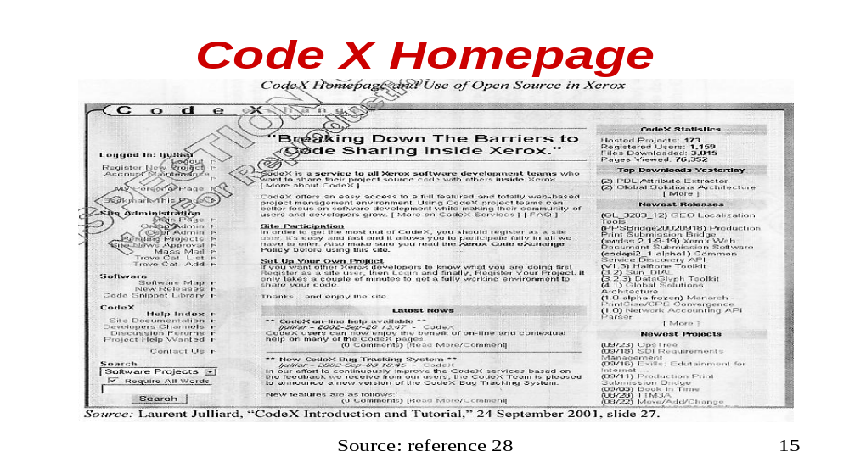This above home page is where programmers go to enter and search for software codes. On the right hand side, it lists the number of projects and users in the system. It also lists the top downloads and any new projects listed.

Code X has shown several positive results. With an initial investment of only a three-person team to set up the system, Code X saves Xerox approximately $3 million per year. These savings come from productivity improvements, infrastructure improvements, software licenses, and administrative time. The company says that 85% of its developers are “very satisfied” with Code X, and that it has created a growing sense of community (28).
Docushare: A Researcher’s Library

Docushare is very similar to Eureka, but was developed for its researchers. Instead of entering tips like the technicians do with Eureka; researchers enter what they are currently working on and any findings that are discovered. This can speed up and improve the overall research process because of the increased information that is made available. Xerox gives its researchers some freedom in entering their research data into the system because it realizes that they are adverse to structure (29).

This project has spread to other departments such as Product Planning and Marketing. The KM system allows for theses departments to keep track of what employees are working on (29).

Xerox’s KM Philosophy: Don’t Let Knowledge Bleed Away

“For all of us to win in the knowledge economy, we need to unleash the knowledge in our document databases, use and reuse our past knowledge, find ways to create new knowledge and then share it across our enterprise. In the digital, networked age, knowledge is our lifeblood. And documents are the DNA of knowledge (29).”

- Rick Thoman, President and CEO of Xerox in 2000

Knowledge management in Asia Pacific
Knowledge management is becoming popular in Asia Pacific due to the sharp increase in knowledge management activities there the last couple of years. Moreover, there is also increasing interests especially on knowledge management education in the Asia Pacific and that many universities have been offering Master’s degree programs in this field (13, 14).

In the Asian continent, the biggest impact has been Japan, Hong Kong, India, Singapore, South Korea and Taiwan. Japan, the country with the second largest economy, has been turning to knowledge management to realize that talent and innovative capabilities of their employees. In Hong Kong, the bubble burst of 1997 was a main reason to establish knowledge management systems. Many companies had to change their updating processes by from the ground up. Singapore took a similar path to Hong Kong in leading public sectors and government adoption. In India, South Korea, and Taiwan, due to worldwide economic uncertainty, it furthered fostered the growth of knowledge management. These countries have encouraged superior organizational efficiencies and innovation in their organizations (13, 14).

The Most Admired Knowledge Enterprises MAKE Study

The Most Admired Knowledge Enterprises is composed of the Global study as well as studies for Asia, Europe, North America and Japan. The study is providing practitioners and researchers with a clearer picture of how organizations are managing knowledge as a key competitive differentiator in the 21st century. The study investigates organizations for their abilities to deliver superior performances (15).

The study is based on the consensus of expert opinion, using the Delphi research methodology, to identify which organizations are leaders in the new knowledge economy. The winners are chosen by an international panel of Fortune Global 500 senior executives and leading knowledge management experts (15).

According to Rory Chase, Managing Director of Teleos, “These organizations have been recognized as global leaders in effectively transforming enterprise knowledge into wealth-creating ideas, products and solutions. They are building portfolios of intellectual capital and intangible assets, which will enable them to out-perform their competitors in the future.”(15)
- Rory Chase, Managing Director of Telos in 2003

There are eight knowledge performance dimensions which are the drivers of competitive advantage as follows (15):

- Creating an enterprise knowledge-driven culture
- Developing knowledge workers through senior management leadership
- Delivering knowledge-based products/services/solutions
- Maximizing enterprise intellectual capital
- Creating an environment for collaborative knowledge sharing
- Creating a learning organization
- Delivering value based on customer knowledge
- Transforming enterprise knowledge into shareholder value

As the matter of fact, The MAKE winners each year have been measured as leaders from the above eight keys.

History of Global MAKE study

The first GLOBAL MAKE study was conducted in 1998. There were a total of 45 organizations selected as the finalists. However, 20 of the 45 organizations were winners. According to the below table, it is easy to interpret the following geographic distribution (15).

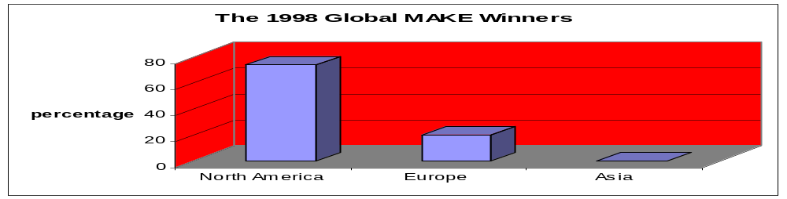

- North America (16 organizations-74%)
- Europe (4organizations-20%)

There was no percentage in Asia. This is due to Asia just beggining to realize the importanance of knowledge management in 1998, which was the year the first Global MAKE just began.

However, everything in the last five years. It is displayed as follows (15):

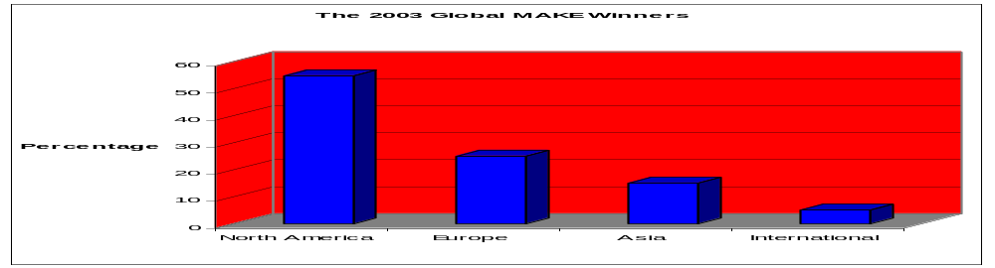

- North America (11 organizations-55%)
- Europe (5 organizations-25%)
- International (1organization-World Bank-5%)
- Asia (3 enterprises-15%)

Three enterprises were from India and Japan. They included Infosys Technologies, the software solution provider, from India. From Japan, it was Canon and Toyota Motor. All three organizations have been maximizing knowledge through senior management leadership and maximizing the enterprise’s intellectual capital, enterprise knowledge sharing and organizational learning (15).

The first Asian Make study was established in 2002. The study used the same policy with the Global MAKE study including eight knowledge performance dimensions. The 2003 Asian focused on creating an organizational learning culture, collaborative knowledge sharing, and maximizing the value of customer knowledge. There were 18 Asian MAKE winners from six countries, including Australia, Japan, India, Korea, Singapore and Taiwan (16).

2003 Asian MAKE Winners
Enterprise |  | Country
BHP Billiton |  | Australia
Canon |  | Japan
Eisai |  | Japan
Fuji Xerox |  | Japan
Honda Motor |  | Japan
Infosys Technologies |  | India
Kao |  | Japan
LG Electronics |  | Korea
Nissan Motor |  | Japan
Samsung Electronics |  | Korea
Samsung SDS |  | Korea
Singapore Airlines |  | Singapore
Sony |  | Japan
Taiwan Semiconductor Manufacturing Company |  | Taiwan
Tata Steel |  | India
Toshiba |  | Japan
Toyota Motor |  | Japan
Wipro Technologies |  | India

The profile of Samsung SDS, one of MAKE winners in 2003

One of the organizations is Samsung SDS, a designer of Samsung contact messaging software platform. SDS is the number one system integration and the largest IT service company in Korea. It was established in 1985. Since 1996, SDS fostered knowledge sharing and collaboration among its personnel (16, 18).

The knowledge management strategy of Samsung SDS consists of three KM orientations as follows (18):

1. Community-oriented KM
SDS aims to promote a knowledge-sharing culture among all employees.
2. Process-oriented KM
SDS improves productivity and output quality of the workgroup.
3. Asset-oriented KM
SDS builds knowledge assets as the company’s core competence.

In the 2003 MAKE study, SDS was recognized for developing knowledge-based products, services, organizational sharing, and transforming enterprise knowledge into shareholder value (18).

In Thailand, knowledge management is less conducive. Many people thought of knowledge management as consultancy type or a type of technology. It is difficult to identify the balance between people’s thoughts and technology components in knowledge management implementations. If the people in Thailand realize the intellectual capabilities of knowledge management, their economy will grow.

Knowledge Communities in Japan

Japanese companies increasingly realize the necessesity of developing “knowledge building communities”. In the 1990s, there was a rapid loss of competition as the result of an inward-looking structure based on factors like seniority rule, a life-long employment system, and corporate-based union movements. In other words, inward-looking is a structure group type of behavior. The old consensus-based management style of “high-context”, which is a lot of unspoken meaning transferred during communication, is no longer suitable now. For instance if Japanese want to say “no” typically other phrases are used. The culture of high context and inward-looking are gradually breaking down in many Japanese companies. Due to the out-dated structures, inward-looking and high context, “knowledge-community building” terms have been set up in Japanese companies (17).

Definition

According to the definition of knowledge communities, “knowledge communities are groups where knowledge and best practices in a given field are developed, nurtured and transmitted through the social interaction of its members”(18).

Increase “knowledge communities” in Japanese companies

Most of the “Knowledge Communities” in Japan are on-line. In previous eras, the importance of face-to-face based tacit knowledge transfers were strongly emphasized. However, it is not currently suitable for the industrial age. Some knowledge communities are based on on-line magazines; others are based on Q&A type community system. Knowledge Management Society of Japan (KMSJ) presumes that new cultural mix of western style and oriental style is emerging in the shape of on-line based knowledge communities at the beginning of 21st century (17).
The oriental style particularly in Japan has the following unique local features that are different from the global standard:

1. Most of knowledge communities are IT based

Japanese companies are making themselves open to their employees. Fresh and new ideas have been issued not from an introverted community environment but from an open and individual treasured community environment. Open and low context are installed rapidly in Japanese organizations (17).

2. Retaining traditional collective decision-making flavour

Some considerations are given to middle managers as well as young employees. However some sort of a consensus-based traditional flavour can be seen in newly built Japanese knowledge communities because some old employees are not ready to change their own styles (17).

3. Nickname based on-line communities

This is a big surprise in Japan. Employee nickname basis is operated in knowledge communities. The use of multiple identities is considered incompatible with Japanese traditional culture. However, the use of a nickname enables employees to exchange knowledge more easily. The use of nickname has revived unselfishness, which is the new form of Japanese style (17).

4. One big knowledge community is preferred

A big knowledge community is preferable in Japan. It is called Paternalistic tradition. Some big knowledge communities include all employees for example Mitsubishi Electric Company with 90,000 employees working in all the group companies. A large knowledge community is the revival of paternalism (17).

5. Vertical as well as horizontal knowledge exchange

In Japan, the flexible time system has currently become more popular with companies. For instance, a salesman may return home without visiting office. Top managers learn to consider managing employees through an IT network. The coordination between community members and top management is workable. They could be on equal footing called “dual context community”, the new social environment of Japanese companies (17).

Some exports were surprised to know that Ricoh was nominated as one of the finalists of MAKE 2003. In the record so far, Ricoh gives a clear picture of Japanese “knowledge communities building” in a typical Japanese way. Ricoh, well known manufacturers of copying machines in Japan, is an interesting example of a knowledge community (17).

Ricoh has an on-line newsletter-based “knowledge communities” that are full of specific and useful business knowledge such as how to persuade customers to buy Ricoh products, as well as the articles useful for employees. This simple operation produces a big on-line community with more than 10,000 participants from all over the world. Employees around the world can attend and engage in discussions. In case these participants would like to communicate with others, all they have to do is send a letter to the coordinator asking permission. The letters are used to exchange within the knowledge community as a helper. It has created a big business knowledge community with more than 300 related businesses (17).

KM BEST PRACTICES COMPARISON

 | XEROX | BRYAN CAVE
Are there steps in place to ensure information entered into KM system is accurate and reliable? | Yes – Eureka project has a peer review in which all tips entered are validated; Code X requires of approval of code modifications | Yes – Opinion database requires that facts are checked, group leader signs off on it, and the executive committee agrees to it
Is there motivation for sharing knowledge? | Yes – Social recognition in which employee’s names are attached to tips submitted in Eureka | Yes – Creates a sense of community in the workplace
Does management support KM and give it necessary resources? | Yes – In 2003, Xerox spent 5.5% of its revenue on IT and R & D | Yes – It has funded a variety of different databases
Are there any cost savings as a result of the knowledge management procedures? | Yes – Eureka saves Xerox $10 million a year; Code X saves approx. $3 million a year | Yes – Not exact numbers available
Was there any recognition for the knowledge management projects? | In 1999, Eureka was voted the best KM Project in the Information Management Awards | Received the first ever “Champion of Technology” Award presented by the Law Technology News

References

1: Steven L. Mcshane & Mary Ann Von Glinow. “Organizational Behavior: Emerging Realities for the workplace revolution.” Knowledge management, second edition, page 19.
2:Dykeman, John B. “Knowledge Management Moves from Theory Toward Practice.” Managing Office Technology. May 1998. Vol. 43, Iss. 4; pg 12.
3: Jarrar, Yasar F. “Knowledge Management: Learning from Organizational Experience.” Managerial Auditing Journal. Bradford: 2002. Vol. 17, Iss. 6; pg 322.
4: Stenmark, Dick, Ph. D. “Data, Information, and Knowledge: definitions and relationships.” URL: http://w3.informatik.gu.se/~dixi/km/chap3.htm 03/15/2004
5: Whiting, Rick. “Myths and Realities.” Knowledge Management. Manhasset: Nov. 22, 1999., Iss. 762; pg. 42.
6: Pastore, Richard. “Why We Fear Knowledge Management; Knowledge Management spooks people, especially in this environment of jobless recovery.” CIO. Framingham, Dec 1, 2003. Vol. 16, Iss. 5, pg 1.
7: Paul, Lauren gibbons. “Why Three Heads Are Better Than One (How to Create a Know-It-All Company).” CIO. Frmingham: Dec 1, 2003. Vol. 17, Iss. 5; pg 1.
8: Ferris, Nancy. “Knowledge is Power, Really.” Government Executive. Washington: June 1999. Vol. 31, Iss. 6; pg 63.
9: “The Knowledge Management Glut.” Strategic Direction. Bradford: Sept. 2000. Vol. 16, Iss. 9; pg 29.
10: Birkenshaw, Julian. “Making Sense of Knowledge Management.” Ivey Business Journal. London: Mar/Apr 2001. Vol. 65, Iss.4; pg 32.
11: Probir, Roy and Preeta M. Roy. “Tacit Knowledge management in organizations: A move towards strategic internal communications systems.” Journal of American Academy of Business, Cambridge. Hollywood: Sept 2002. Vol. 2, Iss. 1; pg 28.
12:“Knowledge Management Research Report.” KMPG Consulting. URL: http://www.kpmg.nl/Docs/Knowledge_Advisory_Services/KPMG%20KM%20Research%20Report%202000.pdf 03/15/2004
13: American Society for information Science and Technology ;Feb 1,2003;54,3.
14:http://www.kmmagazine.com/xq/asp/sid.CB3196D9-072F-4CD8-96BA7E66F88A2B1B/articleid.96C4BD01-3AEB-43B5-944E-08813C6CD896/qx/display.htm 03/01/2004
15:http://www.knowledgebusiness.com/knowledgebusiness/upload/2003_GlobalMAKE_Summary.pdf 03/07/2004
16:http://www.knowledgebusiness.com/knowledgebusiness/upload/2003AsianMAKE-ES.pdf 03/05/2004
17: http://knowledge.typepad.com/ikms_newsletter/km_in_japan.pdf 03/08/2004
18: http://www.knowledgeboard.com/cgi-bin/item.cgi?id=108645 03/25/2004
19: http://www.tcm.com/trdev/cops.htm 03/25/2004
20: http://www.wec.org/WEC-Review_Feb03.pdf 03/25/2004
21: http://www.ewenger.com/ewtheme.html 02/25/2004
22:http://www.knowledgebusiness.com/knowledgebusiness/upload/2003MAKEJapanES.pdf 03/07/2004
23: http://www.knowledgeboard.com/cgi-bin/item.cgi?id=96134 03/04/2004
24: http://www.knowledgeboard.com/cgi-bin/item.cgi?id=99458 03/04/2004
25: http://www.pliant.org/personal/Tom_Erickson/KnowCommunities.html 03/25/2004
26: http://www.apmforum.com/emerald /knowledge-management -3.htm 03/01/2004
27: Street Journal. (Eastern edition). New York, N.Y.: Jun 21,2001. pg. B.12
28: Reese, P., “Xerox: Building, Sustaining and Monetizing Knowledge Management” INSEAD, 2003
29: Regani, S., “Knowledge Management @ Xerox Corp” ICFAI Center for Management Research, 2004
30: Seely, B., and Duguid, P., “Balancing Act: How to Capture Knowledge Without Killing It” Harvard Business Review, R00309 May-June 2000
31: Xerox Corporation, www.xerox.com, viewed March 26, 2004
32: www.bryancave.com viewed 03/25/2004
33: David Whelan, "And the Winners Are... Our first annual Law Technology News Awards" Law Technology News. march 2004, Vol. 11, No. 3
34: www.cia.gov viewed 03/25/2004
35: www.boeing.com viewed 03/29/2004

