Customer Relationship Management (CRM)

Julien Couilloud
Eric Meyer
Nancy Prives
Jon Stegen

April 29, 2004

EXECUTIVE SUMMARY

Customer relationship management (CRM) is a business strategy that focuses every business activity a company does on its customer. CRM entails getting upper management support for implementing new strategies and technologies that allows the organization to get a single view of each customer and to better service the customer both now and in the future. Companies are interested in retaining current customers because of higher costs associated with seeking new customers—at times, these costs can be as much as five to one.

The size of the CRM market is debatable, but it is a billion dollar market with estimates for 2004 ranging from $2.14 billion to $26.5 billion. The big vendors that provide CRM are Siebel Systems, PeopleSoft, and Oracle. A big focus of CRM is to integrate all of a company’s departments and customer touch points so that customer information can be turned into knowledge to lead future decisions. CRM consists of different modules, the four most prominent being sales force automation, marketing automation, call centers, and analytics/data mining.

Like other IT strategies, CRM has critical success factors to follow if a company hopes to implement a program successfully. These success factors are:

●planning and setting the direction
●managing service and communication
●strategizing technology relationships
●managing personnel and enterprise
●protecting information
●strategizing resource investments and applications
●rewarding and acknowledging contribution
●implementing correctly
●focusing on the customer

From these critical success factors of CRM come best practices; they are—

- high level of communication
- management support
- strategy drives technology
- implement incrementally
- hire outside experts if necessary
- involve knowledgeable users
- customer-oriented focus

Keeping best practices of CRM in mind, Nexstar was studied and evaluated to see its use of CRM. Nexstar was formed in 1999 with the vision to be a leader in customer service and satisfaction in the mortgage loan process industry. It utilized Siebel, one of the aforementioned big vendors in CRM, to integrate its call center and manage its workflow. Nexstar has a successful CRM system in place and enjoys higher-than-industry-average customer satisfaction ratings.

CRM is a good business strategy and is likely to continue its growth in the future but companies must be aware that it is not a cure-all and must be planned and implemented appropriately to be successful.

AN INTRODUCTION OF CRM

What is CRM?
Customer relationship management (CRM) can mean different things to different people. Kay Mandati, Relationship Manager for BMW North America, states:

“CRM is…a long-term commitment, best when initiated in a well-defined
scope and with clear objectives, and then slowly grown and expanded
as successes and failures are realized.” [16]

Inherent in her definition is that CRM is a process that requires clear objectives and commitment. Joe Rapolla, the CRM manager for Venvidi Universal Music Group, was in charge of getting the group’s eight divisions to share information. He feels that

“CRM is not a tool or a technology; it is a business practice that utilizes
technology and requires organizational evolution.” [16]

Mr. Rapolla’s comment touches on the fact that CRM is not an IT strategy alone but also a business focus. A good working definition of CRM found on a CRM website is

“CRM…is a company-wide business strategy designed to reduce costs and
increase profitability by solidifying customer loyalty. True CRM brings together
information from all data sources within an organization (and where appropriate,
from outside the organization) to give one, holistic view of each customer in real
time.” [30]

Thus, CRM is a strategy companies can use to effectively use technology to provide a unified view of each customer which allows them to create loyalty and reduce organizational costs. To better understand what something truly is, it is often useful to know what it is not; in the case of CRM, it is not to be mistaken for a database marketing system. Such systems can be extremely useful to companies to better know their customers, yet CRM goes beyond the scope of this system—it touches on every department of a company to provide a single view of the customer. [16]

CRM is also not just a software package. It includes the use of software, but having the right package installed does not mean that a company will have a true CRM system. CRM, finally, is neither a pure marketing strategy nor a pure IT strategy; it is a business strategy which utilizes both marketing and IT to achieve its end.

Why CRM?
CRM is attractive to companies because it promises, if done properly, to aid in retaining customers and building loyalty. This is important in today’s competitive, global economy as a customer can shop anywhere for anything. There are higher costs associated with going out and seeking new customers as opposed to selling more to the customers one already has—some estimates show the cost ratio can be as much as five to one for new customers to existing customers. An example of these higher costs is seen in industrial sales where it generally takes 8 to 10 calls to get a new customer rather than 2 to 3 calls to service an existing customer. The costs for marketing to Web customers are $34 for a new one and $6.80 for an existing one. To be more cost effective, it is worthwhile for a company to sell more to customers it already has through cross-selling and up-selling than to constantly seek new customers. CRM, when implemented correctly, allows a company to do just that. [12]

Size of the CRM Market
Researching the size of the CRM market shows many discrepancies as different organizations and research groups evaluate the market in different ways. The table below shows the market size according to four independent, U.S.-based IT research companies:

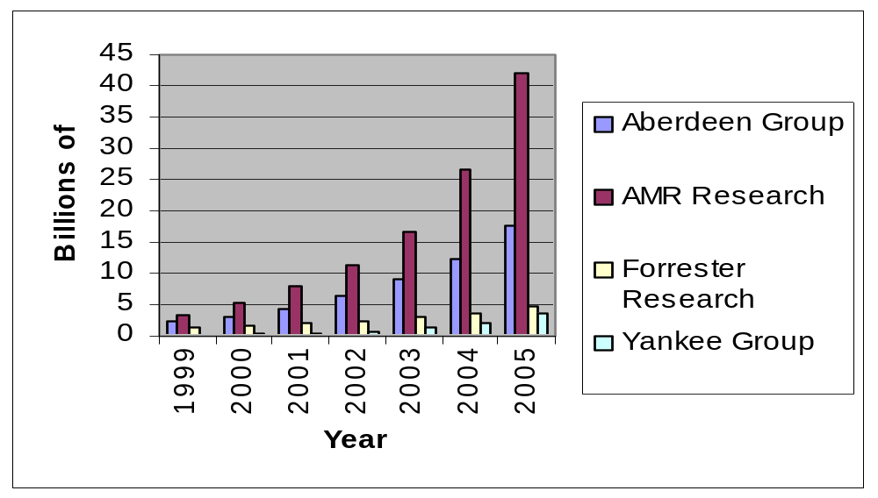

The AMR Research group values the market the highest, with a projected size of nearly $42 billion in 2005. The Yankee Group has the most conservative estimate with a valuation of $3.8 billion in 2005. [2] A recent report by the Hewson Group, a U.K.-based IT research and consultancy group, reported the CRM market in 2003 to be $8.8 billion. [11] Because each group takes different aspects of CRM into account in their market forecasts, there is no consensus on the size of the market but it is definitely in the billions of dollars. [2]

CRM Vendors—the “Big Guys”
Several of the dominant vendors kept popping up in research for this paper; according to AMR Research, the big vendors in CRM currently are Siebel Systems, PeopleSoft, Oracle, Nortel Networks (Clarify), SalesLogix, and E.piphany. [29]

HOW DOES CRM WORK?

Multi-Channel Principle
Understanding CRM might be more complex than it seems at first sight. To better understand, one can look at a bank as an example. Today, any bank customer willing to communicate with his/her bank has the opportunity to do so through a multitude of channels: phone, ATM, teller, personal banker, etc … (See Fig.1) [7]
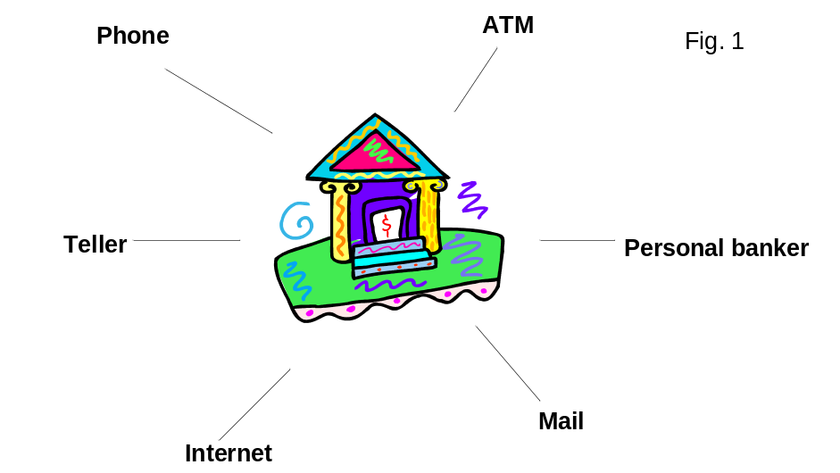

From an end user perspective, being able to use these channels is a given and should be as simple as it is effective. Now, suppose that the same bank, which has millions of customers generating billions of transactions each week, wants to build a unique image of each of its customers with the purpose of offering each of them the right financial services at the right time and the right place. How would CRM help them do that?

End to End CRM Infrastructure
Here is a hint. In CRM theory, each time a customer interacts with any of a company’s touch points, the information that is collected (quantitative, qualitative, and behavioral) is sent to the company’s systems databases (See Fig. 2).

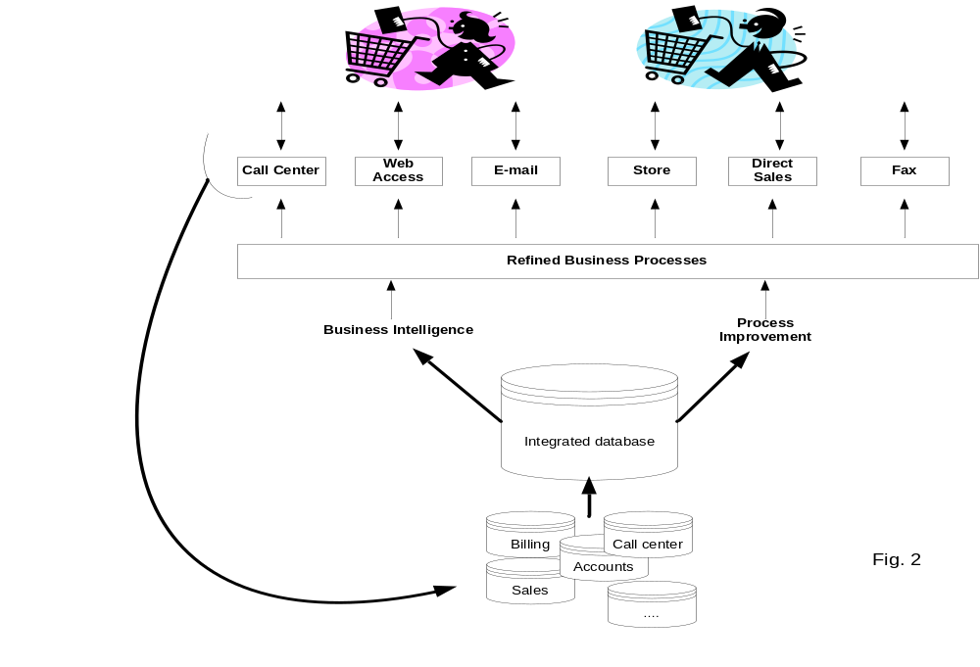

This information is then aggregated into a single CRM data warehouse where it is cleaned, analyzed, refined, and made ready for immediate or future one-to-one interaction with the customer. Amazon is a good example of CRM. When Amazon customers look for items on Amazon.com, they are systematically suggested additional offers based on their current choices. [7]

Scope of CRM
When implementing a CRM process, companies can go different avenues and implement different CRM modules. There are typically four families of CRM initiatives: Sales Force Automation (SFA), Marketing Automation (EMA), Call Center, and Analytics/Data mining. Implementing a single CRM module can be very complex and demanding; it is very uncommon to find companies that tackle more than one or two modules at the same time. [32]

Sales Automation
“Sales automation streamlines the sales process and helps salespeople and their supervisors manage both customers and the sales cycle through such applications as contact managers, opportunity or pipeline managers, configurations, and order entry.” [32] SFA is considered the “grand father” of CRM because most customer-orientated software initiatives start in the sales departments. SFA implementations range from simple contact management packages (such as Outlook) to more comprehensive solutions such as account management, opportunity management, etc …
Beyond leveraging sales teams’ efforts toward higher sales revenues and customer retention, SFA systems are praised for their synchronization capabilities that allow sales department employees to share real-time customer data wherever they are and regardless of the number of sales people inputting information in the systems. [32]

Marketing Automation:
“Marketing automation is a set of applications that help marketers manage and simplify the marketing process. Applications include campaign management; email marketing, database marketing and data marts, and marketing encyclopedias” [32]
Traditional marketing campaigns are sequential. Marketing departments prepare the campaign, launch it through the company’s communication channels, and wait for the end of the campaign to analyze the results and prepare the next campaign from the feedback collected from the previous campaign (See Fig. 3). [9]
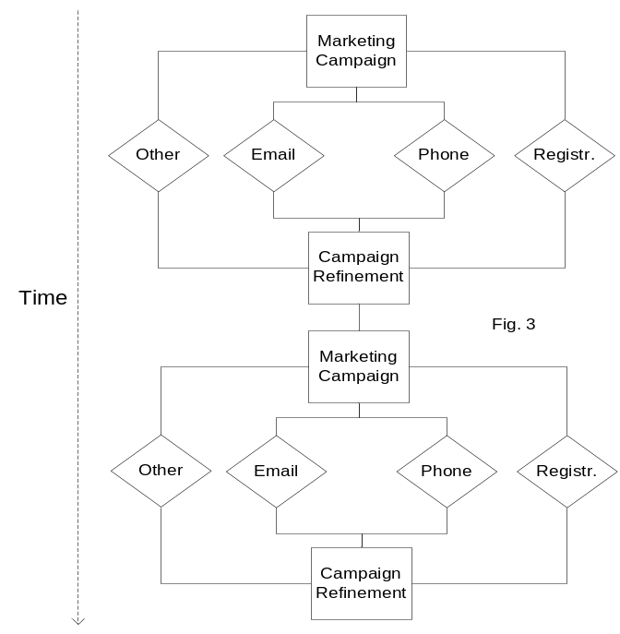

Marketing Automation (EMA) is meant to allow marketing departments to run more efficient campaigns. Instead of waiting for extensive periods of time before launching new campaigns (sometimes several months), EMA software tools allow a company to run permanent and “self feeding” marketing initiatives (See Fig. 4) [9]

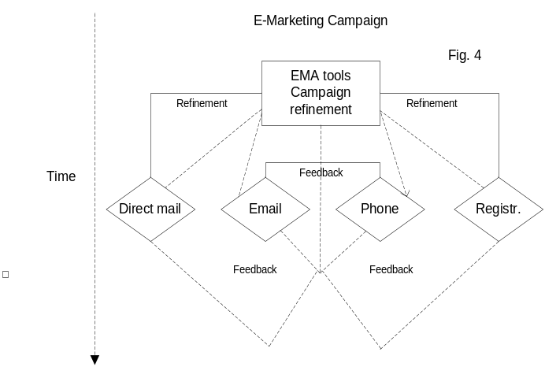

Rather than being stored for further analysis, customer feedback is immediately used to refine an ongoing campaign, making it both more effective and less resource consuming.

Calls Centers
“Call centers are the primary conduits between consumers and corporations. Customer Service is the primary business process for creating customer loyalty, promoting customer retention, and ultimately increasing customer value while reducing cost of sales.” [32]
Long gone is the time when customers only interacted face-to-face with a customer service representative. We are living in the 1-800 era. Call centers have three major purposes: to reduce costs by limiting (costly) human interaction, to provide consistent service levels, and to collect customer feedback on products and services. Most systems also come with agent scheduling and call volume forecast capabilities.

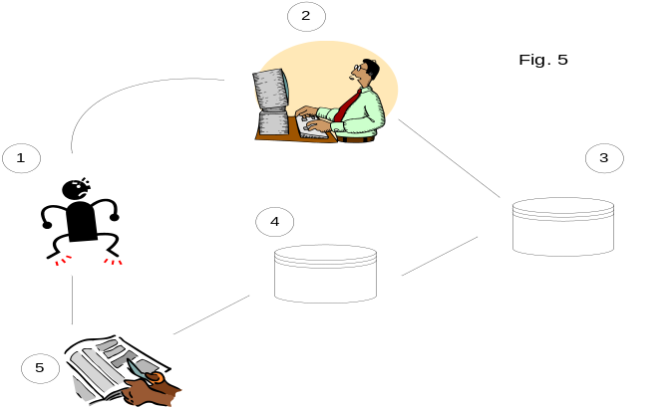Here is an example of how a typical Call Center works (See Fig. 5). [9]

Customer A calls to complain about a product or a service (1). The call center will first pull up this customer’s account from his phone number, name, or account number (2)-(3) or any other way. The system will then determine what the issue is and communicate with the central system to determine the best options to address the issue (4) based on the customer’s profile (at this point, the customer may or may not talk to a live person). In this example, customer A is finally offered a coupon towards a next purchase (5).

Analytics/Data Mining
“Analytics covers the process of extrapolating true business intelligence from disparate customer data sources in order to segment, analyze, and serve the consumer in the most efficient manner possible. Additionally, analytics is also getting predictive, empowering businesses to identify how a customer is likely to respond to different sales and marketing campaigns.” [32]
We are touching on here what is probably the most important challenge of a CRM program: how do we get a “single version of the customer truth?”. A CRM program could consist of the implementation of multiple modules. If these modules do not communicate with one another, they will provide only snapshots of customer information, leading to a CRM “stovepipes” situation (See Fig. 6). [9]
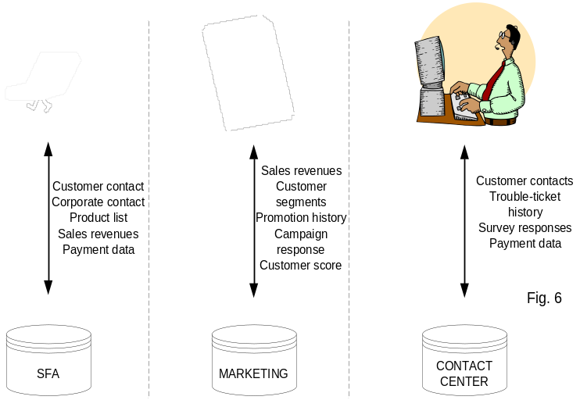

Motivating customers to come back and buy more requires us to know a lot about them: preferred products, consumption rates, lifestyle, life stage …This can best be achieved if the data collected from each of the modules is stored in a data warehouse for further data analysis (See Fig. 7). [7]

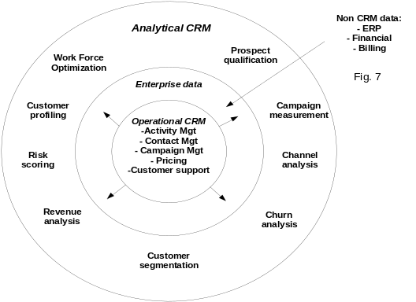

Implementation Rates
Gartner group has conducted a recent survey suggesting that approximately 42% of all CRM licenses purchased have not been installed yet. Even though these figures include companies on the way to implementation, trends show that a lot of CRM software sold end up on a shelf. Many companies have been attracted by discounts offered by CRM software vendors trying to get around the depressed economy. Unfortunately, the licensing cost is often the tip of the iceberg and businesses are investing millions of dollars in technology they can not use because they do not have enough financial and human resources to implement and maintain it. Consulting fees average five times the cost of the license, while maintenance usually reaches a quarter of the license cost per seat. Depending on their contract with the CRM provider, many might even have to pay maintenance fees even though they do not actually use the software. [25]

Success Rates
Five years ago, most CRM implementations ended up failing. Today, CRM technology buyers have become more careful about their investment and have adopted a more pragmatic approach when it comes to making CRM buying decisions. Companies now tend to set up reasonable goals and cherry-pick the applications that would be the best fit. Instead of jumping on the first attractively packaged solution, companies tend to spend more time on their existing processes and adopt small step approaches. This way, projects are easier to monitor and far less risky. Also, from a psychological perspective, little successful steps are sometimes necessary to obtain management-level buy-in and accountability for the success of a CRM project.
Companies that have recently implemented a CRM program start to get significant paybacks. IDC found that 60% of the participants to its latest survey said they saw a payback in less than a year, most of it coming from increased productivity (51%) and process enhancement (42%). [25]

WHAT YOU NEED TO KNOW:
CRM CRITICAL SUCCESS FACTORS

In order for CRM to be successful, a number of critical success factors (CSFs) should be given appropriate consideration. Although each industry and each company will have specific needs, these CSFs are general enough to be applied to most companies and will help to keep each company on track. Two helpful examples that explain the use of these CSFs are Harrah’s Entertainment, Inc. and Eddie Bauer, Inc. Harrah’s operates casinos and hotels around the country and started their Winners Information Network in the mid-90s in order to better understand each of their customers. Eddie Bauer is a retailer that sells apparel and accessories around the world. It used CRM to integrate customer information from their three channels: stores, catalog, and Internet site. [7]

Planning & Setting the Direction
In order to use CRM successfully, a company needs to have a CRM-focused vision. This means more than simply having one company department focus on CRM. It means having the company’s mission statement, strategies, goals, and expectations all focused on CRM. Harrah’s was ahead of its time by being CRM-focused before most people had even heard of CRM. [7] Although this vision is very important, it must include expectations that are realistic and specific. Otherwise, the company will not be able to attain its goals and CRM will not be effective. Part of these reasonable expectations includes a plausible timetable. [27]

Failure can arrive even with the best possible vision if there is no commitment from both management and the staff. When the CRM program is initially being discussed, one must explain why CRM is so important to the company and to the employees. [27] Management must understand how this program will help the company succeed and the staff must understand how CRM will make their lives easier and how it can help them do their jobs better. Harrah’s had trouble acquiring the commitment of its staff when the CRM program was first discussed. Harrah’s employees felt that the old way had worked well in the past and did not want to change. [7] This is not surprising or unique since people are creatures of habit and often stick to their routines even if something better comes along. It took time to convince these employees to change their ways. The company also needs to involve both management and staff in the planning process. If both parties are involved, then each can add their own valuable input to the CRM program. [8]

Failure can also drop by if enough resources are not committed to the CRM program. A company may have the right vision and the commitment it needs and still have trouble if there is a lack of funds. [27] The proper resources are needed in order for a CRM program to get off the ground and thrive. It is also important that the company makes sure that each employee’s individual goals match up with the organizational goals. [8] If this step is not taken, then employees may end up working against what the company wants.

Service & Communication Management
A major goal of CRM is to provide quality customer service, but in order to reach this goal, the company needs to provide quality support to the staff. This needed support may vary based on the industry, but one important way to provide this is through communication integration, which gives a full picture of each customer instead of a single piece. [27] Eddie Bauer accomplished this through their channel integration. Harrah’s was able to give the appropriate support to its customer service reps by giving them information on each customer. This information included which location that customer frequents, his or her favorite games and events, and which upcoming promotions that person might enjoy in the future. [7]

Technology Relationship Strategies
Although CRM does involve technology, this technology can not stand on its own. It must be integrated into the company’s business strategies. A helpful way to think about this idea is that the technology works for the strategy. Harrah’s followed this idea because the company realized that their relationship with each customer was the driving force in their success and they simply used technology to further enhance this relationship. [7] As important as technology is to CRM, it will be useless to the company if the employees do not know how to use it. This is why both initial and ongoing training is necessary to keep employees up-to-date on the changing technology. [27]

Personnel Development & Enterprise Management
One of the worst mistakes a company can make is to take its employees for granted. Employees need to be valued because they are the ones who make the difference to customers. [27] In Eddie Bauer’s case, the company needs to value the employees working in the stores since they are the ones that can interact with customers in the flesh. [7] A vital way to show employees that they are valued is to give each employee individual attention and set goals for each employee. These goals can help spread some healthy competition among employees, but this competition should not go so far as to get in the way of cooperation. Both competition and cooperation are needed to improve customer service. Part of valuing these employees is to know their limits as well. If the employees do not have all the necessary skills needed for the CRM program, it may be essential to hire expertise outside of the company. [15]

Information Protection
Just as a company wants to protect its vital strategies, it also needs to protect its customer information. [27] This information should be treated as an asset. The company obviously wants to protect this information from competitors, but internal protection is important as well. Rules and policies need to be in place in order to ensure that the information is not used in an inappropriate manner. Accountability should also be assigned and clear limits on the information are needed. Customer privacy is an important issue today so the information should be used only to provide better customer service.

Resource Investments & Application Strategies
In order to be successful with CRM, a company can not just buy a single software package, install it, and wait for success to occur. Instead, a full portfolio of technology investments is needed. [27] This portfolio will need to change with technology since it is not static. The portfolio is useful for refining customer information into customer knowledge. [8] This knowledge can be used as a sustainable competitive advantage for the company. This advantage is sustainable because CRM is not merely an IT project, it is a process. [27] An IT project has a beginning and an end, but a process has a beginning without an end. The process continues on and changes as needed. In order to help this process change, an ongoing evaluation should be used to keep track of CRM’s progress. Eddie Bauer understood this idea of CRM as a process and referred to their CRM program as a never-ending journey. [7] Throughout this journey, Eddie Bauer learns more and more about their customers.

Contribution
Part of valuing employees involves rewarding them for their work. [27] Since people may be under the mistaken impression that someone is getting rewarded simply because they are the boss’s favorite or for some other reason, it is important to explain to everyone the real reasons for rewards. A variety of reasons should be used. One reward could be for getting a job done in record time while another could be for the high quality of work. A variety of rewards should be used as well. Instead of just using cash, intrinsic rewards should be used. For example, an employee might get an award and a pat on the back. If employees are rewarded appropriately, they are more likely to go the extra mile when dealing with a customer. [8]

Implementation
No matter how great a CRM plan is, a company can run into snags if enough time and resources are not set aside for implementation. If implementation is not given the appropriate attention, then all the work and money given to the planning process may have been for nothing. [27] It is also important that implementation occurs in small steps, instead of all at once. [15] Eddie Bauer made the mistake of implementing in one step and had problems with their CRM system initially. Fortunately, Eddie Bauer learned from this mistake and was able to make their CRM system work with time. [7] Although the company should do its best to plan the necessary steps for implementation, there will almost certainly be problems and issues that can not be planned for. With this in mind, flexibility is needed in order to make any changes to the CRM system. [7] Without such flexibility, the company will not be able to react to any changes in the industry or to moves from competitors.

Customer Focus
For CRM to be successful, the strategies of each company need to focus on the end-customer relationship. Although most companies focus on selling what they already make or offer, a company that is focused on the end-customer should focus on selling what the customer wants. [27] Harrah’s did an excellent job of this by using its customer information to figure out what services its customers wanted and that they were not yet offering. [7] Part of this customer focus includes measuring customer attitudes as the CRM system is implemented in order to determine if the program is improving customer information. [8] It is also important to keep tabs on what competitors are doing with CRM. Whether these competitors are ahead of the company or behind it in terms of CRM, it is still important to know what they are doing. In Harrah’s case, the company needs to keep track of other casinos and hotels around the country to make sure they are keeping up-to-date on their CRM system. [7]

CRM Best Practices

- High Level of Communication: Communication throughout the organization is essential. Integration of this communication is needed for CRM success. [27]

- Management Support: The support of all involved in the CRM process is important, but management support is a high priority. [27]

- Strategy Drives Technology: The technology works for the strategy, and not the other way around. [27]

- Implement Incrementally: Implementing all at once greatly reduces the chances of success. Implementing in small steps, on the other hand, is more likely to lead to CRM success. [15]

- Hire Outside Experts if Necessary: There is nothing wrong with recognizing the limits of one’s own staff. If expertise is needed and it does not exist within the company, look outward. [15]

- Involve Knowledgeable Users: Those that will be using the CRM system should be involved in the planning process. Excluding these employees would only be a waste of their valuable input. [27]

- Customer-Oriented Focus: Without focusing on the customer, a CRM program will do little for the company except cost time and money. [27]

A CLOSER LOOK AT CRM IN A CALL CENTER ENVIRONMENT: NEXSTAR FINANCIAL CORPORATION

An experienced mortgage management team and the investment firm Kohlberg Kravis Roberts and Co. founded Nexstar Financial Corporation in 1999. The strategic vision of Nexstar was to completely redefine the mortgage loan process (i.e. application, underwriting, closing, loan servicing set-up) by more quickly and accurately delivering the service to its clients and the customers of those clients. The streamlining of this complex process would be enabled mostly by their highly capable and highly customized web-based system, which was created by Eotek, a fully owned subsidiary of Nexstar.

The Business Case for CRM
Similar to traditional mortgage companies, Nexstar does operate as a direct lender. However, this is not the strategic focus of the company. Nexstar’s direct business was primarily demand-driven. On the other hand, the strategic positioning of the company is that of a mortgage processing outsourcer. With over 90% of its business coming from the BPO line, Nexstar has developed a diversified portfolio of clients, from large national lenders, such as Washington Mutual, to smaller credit unions and community banks. This business model has allowed them to flatten the volatility of demand associated with the mortgage industry. As mortgage rates increase, demand slows and traditional mortgage companies are forced to downsize. As part of the downsizing, many companies look to outsource their mortgage operations to BPOs, such as Nexstar, as a cost saving measure. This difference in market positioning among traditional companies and Nexstar is directly correlated to their varying use of CRM.

At this time, traditional mortgages companies are less focused on CRM initiatives because the market is so volatile, thus making large-scale IT projects unattractive. Most use standardized software or ASPs that only enable them to provide a minimal amount of customer service and customer convenience. While traditional companies may be less focused on improving customer service, Nexstar’s business model necessitates the use of a more enabling CRM project. Poor customer service may cause a traditional company to lose that customer for life. However, if Nexstar provides inferior customer service, they could potentially lose an entire client. Plus, why would potential clients outsource their business to Nexstar if they can perform the same level of customer service in house? Therefore, their absolute dependence on extremely high customer service levels drove Nexstar to implement a customized CRM system in their call center.

Choosing a Successful CRM System
As a startup company, Nexstar had the advantage of researching various possible initiatives without causing interruptions to its current operations or having to replace or coordinate with legacy systems. Management realized that a competitive technology was essential to its strategic success. Therefore, management was extremely supportive of this endeavor. As Nexstar’s senior management and Eotek’s management began researching possible vendors, their main focus was not to establish a large scale CRM system. They were looking at technologies that would allow them to simultaneously deliver superior workflow management and optimal levels of customer service, while also offering easy integration with its new web-based technology framework developed by Eotek. Nexstar’s business process manager further describes this philosophy and the beneficial integration of the company’s technology today:

“In reality, Nexstar’s business process and technology were (intended to be) used solely to bolster customer service levels and workflow management…not deliver CRM. Although not the intended purpose, (currently) all of Nexstar’s software combined can be considered a superior CRM tool…at least compared to other industry competitors.”
-Christopher Hunter, Business Process Manager, Nexstar Financial Corporation [14]

After months of collaboration between the management teams, the choice was narrowed between two established CRM vendors: Siebel Systems and PeopleSoft CRM. They currently used PeopleSoft in its HR department, so there were some internal constituents very interested in PeopleSoft CRM. However, compared to Siebel Systems, PeopleSoft CRM fell short in many areas. First of all, Siebel offered various customizations to their software that PeopleSoft could not. Siebel had a call center vertical that was specifically designed to call centers. Additionally, Siebel had developed various strategic alliances with other vendors in various industries. For example, for those who chose Siebel Call Center, Siebel could employ one of their global alliance partners, Avaya, to integrate its computerized telephone system with the rollout of Siebel. Along with its superior vendor service levels and experienced implementation teams, the possibility of customized product and benefit of multiple strategic alliances made Siebel the obvious choice over PeopleSoft CRM. Simply put, Siebel was closely aligned with Nexstar’s strategic focus of providing superior customer service and a streamlined workflow; PeopleSoft CRM was not. Management saw three distinct benefits that Siebel offered them [33]:

- Increase call center workflow via call and email routing

- Allow customer communication and interactions with various media (email, fax, phone)

- Improve customer service by combining customer information in one user interface

Siebel/Avaya Transforms the Business
The choice of Siebel created great anticipation and optimism at Nexstar. The Vice President of Customer Experience affirms this mindset:

“When we looked at the Siebel-Avaya partnership, it was clear that this was far more than just a marketing agreement; it was a tight, strategic alliance with truly integrated offerings. As we designed our infrastructure, we knew that we could count on the durability of this high-level collaboration.”
-Richard Harkwell, VP of Customer Experience, Nexstar Financial Corporation

After the due diligence and negotiation periods were completed, the implementation process for Siebel Call Center and Siebel eFinance was ready to begin. This is often the most difficult process for a CRM project, and it can effectively squash any feelings of optimism within a corporation if not done correctly. Three parties conducted the implementation: Siebel Global Services, Avaya Professional Services, and Eotek. Fortunately for Nexstar, the implementation process was generally painless and very quick. This was primarily due to the fact that Siebel and Avaya had worked together extensively prior to this rollout. Also Eotek and the Siebel/Avaya team were able to successfully integrate the Siebel software so that the current Nexstar web-based system, CCRWeb, could be accessed directly from the Siebel Activities and Documents page (See Fig 8) [31]. The entire rollout took 90 days and was fully deployed to approximately 75 agents [33]. A third party consulting firm was also employed at the end of implementation to ensure that all functionalities were delivered. While this is generally a good idea for IT projects of any kind, in this particular instance, the feedback was not insightful, nor different from issues that Eotek had already addressed.

Figure 8 Siebel and CCR Web Implemented
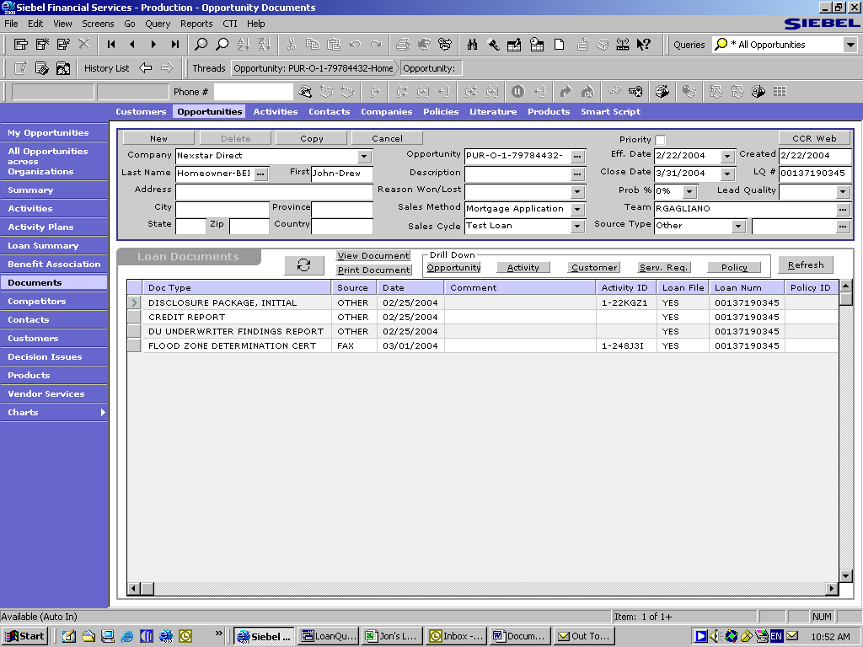

Nexstar Financial and Siebel: A CRM Success Story?
It is clear that the Siebel relationship with Nexstar was a very good strategic fit. All of the proposed benefits were delivered: increased call center workflow, greater customer communication and interactions, and improved customer service levels. In fact, in a discussion with Christopher Hunter, Nexstar’s Business Process Manager, he stated that customer service levels are currently much higher than the industry average. Again, this is very important to their business model since clients would be less inclined to outsource with Nexstar if the service is currently at the same level as the rest of the industry. According to Mr. Hunter, the market’s customer service satisfaction score (represented as a % of customers willing to do repeat business) is around 85%. Nexstar’s score for the month of February 2004 was 95.5%. As you can see, Siebel has been a large factor in strengthening Nexstar’s position in the industry. [14] Outside of customer service levels, Nexstar’s VP of Customer Experience affirms Siebel’s role as a strong workflow management tool [33]:

“The Siebel-Avaya Solution also enables Nexstar to streamline the process of responding to customer inquiries…Avaya and Siebel work in tandem to identify callers by ID number, draw their customer records from the Siebel database, and then route calls automatically to the most appropriate agent based on overall agent availability and skill level.”
Richard Harkwell, VP of Customer Experience, Nexstar Financial Corporation

While we have established the fact that Siebel was a strong strategic fit for Nexstar, in terms of an overall CRM project, how does this relationship rate? Compared to others in the industry, Nexstar scores fairly well on the implementation of a CRM initiative. However, when using our Best Practices Scorecard, the results are somewhat mixed.

Successful Implementation Practices

- High Level of Communication: As a startup company, Nexstar had an advantage of researching this project before the company was operating. Therefore, it had sufficient amount of time to research possible vendors, develop detailed contracts, and plan the implementation of the project. Also, in choosing Siebel, they were working with a vendor that had perfected the implementation process with its own implementation team, Siebel Global Services. Their implementation team along with Nexstar’s Eotek team was able to take a great deal of time planning the integration of Siebel with Nexstar’s current infrastructure. In general, all parties had a very open line of communication so issues could be easily resolved and the rollout could be effectively planned.

- Management Support: Knowing that the business was positioned as an industry leader due to its enabling web-based technology, management knew that highly customizable CRM software was the only alternative. Once Siebel was chosen over PeopleSoft CRM, management was fully dedicated to make it a chief component of their top-of-the-line system. However, for future CRM and IT initiatives, management is currently not very supportive as they are in a cost-cutting mindset.

- Strategy Drives Technology: This is a definite yes. Nexstar needed a highly customized product to supplement their strategic positioning. They found it in Siebel Systems.

- Hire Outside Experts if Necessary: In the onset of the project, Nexstar employed Eotek as a consultant; soon after they decided to buy the technology company. Eotek helped to rollout Siebel and to ensure its integration with Nexstar’s web-based technology, CCRWeb. They also used another third party consultant to evaluate the implementation. While this didn’t provide them with many valuable insights, they did take the necessary steps to make sure all their bases were covered.

- Customer Oriented Focus: Nexstar’s business model necessitates the presence of a streamlined workflow and an extremely high level of customer service to be successful. Therefore, Nexstar must be focused on the customer to outperform the market, and thus become a viable alternative for companies looking to outsource. Siebel enables them to become more focused on the demands and needs of its customers.

Failed Implementation Practices

- Implement Incrementally: One implementation method that Nexstar did not employ was implementing incrementally. This was mostly likely due to the fact that this type of rollout was fairly small (only about 75 agents) and that Siebel’s implementation teams had perfected such installations. While Siebel’s implementation experienced very little problems and was an overall success, Nexstar has been a victim of not implementing incrementally with other IT projects and has paid dearly for them. This is one area of improvement that is needed for the company.

- Involve Knowledgeable Users: This failed practice was similar to implementing incrementally in that Nexstar was quite lucky with the Siebel implementation, but has been victimized by this failure in other IT initiatives. The most likely explanation for not seeking users’ input was the fact that Nexstar had not begun operations yet; the users were not familiar with the Nexstar system yet. They still need much training, and therefore might not be a valuable resource for assisting in Siebel’s implementation.

The Future of CRM at Nexstar
Currently, Nexstar’s management is not supportive of any large IT project. This is primarily due to the fact that they are in a cost cutting mode following some recent market volatility and that, as a relatively new entrant in the market, they are still trying to establish their position in the market. However, upon discussions with Christopher Hunter, Business Process Manager at Nexstar, he assured me that Nexstar is beginning to look more closely at additional CRM projects. Although the nature of the negotiations could not be released, he stated that Nexstar was having discussions with a potential client about expanding CRM initiatives. Most of the talk has been centered around an “offspring of CRM”: Partner Relationship Management (PRM). It is safe to say that Nexstar will continue to evolve is CRM capabilities. However, the timeframe of these steps forward is anyone’s guess.

CONCLUSION

CRM is a growing part of IT that, if undertaken and implemented correctly, can aid companies in becoming more customer-focused. A company interested in adopting a CRM strategy is wise to utilize the seven best practices shown in this paper; namely to have:
▪ a high level of communication
▪ management support
▪ strategy drive technology
▪ incremental implementation
▪ outside experts hired if necessary
▪ knowledgeable users involved
▪ a customer-oriented focus

Successfully implementing CRM can lead to reduced costs and, for some companies like Nexstar, to a competitive advantage. CRM is not a panacea that will cure a company’s ills and must be planned and implemented correctly to be effective.

REFERENCES

1. Abbott, J., Stone, M., Buttle, F., “Customer Relationship Management in Practice- A Qualitative Study” Journal of Database Management, Vol 9, 1, 2001, pp. 24-35.

2. Byun, J. and Gray, P., “Customer Relationship Management” from http://crm.ittoolbox.com/documents/document.asp?i=2629 , viewed 3/11/04.

3. Cambell, A., “Creating Customer Knowledge Competence: Managing Customer Relationship Management Programs Strategically” Industrial Marketing Management, 32, 2003, pp. 375-383.

4. Croteau, A, Li, P., “Critical Success Factors of CRM Technological Initiatives” Canadian Journal of Administrative Sciences, Vol 20, 1, 2003, pp. 21-35.

5. Day, G., “Creating a Superior Customer-Relating Capability” MIT Sloan Management Review, Spring 2003, pp. 77-82.

6. Dubie, D., “IT spending on security, CRM to rise in 2004” Network World. Framingham: Jan 19, 2004, Vol. 21, Iss. 3; pg. 12

7. Dyche, J., The CRM Guide to Customer Relationship Management, Addison-
Wesley, Boston, 2002.

8. Gordon, I., “Best Practices: Customer Relationship Management” Ivey Business
Journal Online, 2002, pp. 1-6.

9. Greenberg, P., CRM at the speed of light, Mc Graw-Hill, California 2001

10. Hansotia, B., “Gearing up for CRM: Antecedents to Successful Implementation” Journal of Database Marketing & Customer Strategy Management, Vol. 10, 2, 2002, pp. 121-132.

11. http://www.crm2day.com/library/EpZZEEuEluLDzGsHRc.php , viewed
4/10/04.

12. Howlett, D., and Rodgers, K., “What is CRM?” from http://www.destinationcrm.com/articles/default.asp?ArticleID=3293 , viewed 3/11/04.

13. Christopher Hunter, Business Process Manager of Nexstar Financial Corporation, interviewed in person by Jon Stegen, April 12, 2004.

14. Kim, Jonghyeok, S., Suh, E., and Hwang, H., “A Model for Evaluating the Effectiveness of CRM Using the Balanced Scorecard” Journal of Interactive Marketing,Vol. 17, 2, 2003, pp. 5-19.

15. Lacity, M., "Management of IT Projects," slides posted on www.umsl.edu/~lacity/read480.htm viewed on 02/12/04.

16. McKim, B., “The Differences Between CRM and Database Marketing” Journal of Database Marketing, 9, 4, July 2002, pp. 371-375.

17. Nairn, A., “CRM: Helpful or Full of Hype?” Journal of Database Marketing, 9, 4, 2002, pp. 376-382.

18. Nancarrow, C., Rees, S., and Stone, M., “New Directions in Customer Research and the Issue of Ownership: A Marketing Research Viewpoint” Journal of Database Marketing & Customer Strategy Management, Vol. 11, 1, 2003, pp. 26-39.

19. Pang, L., and Norris, R., “Applying Customer Relationship Management (CRM) to Government” The Journal of Government Financial Management, Vol. 51, 1, 2002, pp. 40-45.

20. Petersen, Glen S. “Best Practices and Customer Relationship Management (CRM)”Business Credit, New York: Jan 2004, Vol. 106, Iss. 1; pg. 48.

21. Pula, E., Stone, M., and Foss, B., “Customer Data Management in Practice: An Insurance Case Study” Journal of Database Marketing & Customer Strategy Management, Vol. 10, 4, 2003, pp. 327-341.

22. Read B., “The outsourcing alternative” Call Center Magazine, San Francisco: Nov 2001, Vol. 14, Iss. 11; pg. VIII, 4 pgs.

23. Rich, R. Data Quality: CRM’s weak link. Norwalk: Mar 2004, Vol. 22, Iss. 9; pg. 36, 2 pgs.

24. Schmerken, I., “In search of the CRM payoff”. Bank Systems & Technology. New York: Aug 2003. Vol. 40, Iss. 8; pg. 33.

25. Schneider, M., “Is CRM getting better, or are companies learning from past mistakes.” Customer Relationship Management, Medford, Apr 2004, Vol. 8, lss. 4; pg. 13, 1 pgs

26. Schneider, M., “Financial Services Firms Learn to Value Relationships, Not Transactions”. Customer Relationship Management, Medford: Feb 2004, Vol. 8, Iss. 2; pg. 18, 2 pgs

27. Swift, R., Accelerating Customer Relationships: Using CRM and Relationship
Technologies, Prentice Hall PTR, Upper Saddle River, 2001.

28. Verhoef, P., “Understanding the Effect of Customer Relationship Management Efforts on Customer Retention and Customer Share Development” Journal of Marketing, Vol. 67, October 2003, pp. 30-45.

29. “What is CRM?” from http://crm.ittoolbox.com/browse.asp?c=CRMPeerPublishing&r=http%3A%2F%2Fwww%2Eittoolbox%2Ecom%2Fhelp%2Fcrmoverview%2Easp , viewed 3/17/04.

30. “What is CRM?” from www.destinationcrm.com/articles/default.asp?ArticleID=1747 , viewed 3/11/04.

31. www1.nexstar.com/servlet/nexstar.AboutOrigins, viewed 3/1/04.

32. www.destinationcrm.com viewed 3/3/04

33. www.siebel.com/resource_library/search_result.shtm?type=Case%20Study, viewed 3/5/04

34. Anonymous. “Is CRM Worth It?” InfoWorld. San Mateo: Feb 16, 2004, Vol. 26, Iss. 7; pg. 17, 1 pgs.

