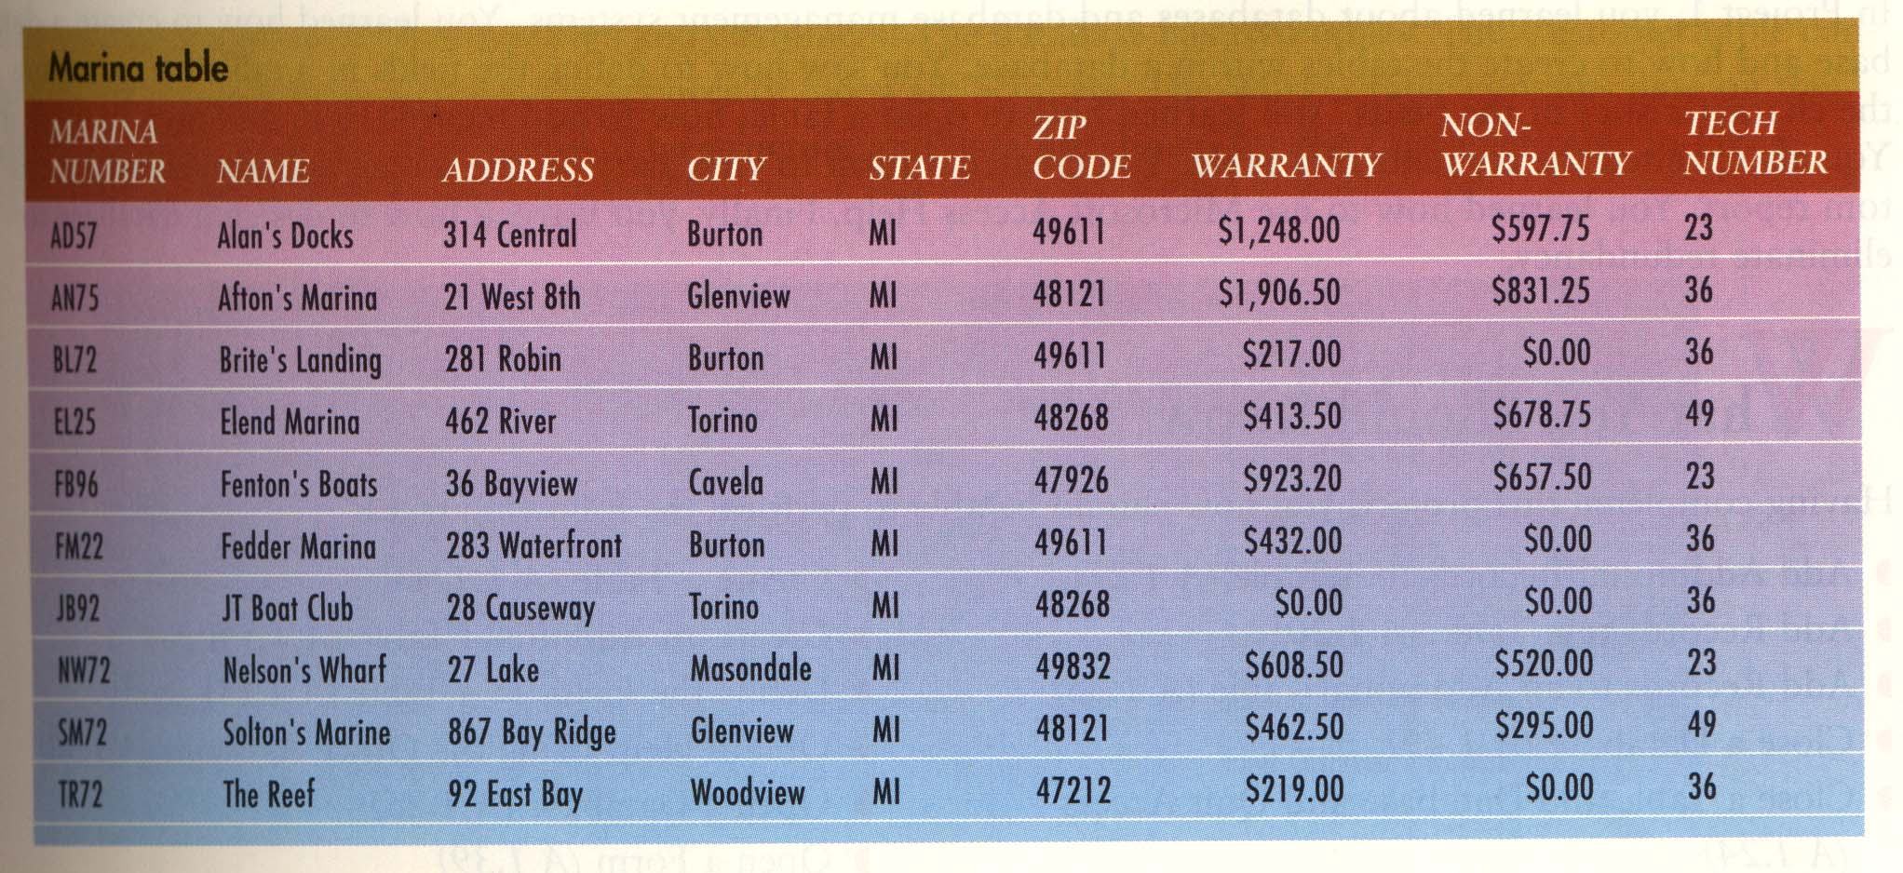

Fig 1-73

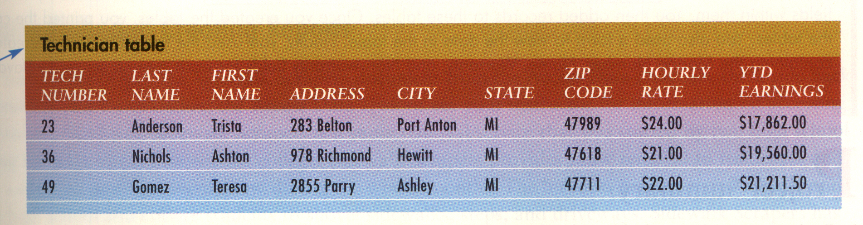

Fig A 1.53

Project 1
- Create a Table with the following fields:
- Marina Number
- Name
- City
- Warranty
- Non-warranty
- Tech Number
Fill in the Table with the records as shown in Fig 1-73.
Save the table as Marina
Print the screen.

- Create another Table with the following fields:
- Tech Number
- Last Name
- First Name
- City
Fill up to table as per records in Technician Table on page A 1.53.
Print the screen

- Print a Billing Summary Report of the above table in Corporate Style with only the following Fields appearing in the report:
- Marina Number
- Name
- City

- Create a Query from the Marina Table, which includes fields Marina Number, Name, and Tech Number. Run the Query . Print the result of the Query.

- Join Tables Marina Table and the Technician table with a query that have the same value in Tech Number fields. Print the result of the query.

- Perform a Query to produce a sorted list of the cities in the Marina table in such a way that each city is listed only once. Print the result of the Query.

- Perform a Query that searches for a Marina whose number is JB92. Print the result of the Query.

- Add a new field called Marina Type in the existing Marina Table. Print the Marina table after adding the new field.

- Sort Marina Table to order the records by marina name using the Sort Ascending button. Print the sorted table. Now sort the data in reverse order, i.e. sort by descending order.

- Display the Relational Schema view and print it.

