Optometry Staff Approver Guidelines for Payroll Efficiency and Accuracy
REVISED 4/27/10
Members of the Optometry payroll team attended a recent in-service by UM System fiscal administrators regarding reconciliation and procedures in the new Time & Labor system. Three screens from the presentation appear immediately below this paragraph. These three graphics itemize the objectives, activities and duties that are required by the UM System for all Approvers (supervisors) of both staff and student employees. Following this System information, we have also provided a summary of internal College of Optometry payroll policies and procedures designed to assist both Approvers and the payroll team in remaining consistently in compliance with the standards set by the System. Please read carefully & touch base with any member of the payroll team if questions should arise. Please share with your supervisees as appropriate.

UM SYSTEM RECAP OF APPROVER ROLES & RESPONSIBILITIES:

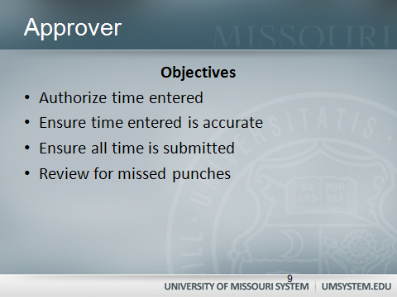

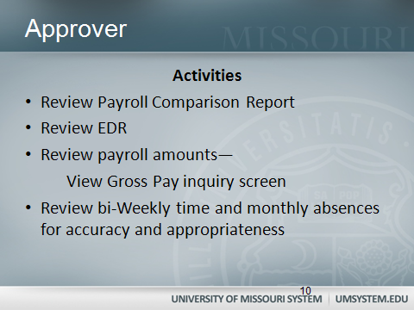

SUMMARY BY ROLES: Time Keeper, Approver, Verification/Reconciliation, Managerial Review

APPROVER RESPONSIBILITIES & TIMETABLE:
- Throughout the pay period: Approvers ensure that all time is entered and submitted accurately by the employee, preferably on a daily basis, and approve all accurately submitted time in timely fashion during the course of the pay period.

- Tuesday afternoons the week immediately after “Payroll Friday”: Review “View Gross Pay” inquiry screen on these Tuesday afternoons or on Wednesday morning before noon, and notify a Payroll member immediately if there are any variations in pay between the current and previous pay period. (See navigation instructions below.)
If variations do occur, a “Payroll Comparison Report” will be generated by Payroll and brought to the Approver for signature and a brief explanation of the variation (e.g., student did not work last week; no labs during week 1 of pay period; etc.).

COLLEGE OF OPTOMETRY INTERNAL PAYROLL POLICIES AND PROCEDURES:

These internal policies and procedures were developed to enable both Approvers and payroll staff to adequately address the System requirements outlined above. Internal policies may change as additional months utilizing Time and Labor provides additional experience to all of us.
MATERIALS TO BE PRINTED & SUBMITTED by 3:00 p.m. on “Payroll Friday” afternoons:
  - the Timesheet screen for each staff supervisee: see printing instructions at http://www.umsl.edu/services/hrs/pdfs/printing_timesheet.pdf *
  - the Payable Time Details screen for each employee for the two-week pay period Remember to set the appropriate dates to get the appropriate time frame!
  - Form 60s (staff only): Supervisors should maintain a file for Form 60s to verify timesheet accuracies and as backup verification for supervisory approvals each pay period. Copies should continue to be submitted to Payroll for auditing purposes. FAXED copies should be obtained from off-sites and should serve as place-holders until the original with signature can be submitted.

- Additional support materials to be maintained by Supervisors: Supervisors may wish to consider utilizing the Comments section on the employee timesheet to document leave requests or other supervisory attendance notations. Employees would need to be reminded to check for supervisory comments, and their submission of the timesheet with supervisor’s comments would certify their concurrence. (Employees can also enter comments to respond/embellish as necessary.)
Each supervisor should also be able to describe and document a system used to verify that they have personal knowledge and adequate means to validate their supervisees’ schedules and timeliness as recorded on timesheets. This may include personal observation, periodic phone calls, e-mails, or requests for regular “check-ins” by phone or e-mail, all of which should be applied consistently within each respective supervisor’s work group. Supervisors may choose to check starting times, ending times, and lunch break times on a random basis for each employee, 2-3 times per pay period, and record observations either on a calendar or in the Comments section in Time and Labor.
Avoid common T&L pitfalls:
Daily tasks:
- Students/Staff: enter time worked on a daily basis; Form 60 (staff only) should match timesheet! [Staff may keep bottom copy of the Form 60 to use as they enter to prevent copy errors.]
- Approvers/Supervisors: review each timesheet by going to the Report Time screens; then approve daily if possible on the Approve Time & Exceptions in order to be able to give timely feedback to staff if questions/inconsistencies occur.
End of week and end of pay period CHECKLIST (Approvers for Staff only):
Four documents must match one another: the timesheet, scheduled hours [unless changes approved by the supervisor], Form 60s and supervisory notes verifying deviations from normal schedule.
- Check Total Reported Hours on timesheet. If decimals appear, check Payable Time Details to verify that T&L has rounded appropriately. If the Payable Time Detail screen does not show that total hours reported have rounded to match the number of scheduled hours, see note re: rounding below and correct timesheets as needed. See a Payroll member for assistance if needed!

- Double check for rounding when (Sick/Vacation/Personal Time, etc.) appears on a timesheet! Use only 1 decimal place to report partial hours of sick, vacation or personal time used on a given day. Time worked will be rounded up to nearest single digit by the system; paid time off should be rounded down to one decimal. The system’s rounding will NOT appear on the timesheets---the rounding must be anticipated. Then check Payable Time Details to verify how the system rounds each entry. Example: Employee leaves 15 minutes early on a day scheduled for 8 hours. 7.75 hours worked will appear (automatically) on the timesheet and will later be rounded to 7.8 by the system on the Payable Time Details screen. Therefore the remaining quarter hour (.25) to be taken as Vacation time (entered manually) should be rounded down and entered as .2.

STAFF PAYROLL MATERIALS ARE DUE on the last pay Friday of the pay period by 3:00 p.m. Payroll team members will need direct contact information for supervisors beginning Friday afternoon and through the morning on Monday to request corrections/clarifications in timeliest fashion.
COMPLETED STUDENT PAYROLL MATERIALS should also be submitted Friday if at all possible. If students work on weekends, materials may be submitted early Monday morning. Remind students that hours MUST be submitted by midnight Saturday; otherwise the supervisor will be responsible for submitting on Sunday or early Monday morning.

Site/Navigation Guide for Approvers:
https://hrprd.umsystem.edu/psp/prd/?cmd=login
To review timesheets: select Manager Self-Service> Time Management > Report Time > Timesheet. Set the calendar: Set the date for the last day of the current pay period (always a Saturday). Click Get Employees and select your student to review your supervisee’s timesheet for accuracy.
To approve time: select Manager Self-Service> Time Management> Approve Time and Exceptions > Payable Time. Set the calendar: always leave beginning date blank; enter last day of pay period as end date. Click Get Employees and then double click on the employee whose time you wish to approve so that you can view the hours submitted. Click to approve.
Payable Time Details: Manager Self-Service> Time Management>View Time> Payable Time Details Click Get Employees, select employee, set dates for current pay period.
View Gross Pay: select Manager Self-Service> Time Management> Approve Time and Exceptions. The View Gross Pay link is in the same group as Approve Time/Approve Payable Time. Enter the EMPL ID of your supervisee (found from the list of employees in the Payable Time approval list; highlight the number w/ mouse & copy). Click View Gross Pay in the left navigation panel. Paste in the EMPL ID in the appropriate data field. Click Search. Click on “Pay End Date” to re-order the data in that column so that the most recent pay period appears at the top (you may have to click the column title more than once. Check to verify that the two most recent pay periods are identical or within a few cents. Notify a Payroll member immediately if there is a discrepancy. Obviously, all payroll information is confidential; your employees’ information should be protected as you would your own.

*Printing note: In order to print the entire timesheet & other screens above without cutting off important details, go to File, select Print Preview, change middle drop down from “As laid out on screen” to “Only the selected frame”, and hit the print button in upper left corner, which will take you to the then the usual Print box.

