
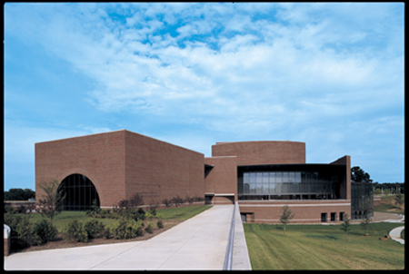

TECHNICAL SPECIFICATIONS
Updated 7/30/04

The Blanche M. Touhill Performing Arts Center at the University of Missouri – St. Louis was opened in September of 2003 to serve the artistic and cultural development of St. Louis City, St. Louis County, and the campus of the University of Missouri – St. Louis. The Center houses two performance spaces, the 1600-seat Anheuser-Busch Performance Hall and the 360-seat flexible Desmond and Mary Ann Lee Theater. The building also provides magnificent lobby spaces for events and receptions. Support areas include fifteen dressing rooms, a wardrobe room, a wig space, performer lounges, and a rehearsal hall/dance studio. The Center is primarily utilized as a rental and presenting roadhouse but supports numerous academic events through out the year as well.

LOCATION & DIRECTIONS

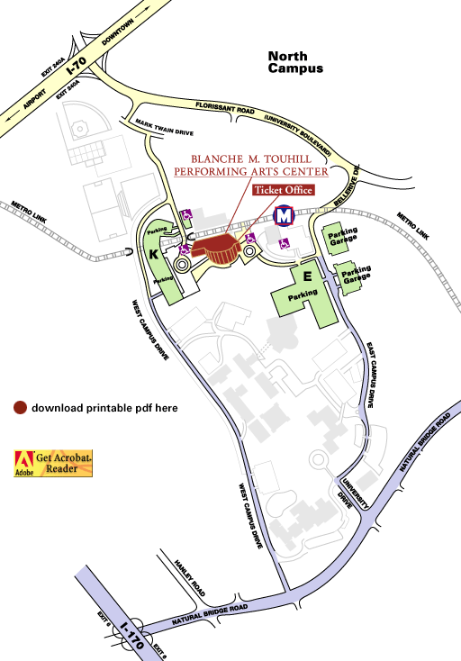
The Touhill Performing Arts Center is located just off I-70 in northern metro St. Louis on the North Campus of the University of Missouri – St. Louis. Take the Florissant Road / University Boulevard exit (#240) and turn south. Turn right at the first stoplight past the highway interchange and then a left at the bottom of the hill. The entrance to the University will be immediately on the right. Follow this road to the first stop sign and turn left to proceed to the main loading dock and Anheuser-Busch stage door.

In order to access the west lobby entrance, Lee Stage (loading) Door, or the Metro stage door, go through the four-way stop and proceed up the hill. The Lee and Metro stage doors can be found to the left of the large curved window, the lobby may be accessed by following the sidewalk around to the right of the window. Public parking can be found in Lot K to the right as you come up the hill.

The administrative offices and ticketing offices are located at the east lobby entrance. This entrance may be accessed off of Florissant Road / University Boulevard by turning right on Bellerive and then taking the next right once on campus.

HOW TO CONTACT US

Main PAC Phone Number 314-516-4100
FAX Number 314-516-4110
Mailing Address University of Missouri – St. Louis
Touhill Performing Arts Center
One University Boulevard
St. Louis, MO 63121-4400

World Wide Web General: www.touhill.org
Technical: www.umsl.edu/~cattanaj

Technical Staff Management
John Cattanach, Director of Stage Services 314-516-4921 cattanachj@umsl.edu
Jason Stahr, Asst. Director of Stage Services 314-516-4934 stahrj@umsl.edu
Lisa Drewel, Technical Management Assistant 314-516-4935
Valerie Thompson, Stage Supervisor 314-516-4935
Maire Steinbach, Stage Supervisor 314-516-4935

Lighting / Electrics
Paul Summers, Lighting Supervisor 314-516-4932 summersp@umsl.edu
Matt Manwarring, Asst. Master Electrician

Audio / Video
James Campbell, Audio / Video Supervisor 314-516-4932 campbelljc@umsl.edu
Pat Murphy, Audio Assistant

Staging / Carpentry / Rigging
Michael Heinicke, Staging Supervisor 314-516-4932 heinickem@umsl.edu
Kenny Moore, Staging Assistant
Terry Nelson, Staging Assistant

LABOR WORK RULES
All stage equipment will be operated by Touhill stagehands unless express permission is given otherwise by the Stage Supervisor. A limited number of production management staff is permitted to come in with an event. Most events will use the Touhill house stagehands, however we do contract with the local stagehands’ union under certain conditions. Basic work rules for both house and union hands are listed below with differences noted.
- Initial calls will be for 4 hours. Any return to work after a break of longer than one hour in a given day, will be considered a callback and subject to a two-hour minimum (4 hours for union).
- A paid 15-minute rest break should be given to each crewmember between 2 and 2.5 hours from the beginning of a call or continuation from a meal break. If a break is not given, then a penalty of 30 minutes will be incurred per each stagehand denied a break.
- A meal break must be given after no more than 5 hours. The meal break may be for one unpaid hour or 30-minutes paid. In either case, the stagehand must to be allowed to leave the event and/or building if necessary. If a meal break is not called after 5 hours, then a meal penalty of double time per stagehand will be in effect until a meal break is given.
- During a performance run or full dress run, rest breaks will not be observed. Individuals should be given break times as available in the natural progression of the event either during the run or intermission. Stagehands continuing on from a show or rehearsal run will not have the hours worked during a performance counted towards hours before a rest/meal break, however show crews should be given a 15 minute break prior to commencing the next work segment. This exclusion does not include technical rehearsals and appropriate scheduling should be made to allow for the required breaks.
- Stagehands may cross departments as long as they possess the competency to carry out the task requested.
- Individual stagehands may be cut at anytime as long as the minimums are respected.
- Union stagehands will receive overtime at 1½ times the billing rate after 8 hours. Any work performed between 12am and 7am or on holidays will be billed at 2 times the billing rate.

Supervision
Technical Manager – This supervisor provides general event administration and coordination leading up to, during, and after an event.
Technical Duty Staff – This is a full-time staff member from the Touhill PAC Stage Services management team who will be assigned to generally assist and oversee events, as well as the building as a whole. This person may or may not be considered part of the direct event crew depending on their overall assigned duties.
Stage Supervisor – This supervisor is responsible for the direct administration and organization during an event. They will provide access, labor management, and policy enforcement. They may be a working member of the crew.
Department Head – This supervisor provides leadership to small departmental groups working within a larger call or independent work calls. They will provide project management, labor management, and policy enforcement. They are working members of the crew.

GENERAL RULES and POLICY

- Participants are not allowed to enter or exit through the lobby or office areas. Groups are responsible for informing their participants where to enter and exit the building.
  - For events taking place in the Lee Theater this is normally the Lee Stage Door off of parking lot K.
  - For events taking place in the Anheuser-Busch Hall this is normally the Metro Stage Door down the sidewalk from parking lot K and alongside the MetroLink tracks, or the Anheuser-Busch stage door off the main loading dock.
  - Anyone needing to park in the loading areas must obtain a special temporary permit from their Stage Supervisor.
- In order to maintain safety and security, the Touhill PAC staff will maintain ultimate control of the building and performance spaces at all times. The Stage Supervisor may stop a performance or activity for safety reasons.
- Unauthorized persons are not allowed backstage. Each event will need to find a way to identify those individuals with backstage access.
- No scenery, equipment, or staging may interfere with the operation of the fire curtain. The curtain must have clear access to the floor at all times.
- All event equipment brought into the venue is expected to be removed immediately following the event unless prior arrangements have been made with the Stage Supervisor.
- Smoking is not permitted inside the building at any time. Smoking, open flame, fog, or other pyrotechnic devices used in a performance must be approved by the Stage Supervisor prior to use.
- University regulations prohibit possession and/or use of alcohol and/or any narcotic or stimulating drug on University property.
- Major scenic building or painting will not be allowed on the stage, receiving area, or loading dock without prior approval of the Stage Supervisor.
- There is to be no altering of any physical part of PAC (walls, ceilings, movement of furniture, draperies, etc.) without the approval of the Stage Supervisor. Nothing is to be nailed, taped, glued, pinned or attached in any way to any curtain, floor, wall, orchestra shell or ceiling, without consent of the Stage Supervisor.

RESOURCES

PHONES
Free local call phones are located in the lobby and in the first floor dressing room hallway. A calling card may be used to access long distance.
STAGE LOUNGE
A soda and snack machine is located in the stage lounge on the Basement level for the convenience of the cast and crew of any production. A refrigerator and microwave are also provided.
PRODUCTION OFFICIES
Rooms #134 and #326 may be used as a small performer’s lounge or as a production office. Room #134 has two active phone lines with long distance service that may be used for voice, fax, or data. Room #135, the Stage Operations Office, is equipped with a phone (314-516-4935), computer with Internet access, fax machine, color copier, and scanner. This room may be used temporarily by visiting artists with the permission of the Stage Supervisor.
ACAD DRAWINGS AND DETAILED TECHNICAL SPECIFICATION SHEETS
AutoCAD LT 2004 or 2000 drawings of the spaces, lighting plots, line schedules, audio layouts, equipment lists, and other information can be found at our technical website: www.umsl.edu/~cattanaj

Building Plans (not to scale)

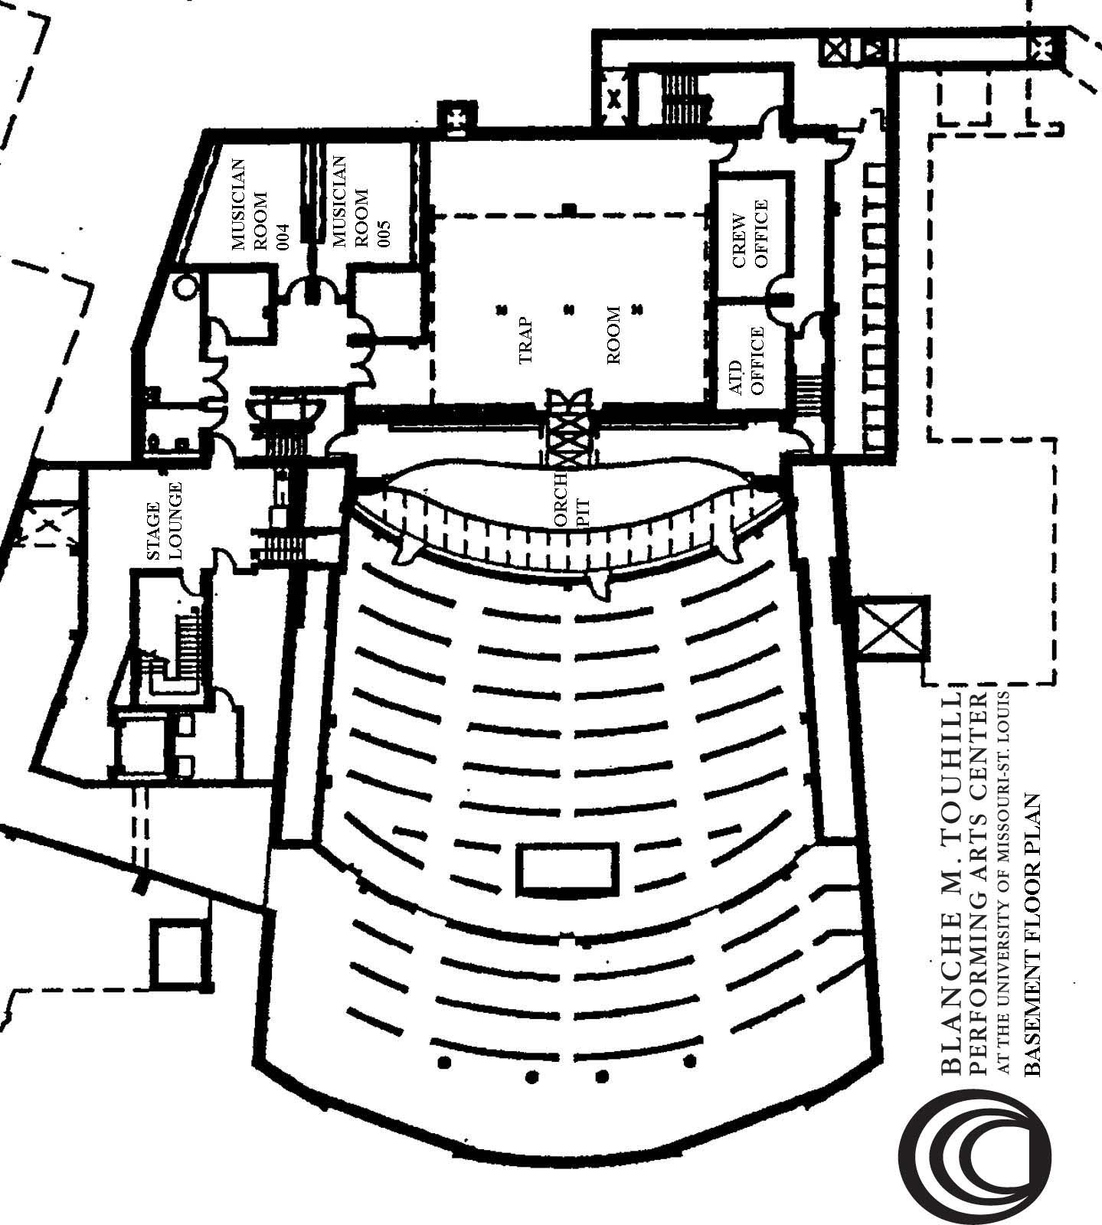
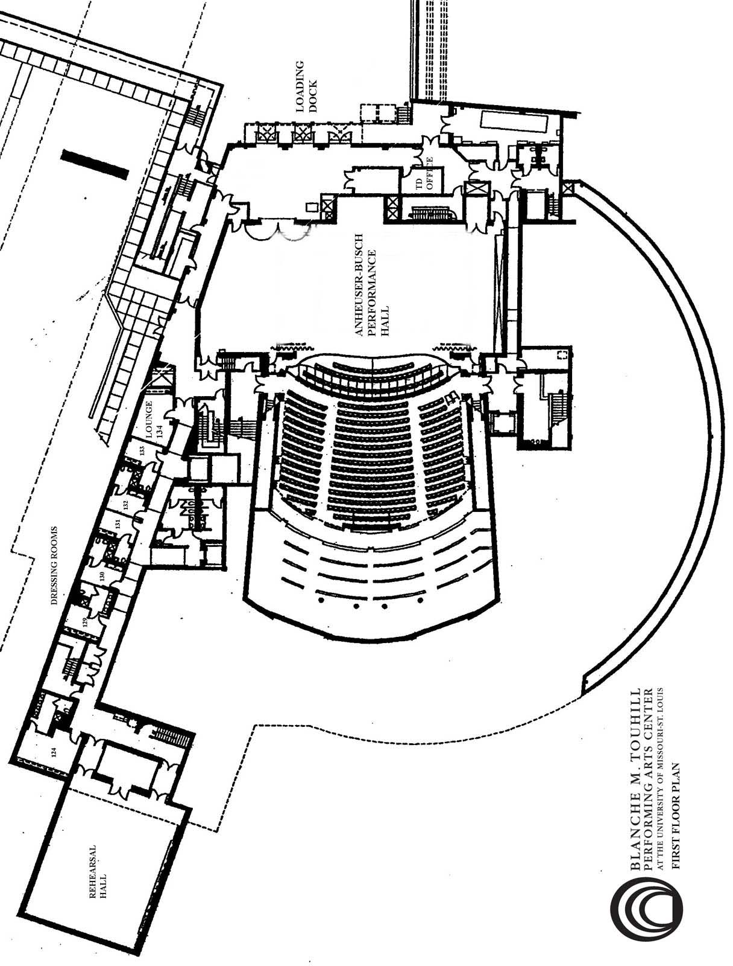

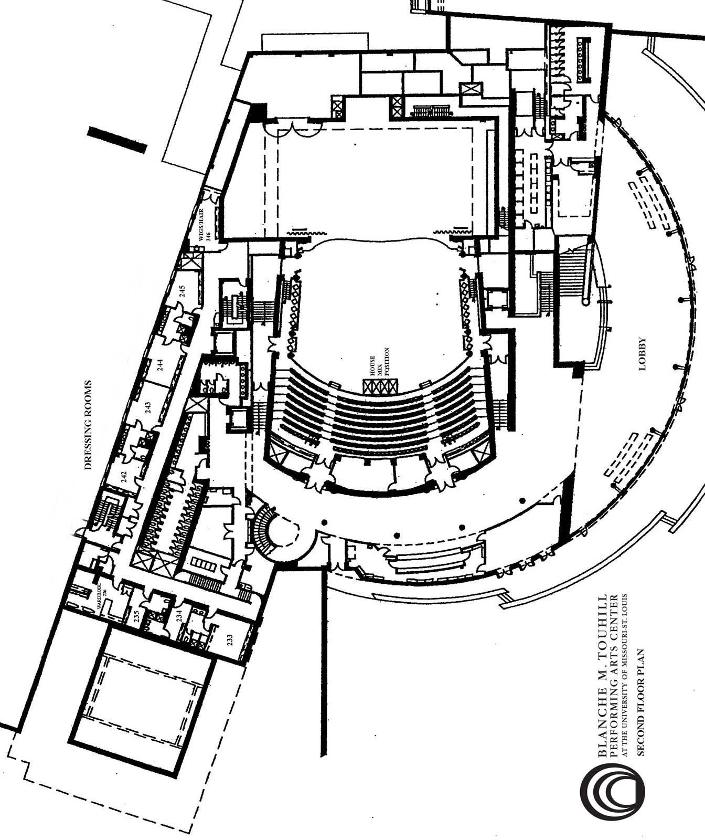

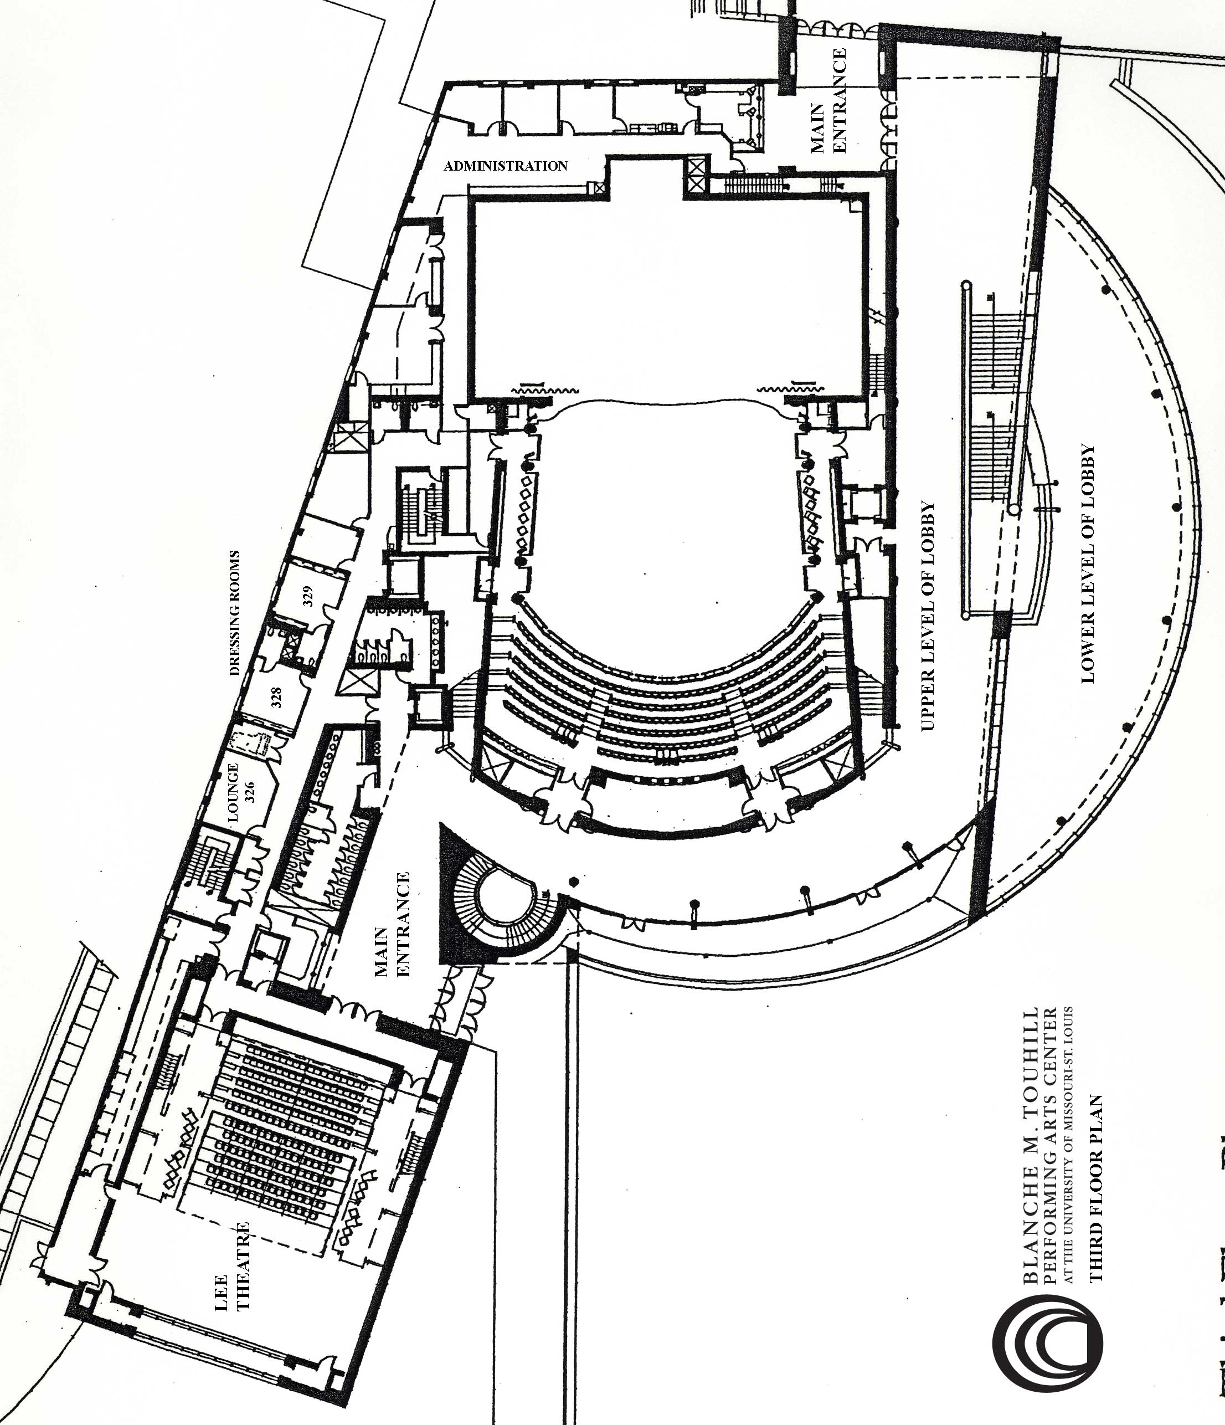

ANHEUSER-BUSCH PERFORMANCE HALL

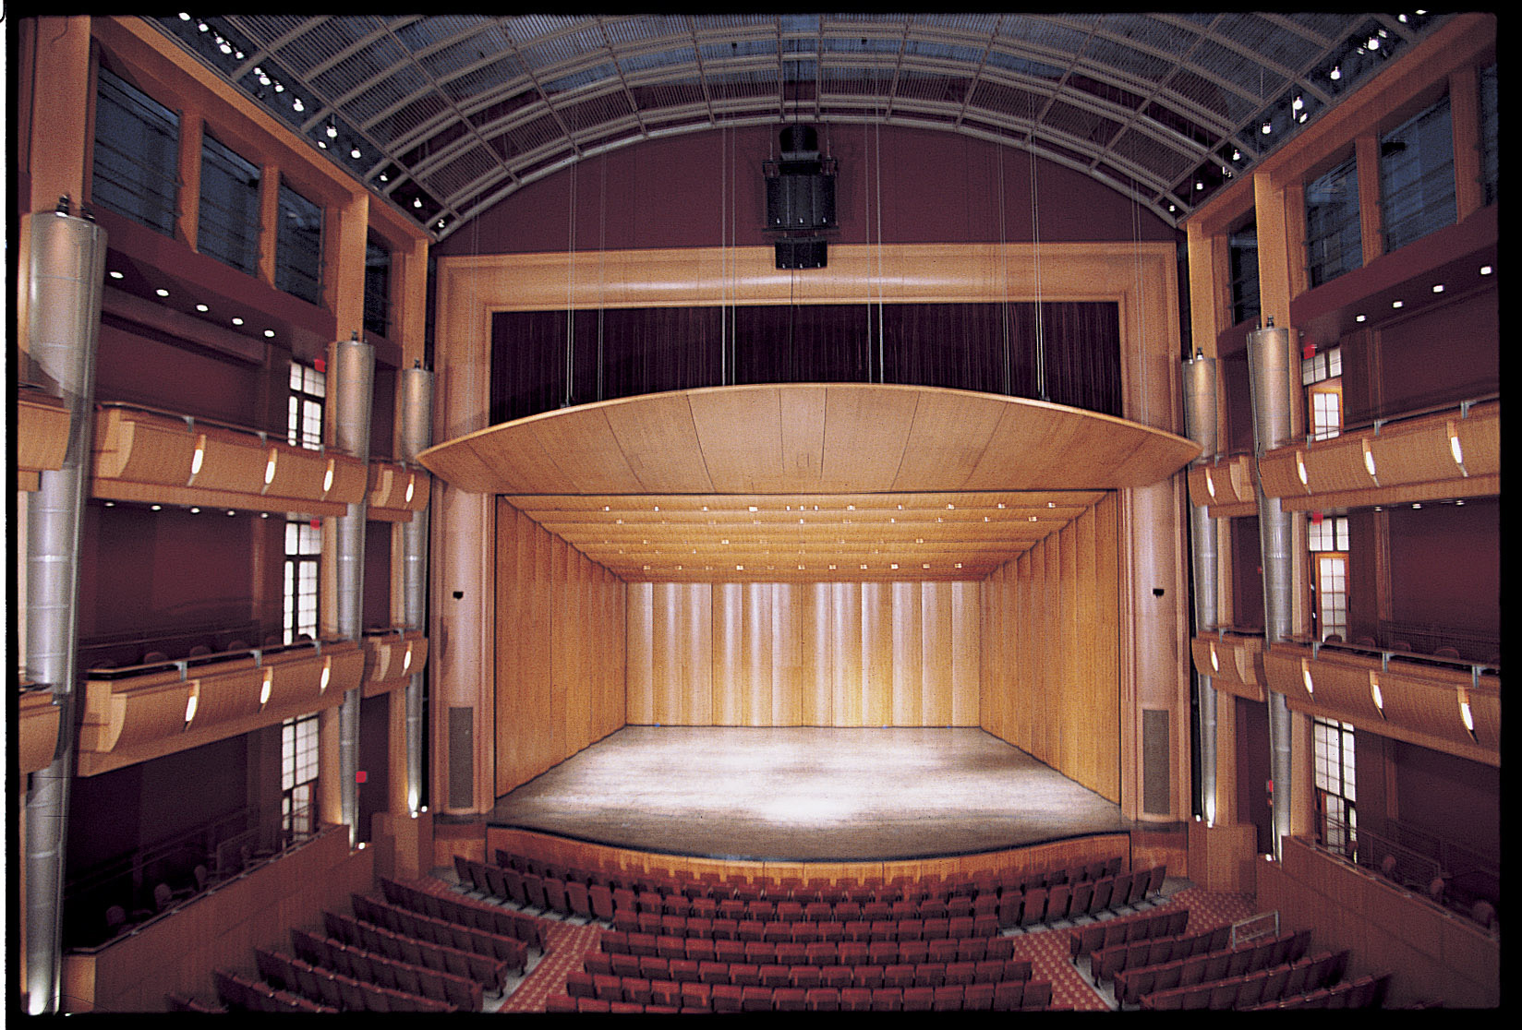

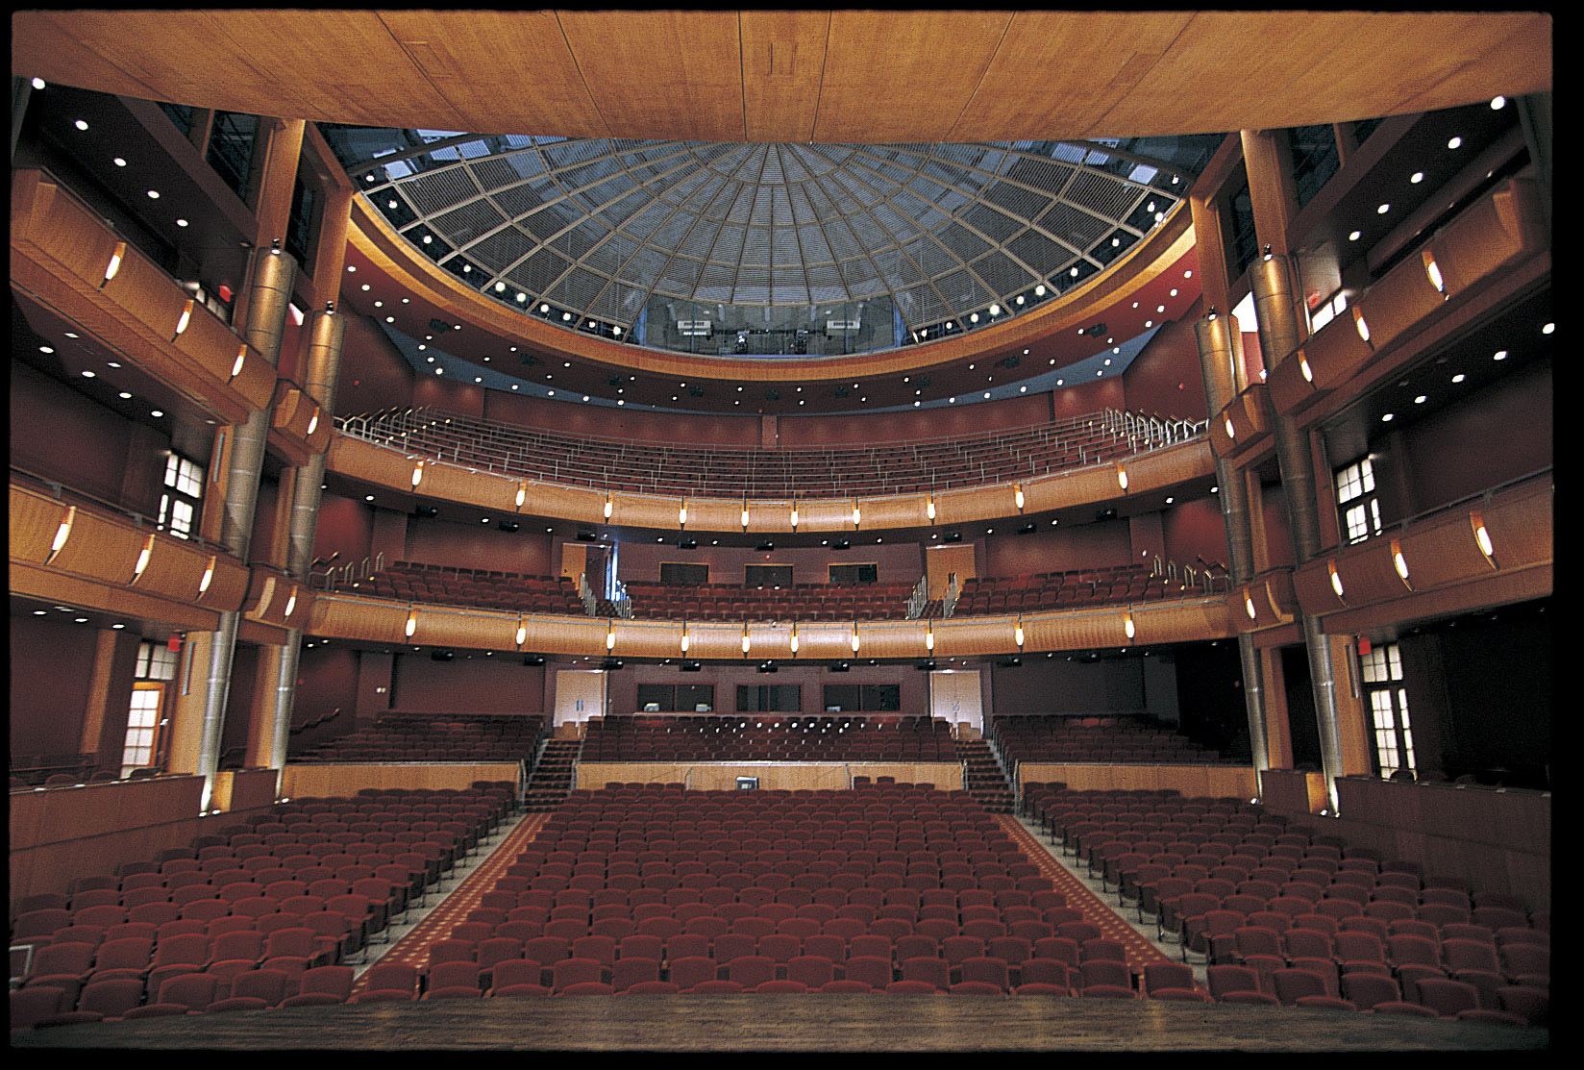

The Anheuser-Busch Performance Hall is a 1600-seat state-of-the-art roadhouse. The Hall is designed to accommodate Broadway musicals, opera, rock and pop concerts, entertainers, symphonies, chamber groups, presentations, and meetings. The stage has two main configurations, theatrical with full rigging, lighting, and sound support, and orchestral with a full acoustical shell.

MAIN LOADING DOCK AND ACCESS
Refer to location directions earlier in this document. Once you have turned left at the stop sign, continue around the General Services Building and go under the bridge (clearance 15’ 4”). Pull to the left after passing under the bridge and back into the dock. There are three receiving doors. Dock height is 4’ above the ground. Dock #1 and #2 have dock levelers and Dock #3 has an elevator from ground to dock height (84”w x 60”d, capacity 5000lbs).

The loading doors are 84”w x 105”h.

Shore Power is provided by a 100 AMP and a 60 AMP disconnect located in the dock receiving area. A 50’ cable run is required from the dock face to the company switches.

The interior receiving area is approximately 46’w x 24’d. There is a large (11’9”w x 20’h) pass through door from the receiving area directly onto the stage right wing. Pass-through doors to the dressing rooms lead off to the right from this area with a door portal of 60”w x 83”h. This is typical of passage hallway doors in the building. A service elevator provides access to the second and third floor dressing rooms and wardrobe areas. The elevator door portal is 72”w x 83”h and the interior box is 87”w x 67”d x 100”h. The elevator has a 5000lbs lift capacity. To the left of the receiving area is access to the main catering prep area and the lower lobby. There is a catering lift that is 80”w x 120”d with a 4000lbs capacity that allows access to the main floor, one-half floor up.

ROAD POWER: Stage Right Wing: 4 – 400 AMP, 1 – 200 AMP (isolated ground)
Dock receiving area: 60 AMP, 100 AMP
Trap Room: 100 AMP

PROSCENIUM: 56' wide x 30' high
Normal playing width is 38’6” inside leg to inside leg

VARIABLE
TORMENTORS: Portal opening between 56' to 28' wide
- Screen covered with black velour
- Each panel is 6’w x 30’6” tall with velour legs hung directly upstage for additional masking
- Top of tormentors may be closed in by border #1

STAGE: 9' from front edge of pit to fixed stage edge (CL)
2' from fixed stage edge to plaster line
47’ from PL to rear wall
17" from PL to house curtain
10” from PL to 1st usable line set (#2)
42’ 7” from PL to last line set (Cyc)
60’ from CL to SR wall
46’ from CL to SL wall (43’ CL to locking rail)

FLOOR: Sprung hardwood maple, stained black
Stage deck to auditorium floor: 3’6”
Note: Nothing shall be nailed, screwed, lagged, or bolted to the stage floor without prior consent of the Stage Supervisor. All lag bolts must be less than 1.5” in length, high strength, and pre-drilled. Renter will pay for materials and labor to have the house plug and repair the floor.

DANCE FLOOR: Harlequin Cascade, black, 7 rolls, 6’6” wide by 64’ long

ORCHESTRA SHELL: Comprised of 4-33’ tall towers, 6-24’ tall towers, and 3 ceiling pieces.
- Full shell configuration is 56’w x 30’h (front) 47’w x 20’h (rear) depth from PL is 37’
- Two-Third shell configuration is 23’w x 24’h (rear) depth from PL is 26’
- One-Third shell configuration is 20’w x 28’h (rear) depth from PL is 14’
The shell is also supported by a FOH reflector that can play at multiple heights and angles.

PIANO: Steinway 9' Concert Grand Piano

ACOUSTICAL PANELS: There are a series of acoustical panels and drapery that can be deployed in the house to alter the reverberant sound.

APRON / PIT: 9' from front edge to fixed stage edge (CL)
8’ from front edge to fixed stage edge (QL)
53’ at widest point
Pit floor when at orchestra level is 53’w x 15’d
Manual platforming may be removed to increase pit into house to overall dimension of 53’w x 21’d
Pit lift allows a variable depth from flush with stage to 16’ below stage deck level
8’ from stage or orchestra level
Spiralift speed – 6 ft per minute
Lifting capacity – 21,000 lbs (58,000lbs even static load)

RIGGING

GRID: Clear grid system, most rigging is suspended above gridiron from overhead beams
Bottom of gridiron at 76' 6” from stage floor
Top of gridiron at 77’ 6” from stage floor
Bottom of overhead rigging beams at 85’ from stage floor

FOH RIGGING: There is an attic space above the house that provides access to structural beams for rigging. 32 pass through points permit FOH rigging to pass through finished house ceiling. There are two points at each position.

From PL | HR | HCR | HC | HCL | HL | Far HL
12’ | 24’ | 12’ | 0 | 12’ | 24’ | -
28’ | 25’ | 13’ | 0 | 13’ | 25’ | -
44’ | 25’6” | 13’6” | 0 | 13’6” | 25’6” | 34’

LINE SETS: Battens are schedule #40 1-1/2" pipe at 63’ in length
Batten high trim 75’ 6”
low trim 4'
59 single purchase counterweight line sets on 6” centers, arbor capacity at 1450 lbs
(see separate line schedule for position and rep hang)
4 Transverse line sets that run US-DS over both wings, 39’ in length
Deck level locking/running rail (SL)
Mid loading rail at 30’ (SL)
Grid loading rail at 69’ (SL)
Pin rail at 30' (SR and SL)

DRAPERY: See line schedule for rep placement:
1 - Main house curtain, w/ fullness, burgundy
- Motorized variable speed guillotine
- Manual travel
1st Border, black, sewn flat, 12’h x 63’w
4 – Border, black, sewn flat, 8’h x 63’w
8 – Legs, black, sewn flat, 30’h x 12’w
US traveler, black, sewn flat, 30’h x 65’w
Mid traveler, black, sewn flat, 30’h x 65’w
Black scrim, 29’h x 58’w
White Cyclorama, 29’h x 62’w
2 – Panels/tabs, black, sewn flat, 30’h x 35’w
5 – Alternate legs, black, sewn flat, 30’h x 13’w

LIGHTING
The lighting system is flexible and robust with a total instrument count of over 350 units including 20 Chroma Q color scrollers. A custom plot can be installed per client specifications or a number of stock lighting plots are available to choose from including dance, theatrical, and rock/pop rigs. Stock plots, instrument inventories, circuit plots, and other lighting details can be found at www.umsl.edu/~cattanaj

LIGHTING
CONTROL: Strand Light Palette 550i with 54 Submasters, Software Version: 2.6.15
Ethernet based lighting network
570 Entertainment Technology solid-state dimmers
- Capio IPS-CM-HP-20, 2400w
- Control module per rack is a Capio IPS-RCM-96
Pathway DMX distribution system is deployed throughout the theatre.
- House owns 8 output and 2 input Pathport units
THROW
DISTANCE: Distance and angle from 6’ above CL at PL
- Spot booth: 96’ at 30 degrees, 82’ out from PL, 54’ up from deck
- FOH beam (68’ wide): 70’ at 50 degrees, 46’ out from PL, 59’ up from deck
- Second balcony: 74’ at 18 degrees, 70’ out from PL, 29’ up from deck
- First balcony: 66’ at 9 degrees, 65’ out from PL, 16’ up from deck

FOLLOW
SPOTS: There are four Lycian 1290XLT 2K xenon spots in the spot booth at the back of the theatre.
The booth has very limited access through catwalks and up vertical ladders. Placing of additional spots is not recommended.

SOUND

CENTER CLUSTER: 3-EV XI-2153/64

STEREO CLUSTER: 3 – FRX-940 per side

STAGE LEVEL CLUSTER: Left and right stacks behind screens in proscenium at stage level
Top cabinet EV XI-1152/64
Bottom cabinet EV XI-1152/94
Subwoofer Bag End DBL 18”

UNDER
BALCONY FILLS: 27 - Bag End and EV cabinets

FRONT FILLS: 5 – EV XI-1082

SIGNAL PROCESSING: Klark Teknik DN 9848

AMPLIFIERS: Crown CL1, CL4, CH2, Macrotech 3600

HOUSE MIX
POSITION: 58’ from plaster line
Pit dimensions are 13’6” w x 6’d (floor is 2’ below auditorium floor)

SNAKE RUN: Center stage to house mix: 140’
Center stage to booth: 180’
Exterior dock to center stage: 70’

ANALOG MIX BOARD: Soundcraft K2
  - 48 channel
  - Mono, Left and Right Mix
  - 8 groups, 8 aux sends
  - Two monitor mixes available from FOH via aux sends

OUTBOARD GEAR
AT FOH MIX POSITION: Processors:
- Lexicon MPX1
- 2 - Yamaha SPX990
- 8 - Channels BSS Comp
- 2 - Channels Tube Exciter
- 1 - Antares Pitch Corrector
Digital EQ: 8 channels Ashly Protea System II 4.24G /w Remote
Playback:
- Tascam MD-350 Minidisc
- Tascam DA-45HR DAT
- Marantz PMD331 CD player
- Marantz PMD510 dual well cassette recorder

MONITOR SYSTEM: Crest XR-20 mixing console, 16 in x 6 mix, Cue, Stereo side fills
Tascam MD-350 Minidisk
Marantz CD player
8 channels of digital graphic EQ, Ashly Protea System II 4.24G
Beheringer 4 Channel Headphone Amp
Amps: Crown Macrotech 24x6/w PIP
12 – EV T22IM Bi-amped wedges
3 – EV Xi-1152/64 Bi-amp / Side-fill / Drum Fill
4 – SB 180 Subs
ARCHIVAL
RECORDING: Basic archival recording available via independent hall monitor recording array to stereo minidisc

PRODUCTION
COMUNICATION: Production Communication is provided by a 4-channel Clearcom PL Pro RM-440 system.
- 10 Belt packs
- 4 TW-30 lightweight headsets
- 8 Single muff headsets
- 2 Double muff headsets
- 3 Blazon flashers
- 3 HS6 handsets
- 1 TW-40 two-way radio interface
BACKSTAGE
PAGING &
AUDIO MONITOR: An audio stage monitoring system provides stage program to most parts of the building including all dressing rooms. Audio paging is available from room 135 and all SM panels.

VIDEO MONITOR: CCTV is distributed throughout the building. Each theater is on its own channel. A full-color camera mounted in the theatre feeds channel 4. External cable programming is also available.
VIDEO TRUCK
INTERFACE: 6 – Video lines run from the Control booth patch bay to the loading dock
ALL four com channels are available
6 – Audio Lines run from the Control booth to the loading dock

SM PANEL: A full SM desk with video stage monitor, master com station, and backstage paging can be connected in the lighting booth, sound mix, backstage left or backstage right. A smaller portable desk is also available without the video monitor.

Additional audio information can be found at www.umsl.edu/~cattanaj

DESMOND AND MARY ANN LEE THEATER
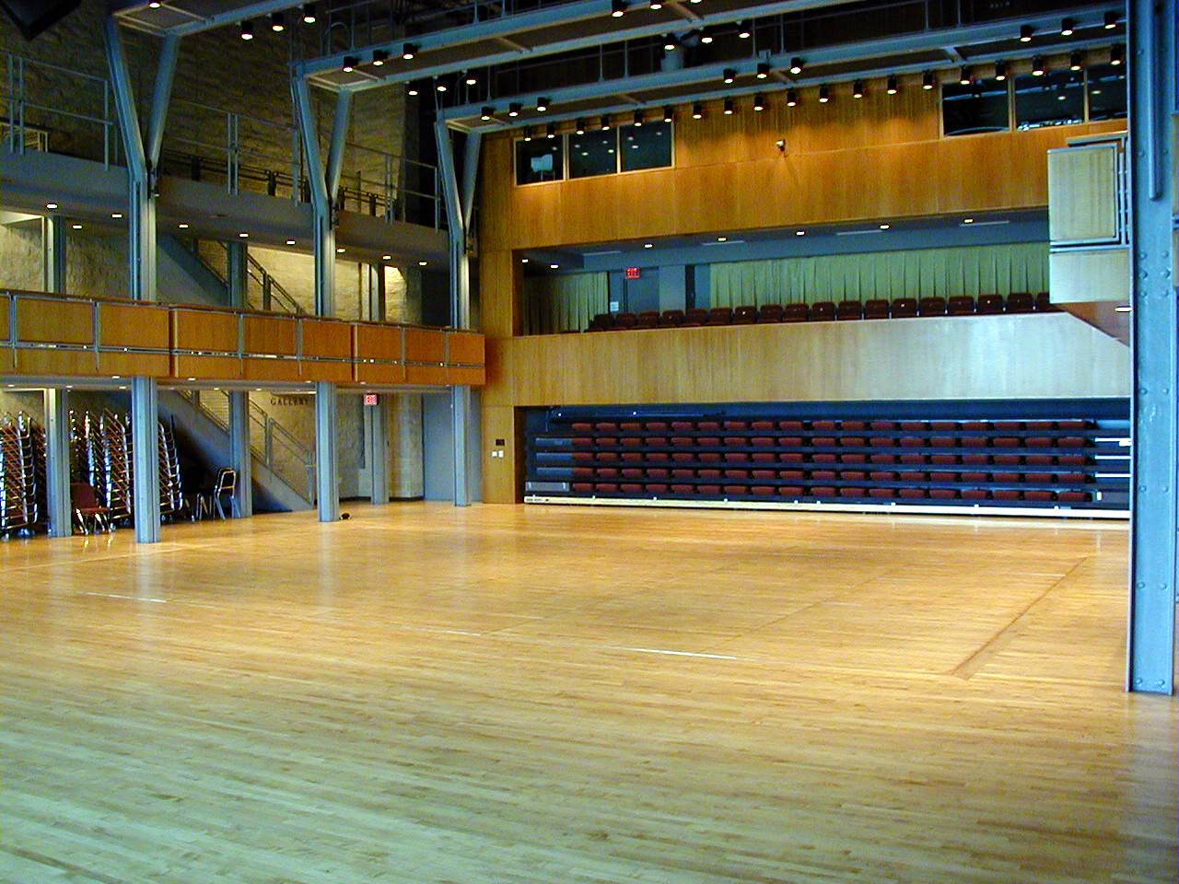
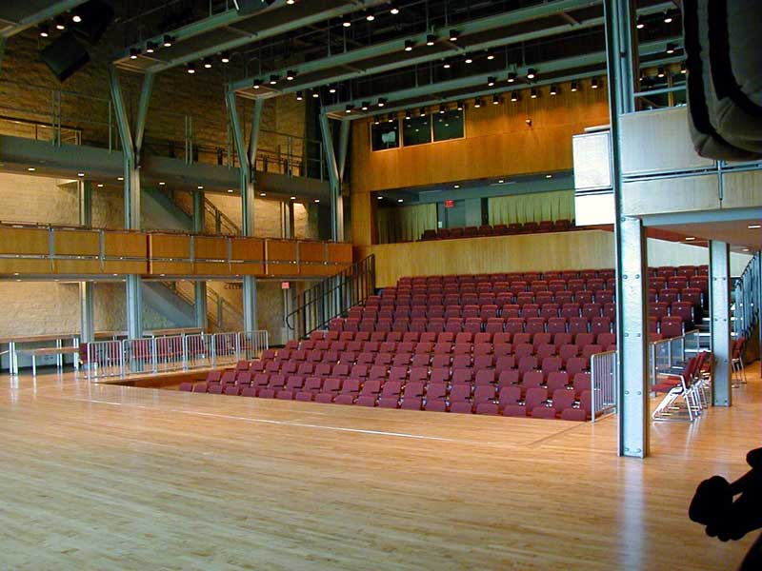
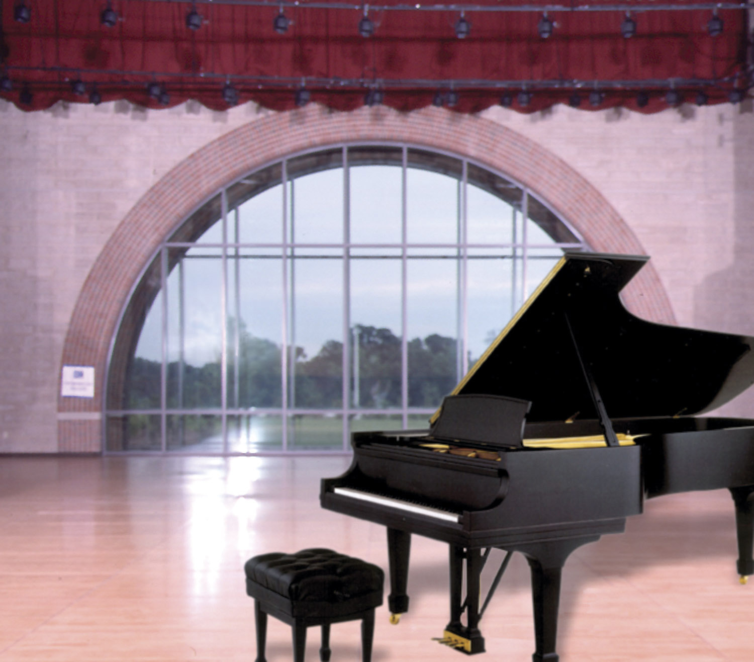
The Lee Theater is a 360-seat flexible performance space designed to hold small chamber concerts, recitals, dance, dramatic plays, presentations, meetings, and receptions. The theater is defined by a large curved window directly behind the main performance space. Curtains can be deployed to mask the window, blackout light or filter light. A complete stage drapery set is also available to convert the space into a traditional proscenium theatre with act curtain, legs, borders, scrim, and cyc. Seating may be set up in number of configurations including proscenium, thrust, or arena. The seating may also be completely cleared in order to provide a flat floor for performance, events, or receptions.

LEE THEATER LOADING AREA
Follow the location directions earlier in this document. Proceed through the four-way stop and continue up toward the PAC. Turn into the driveway on left just before the circle drive. The Lee loading doors are at ground level off a loading pad. The exterior doors are 65”w x 89”h. They swing out with a clearance between the open door and the brick retaining wall of 70”. The interior doors to the stage are 73”w x 100”h.

ROAD POWER: Dock receiving area: 400amp, 200amp, and 100amp

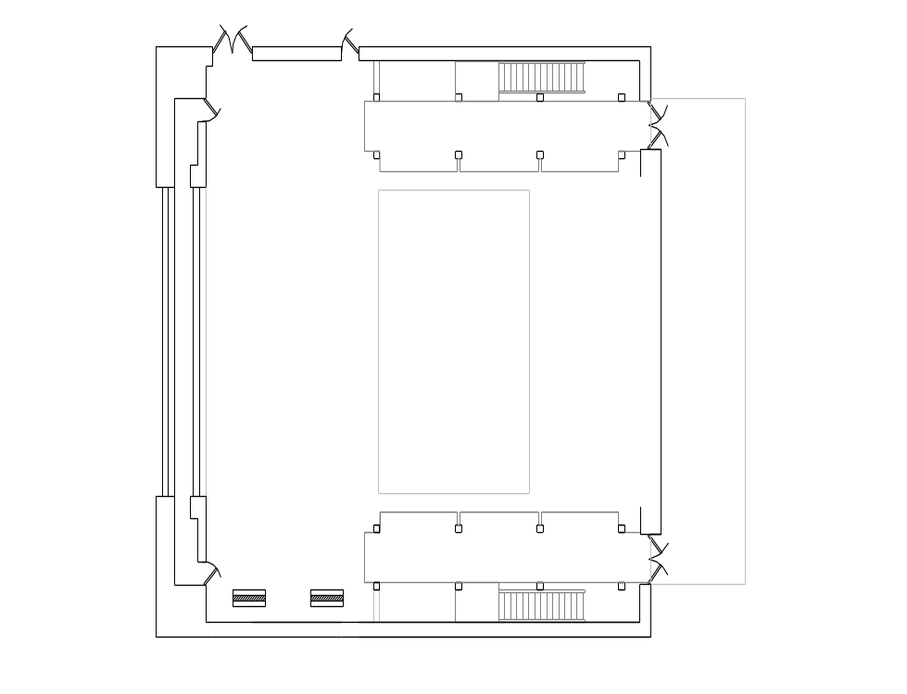

SPACE DIMENSIONS: Open floor is 66’w x 71’d
Stage end is 66’w x 27’6”d
Clear space from under galleries is 40’w x 71’d

FLOOR: Sprung hardwood maple, sealed to a natural golden stain
Note: Lagging, screwing, or bolting into this floor is not permitted

DANCE FLOOR: Harlequin Cascade, black,
4 rolls, 6’6” wide by 50’ long
1 roll, 6’ wide by 42’ long (to fit between columns)

PIANO: Steinway 9' Concert Grand Piano

SEATING SYSTEMS: The seating for the Lee theater is composed of fixed seating in the rear upper gallery, loose seats in the side upper galleries, a telescoping riser system, and loose seats that may be placed on the flat floor or on 3’ x 6’ platforms raked into the 3’ deep pit in the center of the space. A custom-seating plan can be developed for each event or a standard setup may be chosen. Various seating configurations will change the available seating as well as performance space dimensions. For standard setup maps visit: www.umsl.edu/~cattanaj

RIGGING

CATWALKS: 24’6” to bottom of catwalk
27’ to light hanging position

RIGGING BEAMS: Rigging beams run down the length of the room on 10’ centers and are 33’ to bottom of beam

COUNTERWIEGHT
SYSTEM: There are 7 rope lines sets run over the stage deck balanced by sandbags on stage right
Battens, schedule #40 1-1/2” pipe at 42’ in length

LIGHTING TRUSS: There are 4 – 46’ wide 12”x18” trusses spanning over the stage deck to accommodate overhead lighting.

See separate line schedule for pipe and truss placements.

DRAPERY: Modular draperies:
6 - legs, black, flat sewn, 23’11’h x 13’w
4 – legs, black, flat sewn, 23’11’h x 8’6”w
(legs are dead hung under SL and SR catwalks)
4 – borders, black, flat sewn, 6’h x 44’w
2 – panels, black, flat sewn, 27’h x 24’w
Fixed draperies:
Brail drape, red, 32’h x 48’w – to cover window
Sheer Traveler, white, 23’3”h x 39’w – inside window
Blackout Traveler, black, 23’3” x 39’w – inside window

LIGHTING

The lighting system is flexible and robust with a total instrument count of over 150 units. A custom plot can be installed per client specifications or a number of stock lighting plots are available to choose from including dance, theatrical, and rock/pop rigs. Stock plots, instrument inventories, circuit plots, and other lighting details can be found at www.umsl.edu/~cattanaj

LIGHTING
CONTROL: Strand Genius Pro Light Palette with 24 Submasters, Software Version: 2.6.15
Ethernet based lighting network
192 Entertainment Technology solid-state dimmers
- Capio IPS-CM-HP-20, 2400w
- Control module per rack is a Capio IPS-RCM-96
Pathway DMX distribution system may be deployed throughout the theatre

FOLLOW
SPOTS: There are two Lycian Super Arc HTI Followspots, 400w in the booths at the back of the theatre.
50’ throw to CL at fixed stage at 28–degrees, 43’ to fixed stage edge, 23' above stage deck

SOUND

SPEAKERS: 2 primary speaker arrays consisting of 2 EV FRX-940 cabinets that direct sound over the majority of the house with and EV XI-1082 as down-fill.
Crossovers and processors are Ashly Protea 4x8
2 Bagend S18B Subwoofer cabinets with Bagend ELF processor

AMPLIFIERS: Crown CL1, CL4
HOUSE MIX
POSITION: From booth, may also be mixed from stage floor or seating gallery

ANALOG BOARD: Soundcraft K1
- 24 channel input + 2 stereo inputs
- Left and Right Mix
- 4 groups, 4 matrix, 4 aux sends
- 2 stage monitor mixes are available from FOH via aux sends, additional stage mixes may be available through independent monitor system
RACKED GEAR
AT FOH MIX: Processors: Lexicon MPX1
Digital EQ: 4 channels Ashly Protea System II 4.24G
Playback: Tascam MD-350 Minidisk
Tascam DA-20 MKII Digital Audio Tape recorder
Marantz PMD331 CD player
Marantz PMD510 dual well cassette recorder
ARCHIVAL
RECORDING: Basic archival recording available via independent hall monitor recording array to stereo minidisc

PRODUCTION
COMUNICATION: Production Communication is provided by a 2-channel Clearcom PL Pro RM-220 system.
- 5 Belt packs
- 5 Single muff headsets
- 1 TW-40 two-way radio interface
AUDIO
STAGE MONITOR: An audio stage monitoring system provides stage program to most parts of the building including all dressing rooms.

VIDEO MONITOR: CCTV is distributed throughout the building. Each theater is on its own channel. A full-color camera mounted in the theatre feeds channel 6. External cable programming is also available.

SM PANEL: A SM desk with master com station and backstage paging can be connected in the lighting booth, HR wall, or rear center gallery.

Additional audio information may be found at www.umsl.edu/~cattanaj

DRESSING ROOMS AND OTHER SUPPORT SPACES

There are a total 15 dressing rooms in the center.
Basement (next to orchestra pit)
2 – Musician changing rooms with mirrors, benches, and coat hooks
1st floor (Anheuser-Busch stage level)
4 – Star rooms with private toilet and shower
1 – Small chorus room with private toilet and shower (4-6 people)
1 – Large chorus room with private toilet and shower (8 –12 people)
1 – Production office / lounge with tables, chairs, TV, refrigerator, microwave, sink
2nd floor
2 – Star rooms with private toilet and shower
1 – Large chorus room with private toilet and shower (12 –14 people)
4 – Large chorus rooms with shared toilets and showers (8 – 12 people each)
Wardrobe room with two sets of washers and dryers, irons, steamer, sewing machine, serger, TV
Wig / Hair room with salon chair and wash sink
3rd floor (Lee stage level)
2 – Large chorus rooms with private toilet and shower (8-10 people)
1 – Production office / lounge with tables, chairs, TV

WHITAKER REHEARSAL HALL / DANCE STUDIO
Located at the end of the first floor dressing room corridor. Often used for a large green room, holding room, warm up, catering, rehearsals, and dance classes.
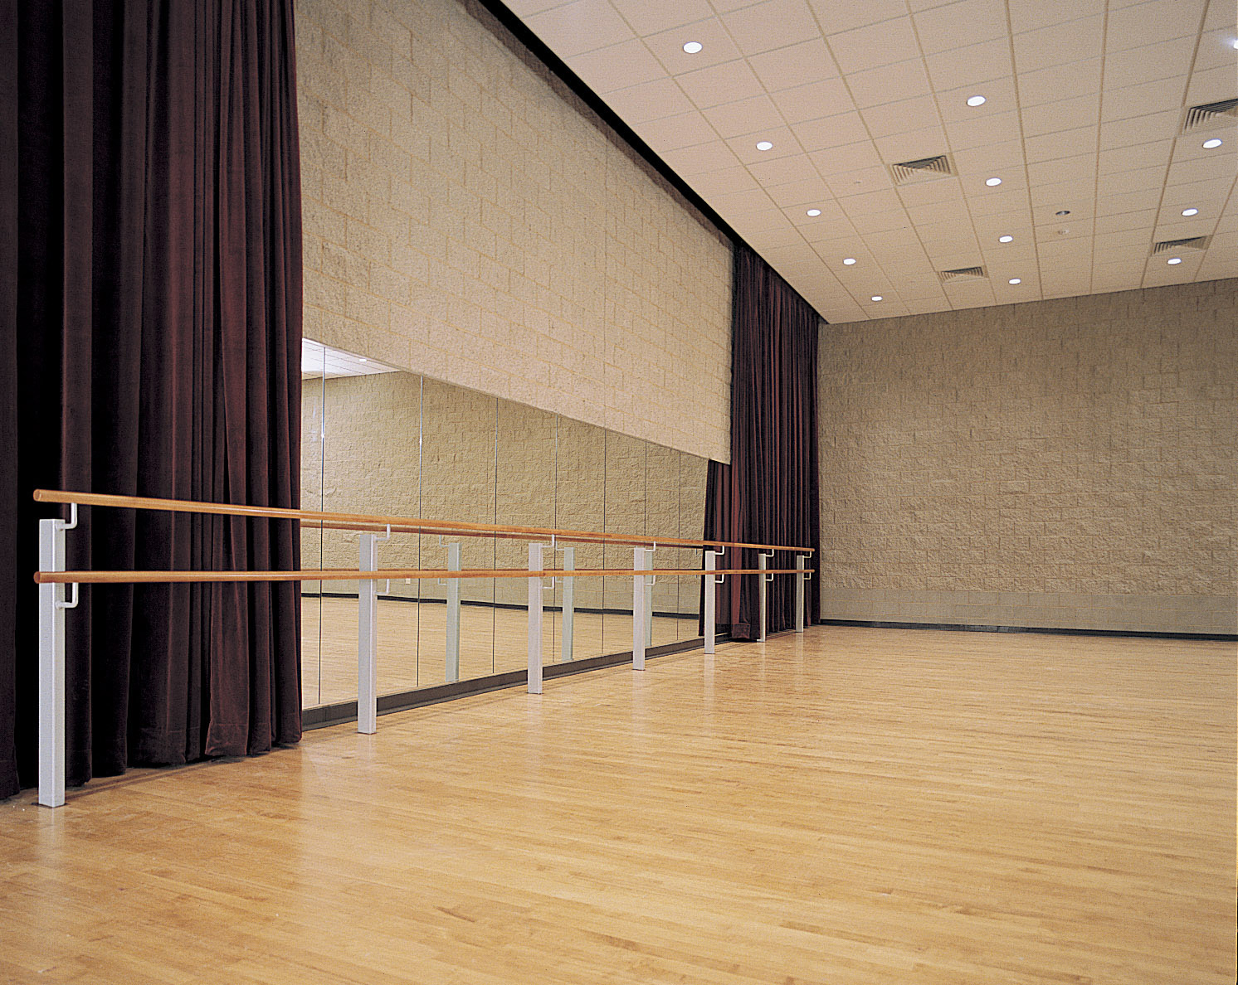
DIMENSIONS: 54’w x 42’d x 16’h

FLOOR: Sprung maple floor, natural golden color
Note: Lagging, screwing, or bolting into this floor is not permitted

DANCE FLOOR: Harlequin Cascade, black, 50’w X 40’d
May be deployed in not in use in Lee Theater

DANCE MIRRORS: On one wall, 36’w x 8’h

BALLET BAR: 36’ long in front of mirrors

PIANO: Boston Upright

AUDIO: Permanently installed audio system containing a pitch control CD / cassette player, 2 mic input mixer

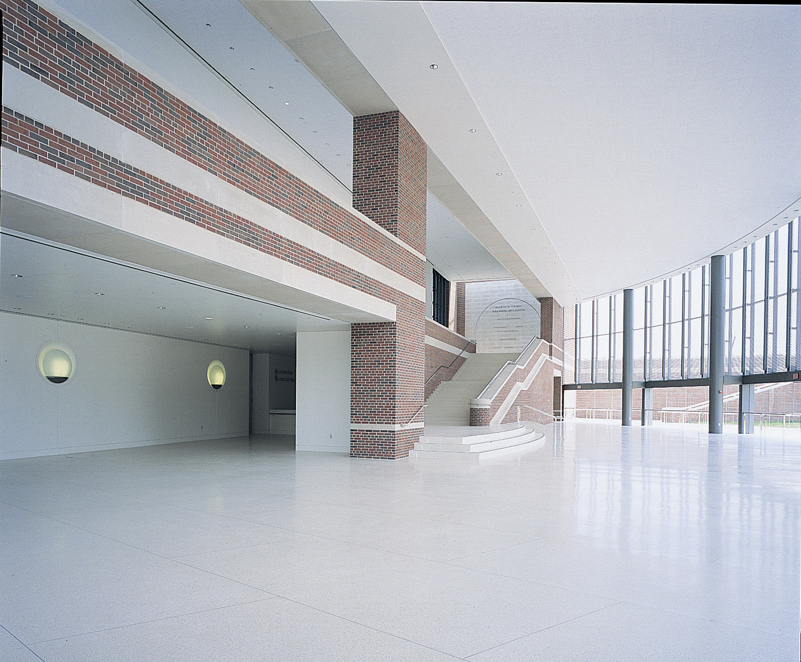
LOBBIES
There are two large lobbies (upper and lower) as well as an intimate patrons’ lounge that may be booked for conventions, luncheons, dinners, parties, meetings, and receptions.
- Tables, chairs, and full catering facilities are available.
- Ample electrical circuits and data ports are available through out the lobby areas.
- A portable public address system and/or staging may be brought in.

ADDITIONAL EQUIPMENT

This equipment is not assigned for use in any particular space. Check with your Technical Manager for availability and if any additional costs may be incurred.

FURNITURE
6’ banquet tables, stacking chairs
Assorted black stage tables
30” black stools padded or not padded

LECTERNS
2 Pecan finished wood lecterns with electric variable height adjustment

REHEARSAL PIANO
Boston upright piano available for onstage studio or class work

RISERS / PLATFORMS
16 - StageRight All-Purpose decks
- Reversible with black hard surface or grey carpet
- Can be set to 8”, 16”, or 24”
- Skirting, railing, and stairs are available
- A complete parts inventory is available for custom configurations

PIPE AND DRAPE
Approximately 85’ of 12’ high, black, heavyweight drape on 10 poles

PERSONNEL LIFTS AND LADDERS
Genie IWP 30S – 30’
Genie AWP 30S – 30’
6’, 8’ ladders
21’ Little Giant offset ladder

ORCHESTRA EQUIPMENT
9 – Choral Risers, 6’ Wenger Tourmaster
100 – Orchestra Chairs (Wenger Musician)
20 – Orchestra Chairs (Wenger Cello)
8 – Conductor / Bass / Percussion Stools (Wenger)
80 – Music Stands (classic 50)
40 – Stand lights
1 – Conductor’s stand with shelf
1 – Small conductor’s stand
1 – Double conductor’s podium

VIDEO PROJECTION
LCD video projector, Sanyo 4500 Lumen
Kramer Electronics Scalar
Marantz DVD player
JVC PRO VCR

VIDEO PRODUCTION
Digital camera, Cannon XL1s/w Zoom/focus remote & XLR boot
Bogen fluid head tripod
3 - Panasonic 13” Monitors
2 - JVC 12” Monitors
Panasonic color/infrared Utility Camera
Good stock of 5-wire & VGA cable
Video editing station, Dell Precision Workstation, 1TB Hard drive space, Avid DV express pro w/ ADVC100 Digitizer

DIGITAL RECORDING
72 channels of digital recording through the Mackie D8B
2 - MDR 24/96 24-track hard drive recorders
Alesis master-link CD Mastering Burner
Tascam DA-45HR DAT
AES Matrix router/format converter 8 in/out
4 – Mackie HR-824 near field monitor
Protools conversion / exporter

POWER DISTRIBUTION
Custom Motion Labs 200A 3P Power Distribution Rack allowing various power distribution schemes including 8 – 20amp convenience outlet boxes at assorted lengths

WIRELESS MICROPHONES
4 - Wireless microphones, Shure UC with handheld or lavaliere transmitters

PORTABLE PA SYSTEM
16 channel board with up to 4 speakers on boom stands

Further details on additional equipment may be found at www.umsl.edu/~cattanaj

