Focus on Teaching & Technology 2014 Nov. 13, 2014 Fatemeh Mardi
Elevating the Discussion: Challenging Ideas in the Online Format
Experience how online students present, exchange, and challenge ideas using technology. Learn to design and reinforce meaningful discussions using Google tools and Screencast-o-matic with carefully structured activities. Come with your Gmail accounts!

http://padlet.com/fatemehmardi/FTTC
https://www.polleverywhere.com/mardi2

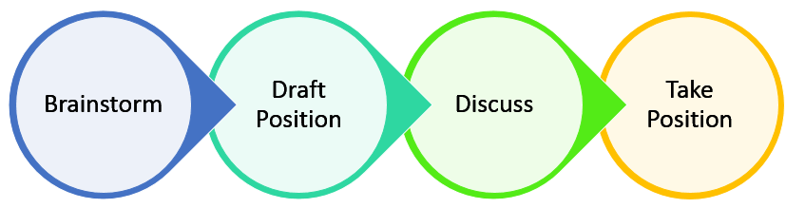

- Google form http://goo.gl/CRm3Zi
- Live polling http://www.polleverywhere.com/
- Ted Talk http://www.ted.com/talks/margaret_heffernan_dare_to_disagree?language=en
- Mission Impossible http://www.powtoon.com/
- Role Assignment Cards: Creative Whack Pack Cards by Roger Von Oech

Ertmer, P. A., Sadaf, A., & Ertmer, D. J. (2011). Student-content interactions in online courses: The role of question prompts in facilitating higher-level engagement with course content. Journal of Computing in Higher Education,23(2-3), 157-186.
Richardson, J. C., Sadaf, A., & Ertmer, P. A. (2012). Relationship between Types of Question Prompts and Critical Thinking in Online Discussions.Educational Communities of Inquiry: Theoretical Framework, Research and Practice. Calgary: IGI Global.

 | Question type | Question Type Description | Example
1 | Playground (PG) | Questions require the interpretation or analysis of a specific aspect of the material, or “playground,” for discussion. Students are free to discover and interpret the material
2 | Brainstorm (BS) | Questions ask students to generate a number of conceivable ideas, viewpoints, or solutions related to a specified issue. Students are free to generate any or all ideas on the topic
3 | Focal question (FQ) | Questions relate to a specific issue and require students to make a decision or take a position and justify it. Students are asked to support one of several possible positions
4 | General invitation (GI) | Questions invite a wide range of responses within a broad topic in an open or unfocused discussion
5 | Lower-level divergent (LD) | Questions require students to analyze information to discover reasons, draw conclusions, or make generalizations
6 | Analytic convergent (AC) | Students are required to examine relevant material and produce a straightforward conclusion, summarize material, or describe a sequence of steps in a process. Answers require analytical thought but lead to a single correct answer
7 | Shotgun (SG) | Multiple questions that may contain two or more content areas
8 | Funnel (FUN) | Prompt begins with a broad opening question, followed by one or more narrower question, and ending with a very concrete question
9 | Critical incident (CI) | Questions relate to a scenario or case study students have read; students are typically asked to propose solutions to the issues presented in the scenario/case study

