Task 1: Remix and Organize from My Example

Assignment: Begin to explore the capabilities of ThingLink while learning more about the P21 Partnership for 21st Century Student Learning Outcomes.

THINGLINK: http://www.thinglink.com/edu
Log in using your provided username/email and password. (Note: you can keep this account and go into the settings to change the fake email to be your own.)

- You will see the “Stream” that I’ve begun from you. The images that show up here come from the images I’ve uploaded into our channel. Click the “21st Century Student Learning Outcomes” interactive image to begin.
- Click the “Remix” button on the far right to create a remixed copy.

- You are now in editing mode. Rename the page with your last name as the first word of the new title of your remixed image.
- The interactive elements I’ve added are all across the top of the page. Move the interactive elements around on the page to illustrate what you value as important to the most important. Some of these elements will take visitors to webpages, others to videos, etc.
- Save each tag as you work. Then click the big green “SAVE” button when you’re done.
- Finally, you must add your new remixed image to our group channel. To do this, click the “Add to Channel” link just under your new version and to the right. Choose “FTTC Workshop Group Channel.”

Task 2: Explore Educational Uses of ThingLink

Now that you’ve remixed our ThingLink in Task #1, let’s look at other ways to use ThingLink.

Assignment: Explore the example ThingLinks on this site: http://tinyurl.com/fttc-thinglink
and discuss with your partner which examples and uses of ThingLink appeal to you.

Instructor Created ThingLink Ideas:

Student Created ThingLink Ideas:

Now that we’ve explored ThingLink a bit more, take a look and get inspired by the images I’ve collected for you to use as the background for your own ThingLink (http://fttc-thinglink.weebly.com )

Next up…begin to gather resources to build a ThingLink about your own topic!

Task 3: Explore and Share Open Education Resources (OER)

Assignment: Begin to explore existing OERs in your discipline and area. Then, share examples onto your our collective Padlet with your insights about why this resource is potentially valuable to you.

Links to Explore:
- OER Commons: http://www.oercommons.org/oer
- Gooru: http://www.goorulearning.org/#home

Find 1-2 examples, copy the link to the resource, and paste into our group’s Padlet Wall.

http://padlet.com/holmeskm/fttc2014

Task 4: Gather Great Materials

Assignment: Find 1-2 images, files, videos, and websites that you want to build onto your interactive ThingLink. Use the resources on our workshop website: http://fttc-thinglink.weebly.com

Save website, image, and video URLs in a special place such as a Word document. You’ll refer to these links later when you build your ThingLink interactive image.

Or, alternatively use Scoop-It, a digital curation tool to gather your resources. Here’s how:

- Create a free account on http://scoop.it or sign up with your Facebook or Twitter account.
- Once you are logged in, click your name in the upper right hand corner and “Create a Topic.” Name it with an umbrella term for all of the resources you’ll add to the topic page.
- Add the Scoop-It Bookmarklet to your browser. Then, browse the web freely. When you find a topic that you would like to add to your ThingLink, click that bookmarklet and add the link to your Scoop-It topic page. Add an “insight” if you want to note what interested you.

Scoop-It is a digital curation too. Learn more about Scoop-It here:
http://www.teachertrainingvideos.com/sharing-social-networking/scoop-it.html

Design Your Activity
Task 5: Put it all together!

Assignment: You will create one interactive image that packages and presents the content you’ve gathered.

- Once you’re logged back into ThingLink, click the CREATE menu and start creating. You can choose images or drag-and-drop directly onto the page. You may also choose to import images from Facebook, Flickr and the web.
- Click anywhere on the image to add a link to a file or website. Change the icon as preferred. Enter and format the text for each interaction, as desired.
- Arrange your interactions on the image.
- Save your interactive image. After saving, go to your image and click “Add to Channel.”

Task 6: Reflect and Discuss What We’ve Learned

What ideas do you have for using ThingLink in your teaching/practice?

What questions do you have?

More Information about ThingLink for Teachers

With a ThingLink EDU Premium account ($35/year), you can manage students and see the work of all of your students in one place.

Create Classroom Groups

You can add groups and register students or add existing ThingLink uses to your classroom group using the Group Management feature.

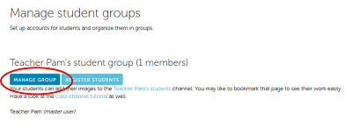

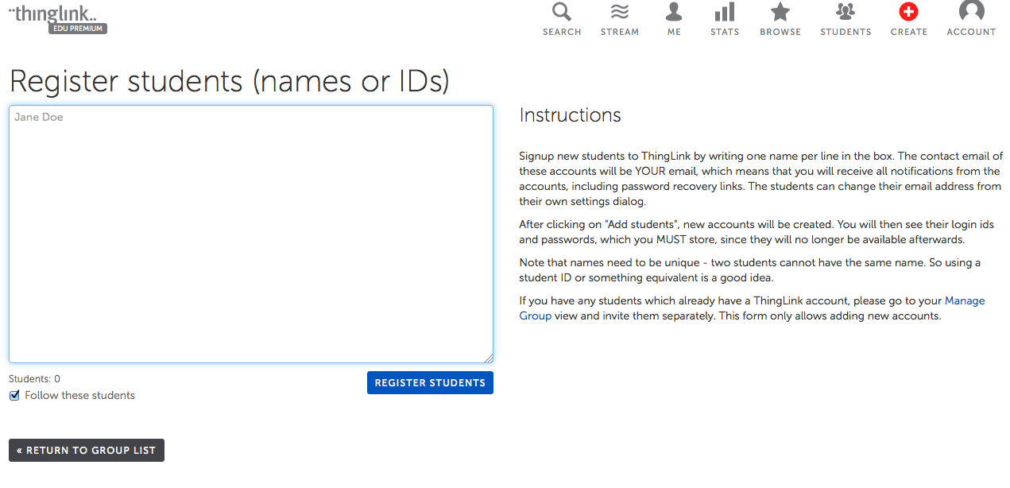

When the accounts are created, you will see a list of all the students’ account usernames and passwords. PRINT THIS. Your email address will be the default email address until they change it using their own Settings dialog box. Log into the Group account and create a channel for your group where their work will appear.

