IS 6840 – FALL 2013
INFORMATION SYSTEMS ANALYSIS

DR. VICKI SAUTER

PAPER ON
CMMI AND ISO AND / OR THEIR IMPACT

SUBMITTED BY
SHAILESH LANJEWAR
11/18/2013
Introduction to Best Practices
‘Best Practices’ has become one of the most used buzzwords in nearly all industries and organizations around the world.^{1, 2} Whether it is the education system or the health care industry, business world or the charity/non-profit sector, government administration or the hospitability management, department of defense or social media, best practices is being given plenty consideration not only in designing new projects and system but also in improving existing systems and processes.^{2, 3} Therefore, it becomes critical to define best practices for the sake of further discussion.

The definition of best practices can be as simple as ‘commercial or professional procedures that are accepted or prescribed as being correct or most effective’⁴, ‘methods or techniques that have consistently shown results superior to those achieved with other means, and that are used as a benchmark’⁵ or ‘techniques or methodologies that, through experience and research, have proven to reliably lead to a desired result’³. Alternatively, some prefer to define best practice more specifically as ‘an approach to find win/ways to change and improve what you do, respecting the various stakeholders and showing empathy for their situation; an approach using step by step processes to tackle challenges, recording at each stage what works and what doesn’t, sharing the results, and then repeating the successful formulae to create consistency, quality, and repeatability; an approach that questions what you do and why you do it both at the strategic and operational level constantly seeking the most efficient and effective ways to make profit for the business’⁶.

In general, a best practice can be a method, a technique, a set of guideline, ethics, idea, processes, systems or practices used by a company or organization to consistently achieve the “best” goals or results.^{1, 2, 7} These best practices should be reproducible not only for the organization in question but also for other organizations or industries that adopt them, with equally successful results. That said, best practices cannot be the same over a very long period of time. With fast advancing research and development in the field of computers and technology, best practices may or may not be the “best” available for that time. Thus, there has to be a constant analysis of the needs of the organization or system over time to make the necessary updates or upgrades to ensure that the “best” practices are still better than others.

While a blog, ‘Best Practices Club’ considers best practices as a discipline, provides steps for identifying best practice and provides a list of pitfalls to be avoided⁸, another website indicates that lack of knowledge about current best practices, a lack of motivation to make changes involved in their adoption and a lack of knowledge and skills required to do so may be big barriers for adoption of best practices.³ There has also been some criticism to best practices. An article from Forbes insists that these ever changing so called “best” practices should really be called “next” practices because they seldom are on-size-fits-all solution. In fact, the author goes not so say that every business problem is different and therefore, the “best” practices from each of them will obviously be different.⁹ Another article from Inc.com also reinforces that not all business problems are same and it is essential to determine if the problem is industry specific, context based or user based. Only then can the best solutions be sought. It cautions its readers that best practices are only an average or a benchmark and that creativity and innovation can help business excel and stand out from the rest of the crowd.¹⁰

Video 1: Dilbert on Best Practices
http://www.youtube.com/watch?v=ESDOJc1APAk

Video 2: Quality Standards, ISO, CMMI & Six Sigma
http://www.youtube.com/watch?v=eAmGi88D8rU
CMMI
CMMI stands for Capability Maturity Model Integration

History & Origin of CMMI
CMMI was developed at the Software Engineering Institute or SEI of Carnegie Mellon University in Pittsburg, Pennsylvania, USA. CMMI was originally developed as CMM (Capability Maturity Model) in 1987 at the Research and Development Center at Carnegie Mellon University known as SEI. CMM was the child of a U. S. Air Force financed research for objectively evaluating the work of software subcontractors. Thus, the Department of Defense established SEI to develop CMM and though originally it was meant to evaluate software development, it has since been applied as a model for maturity of processes in both IT and non-IT organizations.^{11, 12}

Over time, with increasing examples of successful implementation of CMM, the model was revised several times and applied to various subjects beyond software. This rapid proliferation of different models of CMM became confusing and thus dawned a new project involving more than 200 industry and academic experts funded by the government with the goal of developing a unique, extensible framework integrating systems engineering, software engineering, and product development.¹² Thus was born CMMI. Though it was an improvement over CMM, it had the original five levels of process maturity namely Initial, Managed (previously known as Repeatable), Defined, Quantitatively Managed (previously known as Managed), and Optimizing. The model has 22 process areas categorized into process management, project management, engineering, and support.¹¹ CMMI comprises of three overlapping constellations or disciplines: CMMI-DEV (Product and Service Development), CMMI-SVC (Service Establishment, Management, and Delivery) and CMMI-ACQ (Product and Service Acquisition) focusing on Development, Service Management and Acquisition respectively.¹³
More on CMMI, CMMI Maturity Levels & Benefits of using CMMI
CMMI is a proven approach, developed with practices and goals seen in thousands of real organizations worldwide, to performance management with decades of successful results indicating its effectiveness. Implementing CMMI helps the organization to have predictable cost, schedule and quality to give it an edge over its competitors.¹⁴ In other words, CMMI helps the organization better their processes to control costs while giving better quality results and realistic time estimates for projects.¹¹ CMMI provides the organization with guidelines for processes improvement, an integrated approach to process development, embedding process improvements into a state of business as usual and a phased approach to introducing improvements.¹³

Maturity levels are well-defined platforms or foundation layers that evolve over time and undergo continuous improvement process in order to get developed into mature software processes. Each maturity level is similar to a base of a pyramid which has some objectives, which when reached, strengthens it. Once the level of maturity framework is reached, a different component of the software process is established. This results in increased process capacity in the organization.¹⁵ Thus, a business can utilize CMMI to decrease costs, improve on-time delivery, improve productivity, improve product quality, improve service quality, improve customer satisfaction, gain impressive returns on investment, and so on.¹⁴

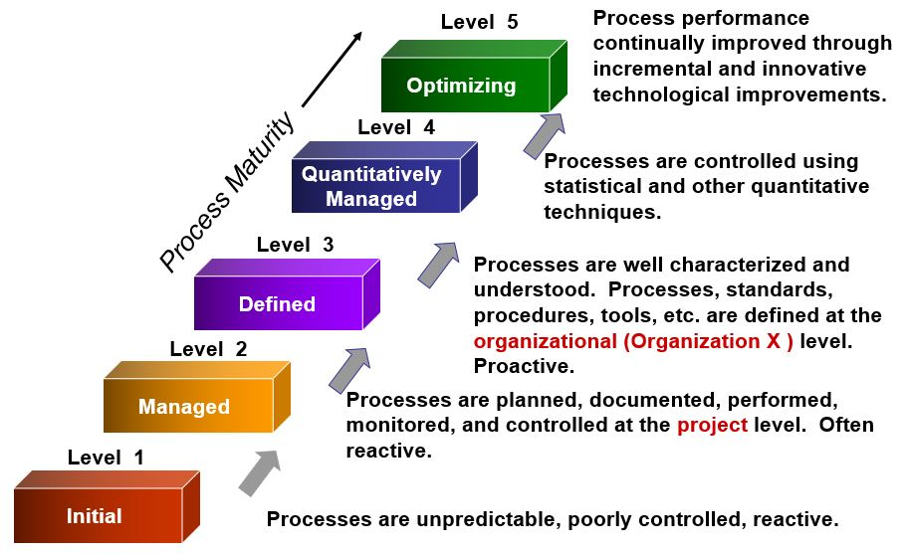
Figure 1: CMMI Maturity Levels

ACRONYM | PROCESS AREA
CAR | Casual Analysis & Resolution
CM | Configuration Management
DAR | Decision Analysis & Resolution
IPM | Integrated Project Management
MA | Measurement & Analysis
OID | Organizational Innovation & Deployment
OPD | Organizational Process Definition
OPF | Organizational Process Focus
OPP | Organizational process Performance
OT | Organizational Training
PI | Product Integration
PMC | Project Monitoring & Control
PP | Project Planning
PPQA | Process & Product Quality Assurance
QPM | Quantitative Project Management
RD | Requirements Management
REQM | Requirements Management
RSKM | Risk Management
SAM | Supplier Agreement Management
TS | Technical Solution
VER | Verification
VAL | Validation

Table 1: Elements of CMMI model

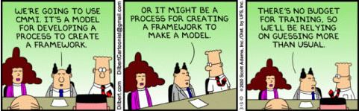
Comic Strip 1: Dilbert on CMMI
SCAMPI & CMMI Appraisals
Unlike other certifications, CMMI does not have the concept of certification. Instead, the concerned organization is appraised and may receive maturity level rating from 1 to 5 or a capability level achievement profile. The appraisal measures the efficiency of the organization’s processes against CMMI best practices and provides some insight in their improvement. It further helps the organization meet its contractual requirements with clients and customers and inform them how it is doing in comparison to CMMI best practices.¹³ The CMMI appraisal requirements have been mentioned in Appraisal Requirements for CMMI (ARC) and there are three different types of appraisals – A, B and C.¹⁶ SCAMPI stands for Standard CMMI Appraisal Method for Process Improvement. SCAMPI A is the only SCAMPI appraisal method that can result in a Maturity or Capability Level Rating. SCAMPI B is often helpful for User Acceptance or ‘test’ appraisal and SCAMPI C is employed for gap analysis and data collection tool. SCAMPI appraisal can only be carried out by a Certified SCAMPI Lead Appraiser.^{13, 17} The SCAMPI A Appraisal results are published on the SEI website.^{16, 17}
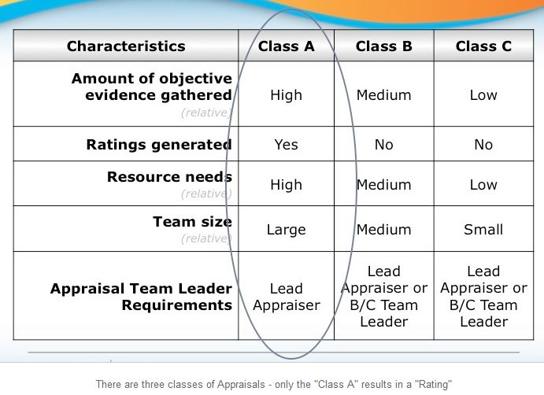
Figure 2: CMMI Appraisals

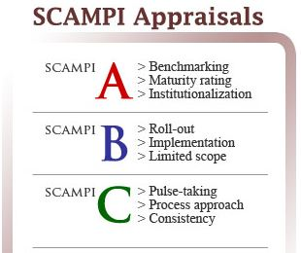
Figure 3: SCAMPI Appraisals
ISO
ISO stands for International Organization for Standardization. It is said that ISO is a word derived from Greek isos, which means ‘equal’, thus giving this organization a perfect name.¹⁸

History & Origin of ISO
Back in 1946, 65 delegates from 25 countries met in London to discuss the future of International Standardization. This, in 1947, gave birth to ISO with 67 technical committees with experts focusing on specific subjects. Today, ISO has a full time staff of 150 people working at their Central Secretariat in Geneva, Switzerland and members from 164 countries. In this period, ISO has published 19,500 International Standards covering nearly all aspects of technology and business.¹⁹

Standards, Standard Development & Importance
A standard is a document providing specifications, requirements, guidelines or characteristics that can be used consistently anywhere and everywhere. This ensures that different products, materials, processes and services available round the world are fit for their purpose. To develop such standards, the first step is to identify the need for a standard. Once established, experts meet up to develop opinion and negotiate a draft standard. It is then shared with ISO members for feedback and a consensus is reached. The draft is then modified according to needs and the standard is finalized. These standards are developed by a groups of experts within a technical committee.¹⁹

As can be imagined, ISO standards are very beneficial not only to the society, but also to businesses and even governments. For a business, savings, better customer satisfaction, access to new markets, increased market share and minimization of negative impacts on the environment are some of the important benefits of implementation ISO standards. As far as society is concerned, ISO involves consumers in standard development through COPOLCO (Committee on Consumer Policy). This ensures that consumers have confidence in the use of services and products in regards to their safety, quality, and reliability. ISO also ensures health of citizens and preserving the environment through International Standards on air, water, and soil quality, on emissions of gases and radiation and environmental aspects of products. For governments, ISO standards provide them with experts’ opinions without having to call on their services directly and by integrating ISO standards into national regulations, governments ensure the movement of goods, services and technologies from country to country.¹⁹

Video 3: Benefits of ISO Standards
http://www.youtube.com/watch?v=AYBVTeqKahk&feature=c4-overview-vl&list=PLD1CD58D7A5035F2B

Video 4: Happy World Standards Day
http://www.youtube.com/user/PlanetISO

STANDARD | CATEGORY | PURPOSE
ISO 9000 | Quality Management | To ensure that the products and services meet customers’ requirements and quality is consistently improved
ISO 14000 | Environmental Management | To control the organization’s environmental impact and improve their environmental performance
ISO 3166 | Country Codes | To establish internationally recognized codes to avoid confusion when referring to countries and their subdivisions
ISO 22000 | Food Safety Management | To identify and control food safety hazards and ensure safety of the global food supply chain
ISO 26000 | Social Responsibility | To guide organizations operate in a socially responsible way, contributing to the health and welfare of the society
ISO 50001 | Energy Management | To make the organization more energy efficient and environment-friendly
ISO 31000 | Risk Management | To manage risks that could be negative for the company’s performance
ISO 4217 | Currency Codes | To establish internationally recognized codes to avoid confusion when referring to world currencies
ISO 639 | Language Codes | To establish internationally recognized codes for representation of languages or language families
ISO 20121 | Sustainable Events | To manage the social, economic and environmental impacts of the event
ISO 27001 | Information Security | To ensure the organization’s information is secure

Table 2: Some Popular ISO Standards

ISO 9001
The ISO 9000 family has one of the best known standards and concerns varied aspects of quality management. These standards are used as guidelines and tools by companies and organizations to consistently meet customers’ expectations through improved quality of products and services. Some of the members of ISO 9000 family are ISO 9001:2008 (sets out requirements of a quality management system), ISO 9000:2005 (covers the basic concepts and language), ISO 9004:2009 (focuses on how to make a quality management system more efficient and effective), and ISO 19011:2011 (sets out guidance on internal and external audits of quality management systems).

Of these, ISO 9001 is widely recognized and its versatile design makes it useful for virtually any product or service made by any process anywhere in the world. ISO 9001:2008 is the only member of the family that can be certified regardless of the field of activity or the size of the company or organization. Over a million companies and organization around the world have already implemented ISO 9001:2008. The principles involved with this standard include motivation and implication of the top management, strong customer focus, the process approach and continual improvement. Internal audits to check the quality management system or external audits by independent certification body to verify the conformity to the standard is an integral part of this standard.^{19, 20}

CMMI Implementation, ISO Certification & Impact
A little research about topics like best practices, CMMI model implementation and ISO certification may lead to a theoretical perception that they are vital for betterment of business in general and very profitable in the long run for any organization or company. Superficially, these processes seem to be very appealing for a successful launch of a new business or for the improvement of existing, not so good business. This section includes some research and discussion about the practical implementation of CMMI or the ISO certification, the problems and challenges faced in doing so, and the impact it had on the concerned organizations and businesses.

A study involving skilled professionals from software industries working in Brazil, China and India from 2009 focused on the perception these professionals had about the implementation of CMMI and its subsequent impact. Nearly 430 employees from 19 different software production companies participated in this study. It centered on three different dimensions namely the country, company’s maturity level and the company’s size impacting software project development, quality and productivity, professional career, team/working environment, problem identification, and analyses and modelling. The study found that CMMI model implementation improved software project management and quality and productivity in China and India than Brazil, while improvement in problem identification was more in Brazil than the other two countries. In general, professionals from all three countries agreed that though CMMI model implementation has overall positive results and that smaller firms have more impact, areas like HR management still seemed lacking. Improvements in such areas may be given more consideration when developing the future versions of CMMI.²¹

While improvements with the implementation of CMMI model cannot be denied, there are concerns whether the focus should be on the CMMI ratings or actual improvements recommended by CMMI model. In an interview, an expert in software and process improvement, Richard E. (Dick) Fairley has expressed this concern. According to him, data published by SEI indicates that if the improvements focus on CMMI ratings, a positive ROI can be achieved in two or three years. Dick Fairley dismisses this and remarks that CMMI ratings should in fact be the byproduct of improvement and no the goal of improvement. He informs that by reducing the avoidable rework and focusing on improving techniques can actually help achieve ROI within 12 months! Unfortunately, due to contracting issues, CMMI ratings are perceived as cost of doing business but without any perceptible benefit. Instead, focus on implementing CMMI best practices will lead to improvements and automatically ensure higher CMMI ratings.²²

A group from South Korea realized the difficulties encountered by ISO certified organizations in implementing the CMMI model to their systems. While CMMI model would work for process improvement, ISO 9001 is a standard for quality management systems. So, improving processes in already ISO certified organizations seems to be a good choice. But, this implementation is not as straightforward as one would expect. The language, structure and details in these two sets of documents are very different. Also, it is not very clear as to what parts of ISO could be reused in CMMI adoption. The group proposed a unified model for the implementation of both ISO 9001:2000 and CMMI by ISO-certified organizations. By doing so, they claim that this unified model will not only be useful to complete the necessary gap analysis, but also in maintaining their quality documentation. Furthermore, the model will help simultaneous implementation of CMMI and ISO 9001:2000 even for the organizations that do not currently have ISO certifications. However, the efficiency with which this unified model will help the organization has not been evaluated yet and the group wants to finish this work in the future.²³

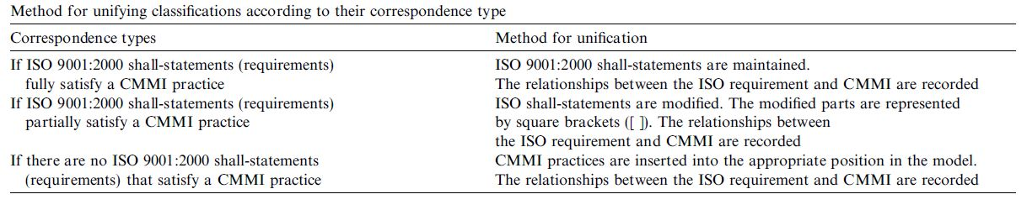
Table 3: Methods for Unifying Classifications

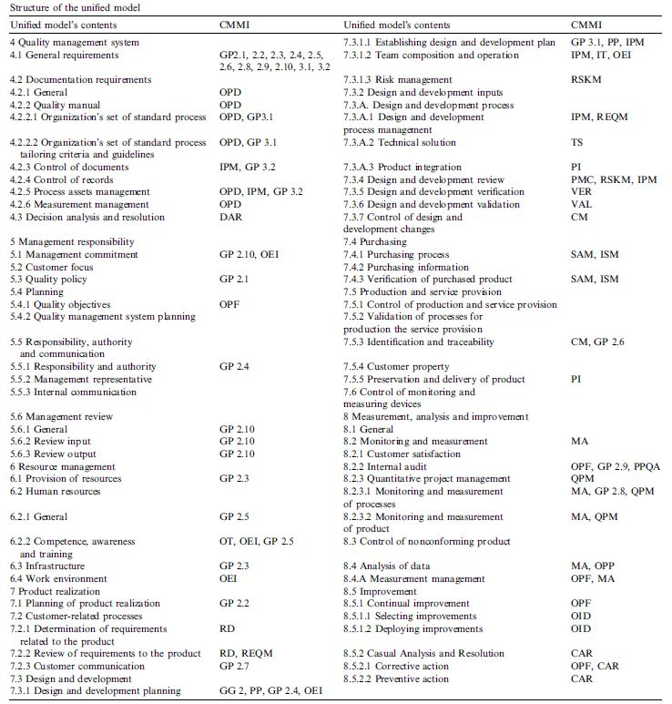

Table 4: Structure of Unified Model

Trudel et al developed a software process quality evaluation method for smaller firms. They based their method on the already existing ISO/IEC 14598-5 standard methodology. To this, they combined the CMMI-based evaluation method to create their unique evaluation that not only reduced evaluation costs but also was tailored to the needs of smaller firms with 2 to 10 employees. The team used the six steps aligned with the ISO/IEC 14598-5 evaluation process and added an extra step to address the findings in the action plans with priorities and assignment of responsibilities. They claimed that this type of ISO/CMMI hybrid evaluation method could evaluate small firms and first draft of action plans addressing the major findings be proposed within a week.²⁴

In yet another study conducted to evaluate the impact of ISO 9000 certification, nearly 500 Italian companies, both ISO certified and without certifications were considered. The goal of this study was to determine organizational effectiveness of the firms in question and the factors considered included customer satisfaction, profitability and productivity. The results obtained for the ISO certified companies and the ones without certification has comparable results. Though the ISO certified companies reflected slightly better results, the differences were not statistically significant. 20 % of these companies were multinational and most of them had market in the EU, although they were not required to be ISO certified. Moreover, there were companies that had been doing business for years now and many practiced TQM based strategies. Despite the fact that individual characterization of the firms before and after certification would have yield better results, a variability in the demographic characteristics that could not be controlled for the sake of study, combined with some of the above mentioned factors were important attributes in the results obtained.²⁵

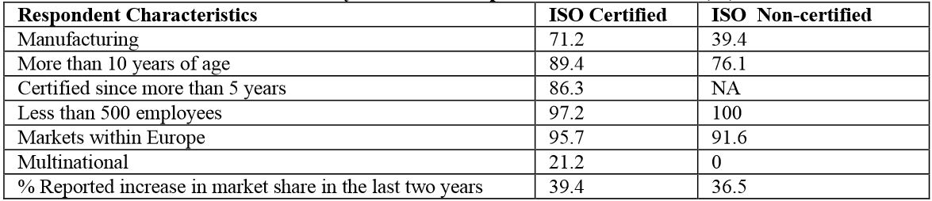
Table 5: Comparison between ISO Certified and Non-certified Firms
The region considered for such studies and types of ISO certifications or best practices may play a key role in such studies. For example, a research conducted in Saudi Arabia to study the effects of ISO 14001 certification revealed a very positive response, although costs involved were a major concern. This study, which involved over 140 firms in the sectors of private manufacturing, private services and public firms, studied the attitudes of managers towards the effects of ISO 14001 certification. The benefits cited by the managers included contribution towards making the environment better, safer internal workplace and safer products to customers while the difficulties were costs involved including fees of external house of experts, costs of internal changes and fees of the certification agencies. Though this certification has not been made mandatory and very few firms in Saudi Arabia (including those involved in this study) have the certification, there seemed to be an overwhelming positive response towards ISO 14001 certification.²⁶

On the other hand, another research conducted in Bangladesh selected a sample of 150 companies to study the implications of the ISO 9000 certification. Again, the perception of the managers was being examined. The intent of the author in selecting Bangladesh was to determine the problems in the implementation of ISO standards in developing economics. Though Bangladesh is still developing, it was clear that ISO 9000 was pretty seriously considered. There is evidence that managers consider ISO certification vital for having an edge over competitors and for survival in the global market. Even though problems exist, implementation of ISO 9000 is definitely beneficial.²⁷

Even though practices like CMMI could be implemented and ISO certifications obtained, a question that comes to mind is – Are these certifications enough for successful and sustainable business in the long run? Roslina Wahid from Malaysia found out that top management commitment, employee involvement, recognition and reward, continuous improvement, teamwork, and quality culture are some of the critical factors for successful maintenance of ISO 9000. There is need to ensure that quality system is running effectively, data about process, system and customers is being collected and analyzed, management review, internal and external audits are being taken seriously to ensure proper maintenance of ISO 9000. Often, problems like lack of commitment. Lack of cooperation, lack of knowledge and training, lack of awareness and understanding of ISO 9000 and lack of communication has been sighted as obstacles for successful ISO 9000 maintenance. The proposed solution to these problems involve major overhaul on top management’s orientation towards quality and ISO 9000, quality orientated managers and employees, commitment and involvement of people, communication and relationship building amongst people along with proper education and training about ISO 9000. These steps, if followed properly and incorporated as a part of work culture will not only help the organization go beyond the certification, but only distinguish them apart from their competitors.₂₈

A quantitative analysis to determine the success of ISO implemented systems in Portuguese Organizations was performed in sector from agro-food to construction. The aim was to econometrically analyze the impact of ISO 9001 on productivity, business value and sales and the variables considered for different hypotheses were sales, gross added value (GAV), current profits, net profits, certification ISO, asset and productivity. The results obtained confirmed that the positive effect of ISO 9001 certification in the agro-food industry was more significant than in the construction industry. Although there was a general increase in the net profits after ISO 9001 implementation, result could not successfully ascribe them to the certification itself. As far as productivity is concerned, the positive effect of certification was not statistically significant in both sectors. It seemed that more research in this direction was needed.²⁹

A Portuguese research studies the impacts of ISO 9001 in educational sector. The results and findings of the work were categorized into internal benefits, external benefits, disadvantages and success factors. Improvements in the internal organization of the vocational institutions was the gist of the internal benefits while improved market creditability was the external benefit gained by the certification. As far as the disadvantages of the ISO certification were concerned, they were limited to the actual implementation of ISO 9001:2000 and to the increased bureaucracy after the implementation. The critical success factors identified in this study circled around management, communication, people involvement and communication and quality teamwork.³⁰

To conclude, it is pretty evident that implementing CMMI best practices and / or ISO Standards has a positive impact on the organization or business in question. There are some concerns about the costs involved, but in the long term, these investments seem to be very effective and worthwhile. That said, the actual implementation is not very easy and seems challenging, depending on the country, the industry and business involved, the size of the organization and the goals and commitment of the people involved. Furthermore, keeping up with these adopted ISO/CMMI standards is not easy and requires considerable commitment and effort. Also, just having these standards and certifications does not guarantee success. To make your mark and stand out of from the crowd of competitors, no matter whether at local or at global level, requires even more work and innovation.

Bibliography
- http://www.webopedia.com/TERM/B/best_practices.html
- http://en.wikipedia.org/wiki/Best_practice#Use_of_Best_Practices_in_Health_and_Human_Services
- http://searchsoftwarequality.techtarget.com/definition/best-practice
- http://www.oxforddictionaries.com/definition/english/best-practice
- http://www.businessdictionary.com/definition/best-practice.html
- http://bestpracticehub.com/best-practice-definition/
- http://www.investopedia.com/terms/b/best_practices.asp
- http://bestpracticesclub.org/?page_id=41
- http://www.forbes.com/sites/mikemyatt/2012/08/15/best-practices-arent/
- http://www.inc.com/eric-v-holtzclaw/forget-your-industrys-best-practices.html
- http://www.cio.com/article/147100/Capability_Maturity_Model_Integration_CMMI_Definition_and_Solutions?page=2#Where%20did%20it%20come%20from
- http://msdn.microsoft.com/en-us/library/ee461556.aspx
- http://www.dthomas.co.uk/dtalm/products/technologies/what-is-cmmi.htm
- http://cmmiinstitute.com/
- http://www.vates.com/eng/cmmi5/what-is-cmmi.html
- http://www.selectbs.com/process-maturity/what-is-capability-maturity-model-integration
- http://www.broadswordsolutions.com/what-is-cmmi/
- http://searchdatacenter.techtarget.com/definition/ISO
- http://www.iso.org/
- http://www.alcumusgroup.com/isoqar/standards/iso9001-quality/

Refereed Articles
- A comparative analysis of CMMI software project management by Brazilian, Indian and Chinese companies. de Oliveira, Saulo Barbara; Valle, Rongerio; Mahler, Claudio Fernando. Software Quality Journal. 18.2. Jun 2010. 177-194. (http://search.proquest.com.ezproxy.umsl.edu/abicomplete/docview/235091049/141C057587B68706A4D/9?accountid=14595)
- Software Quality, Metrics, Process Improvement, and CMMI: An Interview with Dick Fairley. Hinkle, Matthew M. IT Professional Magazine. 9.3. May/Jun 2007. 47-51. (http://search.proquest.com.ezproxy.umsl.edu/abicomplete/docview/206315053/141C0655E3E6A180C7C/23?accountid=14595)
- A unified model for the implementation of both ISO 9001:2000 and CMMI by ISO-certified organizations. Yoo, Chanwoo; Yoon, Junho; Lee Byungjeong; Lee, Chongwon, Lee Jinyoung; Hyun, Seunghun; Wu, Chisu. The Journal of Systems and Software. 79.7. jul 2006. 954-961. (http://search.proquest.com.ezproxy.umsl.edu/abicomplete/docview/229629179/141CA2F102C16005FCF/4?accountid=14595)
- PEM: The small company-dedicated software process quality evaluation method combining CMMISM and ISO/IEC 14598. Trudel, Sylvie; Lavoie, Jean-Marc; Marie-Claude Pare; Suryn, Witold. Software Quality Journal. 14.1. Mar 2006. 7-23. (http://search.proquest.com.ezproxy.umsl.edu/abicomplete/docview/235100572/141C0842F25CCEC70D/25?accountid=14595)
- On Impact of ISO 9000 Certification on Organizations. Kartha, C P. Journal of American Academy of Business, Cambridge. 19.1. Sept 2013. 38-44. (http://search.proquest.com.ezproxy.umsl.edu/abicomplete/docview/1357565473/141C093013D114E5706/1?accountid=14595)
- Attitudes of Mangers towards the Potential Effects of ISO 14001 in Saudi Arabia: Factor Analysis. Kadasah, Nasser Akeli. International Business Research. 6.7. Jul 2013. 91-101. (http://search.proquest.com.ezproxy.umsl.edu/abicomplete/docview/1430974412/141C0B13C327D7EE48F/8?accountid=14595)
- Corporate Satisfaction with ISO 9000: An Empirical Study of Bangladesh. Karim, Ahmad. Journal of Global Business Management. 9.2. Jun 2013. 1-6. (http://search.proquest.com.ezproxy.umsl.edu/abicomplete/docview/1441253970/141C0C8E36F32C40102/15?accountid=14595)
- Beyond certification: a proposed framework for ISO 9000 maintenance in service. Roslina Ab Wahid. TQM Journal. 24.6. 2012. 556-568. (http://search.proquest.com.ezproxy.umsl.edu/abicomplete/docview/1095837268/141CA49A54C33C66D4/25?accountid=14595)
- ISO 9001 and Business Performance: A Quantitative Study in Portuguese Organizations. Dias, Alcina Augusta de Sena Portugal; Heras-Saizarbitoria, Inaki. Revista de Management Comparat International. 14.1. Mar 2013. 14-32. (http://search.proquest.com.ezproxy.umsl.edu/abicomplete/docview/1355900059/141CA4F173D1E396A41/13?accountid=14595)
- The impacts and success factors of ISO 9001 in education. Gamboa, Antonio Jorge; Nuno Filipe Melao. The International Journal of Quality & Reliability Management. 29.4. 2012. 384-401. (http://search.proquest.com.ezproxy.umsl.edu/abicomplete/docview/963340707/141CA4F173D1E396A41/34?accountid=14595)

Videos
- Video 1: Dilbert on Best Practices
(http://www.youtube.com/watch?v=ESDOJc1APAk)
- Video 2: Quality Standards, ISO, CMMI and Six Sigma
(http://www.youtube.com/watch?v=eAmGi88D8rU)
- Video 3: Benefits of ISO Standards
(http://www.youtube.com/watch?v=AYBVTeqKahk&feature=c4-overview-vl&list=PLD1CD58D7A5035F2B)
- Video 4: Happy World Standards Day
(http://www.youtube.com/user/PlanetISO)

Figures & Tables
- Figure 1: CMMI Maturity Levels
(http://www.google.com/url?sa=t&rct=j&q=&esrc=s&source=web&cd=1&ved=0CDMQFjAA&url=http%3A%2F%2Fcs.njit.edu%2F~kirova%2Fppt%2FCMMI.ppt&ei=06qEUrPwFsWyygGJrYBI&usg=AFQjCNHfg5o_OhtrW8IPxruyoezr2oqPUg&bvm=bv.56343320,d.aWc)
- Table 1: Elements of CMMI model
(http://msdn.microsoft.com/en-us/library/ee461556.aspx)
- Comic strip 1: Dilbert on CMMI
(http://www.kennedyryder.com/cmmi.html)
- Figure 2: CMMI Appraisals
(http://www.broadswordsolutions.com/what-is-cmmi/)
- Figure 3: SCAMPI Appraisals
(http://www.spaceminds.com/eng/SCAMPI-Appraisals.aspx)
- Table 2: Some Popular ISO Standards
(http://www.iso.org/iso/home/standards.htm)
- Table 3: Methods for Unifying Classifications
(http://search.proquest.com.ezproxy.umsl.edu/abicomplete/docview/229629179/141CA2F102C16005FCF/4?accountid=14595)
- Table 4: Structure of Unified Model
(http://search.proquest.com.ezproxy.umsl.edu/abicomplete/docview/229629179/141CA2F102C16005FCF/4?accountid=14595)
- Table 5: Comparison between ISO Certified and Non-certified Firms (http://search.proquest.com.ezproxy.umsl.edu/abicomplete/docview/1357565473/fulltextPDF/141C020267E6E0FBCFE/1?accountid=14595)

