The Agile Group
2009
Final Analysis of the University of Missouri- St. Louis Calendar System
Scheduling the Future
Mehdie Ataei, Michael Bruns, Douglas Hughey, and Atchara Sunthornrangsan
IS 6840, Dr. Vicki Sauter
1 University Blvd. St. Louis, MO 63121

Table of Contents
Definition of the Problem 5
A Bird’s-eye View 5
A Narrowed Focus 6
Current System Description 7
History of the Campus Calendar 7
Event Submission Process 8
Campus Events Population Process 9
The Calendar’s User Interface 10
How can I look up events on a certain day? 10
How can I search for events by category? 10
How can I search for events by title or keyword? 11
System and Support Strengths and Deficiencies 11
System Requirements 12
Gathered User Requirements 12
Clients 13
Stakeholders 14
Finalized New System Specifications 19
Exploring Solutions 23
Consideration of All Solutions 23
Solution 1 – “Do Nothing”, but Enforce Usage 23
Solution 2 – Hire a New Employee to code a New Calendar 24
Solution 3 - Outsource the Production of a Calendar to Contractors 25
Solution 4 – Application Service Provisioning (Google Apps) 25
Solution 5 – Application Service Provisioning (Trumba) 26
Solution 6 – Implement an Open Source Solution – Bedework Enterprise 27
Solution 7 – License a Proprietary Calendar Solution – EMS Master Calendar 27
A Closer Focus: Three Options to Consider 28
Solution 1 - “Do Nothing”, but Enforce Usage 28
Solution 6 - Bedework Enterprise 29
Solution 7 - EMS Master Calendar 30
The Agile Group’s Recommended Solution 31
EMS Master Calendar Software Solution 31
Enforced Usage Content Solution 31
Errata/Conclusion 32
EMS Room Management Software 32
Revisiting the Bird’s-eye View 33
Final Justification 33
Appendices 35
Appendix A: Data Dictionary 35
Appendix B: Diagrams of the Current and Proposed Systems 53
Figure 1 - Current System Context Diagram 53
Figure 2 - Current System Level 0 Data Flow Diagram 53
Figure 3 - New Logical System Context Diagram 53
Figure 4 - New Logical System Level 0 Data Flow Diagram 53
Figure 5 - New Logical System Level 1 Data Flow Diagram 53
Figure 6 - New Logical System Level 2 Data Flow Diagram 53
Figure 7 - New Logical System Level 3 Data Flow Diagram 53
Figure 8 - New Logical System Level 4 Data Flow Diagram 53
Figure 9 - New Logical System Level 4.1 Data Flow Diagram 53
Figure 10 - New Logical System Level 5 Data Flow Diagram 53
Figure 11 - New Logical System Level 6 Data Flow Diagram 53
Figure 12 - New Logical System Level 7 Data Flow Diagram 53
Figure 13 - New Logical System Level 8 Data Flow Diagram 53
Figure 14 - New Logical System Level 9 Data Flow Diagram 53
Figure 15 - New Logical System Level 10 Data Flow Diagram 53
Figure 16 - New Logical System Us e Case 53
Figure 17 - New Logical System ER Diagram 53
Appendix C: Campus Web Designers/ Department/Division Heads Survey Results 71
Appendix D: UMSL Student Survey Results 81
Appendix E: Interview Transcripts 124
Figure 1: Mary Fowler, Holli Kubly, Patrick Flanigan, representing ITS 124
Figure 2: Bob Samples, Kit Breshiers, representing Media, Creative Services & Printing Services 128
Figure 3: Gina Ganahl, John Matthews, Bonnie Unahl, Vicky Hawkins, representing Continuing Education 131
Figure 4: Dinesh Mirchandani, representing Business Administration 133
Appendix F: Test Cases 135
Figure 1: Sample Test Cases 135

Definition of the Problem

A Bird’s-eye View
The web site for the University of Missouri-St. Louis (UMSL) is about five years old, and is starting to feel out of date. A lot of university web sites have been updated in this time frame, and while the UMSL web site is generally regarded by the administration as sufficient to get by, the administration has become concerned that the dated look and feel is giving potential students, employees and donors an image that does not live up to the overall quality of the environment and education at UMSL. There are further concerns that UMSL is not doing enough to embrace Web 2.0 technologies , such as social networking, blogs and podcasts.
Upon closer examination of the problem, the team has discovered additional problems with UMSL’s web presence:
- There are two people on campus who are designated as campus-wide web designers. These two people are responsible for the look and feel of the UMSL web site, as well as the UMSL home page, a number of additional divisional pages, and support for the designers of all divisional and departmental web pages. Their qualifications are sufficient for the type of work that they are doing, but the amount of content necessitates that they cannot be reasonably tasked with ensuring the full UMSL web site meets minimum design standards.
- There are over 100 people on campus who are designated as divisional or departmental web designers. The experience and knowledge level of these people ranges from basic training to know how to type words on a page and then upload that content using Dreamweaver, to classroom training and years of experience. Further complicating matters, the majority of the web designers on campus handle their web pages as only a small part of their overall job. As such, even an experienced web designer may neglect his or her web pages for other tasks that are deemed more important. Based on the results of a survey of campus web designers and department leads, we have also determined that there appears to be a lack of communication and training from campus administration. These varying experience and knowledge levels, combined with the time constraints of web developers, have led to an inconsistency in quality from one page to the next.
- There does not seem to be a centralized, cohesive plan for the UMSL web site. Based upon the group’s conversations with various entities, we have found that different departments and administrators hold contrasting viewpoints on the direction in which the UMSL web site should be headed.
Based upon what the group has discovered, we feel that the campus administration has not placed sufficient emphasis on the UMSL web site, and this has led to stagnation, from the top level down to departmental websites. We believe that while campus administration has sought out our class to redesign the web site, it is equally important to reconsider the processes that surround it. As such, our recommendations will include considerations of process redesign and the purchase of off-the-shelf packages. These recommendations are consistent with an approach that includes contributing additional resources to UMSL’s web presence, to help ensure that it is top-tier.

A Narrowed Focus
Given our time and resource constraints, the Agile Group has decided to limit our scope to the Campus Calendar, which is linked from the UMSL home page. We believe that the UMSL Campus Calendar provides a perfect example of the diversity of problems with UMSL’s web presence. Furthermore, we believe that not only would an improved Campus Calendar solution improve the look and feel of UMSL’s overall web presence, but it would also stand on its own as a worthwhile investment to improve student recruitment, student retention, and alumni and community involvement on campus. We will discuss these exciting possibilities soon, but we feel that an important part of finding the right solution is gaining an understanding of the functionality, strengths and drawbacks of the current solution.

Current System Description

History of the Campus Calendar
The calendar was first introduced approximately 7 years ago, and it received a major refresh approximately 4 years ago. It was programmed using Adobe’s ColdFusion software. The programmer who wrote the calendar application is no longer employed by the University. At the Calendar’s inception, Information Technology Services (ITS) was very excited about the application, as it allowed them to automate the process of posting events to the University’s website. Furthermore, at the time that the calendar was implemented, it was considered very advanced. In fact, the University fielded requests by other universities to use the code for the calendar so that they could develop their own similar calendar application.
For the first few years, the campus calendar served the University very well; however, in the last few years, departments have been asking for a means to advertise their own events on their own department web pages. Unfortunately, the categorization scheme for the campus calendar does not support this. The one notable exception to this constraint is Student Life, which feeds from the campus calendar; they have their own category by design. While the University could code new categories for the departments that would like to participate, ITS views an expanded list of departments as too cumbersome for most users given the restraints of the current user interface. We agree with ITS' assessment, as without separate sub-calendars or a way to display events that is not solely text-based, expanding categorization to include every department would lead to an even more confusing structure. ITS was also quick to point out that there are many products available from vendors that not only include an improved user interface and more advanced categorization, but also do much more.
In 2008, ITS looked into commercially available calendar products and selected one called EMS Master Calendar. They intended to pilot this calendar application in January 2009. However, funding for this project was cut as a result of the economic downturn. As this juncture, UMSL is left using the current calendar system until an improved solution can be justified in the wake of current budget cuts.

Event Submission Process
Submissions are made via a link on the calendar page in the lower left corner titled “Submit an Event”. The calendar page can be reached from the homepage via two routes: 1) there is a very small link at the top of the UMSL homepage titled “Calendar”, or 2) a user can click on an event that is listed on the homepage under the header “Campus Events”. Notably missing in this process is the ability to click the header “Campus Events” to navigate to the campus calendar.
Once the user navigates to the calendar and clicks the “Submit an Event” link on the calendar page, the user is presented with a form to complete. This form includes fields such as “Event Name”, “Contact Information”, “Event Category”, “Event Location”, and the time and date, as well as a description textbox and a drop-down menu that allows the user to select who the target audience of the event is.
Once the user fills out an event submission form and clicks the “Submit Event” button, a confirmation page is displayed with the message detailed in Figure 1.
Figure 1:
“Thank you for submitting an event.
Once approved, the event will be available on the calendar site.
If you are submitting several events, you may wish to hit back in the browser to avoid re-entering information which may be repeated.”
If the required fields are not filled out, a field-specific error message is generated, such as:
“Event Title is blank or exceeds 200 characters. Please hit back and try again.”
Or
“Event Contact is blank or exceeds 75 characters. Please hit back and try again.”
All submitted events are posted to a queue. Holli Kubly, employed by the ITS Web Office, looks through the submissions to ensure that the events are actually occurring at the University, aren’t offensive to university stakeholders (such as hate rallies or events that would cause bad publicity), are spelled correctly and generally have good grammar. She checks event submissions each morning and afternoon, Monday through Friday. If submissions meet the University’s criteria, they are then posted to the University Calendar. According to Mary Fowler, inappropriate event submissions are extremely rare.

Campus Events Population Process
Events are pulled dynamically from the calendar to populate the “Current Events” section of the homepage. If there aren’t enough events on a given day, then events from upcoming days are posted automatically. Holli and Mary indicated that they are unsure whether the events pulled are different for each user, and at what time each day the calendar refreshes. Based on our experience, refreshing the homepage does not refresh the list of events posted under the “Campus Events” header, so we assume that the list of events is the same for all visitors to the UMSL homepage on a given day.

The Calendar’s User Interface

How can I look up events on a certain day?
The campus calendar allows users to look up events by date via a monthly calendar interface in the upper left corner of the campus calendar. The user selects the month and then date that she would like to view. Alternatively, she could select the month, and then scroll through a list of events happening that month until she finds the date she is looking for. If there are no events on a particular date, that date will not be highlighted in the calendar interface, and users will not be allowed to click on it.

How can I search for events by category?
The Campus Calendar allows users to narrow their results by utilizing several categories. These categories are selected from a drop-down menu on the middle-left side of the Campus Calendar page. Other than “All”, which does not filter results, the categories are: “Academic Calendar”, “Arts & Culture”, “Campus-Wide”, “Diversity”, “Lectures/Talks”, “Organizations & Clubs”, “Sports/Intramurals”, “Student Life”, and “Workshops/Training”. Events must be classified by the person submitting the event to the Web Office.
The Academic Calendar category is no longer used, as Academic Affairs has chosen not to enter the academic calendar information into the Campus Calendar. The Student Life category was created specifically for the Office of Student Life. This category allows events to be fed directly to the Student Life department page, under a feed titled “Student Campus Events”.

How can I search for events by title or keyword?
The Campus Calendar page has an option for users to search for events by a ‘keyword’ in the title or event description using a search box, located in the lower left margin of the campus calendar page. While the indicated use is a title and keyword search, there is no place to tag an event on the Event Submission Form, so we are unclear how a keyword might become associated with an event, other than being manually created by the Web Office. However, the Web Office has indicated that they do not tag events. As far as we are able to determine, the search function parses through the title of the event to determine if the word entered in the search textbox matches a word in the title of any events. In that respect, the titling of an event may matter for ‘searchability’.

System and Support Strengths and Deficiencies
The Agile Group believes that the UMSL Campus Calendar application is not broken; it merely operates with minimal functionality by today’s standards due to both the age of the application and the level of support provided by campus administration. The application is certainly capable of achieving its basic intended purpose, but only if the University enforces use of the Campus Calendar by all divisions and departments. As detailed earlier, when the Campus Calendar was initially developed seven years ago, it was considered a leading-edge development, garnering interest by other universities. However, seven years might as well be eons in the field of software application development, and calendar solutions have improved drastically in that timeframe. As UMSL has allowed the Campus Calendar application to stagnate, its competitors have developed or purchased calendar solutions that improve on its solution in every way.
Furthermore, we believe that UMSL administration underestimates the importance of the Campus Calendar. The problem appears to be similar to a feedback loop in nature, as stakeholders and users plainly see that the calendar is not comprehensive, and thus deem it to be unimportant. However, it is that very lack of importance assigned to the calendar that leads to departments not making use of it. We believe that if the campus administration places an increased focus on the calendar, provides a solution that is comparable to its competitors, and enforces usage, that this weakness could easily transform into a major strength of the University, especially given its central place in the metropolitan community.

System Requirements

Gathered User Requirements
Based on the group’s research, we have determined quite a few features unavailable in the current calendar that the UM – St. Louis community either requires or desires from a calendar solution. We will break down these requirements by the group that has requested the requirements, and further by whether the features are required or simply desired. We will start by discussing the features specified by the clients, gleaned through two interviews- one with Mary Fowler, Holli Kubly, and Patrick Flanigan, representing ITS, and one with Bob Samples and Kit Breshiers, representing Media, Creative Services and Printing Services. We will then discuss features specified by stakeholders, both through interviews with Dinesh Mirchandani in the College of Business Administration and Gina Ganahl, John Matthews, Bonnie Unal and Vicky Hawkins in Continuing Education, and finally through survey results from UMSL students. Survey results from department heads and web designers will not be included as the scope was not limited at the time to the calendar, and thus no questions regarding the calendar were asked. However, the results did lead to some of our overall conclusions about the state of the UMSL website, and are provided in Appendix C.

Clients

Mary Fowler- ITS, with Holli Kubly, Patrick Flanigan
According to Mary Fowler, et al, one of the greatest drawbacks of the current calendar system is that it is not comprehensive. Many departments and people simply do not make use of the calendar, whether it is because they are unaware of the calendar or because they are not sure how to use it. Therefore, the new calendar will need to be heavily advertised on campus and supported through initial and recurring training as necessary. In order to cut down on training time and costs, the new calendar should be very easy to use. Also, the Chancellor’s office should require departments to use the calendar system to ensure that it is comprehensive.
Additionally, Mary Fowler, et al, would like the new software to have the capability to move events from the campus master calendar to users’ personal calendars and to allow users to subscribe to event types through RSS feeds. They would like the calendar to automatically send reminders about events that users have signed up for. Furthermore, they would like the calendar to be module-based, meaning that events can be submitted to departmental calendars and automatically added to the master campus calendar.

Bob Samples- Media, Creative Services & Printing Services, with Kit Breshiers
Bob Samples and Kit Breshiers agree that UMSL should have a master calendar which is then capable of feeding information into departmental calendars and users’ calendars. They also stated that the events listed in the calendar should have links to the events’ landing pages. Also, RSS feeds would help to disseminate the information. Further, the new calendar system should have better categorization. Finally, they indicated that the University needs to provide the support and mandates necessary to ensure that any calendar solution is successful.

Stakeholders

Gina Ganahl- Continuing Education, with John Matthews, Bonnie Unahl
According to Gina Ganahl, et al, a new calendar should feature a calendar view, much like the paper calendars that we are all familiar with. You start with a month view, and then can drill down to week view or day view. They also believe that there are too many different calendars currently used at UMSL, such as academic, campus, semester, student life, sports, etc. They think that this can be confusing and if we settle on a master calendar with department modules, it would make a lot more sense and provide a central source of information. Gina, et al, would like there to be a more obvious way to determine if another event might be competing with one that you want to hold during the scheduling phase; as such, enforced usage of the calendar would go a long way. They also think that the campus calendar solution should be presented in such a way that it appears to be part of the UMSL web site. Furthermore, there needs to be either sufficient error checking within the calendar or sufficient daily support of the calendar to ensure that no broken links or out of date content exist. They mentioned, as an example, , when you click on the Other Calendars button on the current calendar, then Friday’s Update, you get an error page.
Continuing Education has been using third-party hosting and open-source software for their web site, as they found that UMSL’s tools do not meet their needs. Gina, et al, mentioned that UMSL may be able to find a free or cheap open-source calendar solution that would solve the majority of their technical problems. They also indicated that it would be useful to include the option to enter events into the calendar as recurring appointments, as opposed to needing to enter a recurring event each day that it recurs. Finally, they mentioned that it would be great if a new calendar solution could include statistics tracking, so that departments can find out information about who viewed a given event.

Dinesh Mirchandani- Business Administration
Dinesh Mirchandani would like to see a change in the event approval and editing process. He says that events are handled by one person on campus, and she generally provides a sufficiently quick turn-around on event submissions or event change submissions. However, there are times when events are scheduled last minute or changes occur last minute, and the turn-around time is sometimes not fast enough. He suggested, as a solution, implementing user editing capabilities for event changes. Dr. Mirchandani also echoed the concern that the administration is not doing enough to generate awareness of the campus calendar or indicate the importance of submitting events to the calendar within the UMSL community.
Dr. Mirchandani continuously tied his comments to the main idea that information should be disseminated using as many methods as possible. To that end, he would like to see a new calendar solution that interfaces with department calendars, Microsoft Outlook, personal information devices (such as smart phones), and social media. He also stated that it is very important to him to have a departmental calendar in addition to the main campus calendar. When told about the idea of department calendars being modules that feed into a primary campus calendar, he stated that would be a useful feature.

UMSL students. Sample size: 131
One of the most telling questions that we asked on the survey which we sent out to UMSL students was “How often do you use the campus calendar?” Of 131 students who responded to that question, only 3.1% use the campus calendar daily, and only 13% use the campus calendar weekly. In contrast, 28.2% say that they never use the campus calendar, and a surprising 17.6% of total respondents were unaware that UMSL has a campus calendar. These results could lead to two possible conclusions: either students have no use for a campus calendar, or a combination of a lack of support by the campus administration and departments and a dearth of useful features and information has rendered the calendar obsolete. To find out which scenario is correct, we need to look at the comments that students provided on this question. Figure 3 lists of all 27 comments to this question. Comments were requested if students chose any option other than viewing the calendar Daily or Weekly.
Figure 3: Comments on the student survey question “How often do you use the campus calendar?”
Look at it, see if there is anything interesting...nope.
The campus calendar is not a comprehensive list of all event occuring on campus
I couldnt use it first time and I just forgot about it!
I use the calendar to look at when the semester begins and ends, when the final exams are, and when there are any holidays, so I only look at it a few times per semester
I need to view mygateway often.
n/a
I was aware that UMSL had an Academic calender, but not a campus calender.
I rely on my e-mail and the events that show up on MyGateway.
I get an email of campus events that seems sufficient. I only access the calendar on the website to follow up on something I read about in the email.
doesnt load to my Blackberry phone
It's not important to me.
I don't think about it
I use othere sources
I usually am not interested in what's going on at UMSL because many of the events do not appeal to me.
I'm not that involved and usually get emailed about important events.
I just use it for the scheduled days off and print it off.
It is not done very well.
I'm a commuter student, so the calendar isn't important to me
Just looking for off days
I find it confusing, I generally can't find the info i'm looking for
I refer to the academic calendar more often.
it is not necessary for me
Dont know where it is!
I am only part-time and I work fulltime, so I do not spend much time on campus other than during class time.
I just don't usually check it.
not involved in campus activities
I usually check the mass emails sent out with events
The comments can be broken up into three groups:
- Students who don’t use the calendar because they don’t care about the events occurring on campus- “It’s not important to me.”
- Students who don’t use the calendar because they prefer other methods of communication- “I rely on my e-mail and the events that show up on MyGateway”, and
- Students who don’t use the calendar because they find it difficult- “I couldn’t use it first time, and I just forgot about it!”, they find it not comprehensive- “The campus calendar is not a comprehensive list of all events occurring on campus”, or worse yet, don’t find it at all- “Don’t know where it is!”.
We believe that groups 2 and 3, which comprise approximately 50% of the responses, can both be solved with a new, improved calendar solution along with improved process controls. But what features do the students request for the new calendar solution? For that, we look at the answers to the next question on our survey: “What would you like to see on the campus calendar? What would you like to see changed or added?” Below is a listing of the helpful responses. We have narrowed it down because we required an answer to the question, and many students chose to write “N/A” or “I don’t use it”.
Figure 4: Selected comments on the student survey question “What would you like to see on the campus calendar?
A comprehensive list of events that can be sorted by type
all events defined by their department in calender!
The German Culture Center has numerous events coming this weekend and next week. These events are not on the calander. UMSL is one of 25 Universities to host the Berlin Wall anniverssary events.
I would like to see when (during each semester) registration times begin for the next semester for each student level (freshman, sophmore etc.)
More imnformation
More visually pleasing, more interactive, and pictures added (it is a little dull right now).
It would be nice to have only the current calendar displayed and the rest archived under one link. Also, a live calendar would be nice that had a countdown to breaks and finals weeks.
I would like to see shows that are showing and more events by students
More student events, bigger link on the homepage.
Touhill performances added
What days we have off
Musical performances, speakers, free events
easier to find major and degree coursework needs, financial aid options
make it interactive
I think the Campus Calender i fine just the way it is.
Academic Dates, finals, withdraw deadlines
At this point in time, the calender is fine.
Make it more visible so students can see it
I didn't know there was one or what it is.
Graduate activities
I think it should be explained on its use..
I'd love for it to be easier to find.
More events about campus organizations.
Campus Calendar is good as it is
Easier access
Make it a larger part of the website, I don't believe many students utilize the calendar
What is the point of having different color schemes for the calendar? I think this is unnecessary. If the campus calendar is very important, it should be emphasized more than just a tiny hyperlink.
The calendar is fine the way it is now.
printable
It's fine
where is the campus calendar? I just looked for it online...
Basic information such as when will registration for next semester begin. Now it is there, but other colleges including community colleges, had this information on their pages at least a month earlier.
It's ugly.
Registation, add and drop dates, student event at the touhill
All atheletic, performances, and Presentations.
More and clearer notations. For example, such and such date ... first day of fall semester.
any on campus Event, Exam period, holidays
Everything happening on campus
Please make the Calendar MUCH BIGGER!!!! Currently the calendar is TOO SMALL. Please add additional color options for the calendar because the current color schemes are not very appealing (in my opinion).
I just think it could be presented a little bit better
Semester start and end dates. Break dates. When payments are due. When to register
it's fine
more departmental meetings, not just umsl-wide ones
no changes
Pre-registration dates! I didn't get my e-mail to pre register until 3 weeks after it began and I couldn't find the date anywhere on the site.
Just when classes begin and end, along with breaks
I like to know about speakers and specail events
Perhaps a link for what the weather outlook is going to be for the next 5 days.
Would like to see 2 years at a time.
Spring break should be easy to figure out.
With nursing and optometry being on South Campus we would like to know everything that is going on the other side as well.
more of the events from weekly newletters like volunteer events and guest speakers. Seems sparse at times.
important info
I would like to see an academic section which would state things like start of classes for semester, last day to drop classes, end of semester, etc
For students who juggle multiple responsibilities, including job, volunteer work, children and family, plus schooling, there is little time to take advantage of these opportunities.
to add only events I am interested in automatically
it looks good to me
The finals schedule or a link to the finals schedule.
events
Its fine.
It would be beneficial to have the menus changed to make it easier to find things. I often find myself clicking around several areas before I can find what I'm looking for.
graduation dates and beginning and end of each semester
The dates of semester start & end, all campus events. Days off labeled
more events and happenings around the campus so more people can find out about all the great stuff going on.
I have liked the calendar
Easier access
the academic and campus calendar should be on the same calendar simular to outlook, were you can view the month, week or day
no changes needed
I want to know long range dates, like graduation of 2011
We find a lot of great ideas presented here, but there are some recurring themes that we specifically would like to point out. First, the calendar needs to be more visible to students; whether through bigger links, additional links, or a better, preferably visual based, display on the UMSL homepage. Second, UMSL should have a comprehensive calendar system, with each calendar linking to other calendars; many students requested academic information be present or linked from the main campus calendar. Third, the calendar should be more visually appealing. Fourth, the calendar should be more comprehensive, encompassing all of the events on campus. Fifth and finally, the calendar should have a better navigational structure, allowing students to find events that they are interested in more easily. We would also like to call special attention to a few respondents who recommended the calendar be more “interactive”.

Finalized New System Specifications
Based on feedback from interviews and surveys, we have determined that there are a large number of deficiencies in the current system. We have also gathered a lot of requirements and suggestions for improvements to be incorporated in a new system. This information is summarized in the User Requirements section. Now that we have gathered a lot of raw data, we need to put it into a logical format. To do so, we will summarize the system requirements specified by those who will use the system and those who support the system. We will give our thoughts on the merits of these requirements, and we will explain how they might resolve the deficiencies of the current system.
First, and most importantly, it has become quite obvious through our interviews and survey results that in order to affect real improvement, the University administration needs to do a much better job of educating, supporting, and enforcing use of the UMSL Calendar system. Without this critical ingredient, we believe that none of the software solutions available will truly be effective. We need only to look at the student survey results, where we find that 17.6% of respondents are unaware of the Calendar's existence, to show that the current level of support and education is insufficient. Furthermore, the interviewees brought forth the concern, again and again, that the UMSL Calendar is simply not comprehensive, and our student survey results were quick to point this out as well. As such, we urge the campus administration to consider a more active approach to supporting the campus calendar. We believe that a well-implemented campus calendar solution can successfully lead to improved recruitment through showing prospective students the exciting events occurring on campus, improved retention through getting current students more involved on campus, and improved alumni and community support through showcasing UMSL's variety of events that are open to the public.
Once the campus administration has decided to improve support of the UMSL Calendar system, we believe that the additional requirements and recommendations, as specified by students and departments, should be considered as follows:
Fixed broken links- this one is easy, and verifying that the Calendar system works as it is supposed to should be an integral part of any solution.
Low-Cost option- Given that UMSL is a partially state-supported institution, and that the economy is in a major downturn, even a free open source or low-cost proprietary option may be able to provide most of the features that higher priced options have. Furthermore, we believe that UMSL should focus on procuring the solution with the lowest total cost of ownership that meets the needs of the campus and the community.
Improved organizational structure and search functionality- According to interview and survey results, the current navigational structure and search functionality are marginally sufficient at best. Allowing users to find events based upon department sponsor, a wider range of event types, and "tags" would help immensely with matching users with events that they would want to attend.
Module-based approach to Calendaring Also known as: make the calendar system comprehensive, rather than separate calendars- Many users indicated that they would like for there to be a universal campus calendar that ties in directly with individual department and division calendars. Users indicated that the current system, where information is divided between multiple campus-level calendars (Campus, Sports, Academic, etc.) and departmental calendars, makes things too confusing, and many survey respondents seemed unaware that the Campus Calendar is in fact separate from the Academic Calendar.
Subscription Services (such as Email or RSS) and Integration with Third Party Calendars (such as Outlook or Google)- Users indicated that providing a way for them to automatically receive notifications of events that they are interested in without needing to browse to the UMSL web page would be beneficial. This would likely improve attendance at events, as users would be issued a reminder regarding events in which they have shown interest.
Calendar view, with drill-down from year/month view to week/day view. Also, unified appearance with the rest of UMSL web site. Also, more attractive appearance - These three requirements are very similar. The general focus is on making the calendar more attractive to users, and ensuring that the calendar feels like an integral part of the UMSL web experience. A more attractive, better laid out approach would likely allow students to view more information in a shorter period of time. Also, a traditional month-view based calendar is more intuitive to users.
Printable- Incorporating a print function would ensure that students have quick access to a correct copy of event details. This could cut down on frustration when a user is trying to attend an event.
Basic event editing (day/time, location) after submission without going through approval process- From the point of view of an event submitter, this could be a great time-saving process; however, it may not be feasible in some solutions, and the group would recommend that a solution's acceptance not be based on this criteria alone.
Direct links from the calendar to event landing pages- Many events already utilize this feature on the current campus calendar, so it is not necessarily a new requirement.
Larger timeframe into the future- This could be useful for students planning well into the future; especially if all calendars are integrated into a single master calendar.
Integration with smart phones, etc.- Integration with Outlook and RSS feeds mentioned above takes care of this requirement.
User Statistics tracking, to better understand who views an event- While this could be beneficial to the university administration and event organizers, this may not be feasible, and there are likely significant privacy concerns.
Countdown calendar- The group views this as more of a superfluous feature that is not necessary.
Weather outlook- The group also views this as more of a superfluous feature that is not necessary.

Exploring Solutions

Consideration of All Solutions
Many solutions came to mind when considering possible options for replacing the university calendaring system. The following list of options, while not considered comprehensive, is considered representative of the options that UM – St. Louis would encounter were they to undergo a similar analysis.
One possible solution is to maintain the current system, as is. Given the comments during interviews and surveys, and the requirements we developed from these interactions with the UMSL community, we do not view this as a viable option. Therefore, we will not provide a more detailed analysis of the situation.

Solution 1 – “Do Nothing”, but Enforce Usage
Were this solution adopted, UMSL would continue using the current system. While this is not ideal, as the current calendar lacks functionality desired by the user community and other stakeholders at UM – St. Louis, the university could still attend to the process issues that we have identified in our analysis. Specifically, usage could be enforced across the UM – St. Louis community by directive. This would require the administration to take an active role in ‘championing’ the use of the calendar by the UM – St. Louis community, specifically organizations that host events on campus, and then enforce its use.
Cost information has been calculated for the group by Mary Fowler:
Total Acquisition cost | Total Recurring Costs (Annual) | Total cost (over 5 years) | Annual Cost per constituent | Cost per Constituent over 5 years
$0.00 | $1,495.00 | $7,475.00 | $0.08 | $0.41

The greatest advantage to selecting this option is cost. This is far and away the least expensive option. It simply requires ITS to continue maintaining the calendar program. Also, selection of this option allows the university to implement this solution very quickly. We estimate that, were a decision made before Christmas, the university could implement this solution in time for the Spring Semester, 2010. That being said, there are drawbacks to choosing this route. The first is that the current system does not allow users to access information in an intuitive manner. Every other solution that we have considered allows users access to the events stored in the calendar by means of a monthly calendar-page interface. Users have identified this approach as ideal in our surveys (Figure 3, p. 15, Figure 4, p.16).
Another drawback to the current system is that users are not able to subscribe to receive notification about certain types of events. All of the other options we have looked into would allow ITS to provide subscription functionality. Additionally, they typically allow users to have reminders sent about upcoming events that they have subscribed to. This is something that the current calendar is not capable of. Other functionality that stakeholders have requested include the ability to have department level calendars and department event feeds on the department homepages. While this could, in theory, be supported by the current calendar, it would require adding a new category for every group that would like to make use of the campus calendar. ITS, and our group, view this as a rather unwieldy solution, and any updates or upgrades to the calendar would add significantly to the total cost over our five year window.
Perhaps the greatest area in which the UM – St. Louis E-Calendar is lacking is in actual use. Users and stakeholders have identified the key deficiency of the calendar as the fact that it is not a comprehensive list of events occurring on campus. Particularly frustrating for student users (as determined by our survey) is the fact that the E-Calendar does not include data from the Academic Calendar. When key players in the UM – St. Louis community refuse to use what is supposedly an authoritative source of information about events occurring or happening on the UMSL campus, that source loses both legitimacy and credibility.
Because of the cost of this solution, along with the ease of implementation and the quick timeframe in which it can be implemented, we will recommend it for further review, despite the technological drawbacks.

Solution 2 – Hire a New Employee to code a New Calendar
Reverting to the last method used to create a calendar may seem appealing at first, if for no other reason than the fact that ITS is comfortable with it and the organization has experience with doing it. Additionally, this solution would allow the university to field the most customized E-Calendar, in comparison to all other solutions that were examined. However, this solution would require a long lead time, and there are costs associated with hiring employees that fall outside of salary and benefits. Moreover, the university, due to budget cuts, is currently in a hiring freeze, so there may be a great deal of organizational resistance to implementing this solution. Finally, in terms of time, we would not expect this solution to be ready for implementation prior to the spring semester of 2011.
This cost calculation is based on a below average salary for a suitable computer programmer:
Total Acquisition cost | Total Recurring Costs (Annual) | Total cost (over 5 years) | Annual Cost per constituent | Cost per Constituent over 5 years
$0.00 | $55,000.00 | $275,000.00 | $3.03 | $15.16

Additionally, the university would have to consider the costs of training an employee, providing them benefits, and the increased tax burden associated with additional employees. While it could be argued that five year costs are not reasonable, or that it would not take five years to code and implement a solution, we would argue that this employee, once hired, would likely be retained, and thus, employment costs could be traced back to this project.
Due to the overall cost of this solution, we cannot recommend it for further consideration.

Solution 3 - Outsource the Production of a Calendar to Contractors
Many organizations now outsource the production of information systems projects to other organizations. In light of this, this option is a logical step from the previous option of hiring a new employee to code a solution. Benefits of this approach can include leveraging an outside organization’s expertise, getting a given solution in a shorter amount of time, and incurring lower total labor costs. Although we were able to have the solution completed within 5 months, in our case, at least, lower labor costs would not materialize.
Our group put out a Calendar Development project for bid on freelancer.com, based upon the requirements that we developed in our analysis, and the low cost bid was:
Total Acquisition cost | Total Recurring Costs – 2nd Year On | Total cost (over 5 years) | Annual Cost per constituent | Cost per Constituent over 5 years
$63,500.00 | $95,000.00 | $443,500.00 | $4.89 | $24.45

While this solution apparently includes technical support, it is over 190 times as expensive as competing options. Because of the costs associated with this solution, we cannot recommend it. Additionally, the risks associated with outsourcing a project of this size to a set of individuals that aren’t affiliated with a corporation are substantial, but beyond the scope of consideration here.

Solution 4 – Application Service Provisioning (Google Apps)
Google Apps Education Edition includes the following services: Gmail, Google Talk (similar to the functionality in MyGateway), Google Docs, Google Video, Google Sites (Personalized Sites), and Google Calendar. While this solution would offer the university a great deal of functionality, and relieve the university of hosting the calendaring application (as well as the other services Google would provide), it would require ITS to switch over to Google Apps for most of the university’s communication needs, many of which are provided for little or no cost currently, or have already been paid for. As such, it would likely be seen by some in the community as a ‘make-work’ project.
Google Apps Education Edition is free to license for educational institutions, so the costs associated with this option would be very low – in line with the costs required to support the current calendar solution over the next five years, with many of these costs incurred initially, as the school transitions to the new system. Google Apps would also be able to be implemented quickly, once planning for the transition was completed. Google provides timelines of 6 and 10 weeks for transition to the Google Apps system.
Although the system provides a great deal for free, the calendaring system is based upon multiple ad-hoc calendars that users share with each other. The group could find no documentation on Google’s website that indicated that Google Calendar could be used as a solution where centralized control was required over the events that were to be posted to a calendar. As such, the university would have no authority to screen out or delete offensive or unsuitable events from the system. Additionally, or perhaps because of the preceding limitation, the group could find no instance of a university using Google Calendar to power their Website-based E-Calendar. This suggests that Google Apps is suitable only for use as a back office solution – and thus outside of the scope of our system.
Due to this fact, the group cannot recommend further pursuit of Google Apps as a solution to the university’s E-Calendar needs.

Solution 5 – Application Service Provisioning (Trumba)
This very popular calendar solution is used by many higher education institutions. It meets all the requirements we have determined and, if purchased, would provide tech support. However, the great drawback with this solution, besides price, is that there is a defined service level agreement, which provides a ceiling for the number of views and queries that users may perform each month. This is not compatible with our vision of an engaged public audience.
Pricing information is based on an official request the group made to Trumba’s Sales Department. These figures include Trumba’s discount for non-profit organizations:
Total Acquisition cost | Total Recurring Costs – 2nd Year On | Total cost (over 5 years) | Annual Cost per constituent | Cost per Constituent over 5 years
$6,000.00 | $97,080.80 | $394,323.20 | $4.34 | $21.74

ITS would not be required to shoulder the burden of hosting this software, nor would they have to purchase additional hardware to run it. Because of this, servers and software would not need to be set up, and time and effort expended in converting to the system would be minimal. We would expect roll-out as early as Summer Semester 2010.
However, the main drawback to Trumba’s calendar solution is the licensing cost. For this reason, we cannot recommend this option for further study.

Solution 6 – Implement an Open Source Solution – Bedework Enterprise
Open source software solutions were something our group was very interested in exploring, given the current budget constraints at UM – St. Louis. Many, but not all, open source software packages have the advantage of being free to license. Bedework is one such open source solution. Bedework meets all key requirements that the group has developed for any new calendar solution. Not only would it allow the university to have multiple, integrated calendars with controlled access to each, but it would also enable the university to allow users to subscribe to emails or RSS feeds for events.
While Bedework Enterprise would be free to license, there are other costs associated with hosting a new e-calendar solution, such as the cost of new servers, as well as the costs associated with setting up the new solution and integrating it with other campus software. These costs are estimates provided by ITS, and the administrative labor cost is our estimation, which has the potential to be erroneous. These costs are not minimal, as shown below:
Total Acquisition cost | Total Recurring Costs (Annual) | Total cost (over 5 years) | Annual Cost per constituent | Cost per Constituent over 5 years
$10,000.00 | $1,495.00 (est.) | $17,475.00 | $0.19 | $0.96

Even with the set up costs, Bedework has the distinction of being the lowest cost solution to implement, initially.
Perhaps the greatest drawback of this solution is that it would require ITS to learn the language this software was coded in so that they could maintain it or add new functionality that the open source community has yet to or otherwise won’t develop. While we don’t expect this to add much to the total cost in the short to medium term, we do expect it to significantly affect costs in the longer term. Additionally, tech support is not provided by any vendor or manufacturer. This will contribute to a higher overall administrative labor cost, in relation to the other solution we recommend, Master Calendar.
Because Bedework meets all requirements and has the lowest initial costs, we recommend it for further review.

Solution 7 – License a Proprietary Calendar Solution – EMS Master Calendar
While open source solutions such as Bedework are appealing because they are often free to license, licensing is not the only cost one must consider when looking into new systems. Because of this, we looked into proprietary systems as well. One such proprietary system that stood out was Master Calendar, produced by Dean Evans & Associates.
We were initially informed about Master Calendar by ITS, when we interviewed Mary Fowler and Holli Kubly. During a 2008 review of solutions, ITS had selected Master Calendar for implementation. Master Calendar was scheduled to be implemented in January 2009; unfortunately, state funding was cut in the wake of decreased tax revenues, attributed to the current recession. This necessitated a freeze on acquisitions by the university.
Master Calendar meets all key requirements provided to us by the stakeholders and usergroups within UM – St. Louis. Additionally, Dean Evans & Associates provides technical support, during both implementation and on-going use, as part of the licensing fee the university would pay. ITS indicated during our interview that DEA was very responsive to the needs of educational institutions, and was willing to provide additional functionality to the university if other schools also expressed interest in it. Additionally, updates and upgrades were covered by the licensing fee, so the university could expect new functionality in the years to come without incurring additional outlays. Since technical support would be provided, the administrative costs associated with maintaining the system are expected to be minimal. This helps put the solution on equal footing with Bedework over a 5 year timeframe, even when the added up-front costs associated with licensing the product are considered.
Costs are as follows, and were given to use by Mary Fowler, with the exception of Annual Cost, which is our personal estimation – these estimations have the potential to be erroneous:
Total Acquisition cost | Total Recurring Costs (Annual) | Total cost (over 5 years) | Annual Cost per constituent | Cost per Constituent over 5 years
$12,000.00 | $1,100.00 (est.) | $17,500.00 | $0.19 | $0.96

The greatest drawback of this solution is cost. However, as we have demonstrated, this solution’s costs are substantially lower than all other solutions except Bedework and maintaining the current system, and are in line with Bedework over 5 years. Furthermore, we would expect these costs to be lower than Bedework after the first 5 years. Other drawbacks include the fact that this solution requires minimal on-campus server support and some, albeit reduced, administrative costs.

A Closer Focus: Three Options to Consider
On further inspection, three options seem warranted for further consideration. Given this we will discuss the merits of each.

Solution 1 - “Do Nothing”, but Enforce Usage

A Good Solution that could be Implemented Quickly and Inexpensively
This is the easiest and most feasible option, assuming budget cuts remain an obstacle to replacement of the e-calendar system. The title of the option is somewhat misleading. While the university would not be required to spend money procuring a new calendaring system, they would have to undergo a comprehensive study of the processes involved in populating the calendar. As we have shown, the worst problems with the current system are largely process (and therefore people) based.
The first, and most important, process to be rectified is mandatory and enforced usage by key stakeholders. The fact that the academic calendar is not posted to the campus calendar lends the impression to outsiders that the calendar is somehow not credible, legitimate, or is otherwise ‘on the way out’. This gets to the root of the problem, as our group sees it – the UMSL.edu web site as a whole, and the calendar as an example, have not been a priority for the administration. It has, unfortunately, shown in survey results. Quotes such as “I was aware that UMSL had an Academic calender, but not a campus calender”, or “The campus calendar is not a comprehensive list of all event occuring on campus”, or “Dont know where it is!” and “I get an email of campus events that seems sufficient. I only access the calendar on the website to follow up on something I read about in the email” suggest that the UMSL administration is not working together, in an integrated fashion, to make use of the calendar (Figure 3, p. 15). Thus, it becomes unimportant to the students when it is seen as unimportant by the people in charge. Some remedies to this situation might include referencing the Campus Calendar when emails about events on campus are sent, or providing a link to the calendar in the MyGateway announcements section, along with forcing these announcements to be input into the campus calendar.
Additionally, we believe the addition of a few new, high-level categories, related to the colleges on campus (such as Arts & Sciences, Business, Communications, and Nursing) would go a long way towards making the current calendar system more useful and intuitive. This would allow users to have a categorization scheme that directly relates to them, without cluttering the category menu with 20 or 30 different options. As it is now, events held or hosted by a particular school are buried within a myriad of different categories that are seemingly unrelated (such as Arts/Culture, Campus-Wide, Diversity, and Lectures/Talks). While we do agree that the addition of a category for every department on the UM – St. Louis campus would be unwieldy, we do not agree with ITS’s assessment that the current Campus Calendar is incapable of meeting the university’s needs. Without fixing the underlying causes of the current system’s disuse, it is unlikely that a new system would succeed. Thus, we view process improvements associated with the continued use of the current system as a logical and feasible alternative to procurement of a new system.

Solution 6 - Bedework Enterprise

A Better Solution, Especially if Up-Front Acquisition Costs are an Issue
Bedework is an open source software solution that meets all key user and stakeholder generated requirements for a new calendar system. It is also free to license, even for organizations such as the University, which is ideal, given the current budgetary considerations. It would add new functionality that the current calendar system lacks, such as a module-based approach to organizational calendaring, allowing any and all departments to have their own calendar of events that is integrated with the main campus calendar, all without cluttering it. Additionally, it will soon allow the University to offer subscription services for interested users, whereby they could sign up for notification of certain types of events via email or RSS. Currently, users are allowed to subscribe to events and view them through the calendar interface. It could also be used as a registration service for events; giving event organizers a means to judge how many people plan to come to an event – thus providing a powerful incentive for campus stakeholders to use the calendar as a means of advertising their events. Additionally, the calendar is coded so that events are portable from Bedework to personal calendars, such as Outlook, Google Calendar, or a user’s smartphone. This functionality, along with process improvements, would likely encourage users to utilize the calendar and incent them to pressure the community as a whole to post events on the campus calendar. In this sense, users could possibly drive a reluctant campus community to use the calendar for disseminating information.
Bedework, however, is not without issues, chief among them being that the university would have to learn to maintain the code of the Bedework system. While ITS could choose to view this control as an additional benefit, it is likely, given their current staffing levels, that they would view this instead as a burden. Furthermore, being a free open source product, there is no tech support for implementation or continued use available. Our group views this as a significant cost driver over the long term. Finally, some important functionality is still in the draft stage, such as CalDav Scheduling, or in development, such as email subscriptions or automatic installation.

Solution 7 - EMS Master Calendar

The Ideal Solution if the University is Concerned with Administration Costs and Support
Event Management Systems Master Calendar, produced by Dean Evans & Associates, is a proprietary electronic calendaring system that also meets all university stakeholder and user requirements. Interested parties license the Master Calendar software from DEA for a fixed fee, based upon the number of calendars to be used, and then pay 10% of this initial licensing fee per year thereafter. While this upfront fee may initially seem off-putting, due to minimal hardware requirements and the anticipated low cost of supporting the application, Master Calendar should be cheaper than Bedework Enterprise over the long-term (greater than 5 years).
Master Calendar does everything that Bedework does, including supporting modular calendars, allowing for subscriptions to events – with the added bonus that email and RSS subscriptions are already supported, offering portability of calendar data to user’s personal calendars, and allowing users to register for events through the calendar application. In addition to the functionality that Bedework supports, Master Calendar would also allow the university to implement a variety of security roles for the calendar through the calendar software itself. In Bedework, this security would have to be implemented outside the calendar, requiring ITS to code this should the University community desire it. Master Calendar would also allow ITS to easily brand the Master Calendar application with UMSL’s logo and color scheme, providing a link to the UMSL website that both users and stakeholders identified as missing in surveys and interviews.
Furthermore, the implementation and ongoing maintenance of Master Calendar would be supported by Dean Evans & Associates, reducing the workload on an ITS department that is already stretched thin. We would expect this to reduce maintenance efforts significantly after rollout is complete, as compared to the current system and Bedework Enterprise in terms of both time and dollars, thus saving on administrative costs in the long term. Furthermore, DEA continues to add functionality to the calendar system, and this functionality is provided to clients as part of the yearly licensing fee.

The Agile Group’s Recommended Solution

EMS Master Calendar Software Solution
EMS Master Calendar is the ideal solution for the following reasons:
- Meets all key requirements of University Stakeholders and Users
  - Allows for Modular Calendar Systems (whereby Department and a Main Campus Calendar can be integrated and one event submitted to either calendar will show on the other)
  - Monthly Calendar based view, with the ability to look at weeks, days, or individual events
  - Has greatly improved search functionality, and would allow for better categorization of events through departmental calendars, along with filtering by those categories
  - Management of Department Calendars can be done at Department Level
  - Allows for Automated Workflow by use of Different User Roles
    - Trusted users can be allowed to modify events without web office approval
  - Supports Email and RSS Subscriptions
  - Allows Users to receive event reminders
  - Can be easily branded with the university logo and colors
  - Allows Calendar Managers to place announcements throughout calendar
  - Supports the submission of multiple, recurring events
  - Allows users to port events to their personal e-calendar
- Additionally, it is a low-cost, fully functional, well-supported application that can be expected to meet the information needs of the university for years to come.

Enforced Usage Content Solution
While Master Calendar provides the university with many features that are not available with the current system, the real problem seems to be the lack of engagement within the user community. This is partially due to the lack of functionality within the current system, but the biggest problems with the current calendar are process based, not technical issues. Given this, we believe the root of the problem lies with the leadership responsible for the calendar system. Until the UM – St. Louis leadership makes the calendar a priority, it will continue to languish, regardless of whether or not new features are added.
Given this, we suggest the following process improvements, regardless of the option chosen:
- Leadership must communicate the importance of our web presence as a whole, and the calendar as an example, to divisional and departmental leaders.
  - E-communication is often the primary means of communication between organizations and teenagers and younger adults – the web site and the calendar should reflect this reality.
- Leadership must mandate the use of the calendar for all events that occur on campus.
  - This should done as part of a vision that sees the Campus Calendar as the central point of reference for events that occur on campus.
  - This could be a directive only, or financial strings could be attached as well (such as an additional fee imposed when the calendar is not used to advertise the event).
- Leadership must provide the training necessary to allow stakeholders and users to make use of the Campus Calendar, and then make sure users receive the training.
  - This need not be an expensive proposition. Users and stakeholders could complete training via:
    - Online Tutorials
    - Web – based instruction
    - Faculty and Staff Seminars
- Leadership, ITS, and any affected parties should jointly investigate methods to automate the process of submitting events to the Campus Calendar, perhaps by tying submissions to room scheduling (see Errata).
  - Leadership should pursue this option if it is cost effective.
  - Barring automation, these two processes should be integrated – this may require a redesign of processes not directly related to the calendar.
- Change is hard – expect pushback from stakeholders initially. However, the Agile Group believes that once implemented, stakeholders will appreciate the improved event attendance and sense of community provided by the enforced usage.
- No good deed goes unpunished – expect to find new issues as you begin to address current ones. During this process, it is important to:
  - Be proactive
  - Remain Engaged!
  - Seek Feedback before it is offered
  - Adjust Strategy as necessary

Errata/Conclusion

EMS Room Management Software
In terms of process improvements, we came across an interesting offering from Dean Evans & Associates. Collectively referred to as Event Management Systems Campus (EMS Campus), this comprehensive solution consists of integrated Event Management, Academic Scheduling, and Campus Calendaring software applications. The main benefit of utilizing this software package is that the campus calendar can be automatically populated by the event management software, and the event management software and academic scheduling software coordinate room availability with one another, reducing scheduling conflicts. While we did not allow this to influence our recommendation for DEA’s EMS Master Calendar product, we believe that this would be one suitable and effective way to automate the majority of the campus calendar event scheduling activities.
Given that the scope of this software package would be University-wide, this would be something that would need to be carefully coordinated between many stakeholders and users in the university – this, in and of itself, would be no small, nor easy, task. Change management would be key were this project to be undertaken. Additionally, our group obtained no cost information about this product because it lay outside the scope of our inquiry. As such, we are not able to provide a feasibility recommendation at this time.

Revisiting the Bird’s-eye View
It is important to state that these recommendations cannot be taken out of context. That is, the academic calendar is just a microcosm, or an exemplar, of the problems that exist with UM – St. Louis’ web presence. We cannot state enough that there needs to be a comprehensive, cohesive vision for what the UM – St. Louis website should look like, what users should be able to do while on it, and how data should be integrated. From this, a plan should be developed that details the execution of this vision. This plan should include a determination of the necessary allocation of resources, such as employees, equipment, money, and employee’s time. Then, it should be executed. It should be revisited as necessary, but at least yearly. This should prevent the stagnation seen between UMSL.edu updates in the past.
The UM – St. Louis web site appears to have developed in a somewhat haphazard manner up to this date. As the Internet becomes the primary tool through which universities recruit, and thereby compete for new students, UM – St. Louis must have a web presence that is competitive. Furthermore, UMSL must recognize that the web site has become more than a source of information – it is also the university’s primary marketing tool among younger adults. It must be treated as such.

Final Justification
The UMSL Campus Calendar is now seen as both unreliable and out-of date. While the basic functionality the calendar software possesses may still be adequate to meet the university’s needs, a slight refreshing of the current system is necessary, at least. Additionally, serious process revisions will also be necessary to affect real change. This will require changes in behavior throughout the UMSL community, and these changes will have to be championed by the administration in order to successfully occur.
Given the amount of time that has elapsed since the current Campus Calendar software was created, new offerings have come about that offer functionality not envisioned by the original architects. Two good products on the market today that are available for reasonable cost are Bedework Enterprise and EMS Master Calendar. Both of these solutions would offer functionality that meets most of the defined needs of UMSL E-Calendar stakeholders and users, and both have their merits. Due to the simplified maintenance and the presence of professional tech support, along with a slightly lower total cost of ownership, the Agile Group recommends Master Calendar over Bedework, but we would view either option as an acceptable solution.
Finally, we cannot stress enough that the solution to the university’s problems is not solely technological. Unless serious organizational changes are undertaken, we believe that a transition to a new E-Calendar will not be successful.

Appendices

Appendix A: Data Dictionary
- Web 2.0 Technologies- Web 2.0 is the term given to describe a second generation of the World Wide Web that is focused on the ability for people to collaborate and share information online. Web 2.0 basically refers to the transition from static HTML Web pages to a more dynamic Web that is more organized and is based on serving Web applications to users. Other improved functionality of Web 2.0 includes open communication with an emphasis on Web-based communities of users, and more open sharing of information. Over time Web 2.0 has been used more as a marketing term than a computer-science-based term. Blogs, wikis, and Web services are all seen as components of Web 2.0 (source: Wikipedia.com).
Web 2.0 technologies have really taken off in the past few years, with web applications such as Facebook, Youtube and Twitter attracting millions of users. In fact, it is estimated that as many as 80% of college students use Facebook alone (source: campustechnology.com). When contrasted with the approximately 30% of students who view the UMSL web site on a regular basis for news and information, as opposed to just a launchboard to MyGateway, email or Myview, it is easy to see why the University needs to embrace Web 2.0 technology (source: The Agile Group’s survey of the UMSL student body).
- Adobe Dreamweaver- Adobe Dreamweaver is a web development program which is available for both Macintosh and Windows. This WYSIWYG (What You See Is What You Get) program can hide the HTML code from the user making it possible for non-coders or beginners to create and edit web pages and sites without actually knowing HTML. While this program is not technically required to use or edit any of our templates, many of our tutorials which show you how to edit our templates are done using this program. Unless you know what you are doing you should have this program if a template requires it so that you can follow our template customization guide. This program cannot edit any Flash based content. Source: ozzu.com
The University currently licenses one copy of Dreamweaver to each webmaster on campus. Benefits of Dreamweaver include the fact that it is a WYSIWYG program, so people with minimal web design experience or technical knowledge can jump on fairly easily and add content to a pre-existing web page. Also, it features tight integration with multimedia tools such as Flash, Shockwave, web images featuring animations and slices. Further, it makes use of templates, which allows the user to make changes to one page and then Dreamweaver will automatically update all pages based on the templates. It also features extensive link checking and updating, performed on the fly using the site cache. Dreamweaver is also the most popular WYSIWYG web editor currently in use, virtually guaranteeing strong compatibility with web browsers. Finally, Dreamweaver provides support for a myriad of other web technologies, including CSS, DIV's and Javascript.
On the downside, Dreamweaver costs the University money, and the University pays for the software on a per-seat basis. There are a variety of free web editors available, such as NVU. Also, while Dreamweaver takes the approach of trying to be everything to everyone, a new breed of editors that are even easier to use such as Joomla are available. Furthermore, many of the more tech savvy people prefer to simply code in raw HTML, which can be accomplished using a simple text editor.
- RSS Feeds- RSS (most commonly translated as "Really Simple Syndication" but sometimes "Rich Site Summary") is a family of web feed formats used to publish frequently updated works—such as blog entries, news headlines, audio, and video—in a standardized format.^{[2]} An RSS document (which is called a "feed", "web feed",^{[3]} or "channel") includes full or summarized text, plus metadata such as publishing dates and authorship. Web feeds benefit publishers by letting them syndicate content automatically. They benefit readers who want to subscribe to timely updates from favored websites or to aggregate feeds from many sites into one place. RSS feeds can be read using software called an "RSS reader", "feed reader", or "aggregator", which can be web-based, desktop-based, or mobile-device-based. A standardized XML file format allows the information to be published once and viewed by many different programs. The user subscribes to a feed by entering into the reader the feed's URI or by clicking an RSS icon in a web browser that initiates the subscription process. The RSS reader checks the user's subscribed feeds regularly for new work, downloads any updates that it finds, and provides a user interface to monitor and read the feeds.
The benefit of incorporating RSS feeds into a calendar system, in the eyes of the university, is that stakeholders can subscribe to certain types of events (such as "Business", "Nursing" "UMSL-wide", "Touhill", etc.) The calendar would automatically submit events matching specified criteria to the RSS feed for that criteria, thus sending the event directly to the feed reader of all persons subscribed to that particular feed. This removes the requirement that a user visit the UMSL home page and view the campus calendar for events that specifically match up to a subset of predetermined user interests. The downside is that a user may rely on the RSS feeds as an all-encompassing event indicator, and miss out on other events that may be of interest.
- URL - Abbreviation of Uniform Resource Locator, the global address of documents and other resources on the World Wide Web. The first part of the address is called a protocol identifier and it indicates what protocol to use, and the second part is called a resource name and it specifies the IP address or the domain name where the resource is located. The protocol identifier and the resource name are separated by a colon and two forward slashes.
Uniform Resource Locator; an address that specifies the location of a file on the Internet (e.g., http://wiki.answers.com)
- XML- What is XML? XML is a markup language for documents containing structured information. Structured information contains both content (words, pictures, etc.) and some indication of what role that content plays (for example, content in a section heading has a different meaning from content in a footnote, which means something different than content in a figure caption or content in a database table, etc.). Almost all documents have some structure. A markup language is a mechanism to identify structures in a document. The XML specification defines a standard way to add markup to documents.
Why XML? In order to appreciate XML, it is important to understand why it was created. XML was created so that richly structured documents could be used over the web. The only viable alternatives, HTML and SGML, are not practical for this purpose.
HTML, as we've already discussed, comes bound with a set of semantics and does not provide arbitrary structure.
SGML provides arbitrary structure, but is too difficult to implement just for a web browser. Full SGML systems solve large, complex problems that justify their expense. Viewing structured documents sent over the web rarely carries such justification.
This is not to say that XML can be expected to completely replace SGML. While XML is being designed to deliver structured content over the web, some of the very features it lacks to make this practical, make SGML a more satisfactory solution for the creation and long-time storage of complex documents. In many organizations, filtering SGML to XML will be the standard procedure for web delivery.
- CalDAV- It’s a new calendar sharing protocol used by many common calendar clients today and embraced by dotCal and the CalConnect Consortium.
CalDAV, is a standard allowing a client to access scheduling information on a remote server. It extends WebDAV (HTTP-based protocol for data manipulation) specification and uses iCalendar format for the data. The protocol is defined by RFC 4791. It allows multiple client access to the same information thus allowing cooperative planning and information sharing. Many server and client applications support the protocol.
The CalDAV specification was first published in 2003 by Lisa Dusseault as an Internet Draft submitted to the Internet Engineering Task Force (IETF), and it quickly gained support from several calendaring software vendors. In January 2005 the first interoperability event was organized by the CalConnect consortium. Since March 2007, the CalDAV specification is described in the RFC 4791. CalDAV is designed for implementation by any collaborative software, client or server, that needs to maintain, access or share collections of events. It is being developed as an open standard to foster interoperability between software from different implementers.
Calendaring Extensions to WebDAV, or CalDAV, is an Internet standard allowing a client to access scheduling information on a remote server. It extends WebDAV (HTTP-based protocol for data manipulation) specification and uses iCalendar format for the data. The protocol is defined by RFC 4791. It allows multiple client access to the same information thus allowing cooperative planning and information sharing. Many server and client applications support the protocol.
- OPEN SOURCE- describes practices in production and development that promote access to the end product's source materials—typically, their source code. Some consider it as a philosophy, and others consider it as a pragmatic methodology. Before open source became widely adopted, developers and producers used a variety of phrases to describe the concept; the term open source gained popularity with the rise of the Internet and its enabling of diverse production models, communication paths, and interactive communities. Subsequently, open source software became the most prominent face of open source practices. The open source model can allow for the concurrent use of different agendas and approaches in production, in contrast with more centralized models of development such as those typically used in commercial software companies. The principles and practices are commonly applied to the peer production development of the source that is made available for public collaboration. The result of this peer-based collaboration is usually released as open-source software, and open source methods are increasingly being applied in other fields of endeavor, such as biotechnology.
- Use Case Diagram
  - Event Author - an event author is any person that submits an event to the calendar. An event author may or may not have to go through the event submission approval process, which may involve either the web office or the appropriate departmental approval authority.
  - Registered Attendee - a registered attendee is anyone that has registered for an event in the calendar through the calendar.
  - Approval Authority - the approval authority is the person or persons responsible for approving event submissions to the calendar. At the university level, the current approval authority is the web office. In the new logical design, the departmental approval authority will be the person or persons designated by the appropriate department that are tasked with the responsibility for approving submissions to that department's calendar.
  - Subscriber - a subscriber is anyone that has subscribed to receive notification about any or all events that occur on campus, through Email, RSS, or other means.
  - Event Viewer - any person, organization, or other interested entity that uses the campus calendar to view events that occur on campus.
- ER Diagram
  - Calendar Events Entity - This relational table contains all the information that the university would like to store about any given event that appears on the academic calendar.
  - Event Registration - A record in this relational table consists of, at a minimum, the Event ID (from the event table) and the Registered Attendee's Email. These two items make up the Primary Key for the Event Registration table. Additionally, the registered attendee may submit a request for an email reminder, and can optionally provide their name.
  - User Subscription - This relational table contains all data on an individual instance of a user subscription. This data includes the User's Email or RSS (or both), at least one of which is required, as well as the type of event the user is subscribing for, along with the date/time the subscription was modified. It is referenced by a first-come, first-serve Surrogate Key called Subscription ID.
  - User Subscription (Assoc) - The table is an associative entity that contains a Subscription ID and an Event ID, which together serve as the primary key of the table. This serves to tie together many user subscriptions with many events.
- Data Flow Diagrams
  - Users - users are any person or organization in or outside of the UMSL community that view, submit events to, or otherwise utilize the campus calendar.
  - User Event Submission (interface)- (Current System Context, Current System Level Zero, New Logical System Context, New Logical System Level Zero) the interface whereby an event is submitted to the Electronic Campus Calendar through the submit an event tab on the Campus Calendar page.
  - UMSL Campus - Wide E-Calendar (E-Calendar) - (Current Context, New Logical Context) - the entire system that receives the submission of events, posts them to the campus e-calendar, allows users to view them, and, in the new logical system, allows users to subscribe to events and register for them online.
  - Receive Event Submission - (Current System Context, Level Zero, New Logical Context, Level 0, Level 1) the process whereby event submissions are captured and formatted for storage in the Event Approval Queue, or, in the new logical system where the user is trusted, the Calendar Event Database.
  - Event Approval Queue - (Current System Level Zero, New Logical Level Zero, Level 1, and Level 2) - a data store for Events that are submitted by untrusted users (by default, all users in the current system are not trusted) where they wait for approval to be posted by the web office (or, in the new logical system, department calendar managers where the event is at the department level only).
  - Event Submission Approval Process - (Current System Level Zero, New Logical System Level Zero) - the process whereby the web office or department managers (new logical system only) review events for suitability to be posted to the e-calendar.
  - Calendar Event Database - (Current System Level Zero, New Logical System Level Zero) - a data store for Events that have been submitted to the E - Calendar and approved by the appropriate approval authority if the user is not trusted.
  - Populate Campus E-Calendar (Alias - Populate E-Calendar User Interface) - (Current System Level Zero, New Logical System Level Zero) - the process by which the E-calendar user interface is populated when a user opens the campus calendar page or applies a filter to the data (events) in the calendar that are to be displayed.
  - Campus Wide E-Calendar User Interface (Also Departmental in New Logical System) - (Current System Context, Current System Level Zero, New Logical System Context, New Logical System Level Zero) - The Campus E-Calendar page on the UMSL website.
  - Populate UMSL.edu Homepage Event Feed - (Current System Level Zero, New Logical System Level Zero) - the process by which the 'Campus Events' section of the UMSL.edu Homepage is populated.
  - UMSL.edu Homepage Event Feed - (Current System Context, Current System Level Zero, New Logical System Context, New Logical System Level Zero) - The campus events section of the umsl.edu homepage.
  - Populate Student Life Department E-Calendar Feed - (Current System Level Zero) - The process by which the Student Life Homepage 'Student Campus Events' section is populated.
  - Student Life Departmental E-Calendar Feed - (Current System Level Zero) - The section on the student life page labeled 'Student Campus Events' where calendar events submitted as belonging to the 'Student Life' category may be displayed in an effort to generate interest in the event.
  - UMSL Departmental Homepage Event Feeds - (New Logical Level Zero) - Similar to the 'Student Life Departmental E-Calendar Feed', this is where a list of all departmental events would appear on a particular department's webpage.
  - User Request for Info on Posted Event - (New Logical Level Zero) - the process whereby a user is directed to the E-Calendar page when they click on a posted event in the UMSL.edu or Departmental site Event Feeds.
  - Populate Private Organizational E-Calendars - (New Logical System Level Zero) - The process by which private departmental calendars are populated with the appropriate events upon page load or when a user applies a filter to the data (events) to be displayed.
  - Add/Update/Delete User Registration for Events - (New Logical Level Zero) - The process by which a user is able to register for an event listed in the campus calendar, modify a registration for an event in the campus calendar, or delete a registration for an event in the campus calendar.
  - User Event Registration and Reminder Database -(New Logical Level Zero) - data store where information about user registrations and requests for event reminders are kept for events posted to the campus calendar.
  - User Registration Reminder - (New Logical Level Zero) - the process by which an event reminder is sent to users who have registered for an event.
  - User Web Terminal for Registration - (New Logical Level Zero) - The web terminal (PC, Smartphone, etc) that a user utilizes to receive registration reminders.
  - Private Departmental E-Calendar Interfaces - (New Logical Level Zero) - the departmental E-calendar page, accessed by a login (SSO).
  - User Subscription Request (Interface) - (New Logical Level Zero) - the interface (E-Calendar page) whereby a user subscribes to certain types of events that happen on UMSL's campus.
  - Add/Update/Delete User Subscriptions - (New Logical Level Zero) - The process by which records containing user subscription preferences are modified within the user subscription database.
  - User Subscription Records - (New Logical Level Zero) - a data store where information regarding user subscriptions in kept.
  - User Subscription Services - (New Logical Level Zero) - the process by which User Subscription records are matched with Calendar Events stored in the database and notifications about those matches are generated.
  - User Web Terminal for Subscriptions - (New Logical Level Zero) - The web terminal (PC, Smartphone, etc) that a user utilizes to receive subscription information.
- Level 1 Only
  - Determine if User is Trusted - this process determines if a user is allowed to bypass the event approval queue and the Event Submission approval process.
  - Format Submission for Approval Queue - this is the process that organizes the data in a way so that it can be stored in the event approval queue.
  - Add/Update Event in Calendar Database - the process by which an event is formatted in a way so that it can be stored in the Calendar Event Database.
- Level 2 Only
  - Determine if Campus - Wide Event can be held on campus - In this process, the web office determines if an event that has been submitted to the calendar can be held on campus, or, if it is held off campus, if it should be affiliated with the university. The result is 'yes', 'no', or 'not without clarification'. For the purposes of this DFD, 'not without clarification' is treated the same as 'no' at this stage.
  - Add/Update Event in Calendar Database - the process by which an event is formatted in a way so that it can be stored in the Calendar Event Database.
  - Determine if User is From UM - St. Louis - The web office or the department calendar manager attempts to determine if the person or organization that submitted a denied event is from the UM - St. Louis community or otherwise affiliated with it. If the answer is yes, the web office or calendar department manager will attempt to contact that person or organization. If not, the event will be deleted.
  - Delete Event from Approval Queue - if an event is not appropriate for campus, is not authored by a person, group, or organization affiliated with campus if held off-campus, or otherwise cannot be held on campus, it is deleted from the approval queue.
  - Determine if Department Event can be held on campus - In this process, the department calendar manager determines if an event that has been submitted to the calendar can be held on campus, or, if it is held off campus, if it should be affiliated with that school or university. The result is 'yes', 'no', or 'not without clarification'. For the purposes of this DFD, 'not without clarification' is treated the same as 'no' at this stage.
- Level 3 Only
  - Determine Type of Subscription Request - this process determines how a user would like to subscribe to campus events that they are interested in. The results are "Email" or "RSS" at this point, though new functionality could certainly be added.
  - Email Subscription Request - this process formats a subscription request to be stored as an email subscription record.
  - RSS Subscription Request - this process formats a subscription request to be store as an RSS subscription record.
  - Add/Update/Delete Subscription Record - This process modifies a record stored in the User Subscription Records Database.
- Level 4 Only
  - Query Subscription Records and Event Database for Event Type Matches - the process whereby the event database and the Subscription records database are queried for User Emails, Event Types, and Event IDs, and joined on the event type column - providing a list of user emails and event IDs they should be notified of.
  - Determine Subscription Type, Send Notification - the process whereby the system determines what type of subscription a particular user has request for a given category of events. The system then sends notification of an event through the proper channel.
  - Email - Electronic mail system.
  - RSS - Really Simple Syndication (see earlier definition).
- Level 4.1 Only
  - Query Trigger (Event Submission) - the process that triggers a query of the event database and subscription database. This process is triggered by an event being submitted to the Calendar Event Database.
  - Query Event Database for Event IDs and Event Types - this process queries the event database for event IDs and types so that they can be matched with subscriptions.
  - Query Subscription Database for Usernames, Event Types - this process queries the event database for usernames, (emails or RSS addresses) and the event types to which these addresses have subscribed.
  - Determine matches between subscriptions and posted events - this process determines where usernames and event IDs match, based upon event type. This matching pairs are then sent to the 'Determine Subscription Type, Send Notification' process.
- Level 5 Only
  - Populate E-Calendar User Interface - the process whereby the e-calendar user interface is populated upon page load. The events shown will be filtered based upon the location (homepage, department page) that the user accesses the calendar from.
  - User Request for Detailed Date or Event View - The process whereby a user initiates a request for a new view of the calendar or new data or re-organized data.
  - Re-sort/Filter Data, Query Database - the process by which a database is queried in response to a user request for more detailed or different information.
- Level 6 Only
  - Homepage Load - the process of the homepage or departmental pages (where a calendar feed exists) being loaded in the user's browser. This triggers the population of the appropriate event feed.
  - Populate UMSL.edu Event Feed - the process whereby the 'Campus Events' section of the UMSL.edu page is populated with events from the Calendar Event Database.
  - Populate UMSL Departmental Homepage Event Feeds - the process whereby the appropriate section of a given departmental homepage is populated with events from the Calendar Event Database.
- Level 7 Only
  - Page Load (after user log-in) - the process whereby the user's start page is loaded after they login to their private calendar or another private section of the website.
  - Populate Private Organizational Calendar - the process whereby a user's private organizational calendar is populated with events specific to that user.
- Level 8 Only
  - Add User Registration - the process by which a user registration is added to a public event.
  - Update User Registration - the process by which a user registration for a public event is updated.
  - Delete User Registration - the process by which a user registration for a public event is deleted (cancelled).
  - Add Private User Registration - the process by which a user registration is created for a private event.
  - Update Private User Registration - the process by which a user registration for a private event is updated.
  - Delete Private User Registration - the process by which a user registration for a private event is deleted (cancelled).
- Level 9 Only
  - User Request for Info on Posted Event - the process by which a click on a posted event on the home or departmental event feeds redirects the user the calendar interface.
- Level 10 Only
  - Reminder Trigger (Time Hack) - the process whereby the E-calendar references the system clock for the purposes of sending out event reminders.
  - Query Event Registration and Reminder Database - The process by which the Event Registration and Reminder Database is queried for upcoming events (within an arbitrary system -defined timeframe) that users have registered for, along with the time that they would like to be reminded of the event.
  - Compare System Time to Reminder Time Window - The process whereby the system time is compared to the reminder window supplied by the user.
  - Send Email Reminder of Upcoming Event - the process whereby an email reminder of an upcoming event is sent to a user when the system time is later than the time they would like to be reminded of an event.

Appendix B: Diagrams of the Current and Proposed Systems

Figure 1 - Current System Context Diagram

Figure 2 - Current System Level 0 Data Flow Diagram

Figure 3 - New Logical System Context Diagram

Figure 4 - New Logical System Level 0 Data Flow Diagram

Figure 5 - New Logical System Level 1 Data Flow Diagram

Figure 6 - New Logical System Level 2 Data Flow Diagram

Figure 7 - New Logical System Level 3 Data Flow Diagram

Figure 8 - New Logical System Level 4 Data Flow Diagram

Figure 9 - New Logical System Level 4.1 Data Flow Diagram

Figure 10 - New Logical System Level 5 Data Flow Diagram

Figure 11 - New Logical System Level 6 Data Flow Diagram

Figure 12 - New Logical System Level 7 Data Flow Diagram

Figure 13 - New Logical System Level 8 Data Flow Diagram

Figure 14 - New Logical System Level 9 Data Flow Diagram

Figure 15 - New Logical System Level 10 Data Flow Diagram

Figure 16 - New Logical System Us e Case

Figure 17 - New Logical System ER Diagram

Appendix C: Campus Web Designers/ Department/Division Heads Survey Results
1-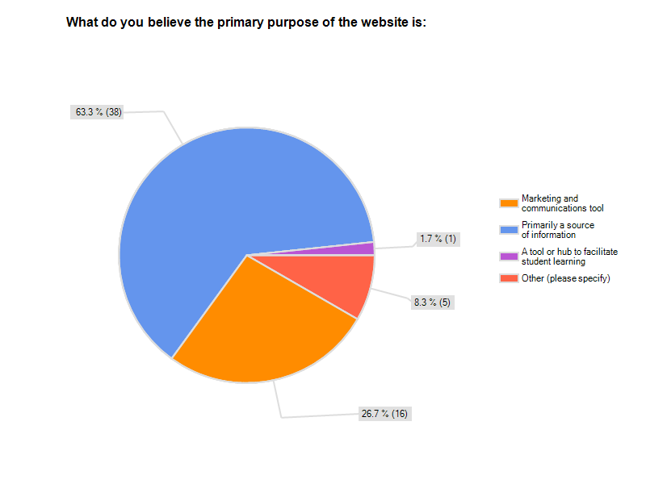2-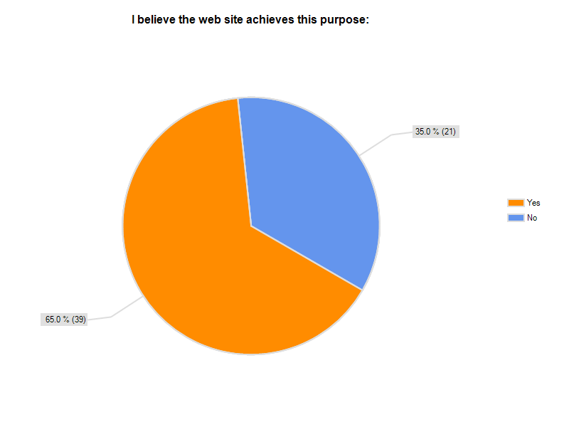

3-
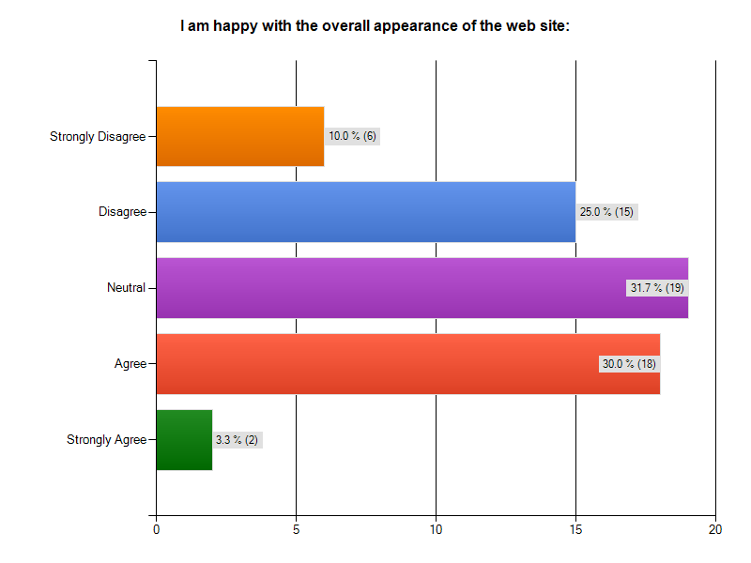
4-
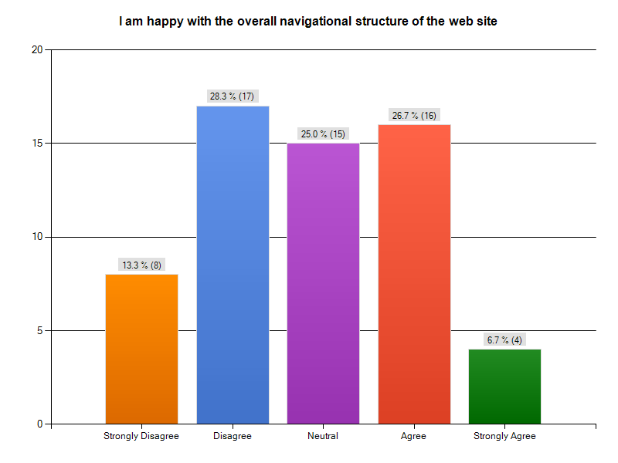
5-
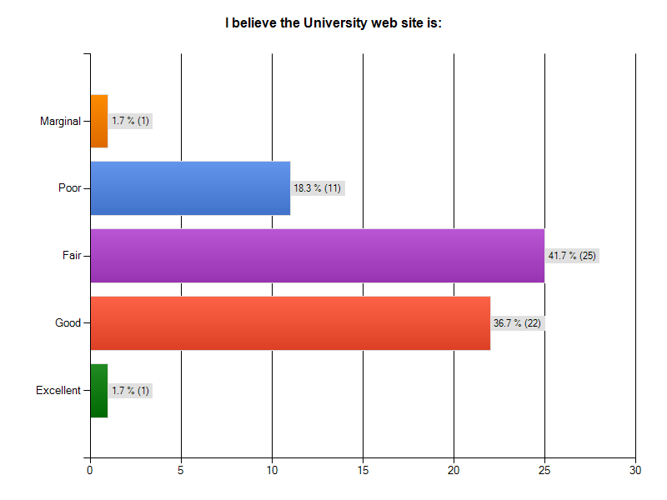
6-
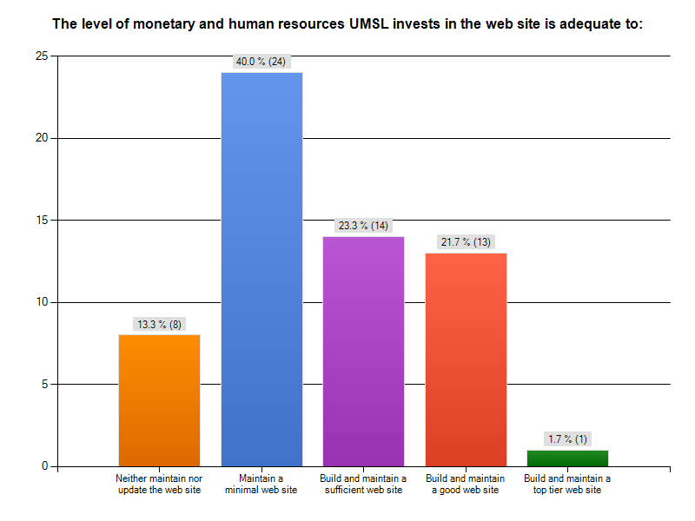
7-
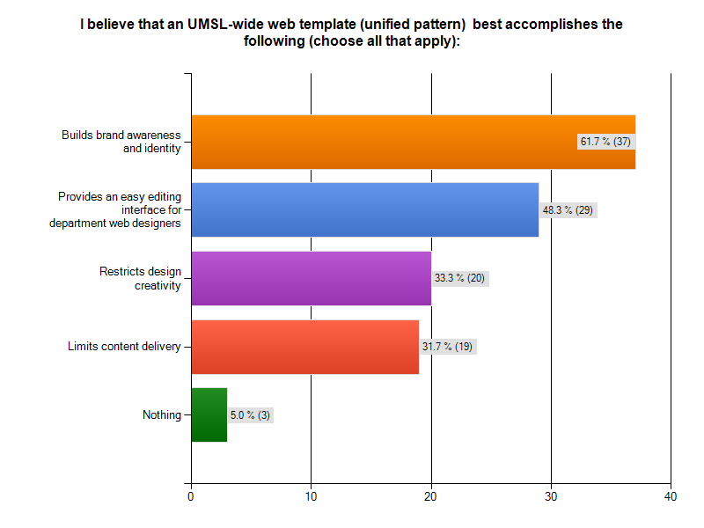
8-
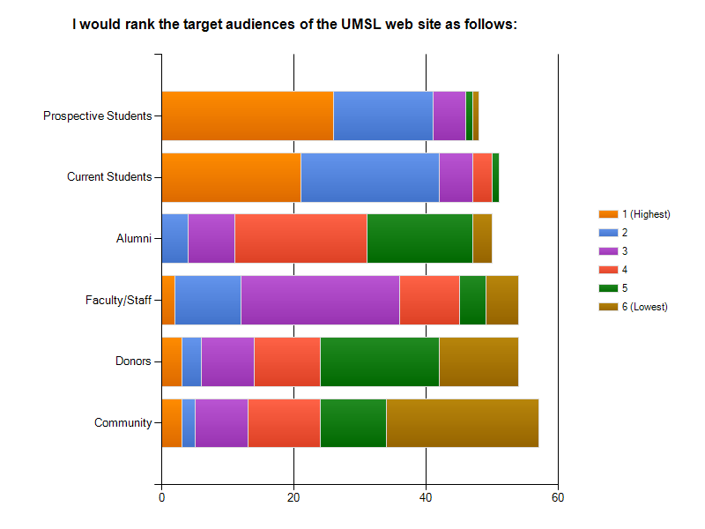
9-
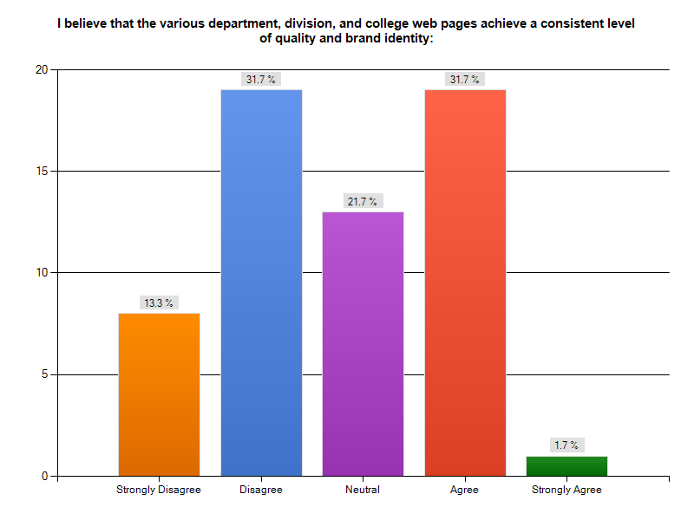
10-
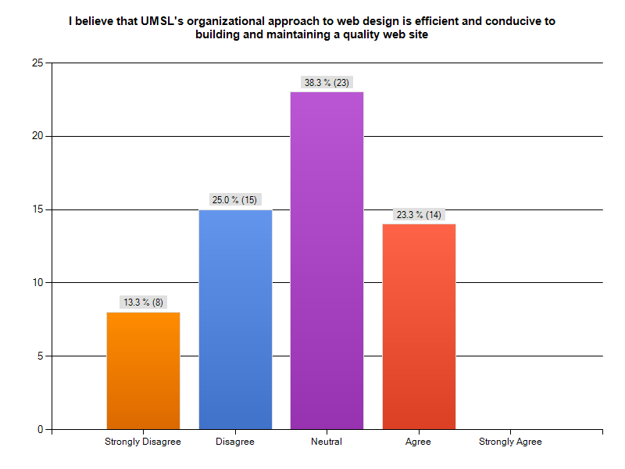
11-
11-I spend __ hours per week building and maintaining my department's web site (If you do not maintain a web site, please type 0):
Answer Options |  | Response Count
 |  | 60
answered question |  | 60
skipped question |  | 0
Number | Response Date | Response Text
1 | Oct 26, 2009 2:31 PM | 3
2 | Oct 26, 2009 2:31 PM | 40
3 | Oct 26, 2009 2:42 PM | 1
4 | Oct 26, 2009 2:56 PM | 15
5 | Oct 26, 2009 2:57 PM | 1
6 | Oct 26, 2009 6:03 PM | 1
7 | Oct 26, 2009 6:51 PM | 8
8 | Oct 26, 2009 8:55 PM | 8
9 | Oct 26, 2009 10:05 PM | 0
10 | Oct 27, 2009 12:54 PM | 0
11 | Oct 27, 2009 2:46 PM | 12
12 | Oct 27, 2009 3:16 PM | 2
13 | Oct 27, 2009 3:58 PM | 5
14 | Oct 27, 2009 5:48 PM | 20
15 | Oct 27, 2009 5:52 PM | 1
16 | Oct 28, 2009 5:25 AM | 2
17 | Oct 29, 2009 6:27 AM | 0
18 | Nov 1, 2009 9:21 PM | 1
19 | Nov 1, 2009 9:46 PM | 2
20 | Nov 1, 2009 10:12 PM | 8
21 | Nov 1, 2009 10:15 PM | 3
22 | Nov 1, 2009 10:20 PM | 0
23 | Nov 2, 2009 12:52 AM | 0
24 | Nov 2, 2009 3:15 AM | 3
25 | Nov 2, 2009 9:53 AM | 0
26 | Nov 2, 2009 12:45 PM | 0
27 | Nov 2, 2009 1:21 PM | 10
28 | Nov 2, 2009 1:21 PM | 0
29 | Nov 2, 2009 1:36 PM | 1
30 | Nov 2, 2009 1:47 PM | 40
31 | Nov 2, 2009 2:32 PM | 1
32 | Nov 2, 2009 2:36 PM | 5
33 | Nov 2, 2009 2:53 PM | 0
34 | Nov 2, 2009 3:07 PM | 10
35 | Nov 2, 2009 3:10 PM | 1
36 | Nov 2, 2009 3:47 PM | 0
37 | Nov 2, 2009 3:59 PM | 0
38 | Nov 2, 2009 4:19 PM | 2
39 | Nov 2, 2009 4:41 PM | 0
40 | Nov 2, 2009 4:42 PM | 1
41 | Nov 2, 2009 5:00 PM | 0
42 | Nov 2, 2009 5:28 PM | 2
43 | Nov 2, 2009 5:29 PM | 1
44 | Nov 2, 2009 6:15 PM | 3
45 | Nov 2, 2009 7:28 PM | 0
46 | Nov 2, 2009 7:42 PM | 4
47 | Nov 2, 2009 7:48 PM | 0
48 | Nov 2, 2009 7:54 PM | 10
49 | Nov 2, 2009 8:19 PM | 1
50 | Nov 2, 2009 10:11 PM | 0
51 | Nov 3, 2009 3:16 AM | 0
52 | Nov 3, 2009 4:04 AM | 3
53 | Nov 3, 2009 4:32 PM | 2
54 | Nov 3, 2009 4:56 PM | 0
55 | Nov 3, 2009 5:02 PM | 0
56 | Nov 3, 2009 10:49 PM | 1
57 | Nov 4, 2009 9:50 PM | 0
58 | Nov 4, 2009 11:18 PM | 1
59 | Nov 8, 2009 4:14 AM | 0
60 | Nov 11, 2009 10:36 PM | 0
 | Descriptive Statistics
 | Mean | 6.184210526
 | Standard Error | 1.49815214
 | Median | 2.5
 | Mode | 1
 | Standard Deviation | 9.235230029
 | Sample Variance | 85.28947368
 | Kurtosis | 8.414048722
 | Skewness | 2.847348521
 | Range | 39
 | Minimum | 1
 | Maximum | 40
 | Sum | 235
 | Count | 38

12-
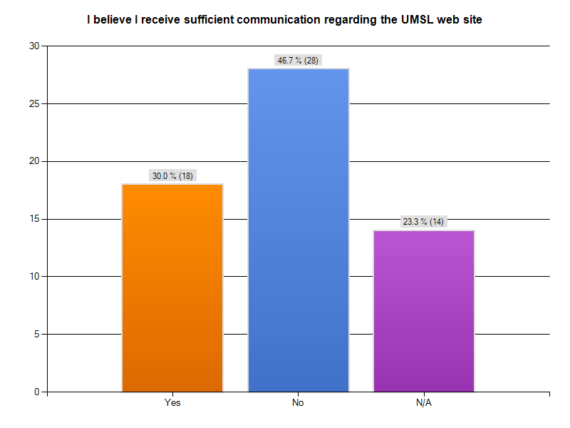
13-
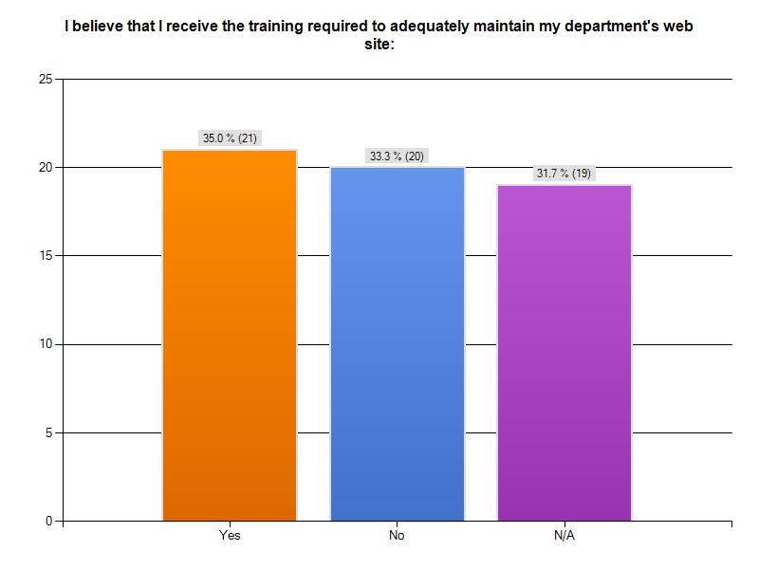
14-
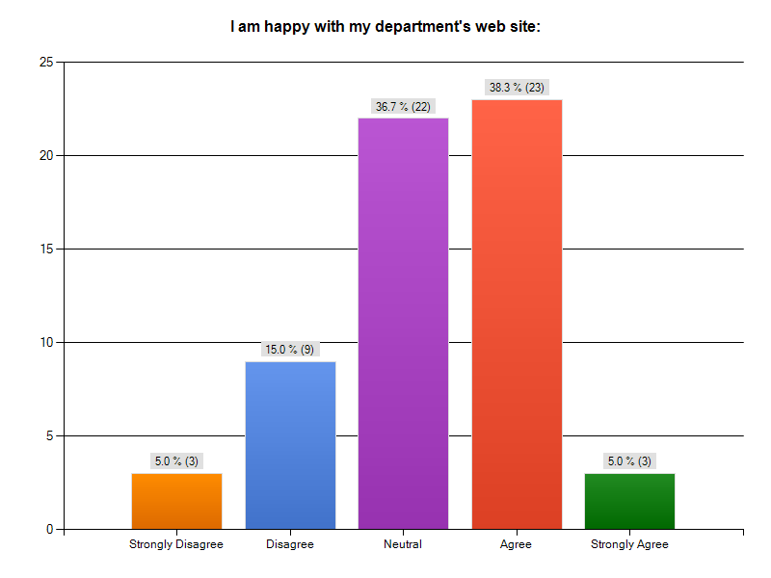
15-
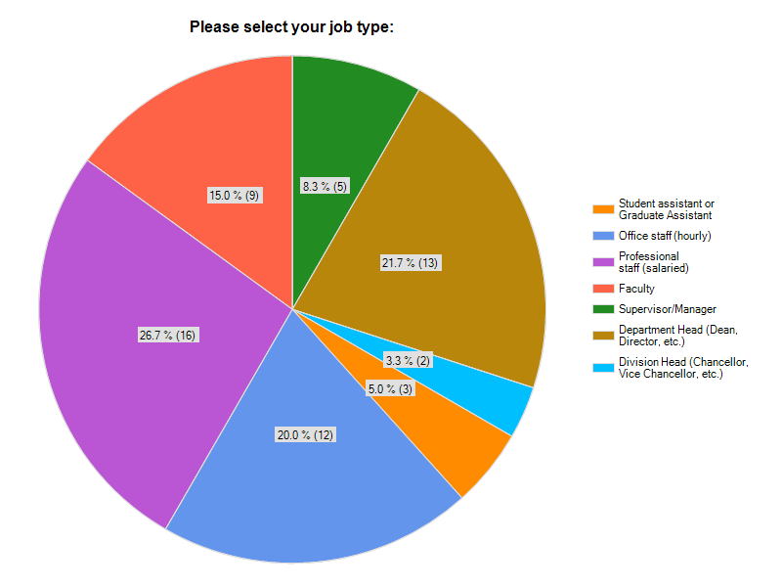

Appendix D: UMSL Student Survey Results
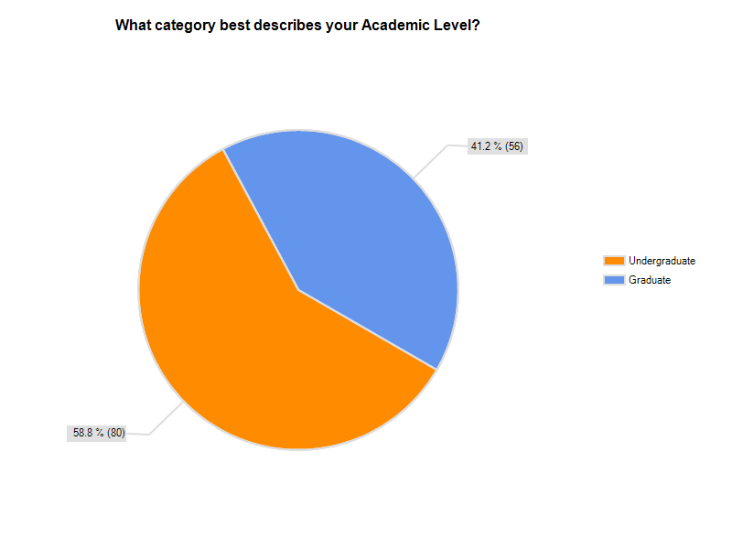

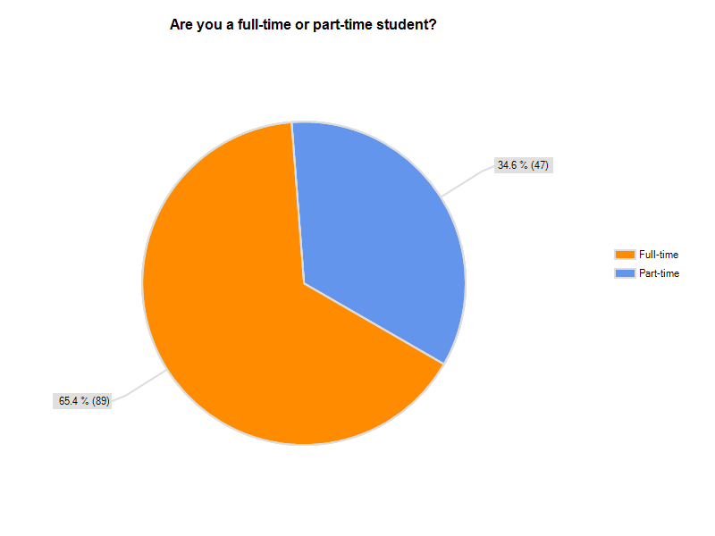

Q03- What is the PRIMARY reason you use the UMSL web site?
 | answered question 136 & skipped question 1
# | Response Text
1 | Blackboard related crap
2 | Access to Mygateway, Myview, and email
3 | MyGateway & Myview
4 | planning classes, my gateway, email
5 | Email
6 | as a link to mygateway and myview
7 | My Gateway
8 | Research and School work
9 | use course pages on MyGateway and use Ovid
10 | my gateway/my view
11 | Library
12 | Email and get information for my classes.
13 | E-Mail access
14 | E-mail
15 | Print out Documents and email
16 | email
17 | Grades, assigments, etc
18 | MYgateway
19 | email, homework assignments
20 | To keep up to date on my university e-mail and my courses in general.
21 | mygateway
22 | UMSL is a great university to be at, but I'm attending UMSL because it's cheaper.
23 | Check email, grades, assignments, announcements
24 | check homework
25 | to use MyGateway
26 | Check email
27 | Check mygateway
28 | school
29 | I use MyGateway to obtain documents for my classes.
30 | my gateway
31 | email and search for information
32 | MyGateway
33 | blackboard
34 | To find information
35 | Class work
36 | Email and financial issues
37 | For updates in my classes and email
38 | school e-mail
39 | e-mail
40 | to access my gateway
41 | My Gateway for classes
42 | emails and course materials
43 | Various campus resources
44 | x
45 | Information
46 | To find information
47 | class stuff
48 | To find Information and check on class changes and communications
49 | MyGateway
50 | Homework/Assignments
51 | email
52 | course schedule
53 | mygateway
54 | Information
55 | To get information about my classes
56 | Administrative.
57 | Find courses available and other information
58 | Online class
59 | mail and online classes
60 | academic work
61 | Class
62 | Information
63 | To do classwork in MyGateway, to see what's going on at UMSL, and to register for classes and check my Student Account on MyView. And to see what's being offered at Mark Twain building for fitness and recreation. And to reserve materials from the UMSL Libraries. And to visit the Fine Arts & Communication website, and the bookstore website. And to see how I want to volunteer on campus.
64 | to gain access about grades, communicate with professors and the overall duties required as a student finances, schedules etc....
65 | link to library and databases
66 | MyGateway
67 | For school related information
68 | mygateway
69 | Check Email and School work
70 | Access Blackboard for assignments, grades, and announcements.
71 | information
72 | Check class information, final grades
73 | Course Documents
74 | blackboard academic for current classes
75 | email
76 | to check on my status in my class and print notes
77 | Mygateway/Email and Access the required text books for my classes
78 | MyGateWay
79 | my gateway
80 | to take classes online
81 | internet classes
82 | my gateway
83 | Blackboard
84 | blackboard
85 | Class information and testing
86 | Class Information/Student E-mail
87 | assignments
88 | check for assignments posted by professors
89 | To get info about the school & academic programs
90 | email
91 | classes, email, library
92 | Mygateway and myview.
93 | My gateway
94 | mygateway
95 | to find forms and general info
96 | to graduate
97 | school info
98 | research about the school, registering for classes, the research papers online, class info
99 | mygateway
100 | I am an outreach student.
101 | Internet courses and to keep up with on-site courses.
102 | Coursework/Research
103 | for my graduate studies
104 | access the library
105 | classwork
106 | keep up with class, grades, contacts
107 | class
108 | e-mail
109 | To Check email and check status on classes. Homework solutions and to check grades.
110 | MyGateway
111 | Class Information
112 | mygateway
113 | To log on to MyGateway to view class assignments and announcements
114 | my gateway
115 | I use it mostly to check My Gateway.
116 | Taking classes
117 | class work and e-mail
118 | online classes/e-mail
119 | Mygateway and Myview
120 | school work
121 | on-line classes
122 | internet courses
123 | gain access to my classes
124 | my view/email
125 | research and email
126 | Look up directory info.
127 | information about classes, fees
128 | My Gateway
129 | soc1010 class Mr. Keel, e-mail
130 | Homework
131 | For new info, to rec'v grades and updates from instruction
132 | my gateway
133 | Assignment updates
134 | my gateway
135 | classes
136 | Library and email
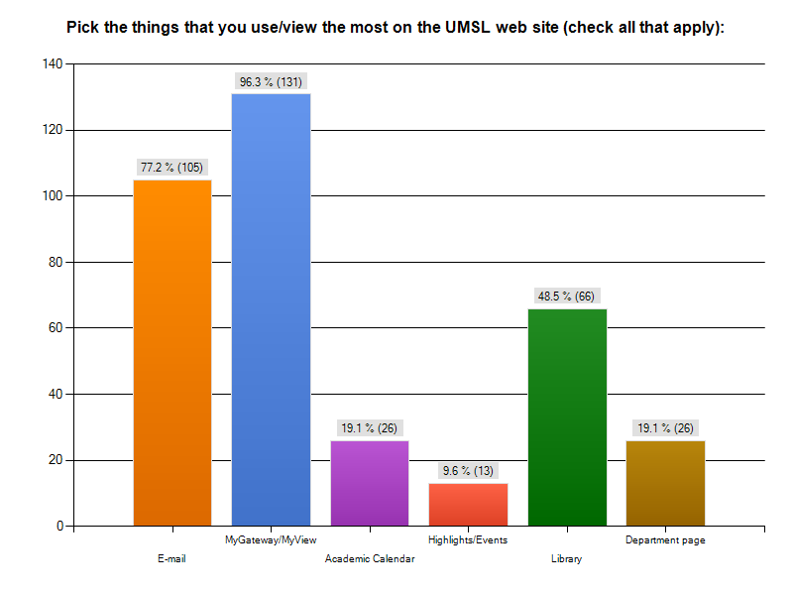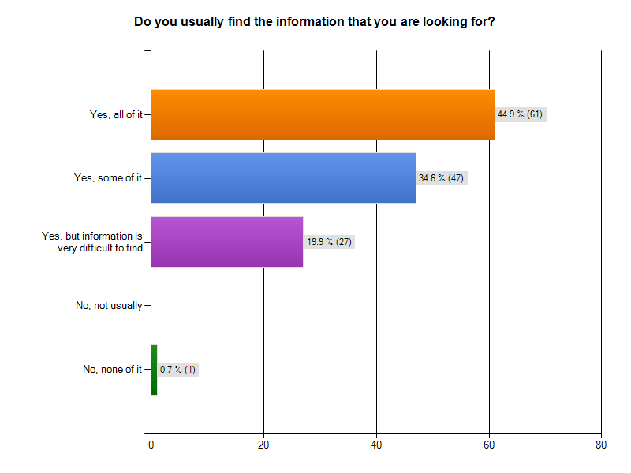

Q06- If you did not find any or all of what you needed, please tell us what information you were looking for. Answered question 28 & skipped question 109
# | Response Text
1 | It is hard to find the events!
2 | Needs an all-inclusive A-Z directory of topics
3 | Phone number, departments.
4 | There are many times when the UMSL databases will not have the full-text version of articles I search for
5 | Information on school events. I often get taken to the wrong department page when looking for events from our school emails.
6 | Not easy for prospective students; application, prerequisites, fees, accommodation is all over the place. I spent many hours trying to figure out how the website hung together. In the end, I didn't and saved the pages I needed in my 'favorites'.  It is strange to have MyGateway and MyView; isn't it all My'Info'.
7 | physics labs and pre labs are kind of well hidden
8 | Professors dont always post grades and lecture notes on a consistant and timely basis.
9 | When applying, I had a hard time finding information on Advanced Placement, as in what scores earned credit and how much.
10 | i find what i need
11 | There are plenty of dead links as well as links that loop you back to where you started.
12 | Grants/Scholarships/FAFSA information.
13 | Information about professors teaching courses
14 | It took me along time this morning to just find an e-mail.  I by accident found dissertations on the site. I am not sure I could get there again.
15 | Journal Articles
16 | none
17 | Still can't enroll without contacting someone. If fees are up to date then we should be able to enroll by ourselves. Also, graduate faculty overall are not good about using blackboard for grades and communication, posting syllabus on website, course information etc.
18 | Hard to navigate through myview.
19 | I'm not sure off of the top of my head. Sorry
20 | However it is hard to find the Colleges offered at UMSL. Especially if you are looking into applying here.
21 | It would have been helpful to have a tutorial before I started back to school after 20 years: how to navigate the browser, how to use the on-line library, hints on how to use the on line class tools more easily, what is all available. I felt thrown to the lions so to speak
22 | I was looking for more info about nursing scholarships that were current
23 | N/A
24 | Occasionally, I must call for permission numbers, etc.
25 | I would like to be able to log in to my view from the web site rather then logging out and in.
26 | I am a veteran, and I found it difficult to locate the enrollment form that I need to fill out each semester to receive my VA education benefits. Also, when I first began attending UMSL, I could not locate the name or phone number of the VA representative. I had to call around and be transferred several times over the phone before I could reach her.
27 | n/a
28 | some article, you must go to the library to get.

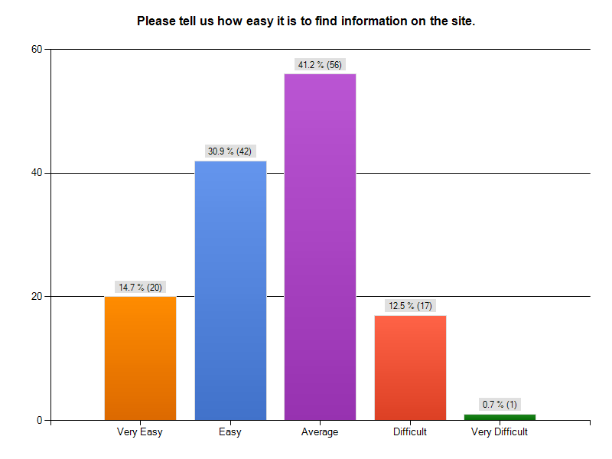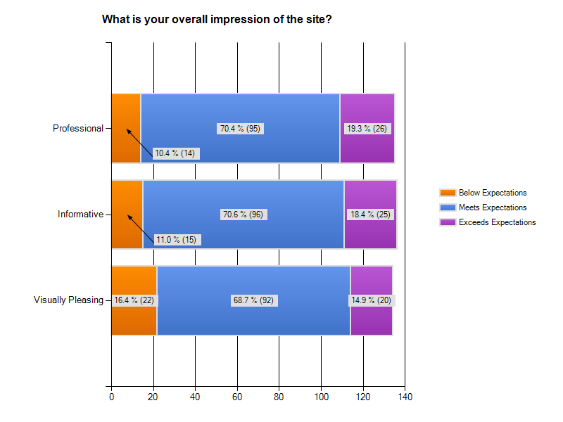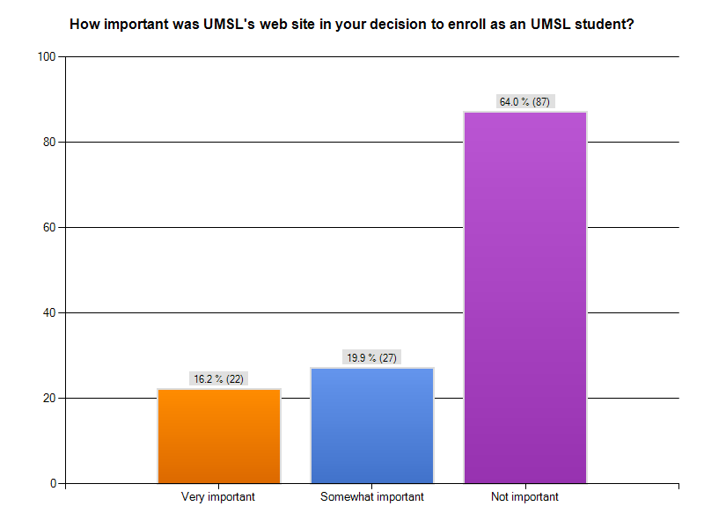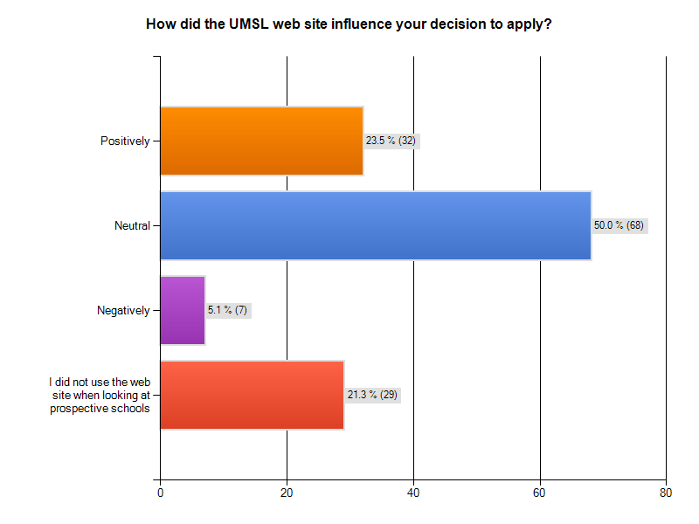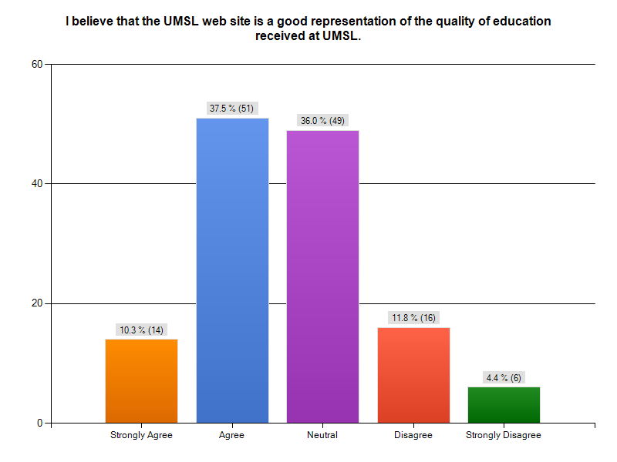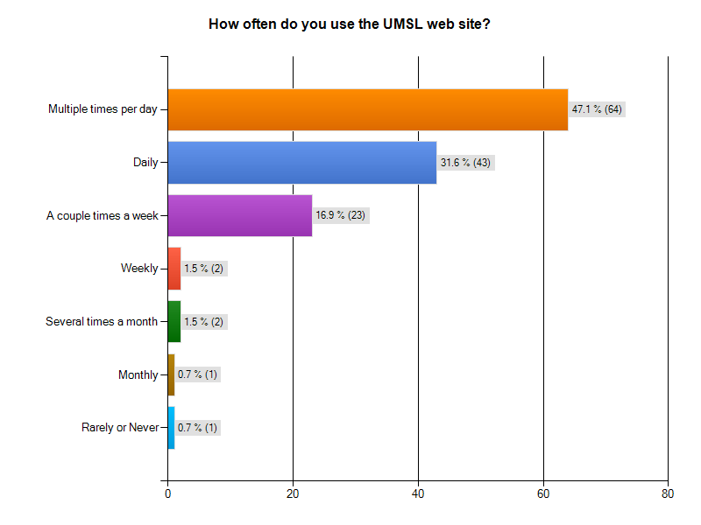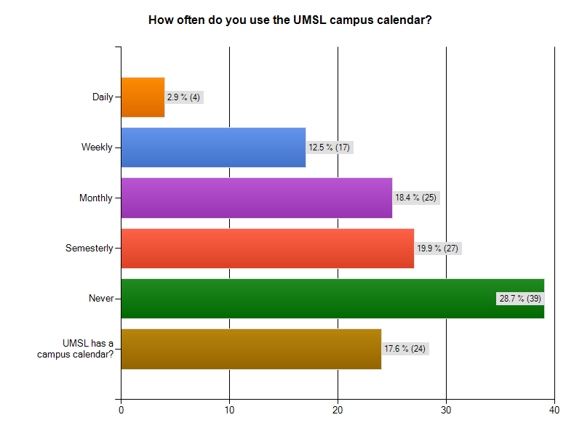

Q14- What would you like to see on the Campus Calendar? What would you like to see changed or added?
Number | Response Text
1 | Uhhh.
2 | A comprehensive list of events that can be sorted by type
3 | all events defined by their department in calender!
4 | don't use it
5 | The German Culture Center has numerous events coming this weekend and next week. These events are not on the calander. UMSL is one of 25 Universities to host the Berlin Wall anniverssary events.
6 | I would like to see when (during each semester) registration times begin for the next semester for each student level (freshman, sophmore etc.)
7 | No clue
8 | More imnformation
9 | More visually pleasing, more interactive, and pictures added (it is a little dull right now).
10 | I don't have time to do additional things
11 | It would be nice to have only the current calendar displayed and the rest archived under one link. Also, a live calendar would be nice that had a countdown to breaks and finals weeks.
12 | I would like to see shows that are showing and more events by students
13 | More student events, bigger link on the homepage.
14 | Touhill performances added
15 | What days we have off
16 | Musical performances, speakers, free events
17 | Not sure
18 | easier to find major and degree coursework needs, financial aid options
19 | make it interactive
20 | I think the Campus Calender i fine just the way it is.
21 | Academic Dates, finals, withdraw deadlines
22 | At this point in time, the calender is fine.
23 | I don't use it.
24 | i don't know
25 | Make it more visible so students can see it
26 | I didn't know there was one or what it is.
27 | Graduate activities
28 | i dont use it
29 | I don't use it, so I'm neutral.
30 | nothing
31 | I think it should be explained on its use..
32 | I didnt know there was one, I wonder what it has on it now.
33 | N/a
34 | I'd love for it to be easier to find.
35 | No opinion.
36 | More events about campus organizations.
37 | Campus Calendar is good as it is
38 | neutral don't use
39 | I don't use it.
40 | not sure.
41 | Easier access
42 | I dont know
43 | Make it a larger part of the website, I don't believe many students utilize the calendar
44 | x
45 | What is the point of having different color schemes for the calendar? I think this is unnecessary. If the campus calendar is very important, it should be emphasized more than just a tiny hyperlink.
46 | The calendar is fine the way it is now.
47 | printable
48 | N/A
49 | Nothing, I don't use it.
50 | It's fine
51 | nothing
52 | where is the campus calendar? I just looked for it online...
53 | -
54 | Basic information such as when will registration for next semester begin. Now it is there, but other colleges including community colleges, had this information on their pages at least a month earlier.
55 | It's ugly.
56 | Don't use it.
57 | Registation, add and drop dates, student event at the touhill
58 | don't know
59 | All atheletic, performances, and Presentations.
60 | More and clearer notations. For example, such and such date ... first day of fall semester.
61 | any on campus Event, Exam period, holidays
62 | Everything happening on campus
63 | Please make the Calendar MUCH BIGGER!!!! Currently the calendar is TOO SMALL. Please add additional color options for the calendar because the current color schemes are not very appealing (in my opinion).
64 | don't know
65 | I don't think I would use it because I'm only on campus once per week.
66 | I just think it could be presented a little bit better
67 | Semester start and end dates. Break dates. When payments are due. When to register
68 | I dont know I dont look at it that often because i usually get emailed about important events.
69 | na
70 | it's fine
71 | more departmental meetings, not just umsl-wide ones
72 | Not applicable, dont' use
73 | ??
74 | did not know there was one
75 | no changes
76 | I dont have an opinion about it
77 | I didn't even know there was a campus calender.
78 | No answer
79 | do not use it.
80 | dont know
81 | As an older professional working a demanding 40-60 hours per week job and taking grad classes, I have no interest in "college life"
82 | Pre-registration dates! I didn't get my e-mail to pre register until 3 weeks after it began and I couldn't find the date anywhere on the site.
83 | I dont use the campus calendar
84 | N/A
85 | Just when classes begin and end, along with breaks
86 | N/A
87 | I like to know about speakers and specail events
88 | I don't know what the campus calender is
89 | Perhaps a link for what the weather outlook is going to be for the next 5 days.
90 | Didn't know we had one
91 | Would like to see 2 years at a time.
92 | Spring break should be easy to figure out.
93 | With nursing and optometry being on South Campus we would like to know everything that is going on the other side as well.
94 | more of the events from weekly newletters like volunteer events and guest speakers. Seems sparse at times.
95 | na
96 | nothing
97 | important info
98 | ?
99 | I would like to see an academic section which would state things like start of classes for semester, last day to drop classes, end of semester, etc
100 | I don't use the campus calendar.
101 | I do not use the campus calendar
102 | For students who juggle multiple responsibilities, including job, volunteer work, children and family, plus schooling, there is little time to take advantage of these opportunities.
103 | Unknown
104 | no more
105 | not sure, don't use it.
106 | to add only events I am interested in automatically
107 | don't use
108 | it looks good to me
109 | The finals schedule or a link to the finals schedule.
110 | events
111 | Its fine.
112 | I don't really use the calendar
113 | It would be beneficial to have the menus changed to make it easier to find things. I often find myself clicking around several areas before I can find what I'm looking for.
114 | graduation dates and beginning and end of each semester
115 | Nothing
116 | The dates of semester start & end, all campus events. Days off labeled
117 | more events and happenings around the campus so more people can find out about all the great stuff going on.
118 | do not use it
119 | I dont use it.
120 | I have liked the calendar
121 | I dont know
122 | Easier access
123 | nothing
124 | ?
125 | the academic and campus calendar should be on the same calendar simular to outlook, were you can view the month, week or day
126 | Stuff
127 | no changes needed
128 | nothing
129 | na
130 | I want to know long range dates, like graduation of 2011
131 | Nothing that I can think of.
132 | don't use it
133 | Haven't looked at it this moment in time.
134 | n/a
135 | more free events
136 | all events on campus

Q15- What is your favorite part about the UMSL home page? Answered question 78 skipped Question 59
# | Response Text
1 | The fact that there is one?
2 | I hate all parts of it equally
3 | Libraries
4 | The search option
5 | the links right under the webpage title (Admissions, Academics, Research etc) because they can get you to a lot of information fast
6 | My Gateway
7 | Sports
8 | Pictures of the campus and clear headings at the top
9 | being able to access the library from off site
10 | The pictures and that the library is a quick link
11 | none
12 | DARS access, my gateway and e-mail
13 | mygateway
14 | nothing
15 | I like the easy tabs to navigate anywhere onto the website.
16 | loads fast?
17 | The UMSL home page has easy access to whatever you need.
18 | Access to MyGateway
19 | email and homework assignments
20 | None
21 | I can sometimes see my grades if the professor posts them.
22 | N/a
23 | no opinion
24 | Direct access to my gateway. I also like to read the news headings about umsl students/profs.
25 | The list of current events
26 | It has a very professional look to it
27 | The links at the top for My Gateway, My View, Libraries, and Technology
28 | student tab
29 | Leaving it.
30 | displaying students acheivements
31 | highlights and events
32 | mygateway and myview are easilly accessed from the home page
33 | It's not too cluttered.
34 | N/A
35 | It's ok, but not great
36 | The red, white and blue colors sitting on a gray background, and the fact that the main picture and the events highlights change each time you visit the homepage, and because most of the places I visit on the UMSL website are ready to be clicked (like MyGateway, MyView, Libraries, Useful Links etc.)
37 | blackboard
38 | link to athletics, databases, and swine flu updates
39 | Overall organization of all the different links.
40 | easy to navigate
41 | nothing
42 | connecting to class info
43 | Not sure
44 | Why people enjoy going to UMSL
45 | easy access to everything
46 | easy to get to My Gateway
47 | i like the student testimonals at the top
48 | N/A
49 | The pictures of current students
50 | easy access to sites I use
51 | the direct links to the parts of the website mostly used like myview and mygateway
52 | It's clean and simple. It's not too flashy.
53 | It's red
54 | The different quotes from students.
55 | my gateway
56 | nothing
57 | News
58 | mygateway has a link
59 | N/A
60 | Access to people and information from a distance.
61 | library links
62 | have titles on top to go to
63 | links
64 | Checking email is very simple.
65 | Updates
66 | I like how there us a direct link to mygateway
67 | The quick links at the top
68 | the easy access tab to my gateway
69 | easy access to what you need
70 | none
71 | a-z tab
72 | Things
73 | my gateway
74 | The gradebook section and the library portion of the homepage is useful.
75 | no opinion
76 | People faces.
77 | navigation
78 | easy to use

Q16- What part of the UMSL home page do you like least? Alternately, what would you most like to see changed or added?
# | Response Text
1 | I've got nothing.
2 | I hate all parts of it equally
3 | Design! Colors! Navigation! Please update the design please!! for upgrade I would say work on Apply link!!
4 | SSO ID and myview. Why call it a single sign on ID if you have to log into my view and my gateway, and each campus computer. I can get multiple errors if opening my view in anoter tab from my gateway, and it is very cumbersome and not user friendly. I appreciate the willingness to put more administrative options at the hands of students, but myview is the worst system possible.
5 | The menu items that we use are small. MyGateway is not readily apparent.
6 | I don't like the pictures that appear everytime you refresh the page, because some of them are outdated
7 | Search system sucks
8 | none
9 | Visually, it doesn't utilize much screen space. It could be made more visually pleasing overall.
10 | it is not always the most userfriendly. I wo uld also like a better search function
11 | Overall appearance, ie. better use of webpage space, larger font, and a more effective within site search tool
12 | there is nothing on the home page that I don't like.
13 | The pictures of students that change are really outdated, some of them are at other schools now. One is even an old TA of mine from freshman year.
14 | The colors of the calender page are horrible!
15 | campus calendar
16 | A better way to search for things.
17 | my view
18 | courses
19 | the ugly pictures
20 | n/a
21 | friendlier menus
22 | I'm not dissapointed with the UMSL home page at all.
23 | Don't know - depends who you are appealing to.
24 | the pre-labs section
25 | nothing specific
26 | Very unorganized
27 | First page. It looks boring.
28 | myview is difficult to use
29 | The site doesn't really bother me.
30 | search engine
31 | Make it more user friendly, easy to find things.
32 | I did not like the email at all, it would always fill up and then not allow emails to get to me.
33 | N/a
34 | Its hard to locate certain bits of information or it takes a while to get where you want to be.
35 | no opinion
36 | Knowledge@UMSL
37 | none
38 | e mail adresses attached to participating students in the mygateway section of class rosters.
39 | It can be difficult to find things from the main page, because you have to know what to look under. Things aren't always where you'd think they'd be.
40 | nothing.
41 | Easier access to various departments
42 | my view, not clear layout
43 | New pictures into the rotating pictures bar, some department websites looks very unprofessional
44 | x
45 | The color scheme is uninviting. Please get rid of that shade of gray, or replace it with a lighter or darker gray.
46 | Although the links at the top of the page are useful, they could be made more prominent and easier to see.
47 | my view makes you log in again
48 | My View. Make registaring for classes more user friendly and interactive. Like being able to drag and drop in to a calendar or something to that effect, so you can see what it will look like.
49 | I hate how hard it is to find what I'm looking for.
50 | It's alright. I'd like to see the pages with more information.
51 | it's messy
52 | the search tool does not put results in order of relativity to the search
53 | -
54 | Too many broken links.
55 | The "Current Students" page is ABYSMAL - just a long list of links, with no visual interest whatsoever.
56 | No preference.
57 | the search engine
58 | don't know
59 | Maybe less with more pictures that would lead to other areas. For example, a Library Icon, same for staff and faculty, or atheletics or your bill.
60 | No comment.
61 | N/A
62 | It's ok but not great
63 | There is a alot of gray on this page (unless it's because my computer monitor is so big). I wish that the Homepage filled the entire page like the rest of the UMSL website seems to.
64 | the rest
65 | nothing
66 | I cannot think of anything
67 | indifferent
68 | none
69 | Not the most eye appealing of all the university websites I have seen
70 | It's perfect just the way it is.
71 | there is no part I like least, but the website could be more visually appealing
72 | Ability to enroll by self
73 | It would be nice to have a larger link to MyGateway since most students use that the most
74 | nothing
75 | DARS is not kept up to date
76 | I think the current student section is very cramped and not easy to navigate. The lists are small and its just not cisually pleasing.
77 | Better organization. I feel that if it is not one of the links under current students, then I generally can't find what I am looking for
78 | Links are rather small
79 | logging in and out from home;expires quickly
80 | dont know dont usually go to home page
81 | I found it difficult to navigate at first, it would take me several times of trying different tabs to get the information I was looking for
82 | nothing
83 | I think the home page is very effective
84 | N/A
85 | The calendar, bookstore, cashiers office and class schedules should be easy to navigate
86 | N/A
87 | My View is not as helpful as expected
88 | more pictures
89 | Could make the box where the 10 links are, below the red UMSL banner/box, a little more noticeable.
90 | N/a
91 | none
92 | The links to mygateway and myview are easy to find.
93 | nothing
94 | email mailbox size is too small
95 | my gateway
96 | nothing
97 | School important news included everything
98 | Don't know...
99 | campus calendar
100 | biggger print
101 | N/A
102 | Streamline access to an Faculty research.
103 | finding academic answers; searching for classes
104 | cumbersome to get to department page
105 | logging in many times to use library use myview etc.
106 | Sports information not high on my list
107 | add course book
108 | everything looks fine
109 | That logged into MyGateway you have to log into MyView when looking at your student account.
110 | n/a
111 | Its fine.
112 | nothing
113 | I don't like the tabs on the left-hand side of the page that have drop-down menus if you hover over them. It is quite difficult to hover and move to the menu you want without the entire tab disappearing before you can click on what you want.
114 | nothing
115 | I can't think of anything.
116 | nothing
117 | more weekly events
118 | it is fine
119 | Nothing
120 | The nursing website was very difficult to find answers to certain questions
121 | I dont know
122 | ?
123 | nothing
124 | none
125 | don't know
126 | The deal
127 | none
128 | nothing
129 | na
130 | ?
131 | I am not erally knowledgeable about the knowledge@umsl part of the homepage
132 | home page is a bit crowded just like every university home-page
133 | It's okay.
134 | n/a
135 | I DO NOT like the fact that when I open MYVIEW there's alot of windows that opens.
136 | like the home page just as is.

Q17- Please add any comments you have for improving the website. We welcome suggestions on specific areas for improvements, features you would like to see added to the site, and examples of what you consider good websites.
# | Response Text
1 | Seriously, just organize it. Right now there are hundreds of options spread all over different systems. MyView/MyGateway/eBill...why can't these all be one unified system.
2 | Any info should be accessible in 2-3 clicks
3 | thanks
4 | integrate myView, myGateway and all the other my's into myUMSL with a true SSO ID
5 | Maybe it's the Blackboard layout that I am displeased with. I prefer drop down menus.
6 | There are some broken links here and there that should be removed or updated
7 | Improve the ease of using the search engine.
8 | The website is of good use.It can only be improve based on outdated technology if there is any.
9 | Improve the visual look overall (use more screen space, also). Add more information about events, highlights, special announcements, and so on.
10 | my view is awful and takes a long time to get anything that you need. it seems like innovative technology 10 years ago
11 | Make better use of our school colors and symbols throughout the website. Especially to highlight important information. So much of text is black on a very boring white background. Please spend some times looking at other effective university websites such as www.iupui.edu or www.iwu.edu These were both my undergraduate institutions for me and they had FANTASTIC websites. Also, the first one actually went through a huge change and facelift while I attended. It was initially awful when I first began attending but they made it wonderful now.
12 | Coments by the students on why this is the school to choose. There are no comments on the page to make people choose this school over others.
13 | I like it, but I think the font is small and the page is a little busy.
14 | n/a
15 | none
16 | >
17 | My view - should give more choice for user
18 | courses
19 | Organize the information better
20 | n/a
21 | it is a decent page, but it needs to have some information about academic deadlines
22 | I'm not dissapointed with the UMSL website at all.
23 | Difficult to say. I use websites everyday and I would consider this poorer than the average for navigating quickly to the information I require.
24 | I don't know. Some teachers are down for it, some aren't. Just make sure they post a link to their page in the announcements or at least post homework assignments.
25 | email on mygateway is very basic... needs improvement
26 | Less steps to get to common places.
27 | Make it more attractive by adding the picture about the event
28 | N/A
29 | I like the drop down link at the right hand side of the page, so if you change anything you should keep that!
30 | use the google as search engine
31 | Adding a search engine that really searches for what you request. I was looking for various forms to sunit for graduation.. M1 and M4.. it took over 40 minutes to locate.
32 | I want to see grades posted and professors use it more often.
33 | N/a
34 | Just make it less complicated! Make it so less links need to be clicked in order to get somewhere.
35 | As a website it is neither a flash of inspiration nor is it dull enough to drive away the reader.Bland is the best way to compare it with other site.It is almost like Wash.U.'s or any other university's site.
36 | Combine myview and mygateway.
37 | I like the website the way it is right now....I'm already used to it and to change things might confuse me or take a while for me to get used to it
38 | e mail adresses attached to participating students in the mygateway section of class rosters.
39 | The search function could definitely be improved; I hardly ever find what I want with it. Overall the website isn't great, and it can be really hard to find anything specific, but it isn't any worse than other college websites.
40 | i don't have any.
41 | It would be nice to have easier access to the different departments and the different degree requirements.
42 | i dont know
43 | I'm very fond of MST's website. It looks very professional and incorporates minimal flash.
44 | x
45 | Whenever I see the main page of the UMSL website, I keep expecting that picture with the text to fade out and be replaced with another after a few seconds. Other websites do this to make their pages seem less static and more dynamic.
46 | Some pages have broken links to other pages. Those should be fixed. When I encountered broken links, I could usually find another way to get the information I needed, but not always.
47 | good questions-- hope this helps
48 | Why couldn't DARS and MyView be connected, so it was able to show the classes I was interested in taking or are required to be taken and possible outcomes for the following semester based on this information?
49 | It's too hard to find the things I want and when I do find information it's all out of date. I refuse to use the website for anything other than checking my classes and e-mail.
50 | I'd like to see the pages with more information.
51 | less messy
52 | Add just a little more color, add more options to the home page. but i like how the homepage doesnt take up the entire screen - that makes it seem organized and manageable.
53 | -
54 | Too many circular links that lead you nowhere.
55 | The interior pages are cluttered and difficult to navigate. Some pages have broken links, which creates an unprofessional impression.
56 | No preference.
57 | Improved layout for tabs on certain pages
58 | don't know
59 | Less on a page. More pictures. Easy to click on folders that take your to other sites. Billing paying, for example can be a real pain.
60 | No comment.
61 | N/A
62 | Change it to be more attractive.
63 | 1.) The UMSL Bookstore  Please make the UMSL Bookstore website a part of the UMSL Website (and MAKE IT LOOK GOOD LIKE THE UMSL WEBSITE PLEASE!). The current UMSL Bookstore website looks very bad. And it is not very informative outside of telling me which books I need for class. I would like to know what other merchandise I can purchase from the UMSL Bookstore via the UMSL WEBSITE PLEASE. And I would like to be able to look up general reading books, guide, UMSL Gear and other things. The current site is ugly.  2.) The Current Website  Why is The Current a separate website from the UMSL Website. I thought that all UMSL entitites (except MAYBE the Touhill Performing Arts Center) would all be under the "umbrella" of the UMSL Website. Why not have www.umsl.edu/thecurrent, and www.umsl.edu/touhill? The world know UMSL newspaper and the Touhill as entities of UMSL, so why not incorporate their websites into the UMSL website.  3.) Clubs and Organizations  I have noticed that some of the webpages/websites of UMSL's Clubs and and organizations to look like crap, or they look TOTALLY DIFFERENT from the Official UMSL website. I understand that different clubs have different goals, themes, personalities, etc., but if they are OFFICIAL organizations at UMSL, then please make them look like they belong to UMSL, as well.  One of the best examples I can give you how some of the Student Organization webpages are ugly and don't live up to the UMSL website's "professionalism" and appeal is the UMSL Gospel Choir website--- it looks very cheap, thrown together and unappealing. I would not be surprised if UMSL's ITs did not design that page, so PLEASE CHANGE IT.
64 | i don't know right now.
65 | afd
66 | I know that certain departments are very out of date and I would like to see them updated so that information is current
67 | I cannot think of any.
68 | There's just so much info, it's intimidating unless you know exactly what you're looking for and exactly where to look.
69 | na
70 | Website is awesome.
71 | there are some great examples of good edu websites, none of them pertains to school in stl metro though.
72 | See above. Bring teach graduate faculty how to use blackboard for their courses!
73 | ??
74 | Easier way to find names and emails for staff
75 | it takes too many steps to get to the student bill
76 | I wish there was a way to navigate back to the umsl website from mygateway, I also think that once you sign into my gateway you should already be signed into myview instead of having to sign in seperately.
77 | See comment for question number 16
78 | No answer
79 | thanks for the survey. it is nice to be asked our opinions for the things we use and count on.
80 | dont have any
81 | Cross referencing, table of contents and indexes similar to text books as an option to navigate web sites would be helpful to me
82 | organized decently
83 | nothing
84 | none
85 | Stated in question 16
86 | N/A
87 | no suggestions
88 | Cannot think of anything at the time
89 | sorry, no ideas at this time
90 | N/a
91 | none
92 | If I was considering going to UMSL for any type of web development, the umsl homepage would make me think otherwise. Nothing pops it is rather plain and not easily navigated.
93 | please stop sending the little police briefs
94 | easier to use "search" option where you can enter keywords on email page and see what matches correspond, and easier way to organize emails into folders, more graphic options for homepage other than change in colors.
95 | it's fine to me
96 | nothing
97 | Can you make easy path to the gateway.
98 | ?
99 | I really like Northern Illinois's campus calendar http://www.niucalendar.niu.edu/EAS/ I find this one easier to use. But UMSL is a way better school! :)
100 | I don't have anything specific to add.
101 | N/A
102 | Even though I have accessed a Faculty person's research articles, I find it difficult to navigate through the system.
103 | It is difficult to access what I need academically
104 | update the student testimonials
105 | none right now. current site is fine for me and what i need.
106 | place self help directory link on web site give new students a quick lick to explainations on how to set things up where to go for help in classes make it easy for those who have only very basic computer skills. This will help a great number to be more successful if they new there were help at the student center. Talks about studing, testing etc..
107 | have had trouble finding course catalog
108 | n/a
109 | Visually pleasing and easy to navigate between the different tabs.
110 | academic tabs to be easier to find.
111 | None.
112 | I wish you didn't have to sign in again when you're going from mygateway to myview and viceversa. Also it would be neat if all email addresses for faculty and staff were already in the email contacts or all in one place because sometimes I have to search around for them.
113 | I think it could be a little more visually-pleasing with more functional menus. Every page looks the same with different text.
114 | nothing
115 | The website is great because I can still find what I am looking for even though I am not great with computers. It is laid out nicely. Sorry I can't be of more help.
116 | improvement of navigation in my view
117 | not so much distractions with pictures and more information that is eye catching
118 | make bookstore easier to use
119 | No comments
120 | As far as the nursing website, it seems like there would be an easier way to access the information in a more logical format
121 | I dont know
122 | ?
123 | nothing. It is very user friendly.
124 | ?
125 | I really don't know how I would improve the web site. on a side note it is not nice to force people to answer a question, its a good way to collect data considering that most people on campus don't know about web site design but I know a lot about survey research
126 | Survey Monkey?
127 | none
128 | It would be great if you could add the function to my gateway to notify of any course page changes, ie grades posted etc.
129 | na
130 | I like the website for Harding University. It's easy to find things. I like the way the teacher profiles are laid out at Maryville.
131 | I think that the website is great. I have nothing to add.
132 | My View- hard to navigate to DARS and hard to find the page on which to pay my bill. Connections to the web for extra resources in my classes is great. Overall, I think teacher's need to be encouraged and trained to use it. There is a big difference in my satisfaction and performance in my courses because of effective use of this resource.
133 | It's fine.
134 | n/a
135 | I really wish that there was a way when viewing MyView account, only one window shows up. It should be all combined together instead of many windows opening.
136 | could be a little easier to navigate.

Appendix E: Interview Transcripts

Figure 1: Mary Fowler, Holli Kubly, Patrick Flanigan, representing ITS
Interviewees Interviewers
Mary Fowler Michael Bruns
Holli Kubli Atchara Sunthornrangsan
Patrick

Date: 16 November 2009

History of Campus Calendar
The calendar was first introduced approximately 7 years ago, with a major refresh about 4 years ago. It was coded in ColdFusion; the person who wrote the program has since moved on. At the time, ITS was very excited about the calendar, as it allowed them to automate the process of posting events to the university website. At the time the calendar was implemented, it was considered very advanced. In fact, the university fielded requests by other universities to use the code for the calendar so that they could make their own.
For a while, the campus calendar served the university very well, however, in the last couple of years departments have been asking for a means to advertise their own events on their department webpages. Unfortunately, with one notable exception, Student Life, (they feed from the campus calendar, but they have their own category) the categorization scheme for the campus calendar does not support this. While the university could code new categories for the departments that would like to participate, ITS views an expanded list of departments as too cumbersome for most users. Also, ITS pointed out that there are many products available from vendors that do not only this, but much more.
Last year, ITS looked into commercially available calendar products and selected one, MasterCalendar, to pilot in January 2009. Unfortunately, funding for this project was slashed in the wake of an economic downturn. This leaves them with the current product until funding can be restored.

General Opinions of Interviewees

Can you tell me how the calendar works?
Any events that people would like to post are submitted to a queue. Holli Kubli then looks over the events to assure that they are applicable to UMSL, they are not offensive to university stakeholders (no hate rallies, things that would cause bad publicity, etc), and that things are spelled correctly. Events are pulled dynamically from the calendar to populate the homepage. If there aren’t enough events on a given day, then events from upcoming days are posted.

What are your opinions of the calendar?
The calendar is outdated and in need of replacement. ITS would like to replace it with a new commercially available product (as opposed to creating one themselves), but cannot obtain the funding to do so at this time.
Perhaps the greatest drawback with the current system is that it is not a comprehensive list of all events that occur on campus. This is because not all people use it – many of these people may be unaware of its existence or be unsure of how to use it (average age of employees is ~45 – they may not be tech savvy).
Prime example of use issue – Academic Affairs will not post the academic calendar to the campus calendar. ITS cannot force them to use it and they choose not to. Campus Calendar is posted only as a PDF – this has accessibility issues as far as ADA is concerned.

Does our current platform support the inclusion of new technologies?
Not without a great deal of recoding – ITS does not view this as worth the effort they would need to expend.

Are there any new technologies you would like to incorporate?
Or, is there a new platform you are interested in that would incorporate these technologies?
New platform that was selected for pilot – Master Calendar. This platform supports many new functions that the old calendar cannot: iCal – events may be moved from campus master to a user’s personal calendar. The calendar can also be subscribed to through email and RSS, and results can be filtered based on user tastes. Additionally, users can be sent email reminders for events they’ve signed up for. Perhaps most importantly to ITS – each department would have their own ‘module’. This would allow them to have event appear on the campus calendar (if they chose to post them there) as well as on a departmental calendar.

Issues with current calendar

Why is there no link to the calendar on the homepage?
There is, located at the top of the Homepage (but not where the calendar events are posted).

Why do events show from as long ago as 2006 when using the search function? Can we archive these old events?
ITS didn’t know. Patrick mentioned that past events could be archived, but Mary pointed out that this had never been an issue as far as complaints were concerned. She pointed out that users were more concerned with content.

Are we able to define our own categories for the calendar when we classify events? (i.e. Academic Departments)
Yes, but ITS does not view this incremental improvement as worthwhile when there are so many other deficiencies of the calendar.

Are we able to allow for tagging of events (can people enter search keywords when submitting)?
Possibly, but again, a commercial OTS system can do this as well.

Can we change the way the calendar is viewed? Specifically, can we link to a full sized calendar from the homepage that has activities listed in date boxes organized by month – much like a real calendar?
Commercial OTS solution does this.

Who has the responsibility or authority for registering events and activities on campus?
Many different places have the responsibility for booking activities on campus. Unfortunately, ITS would have no authority to centralize this function.
General Classrooms – Registrar
Department owned classrooms – department offices
Tech Classrooms – ITS
Gym – Athletics/Campus Recreation
Alumni House – Alumni House…not really controlled by Unviersity
Common Spaces – JCP Ctr – Continuing Education
MSC – Stan Holmes

Is there a way to make an event submission on the calendar part of the normal event registration process? Can we automate this?
Without a centralized registration process, it would likely have to be done manually by the user submitting the event. According to ITS: It would be unreasonable to have the offices responsible for registration complete the campus calendar submission because they might not be familiar with the event that is occurring.
EMS (company that produces Master Calendar) also provides software that manages room bookings at the MSC. There may be a way to automatically pull events from the room booking software and have them show up on Master Calendar. Furthermore, the personal calendar/group calendar function may help with this process – it will allow departments to send out info to their department via the calendar or to the university as a whole – it may encourage participation so that automation is not necessary. Also, if there is a deficiency with EMS’s product, they take fixing it very seriously.
In summary, at this point in time, any process created would have to be manual and users would be forced to do it by decree from the chancellor – room registration is too fragmented. Also, Academic Affairs should be forced to submit the academic calendar to the campus calendar.

How might we centralize responsibility for entering all events on the campus calendar?
Authorization is – Holli Kubly monitors submissions 2X per day M-F.
At this time, ITS feels it would not be reasonable to centralize this responsibility. There would be too much cultural resistance. Also, there would need to be a mechanism in place to allow a calendar submission authority to know about all events occurring on campus. (central booking of rooms and automated calendar submission)

What if the date is changed?
No way to automate the change process at this time. Complaints about this have not been an issue – people typically complain to web office if there is a problem. Not a priority for ITS.

New Technologies

Is there a way to incorporate RSS Feeds?
Commercial OTS solution.

Can we send information to a Campus Facebook page?
ITS is not aware of any application that is available at this time. They feel that in house development would not be feasible due to resource requirements.
On a side note – we did find a way to send info from facebook to users (Social RSS) while researching this topic.
Also, blackboard has a facebook app, and student life has a facebook page – may want to look at these for inspiration.
Patrick pointed out that we may not want to get too tied up in Facebook. What happens if it goes the way of MySpace. He pointed out that it’s less of a networking site these days, and more commercialized.

Can we send information to a campus twitter feed?
Need to have a person do this – wording would be an issue

Summary

Big Issues
Campus Calendar is campus-wide only
No personal or department calendars
ITS cannot force people to submit events – calendar, therefore, is not comprehensive
New solution should support RSS, Email Feed, as well as Email reminders for events
Email reminders would help organizations and departments boost attendance

In Conclusion:
We will have to develop a recommendation for a product. Mary and Holli pointed out that there are two competitors they are aware of to EMS: ActiveDataX and Trumba. When we get into our Feasibility Study, I’ll chose among all competitors I learn of based on the info you guys provide about UMSL’s wants and needs.

Figure 2: Bob Samples, Kit Breshiers, representing Media, Creative Services & Printing Services
Thursday at 3.30 pm Bob Samples and Kit Breshiers (Nat, Mehdie)
1.What are your opinions about the calendars?
It is developed and maintained by the ITS. Nobody does anything with it since it is difficult. As a user (marketing perspective), their comments and complaints are – 1. Many students/departments do not know that the calendar exists. 2. Many students /departments do not put their stuffs on the calendar as there are too much events. And, not every body put their stud up there. That might because either they do not know how to or they choose not to.
Two problems here are:
- Events time conflicts. This leads to the problem of how to populate particular activities. The campus calendar will help this. However, we need to let people aware of the existence of the calendar. The calendar will help us promote the events to the community to populate the events. This is one way to create the university awareness among community. This helps recruit students in the long run.
- The campus calendar is dysfunctional or not fully functional (filter problems). The calendar may have high feature or capability but we did not implement that feature.

Mehdie updated about our survey questionnaire.
2. How does marketing disseminate information?

Many people think that marketing is advertising. It is more than that. The goal of the university is to recruit new student and enhance fund raising. The question here is that are we presenting ourselves according to these goals.

We help student recruitment office create awareness towards their new campaign. We suggest then what they can do to help recruit students. We own the publication/media and newsletter. We help various on-campus offices with support mechanism such as providing photographical support, media support. We are the people behind major events on campus such as founding dinner, commencement etc. We own the campus Messenger, UMSL news and videos. For the Messenger, we gather all events on Friday before sending out to students on Monday.ßWe sometimes contact with off campus vendors to get the best rate for some materials.

3. What communication method do you think most effective?
He thought that it depends on situation. Sometimes, email is the most effective way. He also own Listserve account. Sometimes, cell phone is another most effective way. However, many times, people do not give us this personal info.

4. What are the problems of the UMSL website?
The navigation problem is the major problem. It is hard to find the info on the website. It is hard to find info about the online class.
He added that from our survey, we asked people’s perception of the UMSL website if it is a marketing tool or informational source. He said that it is same as information is part of marketing. Marketing is a way of spreading information to the targeted audience. The marketer has some intended purposes when they get the info out such as they want the particular info affect on the people’s decision making.

5. How calendar helps recruit, retain new students as well as enhance fund-raising campaign.
The calendar, as a part of the homepage, is definitely helpful in create awareness to the community. If people are aware that there are activities on campus, the will be inspired to become a student, or may tell others etc. It is a marketing mix.
People think the website displays what the university offers. It represents digital experience.

6. Should we have one-centralized calendar? Or every department should have its own calendar as well.
He thinks that we should have one centralized calendar. However, he would not allocate the money from his budget for the calendar. It does not mean that he think the calendar is not of important; however, the ITS ,as the calendar owner, should lead this effort.
He suggested that we should do the reverse thing to the calendar. For example every department should put everything on the centralized calendar, then customize what they want to exist in their departmental calendar and have them download on or pop up to their PCs.
7. Although the ITS improve the features of the calendar, it doesn’t mean that every people will use the new version of the calendar, as many people will still not know about its existence. How you will help the ITS at that point?
The ITS can discuss with us to create awareness among users. We will help them communicate of this existence. At least, the ITS may create the larger font of the word “calendar” on the webpage. They are the web owner. They have authority to do that.

8. How to improve the calendar?
No landing pages for the events, no link. The calendar should have more options about RSS feeds. For example, if anything about music showed up on the calendar, send it to me!
Segment calendar by business events.
9. What do you think about the Facebook, Twitter, etc?
These are good in terms of driving people back to UMSL. However, Bob suggested that we dedicate our resource to maintain good content of the website first. Then, we pick only one networking application that we think we will do well. More network communities, mean more resources (both human and monetary) are needed. It is no point if we have all these applications but we only update only once a week.
10. There are a lot of departments that do not use the calendar to announce their events. How can we solve this problem?
The management can make the calendar an institutional priority. It can be an academic mandate from the deans that every event on campus needs to be posted on the calendar.

He added that the website investment today is too small.

Figure 3: Gina Ganahl, John Matthews, Bonnie Unahl, Vicky Hawkins, representing Continuing Education
Interviewees: Gina Ganahl, John Matthews, Bonnie Unahl, Vicky Hawkins
Interviewers: Mike Bruns, Douglas Hughey, Nat Sunthornrangsan
Continuing Ed
Rather than posting the interview write-up as a question and answer format, I’m going to free-flow it, since that’s how the interview actually went…
General take-aways:
Continuing Education is very unhappy with the current state of the UMSL web site and the UMSL calendar. They decided to host their own web site completely separate from UMSL, and they are also using their own Calendar system as part of that web site. However, they do also post content to the UMSL Calendar; they just aren’t particularly enthralled with it.
Some general concerns with the UMSL web site overall:
- The format is boxy, narrow, and looks very dated
- The back-end software support is lacking, preventing users from creating a good web site hosted at UMSL even if they want to
- Lack of human resources prevents innovation; is only sufficient to maintain status quo
Specific concerns with the UMSL calendar(s):
- No calendar view…just a list of events. It would be much more useful to have drill-down options, starting with a month-view, and drilling down to week or day.
- Too many calendars out there, between academic, campus, semester, student life, sports, etc. can get very confusing
- There is no way to easily tell if there is a campus event that is competing with yours, leading to two or more large events scheduled on the same day, causing reduced attendance at each event
- The calendar does not currently keep the unified UMSL appearance, making it difficult to tell that it’s even part of the web site. This can be bad from a marketingperspective
- Some links in the calendar don’t work. For example, when you click on Other Calendars, and then Friday’s Update, you get a 404 error page
Suggestions for improvements to the web page and/or calendar:
- Make use of Google Analytics to determine the profile of site visitors. For example, CE found that only 2% of visitors have a resolution of 800x600 or less, meaning that 98% of visitors see grey bars on each side of the page.
- Continuing Education uses open-source software for their web site, called Joomla CMS. They are very happy with it and find that it is head and shoulders above Dreamweaver in terms of ease of use. It uses a module-based editing method, and it is free.
- They also use a third-party calendar called JCalPro, which is a module for Joomla. The cost of this is minimal, somewhere between $20 and $50 per year for the department.
- It is important to CE that calendar events can be entered in not just as a single time but also as a recurring event; this could cut down drastically on posting time.
- Hit-tracking on the calendar would also be useful to find out statistics on who views specific events posted on the calendar
- Interviewees also recommended that UMSL consider hiring a team of students to assist in web design, since resources are currently so minimal.

Figure 4: Dinesh Mirchandani, representing Business Administration
Thursday at 5.00 pm Dinesh Mirchandani (Nat, Doug)
1. How did you become responsible for making calendar submission?
He supervises student clubs and found that calendar us a good way to disseminate info to students, invite faculties from other colleges on campus.
2.What do you like about calendar?
It helps getting out info to the students as soon as possible.
3.What improvements would you like to see on the calendar?
It takes time for the calendar to get approved. (Sometimes, it takes a couple day). Thus, he needs to plan the events ahead of time. However, if there is any change to the events that has been submitted on the calendar and that change may not have enough notice, it again takes time to submit that change. Anyway, since Mirchandani knows that Holli Kubli is the person who supervises the calendar, he called her directly for any immediate changes. He suggested letting people know that Holli is person behind the calendar, so people will be able to contact her immediately for any change. This helps make the process faster.
4.Why do you use calendar? What is useful about it?
He uses every approach to get out the info such as the messenger, the campus news, a weekly email for on-campus event sent out to all UMSL students every Monday. He also use calendar, listserve(sending an email to all students or customized group of students on behalf of the event organizer) as ways to get out the info. Moreover, Dr. Vicki Sauter also posted events info on mygateway for IS students taking her classes. He thinks that the campus messenger is equally as usful as calendar in the means of announcing events especially research seminar events.
5.How to improve the campus calendar?
He said that the campus calendar has lower features than he likes- It is not in great response since many people do not know that the calendar exists. Anyway, he still thinks the campus calendar is really useful, we should have it and then create awareness among UMSL students for the calendar.
6.Would you be interested in further dissemination, such as RSS, Facebook, Twitter?
It is a great idea to open up channels of communication. He added that many departments also use outlook calendar. He suggested the campus calendar to have options for students to download the calendar onto personal devices or subscribe for a reminder.
7.What do you think about having one centralized master calendar with higher feature without departmental calendar?
I still would like to have my own departmental calendar, as some students who are interested in only IS events will go directly to the IS website, rather than go to the campus calendar.

Appendix F: Test Cases

Figure 1: Sample Test Cases
Reference Appendix B, Use Case
- Event Submission (Untrusted User at Campus or Department Level)
  - User Submits Event
  - Event is held in Approval Queue
  - Approval Authority (Campus or Dept Level, as appropriate) Approves Event
  - Event is Sent to Calendar Database
  - Event can be seen by Event Viewers (people who look at the calendar)
  - Event Author is able to modify location/date or time, cancel event without going through approval process again
- Event Submission (Trusted User)
  - User Submits Event
  - Event is Sent to Calendar Database
  - Event can be seen by event viewers
  - Event Author may modify or cancel event
- Event Viewer (people who look at the calendar)
  - Event Viewer views calendar
  - Event viewer may sort info by: Week, Date, Category, or Search Terms
  - Event viewer may register for event (extends to Event Registration)
  - Event viewer may subscribe to similar events (extends to Subscription Service)
- Registered Attendee
  - May Add/Update/Delete registration (via login)
  - Receive reminders of upcoming events within user defined windows via email
- Subscriber
  - May Add/Update/Delete Subscription (Update/Delete via login)
  - Receive info on events when events are added to the calendar that match their preferences via email or RSS

See Appendix A: Data Dictionary
See Appendix A: Data Dictionary
See Appendix C: Campus Web Designers/ Department/Division Heads Survey Results
See Appendix E: Interview Transcripts
See Appendix E: Interview Transcripts, Figure 1
See Appendix A: Data Dictionary for a listing of all fields
See Appendix A: Data Dictionary
See Appendix E: Interview Transcripts, Figure 1 for more information.
See Appendix E: Interview Transcripts, Figure 2 for more information.
See Appendix E: Interview Transcripts, Figure 3 for more information.
See Appendix E: Interview Transcripts, Figure 4 for more information.
See Appendix D: UMSL Student Survey Results
See Appendix D: UMSL Student Survey Results
http://umsl.edu/about/quickfacts.html Cost is Annual cost divided by sum of (Students, Faculty, and Staff)
http://umsl.edu/about/quickfacts.html Same methodology as 14, but with 5 year costs
http://www.bls.gov/oes/2008/may/oes_mo.htm#b15-0000
http://umsl.edu/about/quickfacts.html Cost is Annual cost divided by sum of (Students, Faculty, and Staff)
http://umsl.edu/about/quickfacts.html Same methodology as 14, but with 5 year costs
http://umsl.edu/about/quickfacts.html Cost is Annual cost divided by sum of (Students, Faculty, and Staff)
http://umsl.edu/about/quickfacts.html Same methodology as 14, but with 5 year costs
https://www.google.com/support/a/bin/answer.py?hl=en&answer=139019
http://www.google.com/a/help/intl/en/edu/index.html
http://www.trumba.com/connect/eventcalendar/pricing_faq.aspx
http://umsl.edu/about/quickfacts.html Cost is Annual cost divided by sum of (Students, Faculty, and Staff)
http://umsl.edu/about/quickfacts.html Same methodology as 14, but with 5 year costs
http://www.trumba.com/connect/eventcalendar/pricing_faq.aspx
http://www.bedework.org/bedework/update.do
http://umsl.edu/about/quickfacts.html Cost is Annual cost divided by sum of (Students, Faculty, and Staff)
http://umsl.edu/about/quickfacts.html Same methodology as 14, but with 5 year costs
http://dea.com/Solutions/MasterCalendar/Benefits.aspx
http://umsl.edu/about/quickfacts.html Cost is Annual cost divided by sum of (Students, Faculty, and Staff)
http://umsl.edu/about/quickfacts.html Same methodology as 14, but with 5 year costs
http://www.bedework.org/bedework/update.do?artcenterkey=10
Personal Interview with Mary Fowler, Holli Kubly, ITS
http://www.bedework.org/bedework/update.do?artcenterkey=10
http://dea.com/Solutions/MasterCalendar/WhatsNew.aspx
http://www.wikipedia.org/

