A Short Introduction to Terrestrial Biomes
Biomes represent the most superficial classification of the ecosystems of the world and cover large geographical areas. Ecologists and naturalists have long noted that geographical regions with similar climate tend to have similar appearing plants and animals. For example regions with long, dry periods with little, or sporadic, rainfall are populated by animals adapted to these dry conditions. The plants tend to be tough, woody shrubs or succulents (such as cacti). Some plants are adapted to flower and set seed during the rare periods of rainfall in the spring. The ground is sparsely vegetated and often the plants are widely separated. The types of plants animals occurring in dry conditions throughout the world's deserts tend to follow these patterns even though the species and families may be, and often are, very different. There are only so many ways for plants to adapt to such conditions. Therefore biomes are broad geographic regions of a specific climate types with plants and animals similar in morphology and adaptations, although not necessarily related phylogentically. Similarly the same climatic conditions in very different places can produce very similar ecosystems. For example the tops of mountains (alpine communities) are very cold and tend to have the same vegetation types found in the polar (tundra) regions of the world.
Naturalists have also noted that as one goes up a mountain, the vegatation zones tend to mirror the larger biomes as the temperature and precipitation change. These changes in vegetation types are sometimes called "life zones". The classic example is the San Francisco Mountains in northern Arizona. On the north side of the mountains the vegetation at the base is a scrub desert changing to a desert dominated by the dry adapted trees pinyon pine and juniper. As the elevation increases the forest changes to Ponderosa Pine, then to a spruce-douglas fir habitat very similar to the taiga, and finally changes to an alpine zone similar to tundra in its appearance on the top of the mountain peaks.
Ecologists have proposed a series of biomes for the oceans of the world as well, although most of their attention has focused on terrestrial biomes. The ocean biomes are sometimes divided into a littoral zone (rocky shores, salt marshes, and beaches), a pelagic zone (the upper layers of the ocean), and an abyssal zone (the deeper levels of the ocean). Other more complicated classifications of ocean habitats have been proposed.
Biomes are a crude way of classifying the ecosystems of the world. Their very size is also their most severe weakness. They lack precision and many parts of the world do not fit comfortably into one biome type or another. The world is almost infinitely complex. Biomes are an extremely useful concept but are not very good at dealing with the particular problems or characteristics of specific ecosystems. In addition no two ecologists are able to agree on a standard list of biomes. For more detailed work on ecosystems for science, conservation, and land management, a different approach is needed. We urge you to look at the ecoregions approach.
The table below lists some of the commonly accepted biomes of North America. The list is not inclusive for the world because a few biomes do not occur in North America, such as tropical rain forest. The table also contains maps showing the extent of each biome and a short description of it. For more information about biomes in general and specific biomes, please follow the links to biome sites on the World Wide Web.

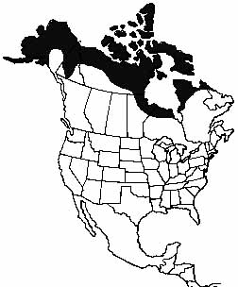  TUNDRA | 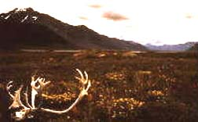  In the polar regions of the Northern Hemisphere where the winters and extremely cold and long and even conifers cannot survive, the land is dominated by a mixed grassland, small shrub, and herbaceous plants ecosystem called the tundra. The most characteristic feature of the tundra is permafrost, a layer of permanently frozed subsoil. In the summer the ground thaws to a depth of a few centimeters and becomes wet and soggy. This freezing and thawing cycle crushes the roots of plants keeping them small and stunted. Alpine ecosystems are mountain top versions of the tundra.
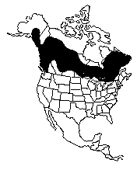  TAIGA | 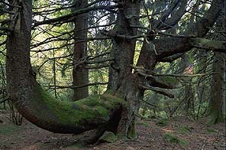  The taiga is characterized by a climate of long, severe winters, and a constant cover of snow and short, cool summers. The vegetation is dominated by conifers such as spruce, fir, and hemlock. Characteristic animals are elk, moose, mule deer, black bears, and grizzly bears. The taiga occurs in the northern reaches of North America and Eurasia.  The taiga is also sometimes referred to as boreal forest or northern coniferous forest. Taiga-like vegetation occurs on the upper elevations of mountain ranges.
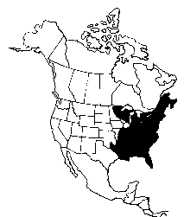  TEMPERATE DECIDUOUS FOREST | 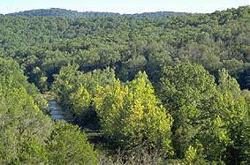  Temperate deciduous forest is characterized by a warm to hot growing season with moderate precipitation, followed by a winter that is not as cold or as long as in more northerly regions. The dominant trees in this zone avoid water loss during the winter by shedding their leaves. The temperate deciduous forests are much richer in plant and animal species than the taiga or tundra zones. A rich variety of tree and other plant species characterize the temperate deciduous forest. Temperate deciduous forest is primarily characteristic of the eastern United States and Canada, and also occurs in Europe, Japan, parts of Australia, and the mountainous regions of Patagonia at the southern tip of South America.
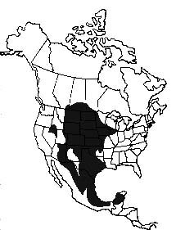  GRASSLANDS | 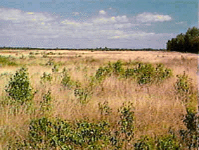  Ecologists prefer to use the term "grasslands" to "prairie". Grasslands are typically areas where either low total annual rainfall (10-20 inches) or uneven seasonal occurrence of rainfall favor grasses and herbaceous plants to trees. Special soil conditions or geology sometimes also favor grasslands over other types of vegetation, and grasslands occur outside of the Great Plains (e.g. the savannah regions of Florida). The most obvious example of grasslands in North America are the prairies of the Great Plains region of the continent. The North American Great Plains have largely disappeared because of agriculture, particularly in the east. The prairie region of the central United States is variable in its composition and appearance depending in large (but not complete) part on the amount of annual percipitation. On the eastern edge of the Great Plains, prairie consists of tall grasses and a tremendous diversity of other herbaceous plants. At the edge of this "tallgrass" prairie with the woodlands of the eastern United States, a form of mixed habitat called savanna occurs. In a savanna the tallgrass prairie is either inter-digitated with patches of woods, or trees may occur as scattered individuals in the grassland. Some tallgrass prairies are referred to as "fire disclimax communities" meaning that fire is necessary to prevent trees from pushing out the grasses and forbs. Fire is a natural part of their environment and controlled burning can be an important conservation measure. Annual rainfall declines as one goes westward in the Great Plains. Grasses decrease in size and the number of herbaceous plants declines in numbers and diversity. On the western edge of the Great Plains the praire is referred to as "short-grass prairie" eventually giving way to the shrublands and deserts of the western United States and Canada.
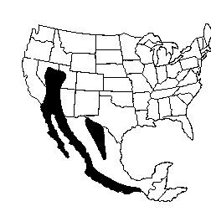  DESERT | 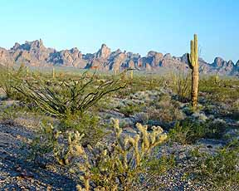  Deserts, in simplest terms, are areas of little rain or rainfall restricted to a short period during the year. Rain is limited because cool air sinks into a warmer region. As air warms its capacity to hold water vapor increases and rain cannot form. The great deserts of the world occur at about 30 degrees latitude on both sides of the equator and extend poleward in the interiors of the continents. These regions are areas of falling, warming air. Deserts can also be produced by the rain shadow effect of mountain ranges. As air masses approach from west to east in North America and meet a mountain range such as the Rockies, the air rises, cools, and loses much of its water vapor as rain or snow. The air falls on the other side of the mountains, warms, and creates a rain shadow on the eastern side of the mountains.
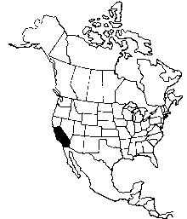  MEDITERRANEAN SCRUB AND WOODLAND | 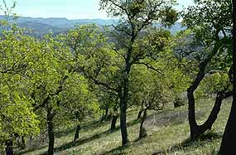  Areas of mild, rainy winters and long, hot, dry summers, such as on the southern coast of California, are dominated by a series of plant communities called Mediterranean Scrub and Woodland, sometimes called "chaparral". True chaparral is a region of dense shrub 10 to 12 feet high, but is commonly interspersed, in wetter areas, with a more open sclerophyl oak forest (such as in the picture). The more open forest occurs in the wetter parts and the true chaparral on the driers slopes of hills and mountains. The web sites below all tend to mix the two together. Similar vegetation communities occur in southern Europe, Chile, and coastal Australia.

